
CENTRAL BOARD OF SECONDARY EDUCATION
CENTRAL PUBLIC SCHOOL
ADITYAPUR, JAMSHEDPUR

A PRACTICAL RECORD FILE IS SUBMITTED TO DEPARTMENT OF COMPUTER SCIENCE FOR THE PARTIAL FULLFILLMENT OF AISSCE EXAMINATION FOR THE ACADEMIC.
SESSION: 2023-24

PROJECT REPORT ON
MOVIE TICKET BOOKING

ROLL NO. : 22712731
NAME : Kaushal Prajapati
CLASS : XII “A”
PROJECT GUIDE : Mr. Sourav Roy
PGT (COMPUTER SCIENCE)
Central Public School, Adityapur,
Jamshedpur.
CERTIFICATE
This project entitled “MOVIE TICKET BOOKING”, is the development project work in COMPUTER SCIENCE (083), successfully completed by Master Kaushal Prajapati, student of class-XII A, CENTRAL PUBLIC SCHOOL Adityapur, with AISSCE Roll No. 22712731
under the supervision of Mr. Sourav Roy (PGT COMPUTER SCIENCE), for the partial fulfilment of requirements for the course completion in pursuance of AISSCE 2023-24.

…………………………………….. ……………………………….
Teacher In-Charge Principal

……………………………………..
Practical Examiner School Stamp

TABLE OF CONTENTS
SL. NO | TOPIC | PAGE NO.
1. | INTRODUCTION | 01
2. | CERTIFICATE | 02
3. | ACKNOWLEDGEMENT | 04
4. | INTRODUCTION ON MOVIE TICKET BOOKING | 05
5. | OBJECTIVE OF PROJECT | 06
6. | PROPOSED SYSTEM | 07
7. | HARDWARE AND SOFTWARE REQUIREMENTS | 08
8. | SYSTEM DEVELOPMENT LIFE CYCLE (SDLC) | 09
9. | PHASES OF SYSTEM DEVELOPMENT LIFE CYCLE | 10-14
10. | FLOW CHART | 15
11. | SOURCE CODE | 17-21
12. | OUTPUT | 22-25
13. | TESTING | 26
14. | CONCLUSION | 28
15. | BIBLIOGRAPHY | 29

ACKNOWLEDGEMENT

I want to express my heartfelt thanks to Mr. Sourav Roy, my Computer Teacher, whose guidance and support were truly invaluable. His mentorship played a vital role in shaping the outcome beyond my expectations.
I am deeply grateful to our esteemed Principal Dr. Moushumi, for her continuous support and supervision and for providing me with the opportunity to create a project on “MOVIE TICKET BOOKING”.
I would also like to acknowledge the unwavering support of my parents, whose encouragement and support provided me with strength and inspiration. Additionally, to all my friends whose valuable suggestions and input were crucial in shaping this project.
Last but not least I would like to thanks my classmate who have helped me a lot.
Sincere gratitude to everyone involved in this project's realization; your collective help and support have been pivotal in its success. Thank you for being a part of this journey.

PROJECT ON MOVIE TICKET BOOKING

INTRODUCTION

Movie Ticket Booking introduces a streamlined and convenient approach to securing seats for cinematic experiences. This process involves the use of technology to simplify and enhance the way individuals reserve and purchase movie tickets. The introduction of online platforms and mobile applications has transformed the traditional ticketing system, allowing users to browse movie schedules, select preferred showtimes, and choose specific seats in advance.
The core objective is to provide moviegoers with a hassle-free and time-efficient means of planning their entertainment outings. Movie ticket booking systems offer features such as real-time seat availability, promotional offers, and user-friendly interfaces, creating an enhanced experience for patrons. By automating tasks like seat selection and payment processing, these systems reduce the reliance on physical ticket counters, contributing to a more efficient and accessible movie-going process. Ultimately, the introduction of movie ticket booking systems embraces technological advancements to make the cinema experience more convenient, enjoyable, and tailored to the preferences of the audience.

OBJECTIVES OF THE PROJECT
The central objective of movie ticket booking systems is to streamline and enhance the process of reserving and purchasing movie tickets for patrons. It involves creating an organized and user-friendly platform that simplifies the ticket booking experience. The system aims to provide convenience by enabling users to browse movie schedules, select preferred showtimes, and choose seats in advance, all from the comfort of their homes or mobile devices.
Efficiency is a key goal, with the system automating tasks such as seat selection, payment processing, and ticket confirmation. By implementing online platforms or mobile apps, the objective is to reduce the need for physical queues at cinema counters and offer users a seamless and time-saving booking process.
Additionally, movie ticket booking systems often incorporate features like real-time seat availability, movie reviews, and promotional offers, enhancing the overall user experience. The goal is to provide moviegoers with a convenient, efficient, and enjoyable way to plan and secure their movie-going experience.
In summary, the objective of movie ticket booking systems is to leverage technology to simplify the ticketing process, increase accessibility, and ultimately enhance the overall satisfaction of movie enthusiasts.

PROPOSED SYSTEM

The proposed movie ticket booking system aims to revolutionize the cinema experience by offering a comprehensive and user-centric platform. Key components of the system include:

1. User-Friendly Interface: An intuitive interface accessible via web and mobile applications, enabling users to effortlessly navigate movie listings, view showtimes, select preferred seats, and complete bookings seamlessly.
2. Real-Time Updates: Providing real-time information on movie schedules, seat availability, and theater locations, allowing users to make immediate and informed decisions while securing their desired seats in advance.
3. Secure Payment Gateway: Implementing robust and secure payment gateways to facilitate safe and hassle-free transactions, ensuring user data privacy and confidentiality.
4. Customization and Recommendations: Offering personalized recommendations based on user preferences, past bookings, and movie ratings to enhance the user experience and simplify movie selection.
5. Interactive Features: Integrating interactive elements such as movie trailers, synopses, and user reviews to enrich the browsing experience and assist users in making informed movie choices.
6. Mobile Access and Alerts: Enabling mobile access for on-the-go bookings and providing instant notifications for booking confirmations, seat availability, and upcoming movie releases.
7. Customer Support: Providing responsive customer support services to address user queries, booking assistance, and issue resolution efficiently.

HARDWARE AND SOFTWARE REQUIREMENTS

I.OPERATING SYSTEM : WINDOWS 7 AND ABOVE
II. PROCESSOR : PENTIUM(ANY) OR AMD
ATHALON (3800+- 4200+ DUALCORE)
III. MOTHERBOARD : 1.845 OR 915,995 FOR PENTIUM 0R MSI
K9MM-V VIAK8M800+8237R PLUS CHIPSET FOR AMD ATHALON
IV. RAM : 512MB+
V. Hard disk : SATA 40 GB OR ABOVE
VI. CD/DVD r/w multi drive combo: (If back up required)
VII. PENDRIVE : (If Backup required)
VIII. MONITOR 14.1 or 15 -17 inch
IX. Key board and mouse
X. Printer : (if print is required – [Hard copy])

SOFTWARE REQUIREMENTS:

- Windows OS
- Python
- MySQL
SYSTEM DEVELOPMENT LIFE CYCLE (SDLC)

The System Development Life Cycle (SDLC) is a structured framework used in software engineering to guide the process of developing information systems. It encompasses a series of phases that collectively manage the entire life cycle of a system, from initiation to maintenance. The typical phases include planning, analysis, design, implementation, testing, deployment, and maintenance. In the planning phase, project goals, scope, and resources are defined. Analysis involves studying existing systems and identifying requirements. Design focuses on creating a blueprint for the system. Implementation brings the design to life through coding. Testing ensures system functionality, and deployment involves making the system operational. Maintenance addresses ongoing updates and improvements. SDLC ensures systematic and efficient development, reducing risks, enhancing communication, and delivering a high-quality system that aligns with user needs and organizational objectives. The iterative nature of SDLC allows for flexibility and adaptability during development.

PICTORIAL REPRESENTATION OF SDLC:

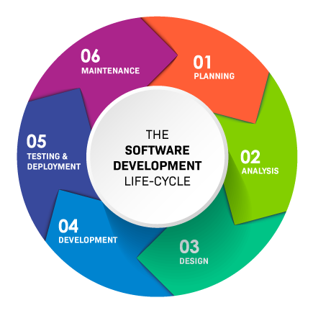
PHASES OF SYSTEM DEVELOPMENT LIFE CYCLE

INITIATION PHASE

The initiation phase in SDLC is like the project's green light. It's where we decide if the project makes sense and is doable. We define what the project is about, what it aims to achieve, and who's involved. It's the time to check if the project is technically possible, financially viable, and aligns with the organization's goals. Stakeholders' opinions and expectations are gathered, helping to set clear project requirements. We assess potential risks and challenges to be prepared. At the end of this phase, we have a project charter, a kind of project ID card, summarizing its purpose, scope, goals, stakeholders, and initial constraints. This document becomes our guide as we move into the nitty-gritty phases of designing, building, testing, and maintaining the system.

SYSTEM CONCEPT DEVELOPMENT PHASE

The System Concept Development phase is a crucial step in the System Development Life Cycle (SDLC) where the initial idea for a system is shaped and refined. During this phase, stakeholders collaborate to define the high-level goals and objectives of the proposed system. The focus is on understanding the broader concepts, functionalities, and expected outcomes. It involves brainstorming sessions, feasibility studies, and initial cost-benefit analyses to evaluate the viability and potential success of the project. Key decisions made in this phase set the foundation for subsequent stages, influencing the scope, requirements, and overall direction of the system development. Effective communication among stakeholders is paramount to ensure a shared understanding of the project's vision and to establish a solid conceptual framework that guides the development team in later phases.
During the system concept development phase, the focus is on defining the overall purpose, scope, and initial requirements of the system. This involves brainstorming ideas, outlining key features, and establishing a high-level understanding of how the system will function.
PLANNING PHASE

The physical characteristics of the system are designed during this phase. The operating environment is established, major subsystems and their inputs and outputs are defined, and processes are allocated to resources. Everything requiring user input or approval must be documented and reviewed by the user. The physical characteristics of the system are specified and a detailed design is prepared. Subsystems identified during design are used to create a detailed structure of the system. Each subsystem is partitioned into one or more design units or modules. Detailed logic specifications are prepared for each software module.

REQUIREMENTS ANALYSIS PHASE

Functional user requirements are formally defined and delineate the requirements in terms of data, system performance, security, and maintainability requirements for the system. All requirements are defined to a level of detail sufficient for systems design to proceed. All requirements need to be measurable and testable and relate to the business need or opportunity identified in the Initiation Phase.

DESIGN PHASE

The Design Phase in the System Development Life Cycle (SDLC) is a critical stage where the detailed plans for the system are crafted based on the requirements gathered earlier. During this phase, system architects and designers work on creating a comprehensive blueprint for the software or system. This involves specifying the structure, components, modules, interfaces, and data for the system. Detailed algorithms and data structures are designed, and user interface layouts are finalized. The goal is to transform the conceptual ideas into a practical and executable design. This phase heavily relies on the requirements analysis and involves continuous collaboration between designers and stakeholders to ensure the proposed design aligns with the desired functionalities. The outcome of this phase serves as a guide for developers during the subsequent implementation stage, playing a pivotal role in shaping the final product.
DEVELOPMENT PHASE
Effective completion of the previous stages is a key factor in the success of the Development phase. The Development phase consists of:
- Translating the detailed requirements and design into system components
- Testing individual elements (units) for usability
- Preparing for integration and testing of the IT system.
Integration, system, security, and user acceptance testing is conducted during this phase as well. The user, with those responsible for quality assurance, validates that the functional requirements are met by the newly developed or modified system. This phase is initiated after the system has been tested and accepted by the user. In this phase, the system is installed to support the intended business functions. System performance is compared to performance objectives established during the planning phase. Implementation includes user notification, user training, installation of hardware, installation of software onto production computers, and integration of the system into daily work processes. This phase continues until the system is operating in production in accordance with the defined user requirements.

INTEGRATION AND TEST PHASE
The Integration and Test Phase is a crucial stage in the System Development Life Cycle (SDLC) where individual components or modules developed during the implementation phase are integrated to form a complete system. The primary objective is to ensure that these components work seamlessly together as intended. Integration involves testing the interactions between different modules, verifying data flow, and identifying and resolving any inconsistencies. System testing follows, assessing the entire system's functionality against defined requirements. This phase employs various testing techniques, such as unit testing, integration testing, and acceptance testing, to detect and rectify defects. Successful completion of the Integration and Test Phase is instrumental in delivering a robust and reliable system, reducing the likelihood of issues during deployment and enhancing the overall quality of the software or system.
IMPLEMENTATION PHASE

The Implementation Phase in the System Development Life Cycle (SDLC) is where the detailed design from the previous phase comes to life. During this crucial stage, the actual coding and programming take place to create the software or system based on the established specifications. Developers follow the design guidelines and incorporate the defined algorithms, data structures, and functionalities. This phase also involves thorough testing of individual components to ensure they meet specified requirements. The Implementation Phase requires close collaboration between developers and designers, with iterative testing and debugging to identify and rectify any issues. Successful completion of this phase results in a fully functional and operational system ready for the next stages of testing and deployment. It marks a transition from planning and design to the tangible creation of the envisioned solution.
In the implementation phase of a project, the theoretical groundwork transforms into tangible reality through the execution of planned activities. This stage encompasses a spectrum of tasks, including coding, configuration, and construction, where the project's components come to life. It's a pivotal juncture where the envisioned design takes shape, and practical solutions emerge. The implementation phase serves as a bridge between conceptualization and realization, laying the groundwork for subsequent testing, refinement, and the eventual delivery of the final product or system.
OPERATIONS AND MAINTENANCE PHASE
The Operations and Maintenance Phase is like taking care of a well-functioning machine after it's been set up. Once the system is up and running, this phase is all about keeping things smooth and making improvements. It involves ongoing support, monitoring performance, and fixing any issues that pop up. Regular maintenance includes updating software, fixing bugs, and adapting the system to meet changing needs. User feedback is crucial for continuous improvement, and user support remains a priority. This phase also looks ahead, considering scalability and planning for future enhancements. It's the post-implementation stage where the focus is on the long-term health and success of the system, ensuring it stays effective and aligned with the organization's evolving requirements.
In the operation and maintenance phase, the focus shifts from implementation to the sustained functionality of the project. This stage involves a spectrum of ongoing activities, including routine operations, vigilant monitoring, and the prompt resolution of issues that may arise. Teams dedicated to support and maintenance play a crucial role in ensuring the system's continuous efficiency and reliability.

FLOW CHART BASED ON CODE

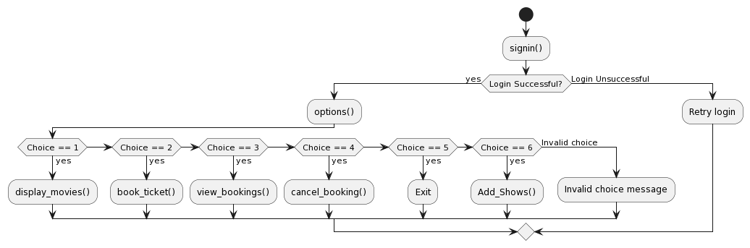

SOURCE CODE

import mysql.connector as ms
from random import randint

con = ms.connect(host="localhost", user="root", password="123456")
c = con.cursor()

c.execute("create database if not exists kp_cinemas")
c.execute("use kp_cinemas")

# Create necessary tables if they don't exist

c.execute('''CREATE TABLE IF NOT EXISTS movies (
S_NO INT PRIMARY KEY AUTO_INCREMENT,
MOVIE_NAME VARCHAR(50),
DATE VARCHAR(10),
TIME VARCHAR(10),
CHARGE INT,
INDEX(MOVIE_NAME),
INDEX(S_NO) )''')

c.execute('''CREATE TABLE IF NOT EXISTS Viewers (
NAME VARCHAR(20),
Ticket INT,
MOVIE_NAME VARCHAR(50),
SEAT_NO INT,
PAID INT,
FOREIGN KEY (MOVIE_NAME) REFERENCES movies(MOVIE_NAME),
FOREIGN KEY (PAID) REFERENCES movies(S_NO) )''')

# Insert movies into the 'movies' table
movies_list = [
(1, 'Hanu-Man', 'JAN', '12:30pm', 250),
(2, 'Interstellar', 'FEB', '7:00pm', 300),
(3, 'The Matrix', 'JAN', '5:00pm', 270),
(4, 'Dangal', 'JAN', '5:30pm', 150),
(5, '3 Idiots', 'MAY', '3:00pm', 120),
(6, 'Man of Steel', 'MAY', '5:30pm', 240),
(7, 'Aladdin', 'JAN', '6:00pm', 200),
(8, 'RRR', 'MAY', '4:30pm', 250),
(9, 'The Dark Knight', 'FEB', '5:30pm', 300),
(10, 'The Lion King', 'FEB', '8:30pm', 280) ]

for movie in movies_list:
c.execute('''INSERT IGNORE INTO movies (S_NO, MOVIE_NAME, DATE, TIME, CHARGE)
VALUES (%s, %s, %s, %s, %s)''', movie)
con.commit()

#SYSTEM PASSWORD LOGIN
def signin():
print("\n")
print(" ----------------------------------------------------------------------------------------")
print(" | >>>>>>>>>>>>>> Welcome To KP Cinemas [ KPC ] <<<<<<<<<<<<<< |")
print(" ----------------------------------------------------------------------------------------")
print("\n")
Id=input("Enter Your id: ")
password = input("Enter Your Password: ")
if Id == "user" and password == "123":
print("-----LOGIN SUCCESSFUL-----")
options()
else:
print("\nIncorrect Id or password. Please try again.\n")
signin()

def display_movies():
print("\n\n *********** Available SHOWS *********** \n")
c.execute("SELECT MOVIE_NAME FROM movies ORDER BY S_NO") # Select movies in ascending order of S_NO
count = 0
for movie in c:
count += 1
print(count, ".", movie[0])

def book_ticket():
display_movies()
choice = int(input("\nSelect Movie To Book Ticket (Enter the number): "))

# Check if the chosen movie number exists in the movies table
c.execute("SELECT MOVIE_NAME, CHARGE FROM movies WHERE S_NO = %s", (choice,))
result = c.fetchone()

if result:
vr = input("Viewer Name: ")
t = int(input("Enter Number of Tickets: "))
movie_name, charge = result[0], result[1]
total_cost = t * charge # Calculating the total cost based on charge per ticket
seat_number = randint(1, 100)

# Inserting data into Viewers table
c.execute('''INSERT INTO Viewers (NAME, Ticket, MOVIE_NAME, SEAT_NO, PAID)
VALUES (%s, %s, %s, %s, %s)''', (vr, t, movie_name, seat_number, choice))
con.commit()
print("TICKET BOOKED SUCCESSFULLY")
options()
else:
print("Invalid movie selection.")
options()

def view_bookings():
c.execute('SELECT * FROM Viewers')
bookings = c.fetchall()
if not bookings:
print('''You have no bookings. How about get started?''')

else:
for booking in bookings:
# Fetch the associated seat number from the database for each booking
c.execute("SELECT SEAT_NO FROM Viewers WHERE NAME = %s AND MOVIE_NAME = %s",
(booking[0], booking[2]))
seat_number = c.fetchone()[0] # Get the seat number associated with the booking

c.execute("SELECT CHARGE, TIME, DATE FROM movies WHERE MOVIE_NAME = %s", (booking[2],))
movie_data = c.fetchone()
movie_price = movie_data[0] # Get the movie price
movie_timing = movie_data[1] # Get the movie timing
movie_date = movie_data[2] # Get the movie date
total_cost = booking[1] * movie_price # Calculate total amount paid
print('''
---------------------------------------------------
| Ticket |
|------------------------------------------------- |
| Name: {} |
| Movie: {} |
| Date: {} |
| Timing: {} |
| Seat No.: {} |
| Total Cost: {} |
---------------------------------------------------
'''.format(booking[0], booking[2], movie_date, movie_timing, booking[1], seat_number, total_cost))
options()

def cancel_booking():
print("\n===== CANCEL BOOKING =====\n")
name = input("Enter your name: ")
movie = input("Enter the movie you want to cancel booking for: ")

# Check if the booking exists for the provided name and movie
c.execute("SELECT * FROM Viewers WHERE NAME = %s AND MOVIE_NAME = %s", (name, movie))
booking = c.fetchone()

if booking:
# If the booking exists, delete it from the Viewers table
c.execute("DELETE FROM Viewers WHERE NAME = %s AND MOVIE_NAME = %s", (name, movie))
con.commit()
print("Booking canceled successfully.")
else:
print("No booking found for the provided details.")

options()

# DISPLAY OPTIONS (MAIN)
def options():
while True:
print('''\n\nOPTIONS

1. Display Available Movies
2. Book Ticket
3. View Your Bookings
4. Cancel Booking
5. Exit
''')

choice = input("Enter your choice: ")
if choice == '1':
display_movies()
elif choice == '2':
book_ticket()
elif choice == '3':
view_bookings()
elif choice == '4':
cancel_booking()
elif choice == '5':
print("Exiting...")
break
else:
print("Invalid choice. Please try again!")

# Start the sign-in process
signin()

OUTPUT OF SOURCE CODE
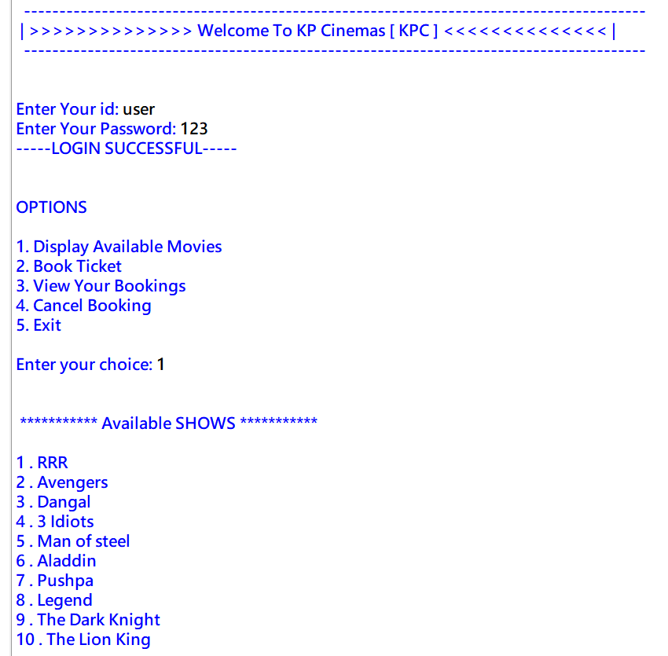

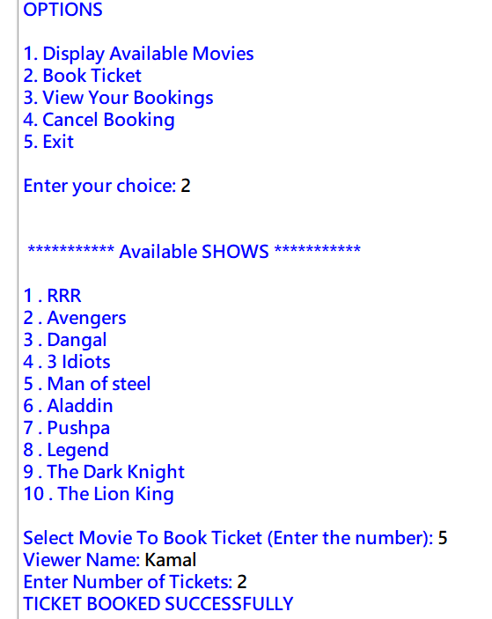

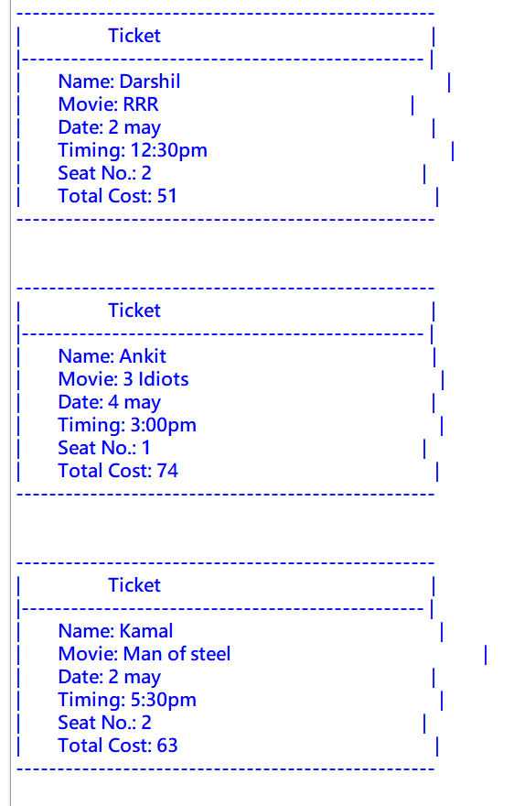
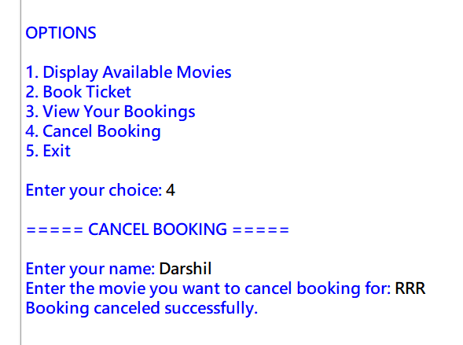

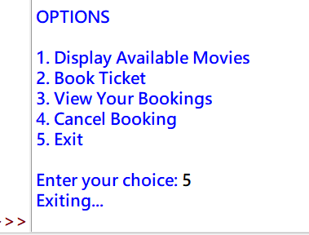

TESTING

TESTING METHODS

The testing phase of the software development lifecycle (SDLC) is where you focus on investigation and discovery. During the testing phase, developers find out whether their code and programming work according to customer requirements. And while it's not possible to solve all the failures you might find during the testing phase; it is possible to use the results from this phase to reduce the number of errors within the software program.

BLACK BOX TESTING

Black-box testing is a technique that assesses the functionality, behaviours, and output of the software without knowledge of its internal structure, logic, or code. To do this, the tester must have access to the specifications and requirements of the software, and use them to create test cases. This method of testing can uncover errors in the functionality, usability, and compatibility of the software, as well as verify that it meets user and stakeholder expectations. Examples of black-box testing methods are equivalence partitioning (dividing the input domain of the software into equivalent classes and testing one representative value from each class), boundary value analysis (testing values at the edges of the input domain), decision table testing (creating a table to show combinations of inputs and outputs for different scenarios), and state transition testing (testing behaviours when changing from one state to another).

SPECIFICATION-BASED TESTING

Specification-Based Testing uses the specification of the program as the point of reference for test data selection and accuracy. Specification-based testing can be used to test any type of system but is particularly well suited to testing systems with a well-defined interface, such as web applications. Specification-based testing is a type of testing that uses a formal specification of a software component to generate test cases.

ADVANTAGES AND DISADVANTAGES

- ADVANTAGES
- Modular Code Structure: Segregated functions improve code readability and maintainability, aiding in future updates or modifications.
- Real-time Interaction: Allows users to perform ticket bookings, view available movies, and cancel bookings interactively.
- Abstraction of Logic: Functions encapsulate specific functionalities, ensuring a clean and organized codebase, simplifying maintenance and debugging.

- DISADVANTAGES
- Limited Error Handling: Insufficient error handling mechanisms may result in unexpected program terminations or incorrect output in case of unforeseen issues.
- Poor User Feedback: The system lacks informative error messages or user prompts, potentially confusing users in case of errors or invalid inputs
- Limited Validation: Insufficient input validation might lead to data integrity issues or incorrect entries, impacting the overall system reliability.

WHITE BOX TESTING

White-box testing is a technique that involves testing the internal structure, logic, and code of the software. It requires the tester to have access to the source code and understand how it works, which can help to find errors in the implementation, logic, and design of the software, as well as to improve its performance, security, and maintainability. Examples of white-box testing methods include statement coverage (testing every statement in the code at least once), branch coverage (testing every possible outcome of a conditional statement in the code), path coverage (testing every possible path of execution in the code), and mutation testing (modifying the code slightly and checking if the test cases can detect the change).

CODE COMPLETENESS EVALUATION

The provided code attempts to create a basic movie ticket booking system using Python and MySQL. However, there are several areas that need improvement and expansion for a more comprehensive solution:

1. Database Interaction: The code establishes a connection to MySQL, creates tables for storing movie show information and viewer details, and enables basic insertion of data. However, it lacks functionality for updating or deleting records, checking for existing entries before insertion, and handling potential errors during database operations.

2. User Authentication and Security: The system includes a rudimentary login with hard-coded credentials, which is not secure or scalable for real-world applications. Implementing secure user authentication, password hashing, and authorization mechanisms is crucial for a secure system.

3. Booking Process: While the code allows users to book tickets by entering their name and the number of tickets, it doesn't link the booking to specific movie shows, calculate total costs based on show charges, or implement seat selection features.

4. Error Handling: Comprehensive error handling is absent in the code. Adding error handling mechanisms for database connectivity issues, incorrect user inputs, or SQL query failures is essential for a robust system.

5. Code Modularity and Structure: The code could benefit from better organization and modularization. Splitting functionalities into separate functions and adding comments/documentation would enhance readability, maintainability, and code reuse.

BIBLIOGRAPHY

Sources which helped me in completing my project are:
- Help from Internet.
- https://code-projects.org/
- https://www.scribd.com/home
- https://www.youtube.com/

- Help from Books.
- Sumita Arora, Class XI Computer Science
- Sumita Arora, Class XII Computer Science
- All in one For Computer Science with Python Class 12

- Also, some other sources that helped me are:
- Our Computer Science Teacher

