**Category 5e In-Line Coupler**

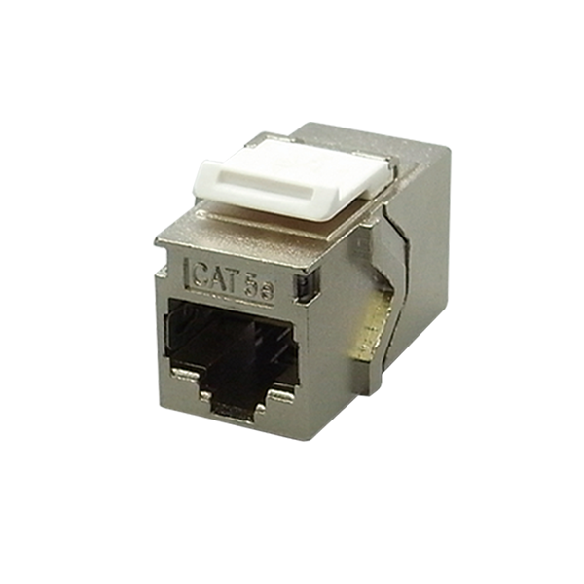

Female to female in-line coupler offer two types - cable extension type and panel mount type, compact housing and great performance. Panel mount type can be used with series I flush mount wall plates.

## **Features**

Metal Housing for STP version: Zinc Alloy with Nickel plated

Option for cable extension type or panel mount type

Contacts are phosphor bronze plated with 50 micro inches hard gold

**Ordering Information**

|  |  |
| --- | --- |
| **Part No.** | **Description** |
| **CP80000e-XX** | RJ45 8P8C Cat.5e, UTP In-line coupler, Panel mount type, H.D. version |
| **CP800XTe-XX** | RJ45 8P8C Cat.5e, UTP In-line coupler, Cable extension type |
| **CP8DZ00e** | RJ45 8P8C Cat.5e, STP In-line coupler, Panel mount, Zinc Alloy Housing, H.D. version |
| **CP8DZXTe** | RJ45 8P8C Cat.5e, STP In-line coupler, Extension Type, Zinc Alloy Housing |

***“XX” = Color choices – Ivory (IV), White (WH).***