**FIELD TERMINATION PLUG - CAT.6&6A**

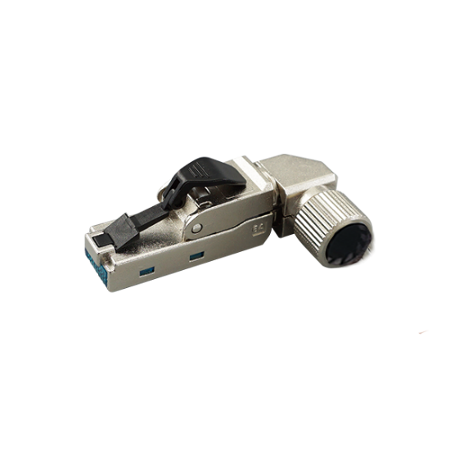

IKCOM Field Termination Plug is designed to be simple to be terminated with the twisted cables at field. The IDC is design to accommodate different diameter conductors up to 22AWG. All eight conductors are terminated at same time when the wire cap is squeezed. This process ensures consistent, reliable termination. The Field Installable plug is particularly ideal for IP enable devices, such as surveillance camera and building automation. And the simple termination design enables the installers easy to achieve Cat.6/Cat.6A.

**Features**

Wiring label: TIA 568A/B & PNO

Available in UTP & STP, Cat.6 & Cat.6A

Durability: 750 mechanical cycles

Termination capability:

STP: 22-26 AWG solid wire / 23-27 AWG stranded wire

UTP: 23-26 AWG solid wire / 23-27 AWG stranded wire

Re-termination capability: 5 times

Supporting cable diameter: STP: 6.0-9.0 mm UTP: 5.5-8.5 mm

4PPoE compliant in accordance with IEEE802.bt Type 4

**Ordering Information – CAT.6**

|  |  |
| --- | --- |
| **Part No.** | **Description** |
| **IKC-FTPS631** | CAT.6 STP field termination plug |
| **IKC-FTPU631** | CAT.6 UTP field termination plug |
| **IKC-FTPS641** | CAT.6 STP field termination plug |
| **IKC-FTPU641** | CAT.6 UTP field termination plug |
| **IKC-FTPS60A** | CAT.6 STP field termination plug |
| **IKC-FTPU60A** | CAT.6 UTP field termination plug |
| **IKC-FTPS60B** | CAT.6 STP field termination plug |
| **IKC-FTPU60B** | CAT.6 UTP field termination plug |

**Ordering Information – CAT.6A**

|  |  |
| --- | --- |
| **Part No.** | **Description** |
| **IKC-FTPSA11** | CAT.6A STP field termination plug |
| **IKC-FTPSA12** | CAT.6A STP field termination plug, 8 axis cable exist |
| **IKC-FTPSA21** | CAT.6A STP field termination plug |
| **IKC-FTPSA31** | CAT.6A STP field termination plug |
| **IKC-FTPUA31** | CAT.6A UTP field termination plug |
| **IKC-FTPSA32** | CAT.6A STP field termination plug, 4 axis cable exist |
| **IKC-FTPSA41** | CAT.6A STP field termination plug |
| **IKC-FTPUA41** | CAT.6A UTP field termination plug |
| **IKC-FTPSA0A** | CAT.6A STP field termination plug |
| **IKC-FTPUA0A** | CAT.6A UTP field termination plug |
| **IKC-FTPSA0B** | CAT.6A STP field termination plug |
| **IKC-FTPUA0B** | CAT.6A UTP field termination plug |