Category .5e In-Line Coupler

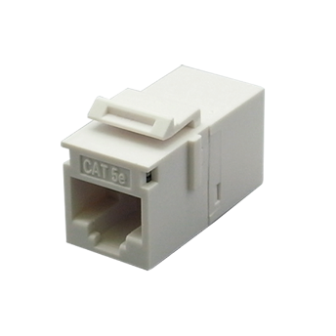

Female to female in-line coupler offer two types - cable extension type and panel mount type, compact housing and great performance. Panel mount type can be used with series I flush mount wall plates.

Features

Metal Housing for STP version: Zinc Alloy with Nickel plated

UL Listed

Option for cable extension type or panel mount type

Contacts are phosphor bronze plated with 50 micro inches hard gold

Ordering Information

|  |  |
| --- | --- |
| PART | Description |
| CP80000e-XX | RJ45 8P8C Cat.5e, UTP In-line coupler, Panel mount type, H.D. version |
| CP800XTe-XX | RJ45 8P8C Cat.5e, UTP In-line coupler, Cable extension type |
| CP8DZ00e | RJ45 8P8C Cat.5e, STP In-line coupler, Panel mount, Zinc Alloy Housing, H.D. version |
| CP8DZXTe | RJ45 8P8C Cat.5e, STP In-line coupler, Extension Type, Zinc Alloy Housing |

"XX" = color. white (WH), ivory (IV).