<https://udith33.000webhostapp.com/sponsors.php>

<https://bootstrapmade.com/rapid-multipurpose-bootstrap-business-template/>

<https://udith33.000webhostapp.com/home.html>

Image Links:

<https://udith33.000webhostapp.com/img/apple-touch-icon1.png>

<https://udith33.000webhostapp.com/img/favicon1.png>

<https://udith33.000webhostapp.com/img/intro-bg-1.jpg>

<https://udith33.000webhostapp.com/img/intro-img.svg>

<https://udith33.000webhostapp.com/img/logo.png>

<https://udith33.000webhostapp.com/img/portfolio/web1.jpg>

#MySQL Query

CREATE DATABASE id15088001_udith_databasename;

CREATE TABLE `id14926292_udith_databasename`.`carers` (

customer_id INT(10) PRIMARY KEY NOT NULL,

PIN LONGBLOB NOT NULL,

given_name VARCHAR(30) NOT NULL,

family_name VARCHAR(30) NOT NULL

);

CREATE TABLE `id14926292_udith_databasename`.`child` (

child_id INT PRIMARY KEY AUTO_INCREMENT,

given_name VARCHAR(30) NOT NULL,

family_name VARCHAR(30) NOT NULL,

date_of_birth DATE NOT NULL,

gender CHAR(1) NOT NULL,

daily_message VARCHAR(100),

carer_phone_number INT(10) NOT NULL,

FOREIGN KEY (carer_phone_number) REFERENCES carers(customer_id)

);

INSERT INTO `id14926292_udith_databasename`.`carers` (customer_id, PIN, given_name, family_name) VALUES (0717925432, PASSWORD(1234), 'Manasha', 'Androo');

INSERT INTO `id14926292_udith_databasename`.`carers` (customer_id, PIN, given_name, family_name) VALUES (0777925432, PASSWORD(5678), 'Kaushi', 'Mandori');

INSERT INTO `id14926292_udith_databasename`.`carers` (customer_id, PIN, given_name, family_name) VALUES (0700925412, PASSWORD(1289), 'Jhone', 'Smith');

INSERT INTO `id14926292_udith_databasename`.`carers` (customer_id, PIN, given_name, family_name) VALUES (0787920032, PASSWORD(3456), 'Pasan', 'Liyanage');

INSERT INTO `id14926292_udith_databasename`.`carers` (customer_id, PIN, given_name, family_name) VALUES (0117925932, PASSWORD(1290), 'Beny', 'Pool');

INSERT INTO `id14926292_udith_databasename`.`child` (given_name, family_name, date_of_birth, gender, daily_message, carer_phone_number) VALUES

('Kaushi', 'Rajapakshe', '1998-7-04', 'F', 'How are You', 0717925432);

INSERT INTO `id14926292_udith_databasename`.`child` (given_name, family_name, date_of_birth, gender, daily_message, carer_phone_number) VALUES

('Udith', 'Loku', '2008-7-04', 'F', 'I am doing good', 0777925432);

INSERT INTO `id14926292_udith_databasename`.`child` (given_name, family_name, date_of_birth, gender, daily_message, carer_phone_number) VALUES

('Jhone', 'Harisan', '1978-7-04', 'F', 'Good Morning', 0700925412);

INSERT INTO `id14926292_udith_databasename`.`child` (given_name, family_name, date_of_birth, gender, daily_message, carer_phone_number) VALUES

('Donal', 'Trump', '1956-7-04', 'F', 'How are You', 0787920032);

INSERT INTO `id14926292_udith_databasename`.`child` (given_name, family_name, date_of_birth, gender, daily_message, carer_phone_number) VALUES

('Wilium', 'Gopal', '1975-7-04', 'F', 'How are You', 0117925932);

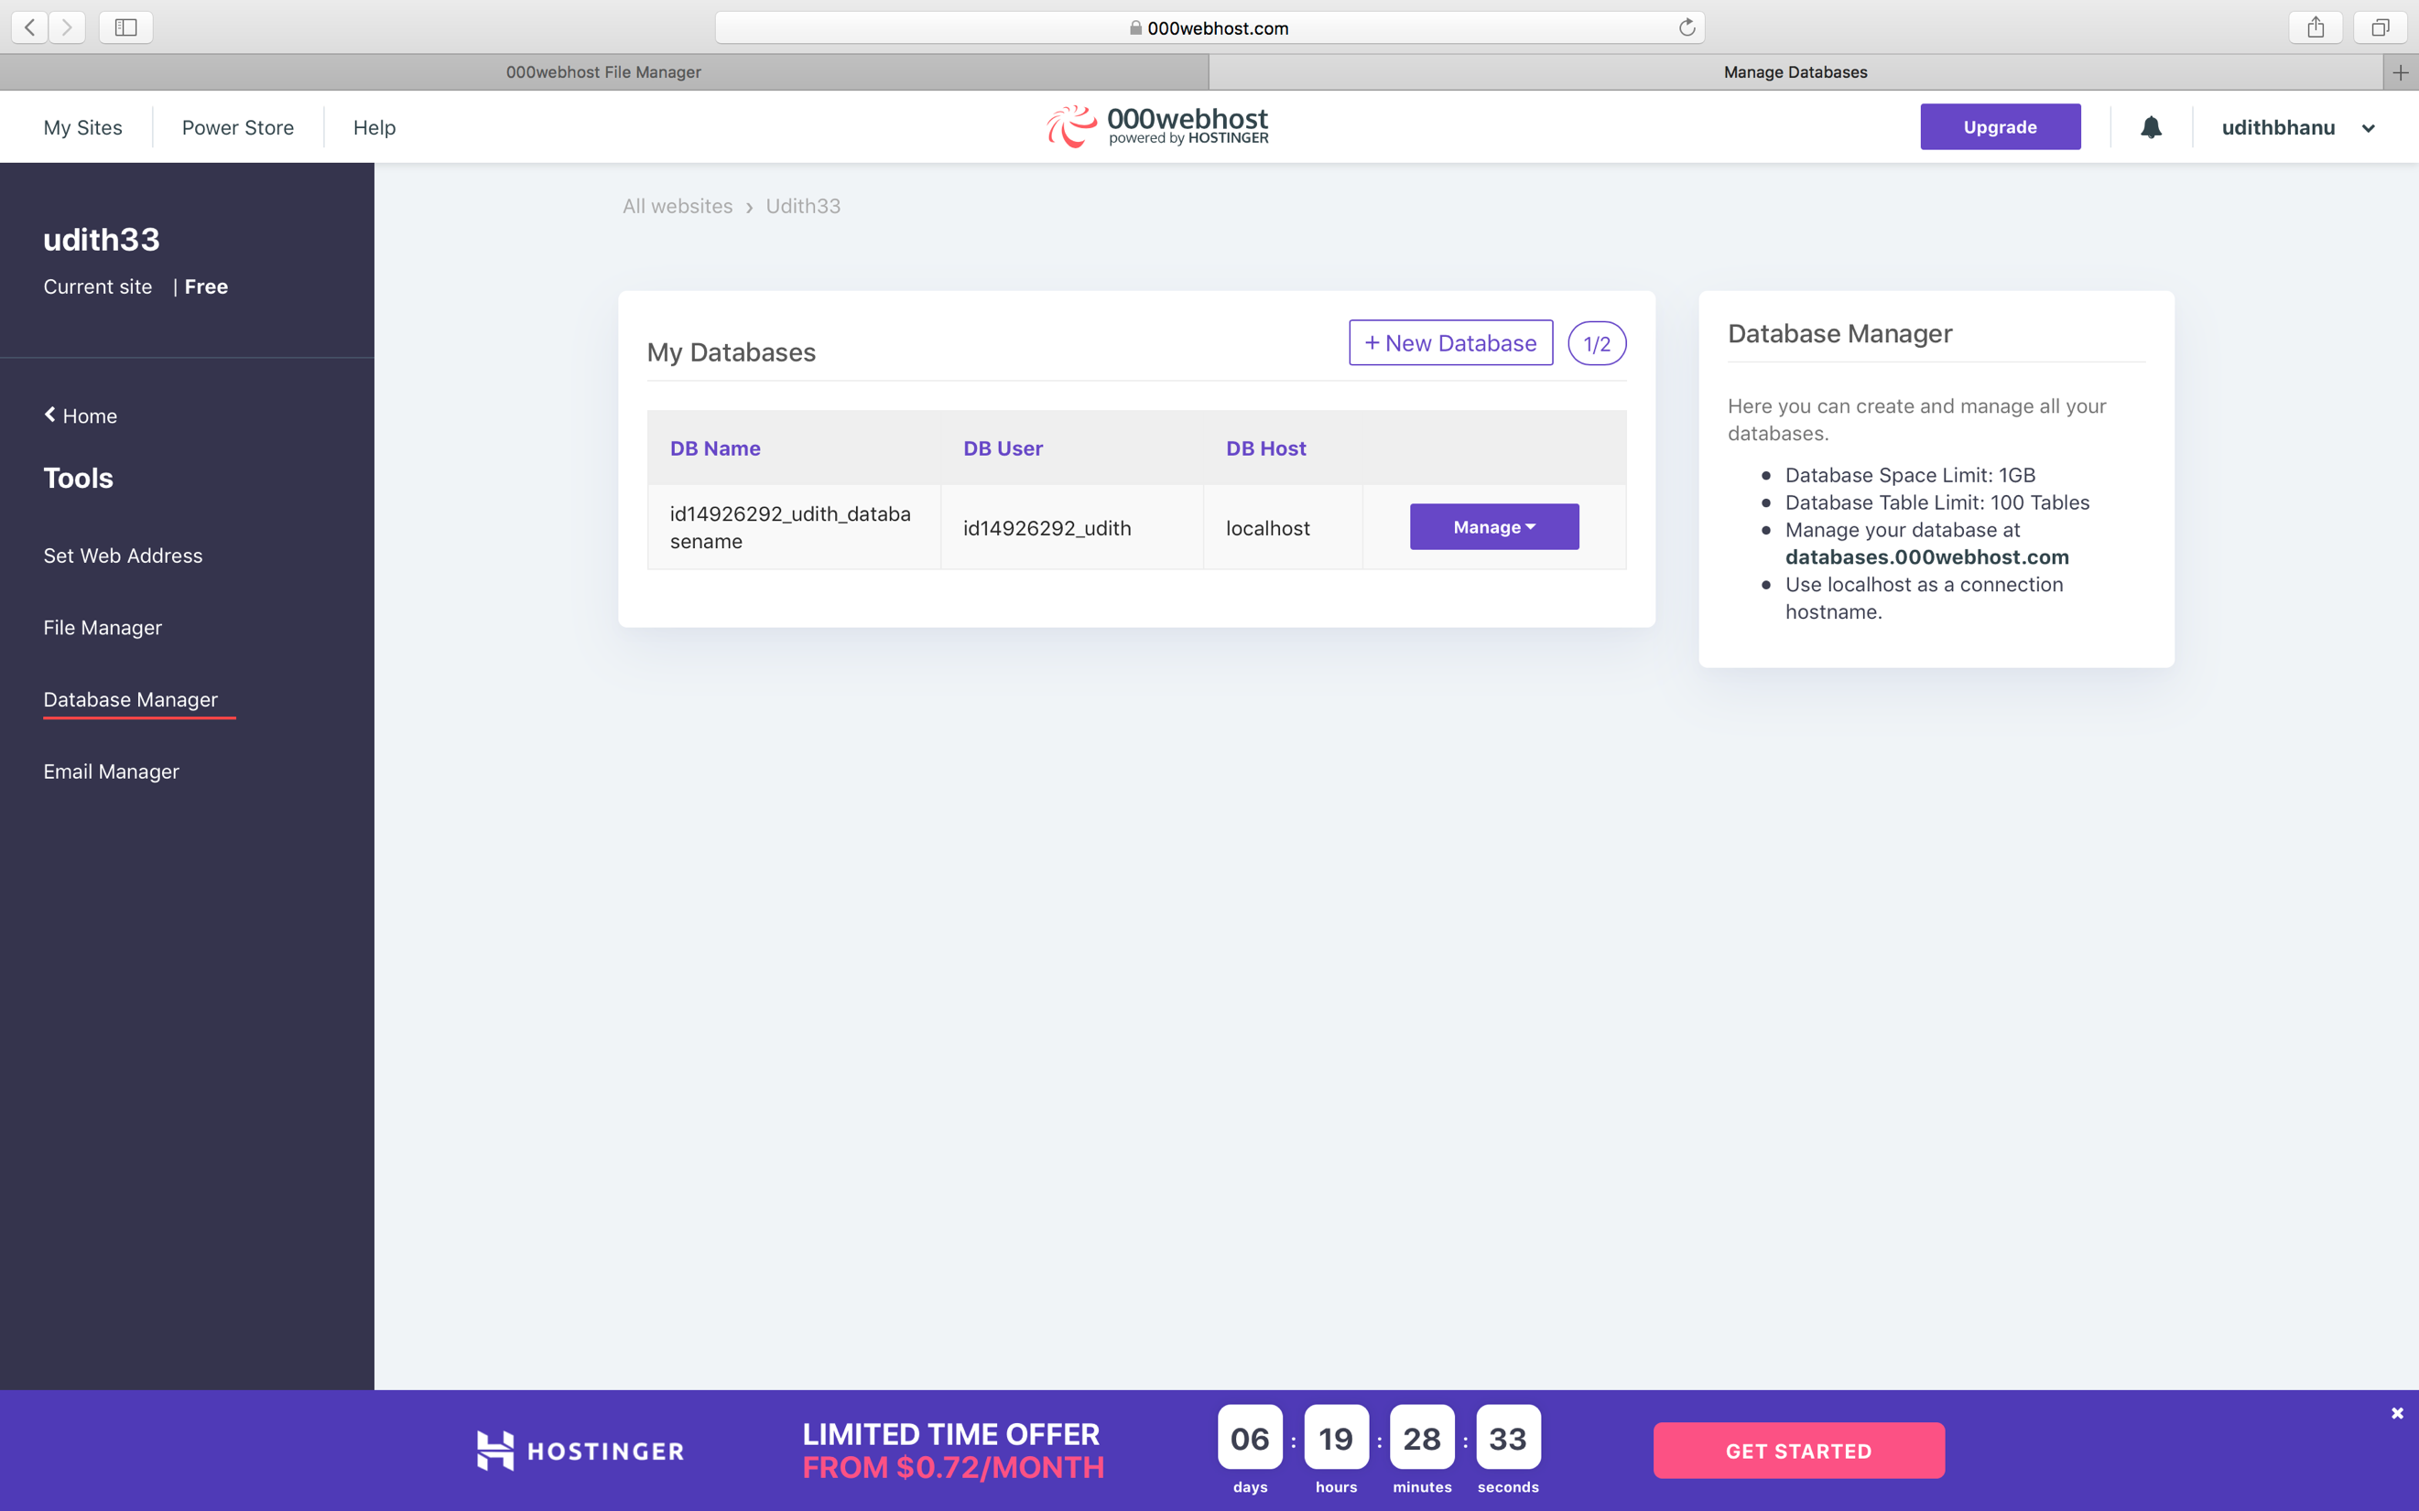

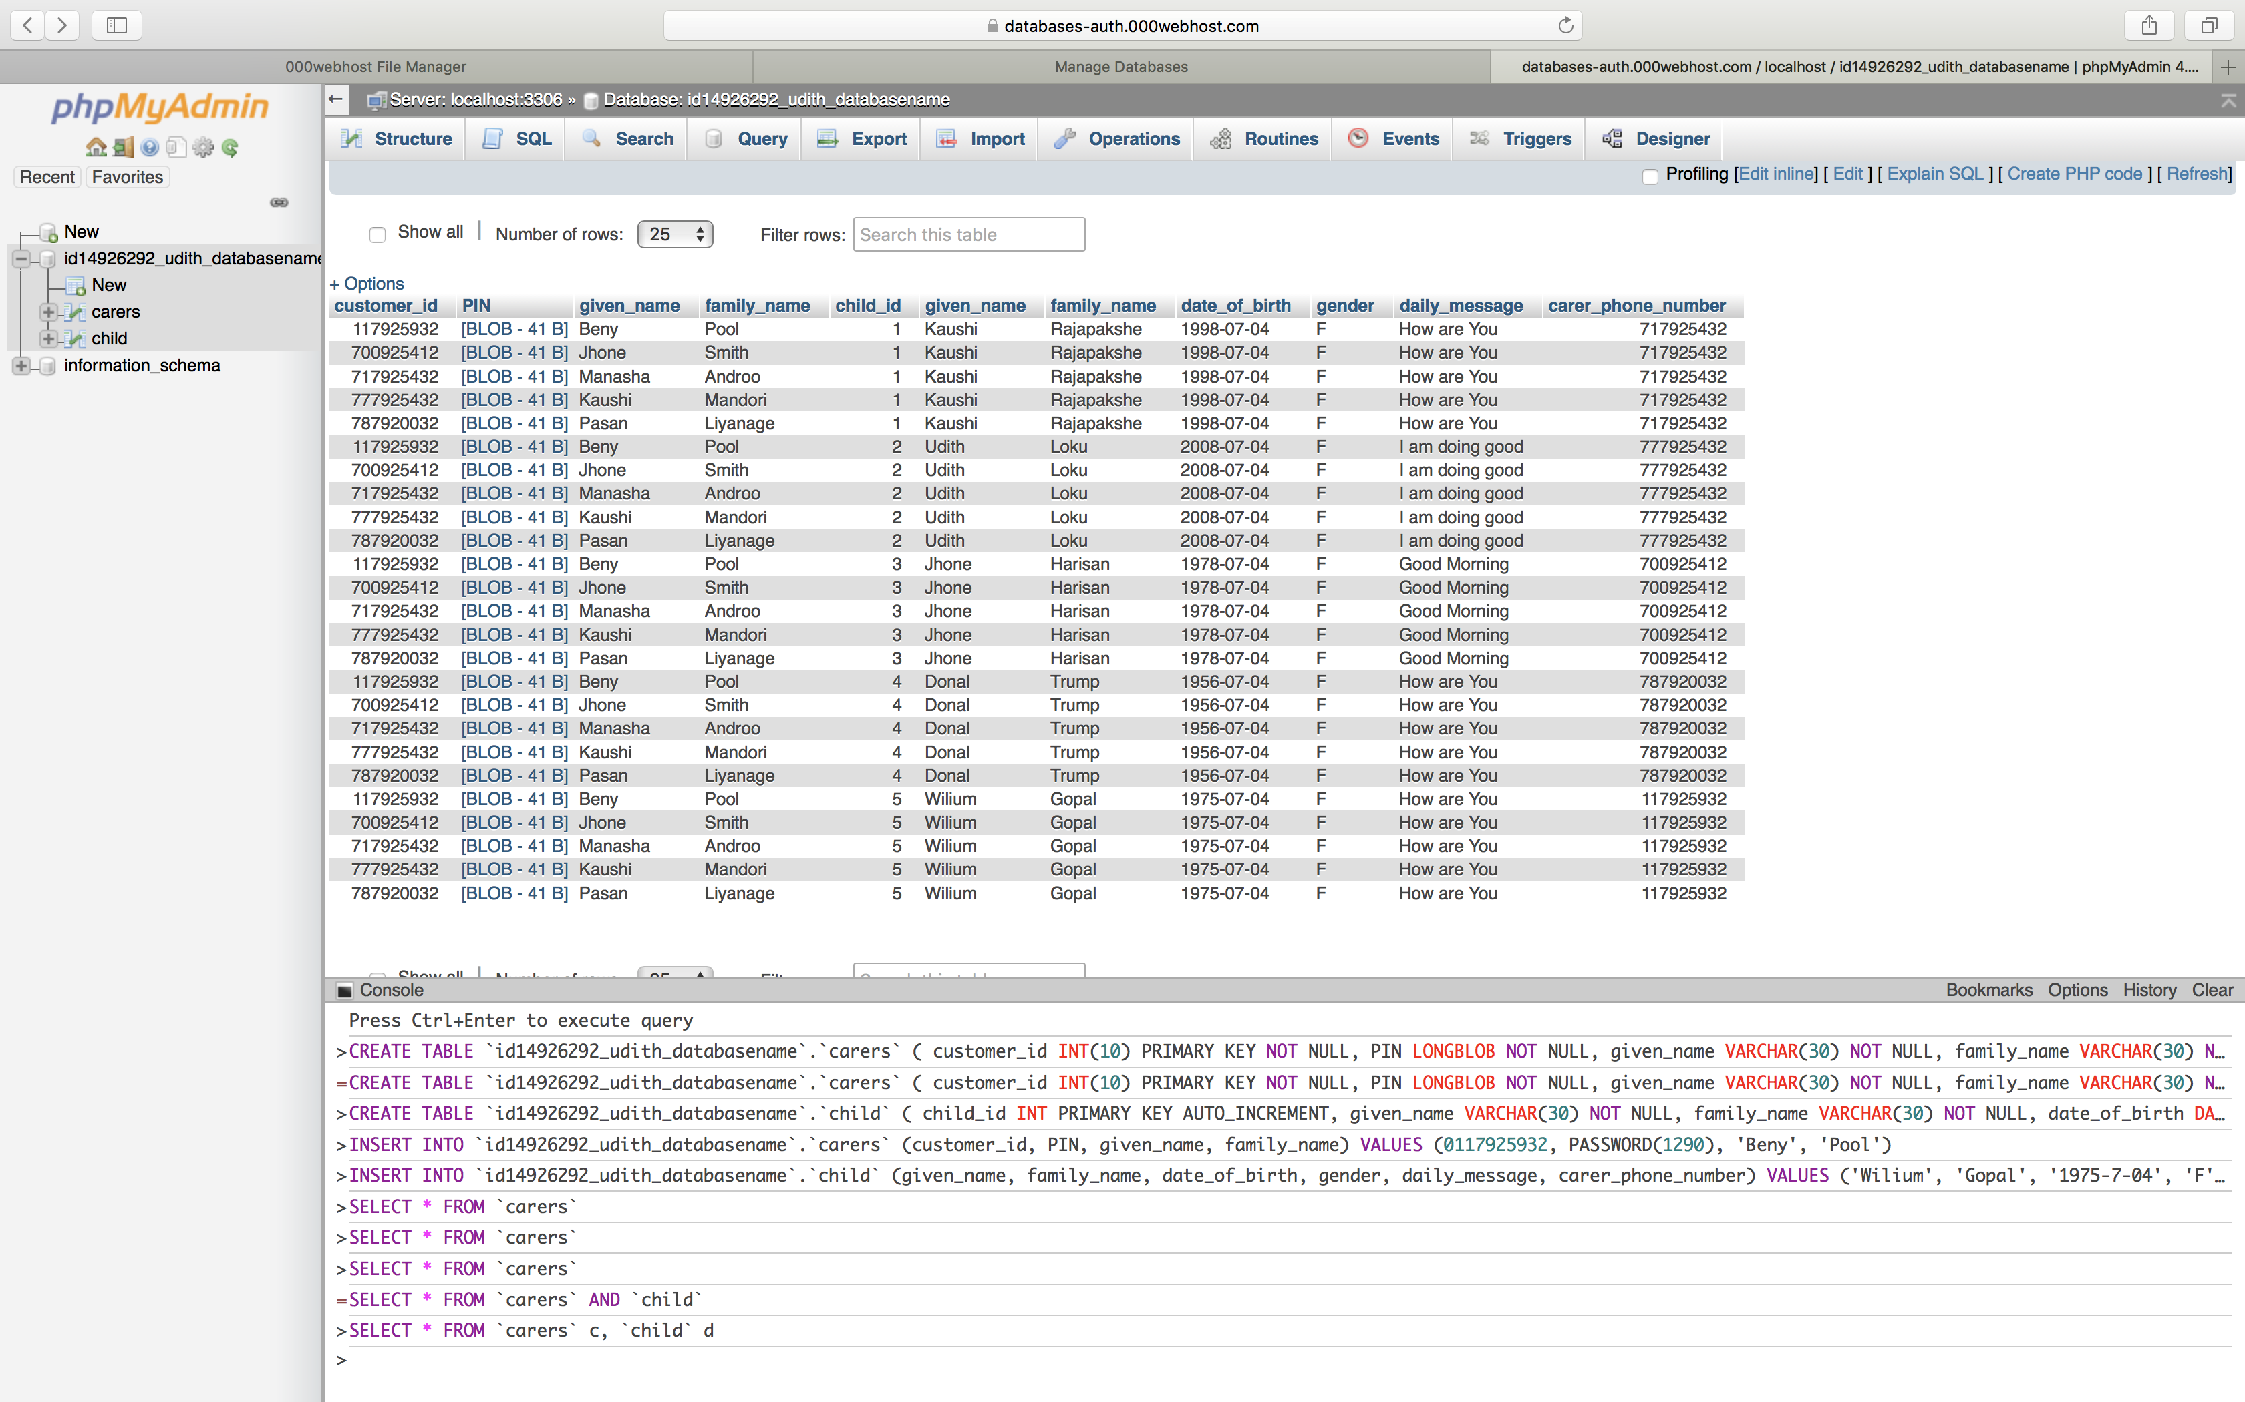

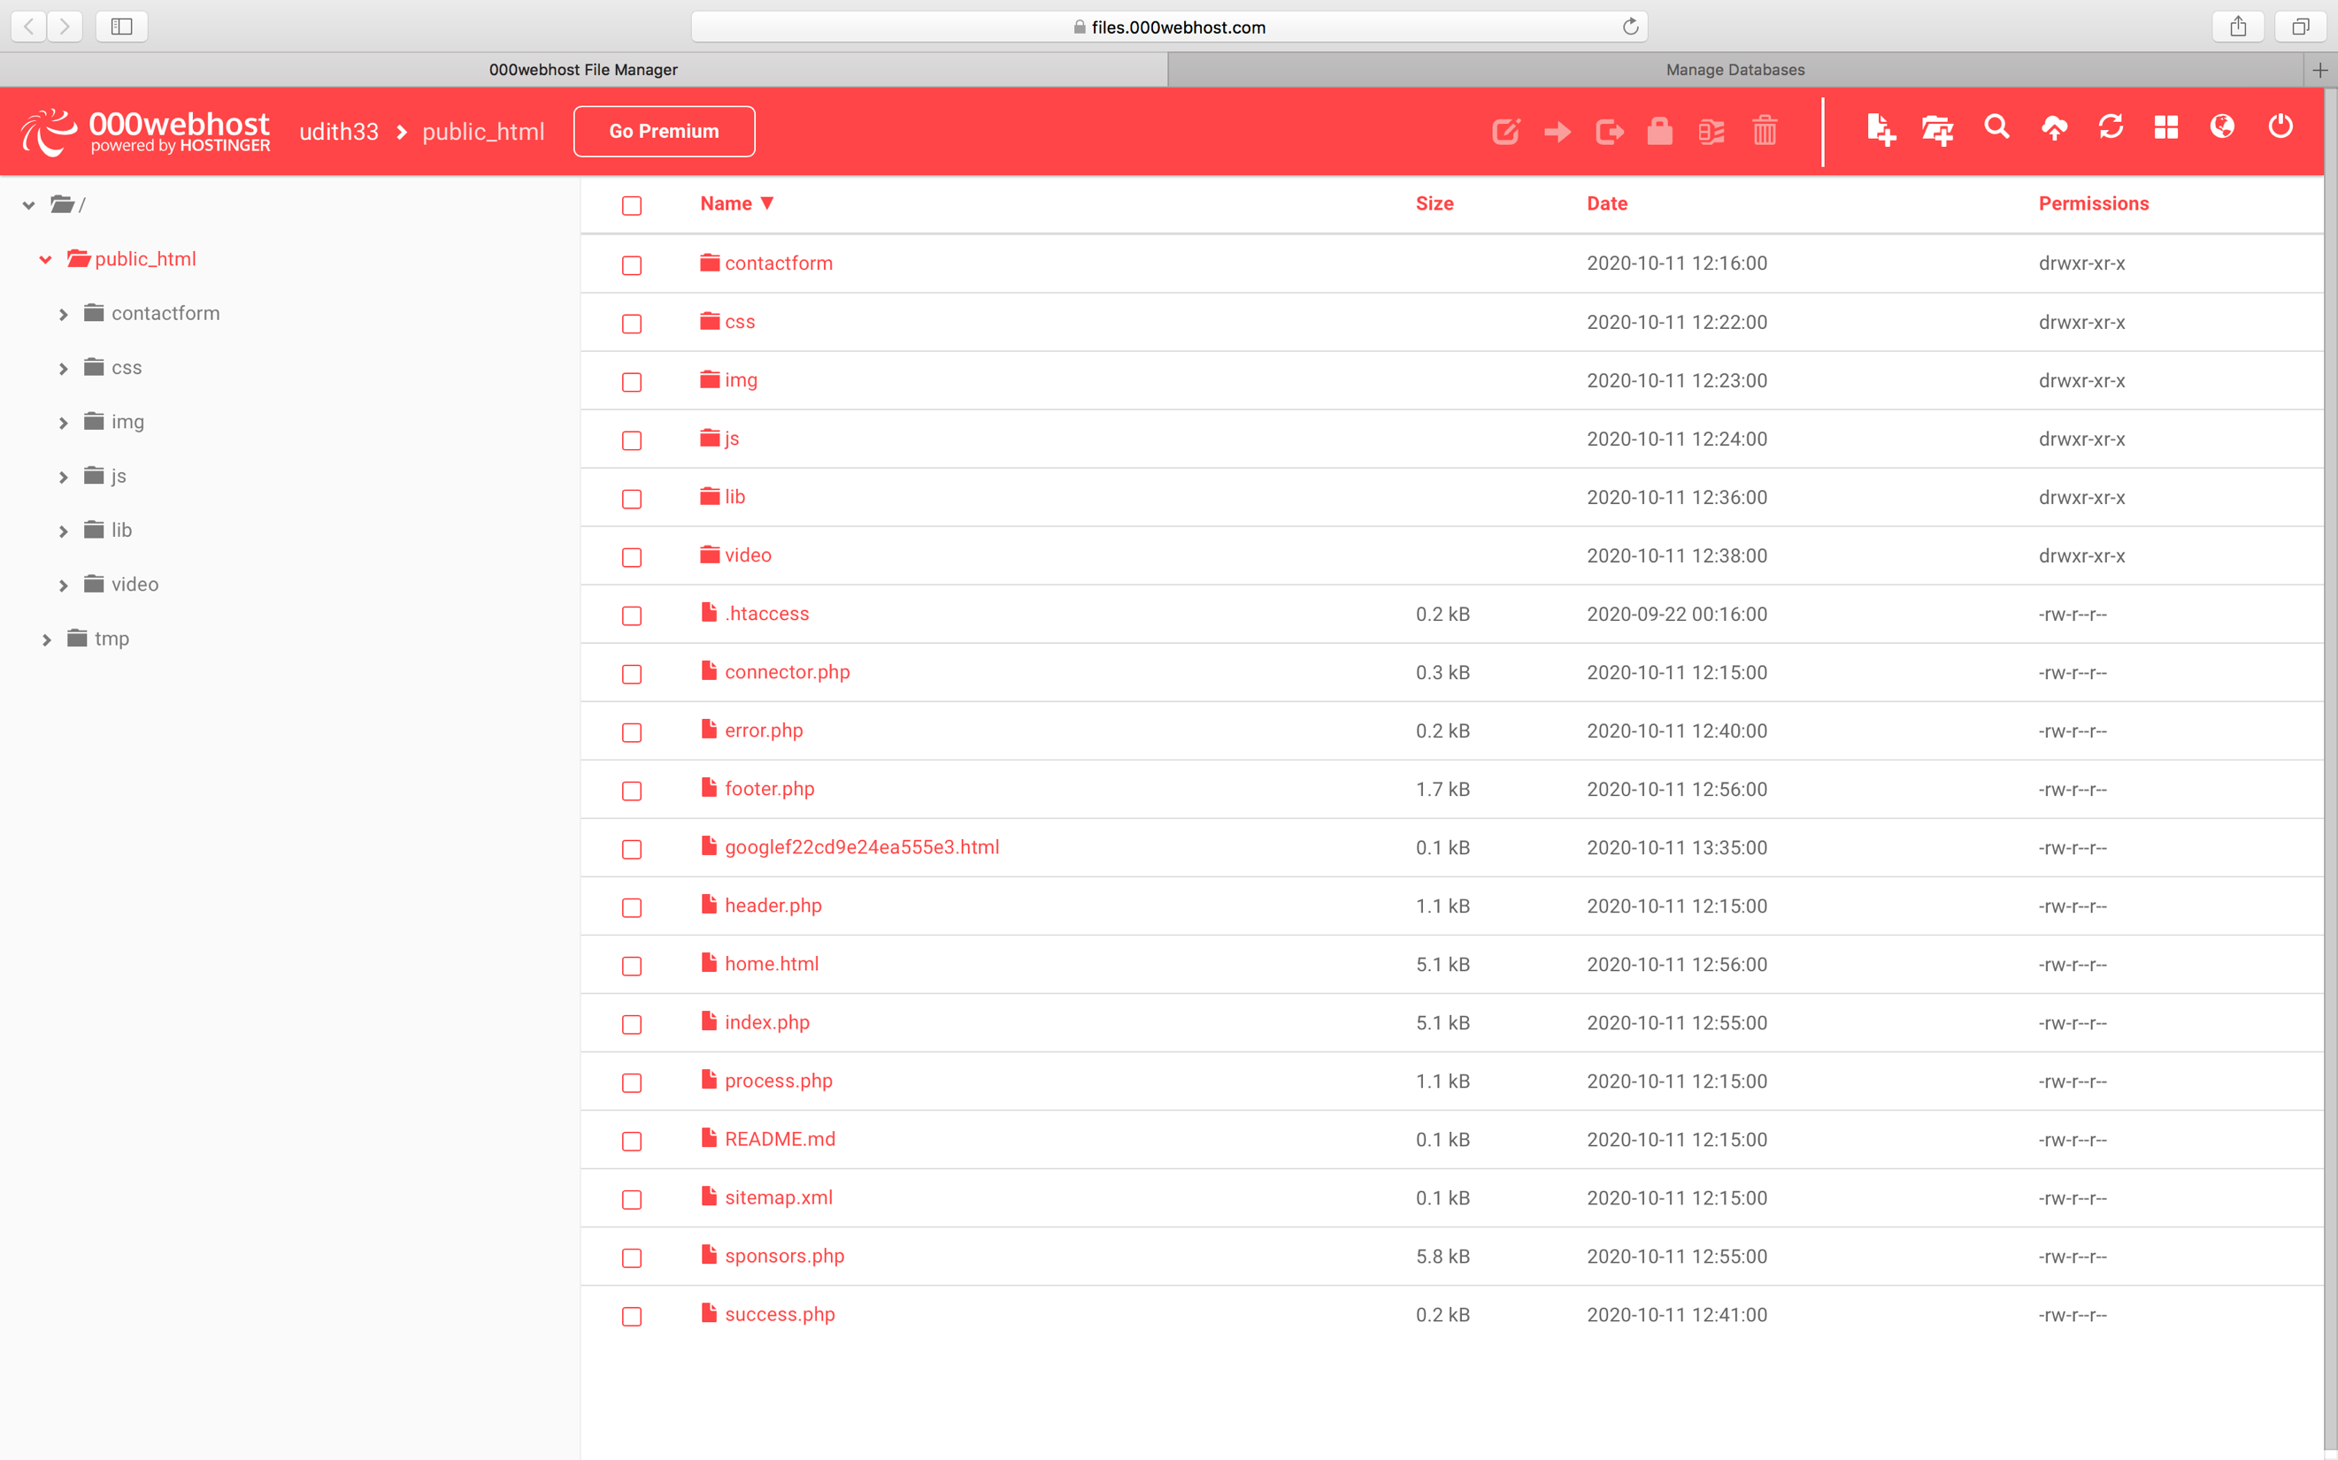

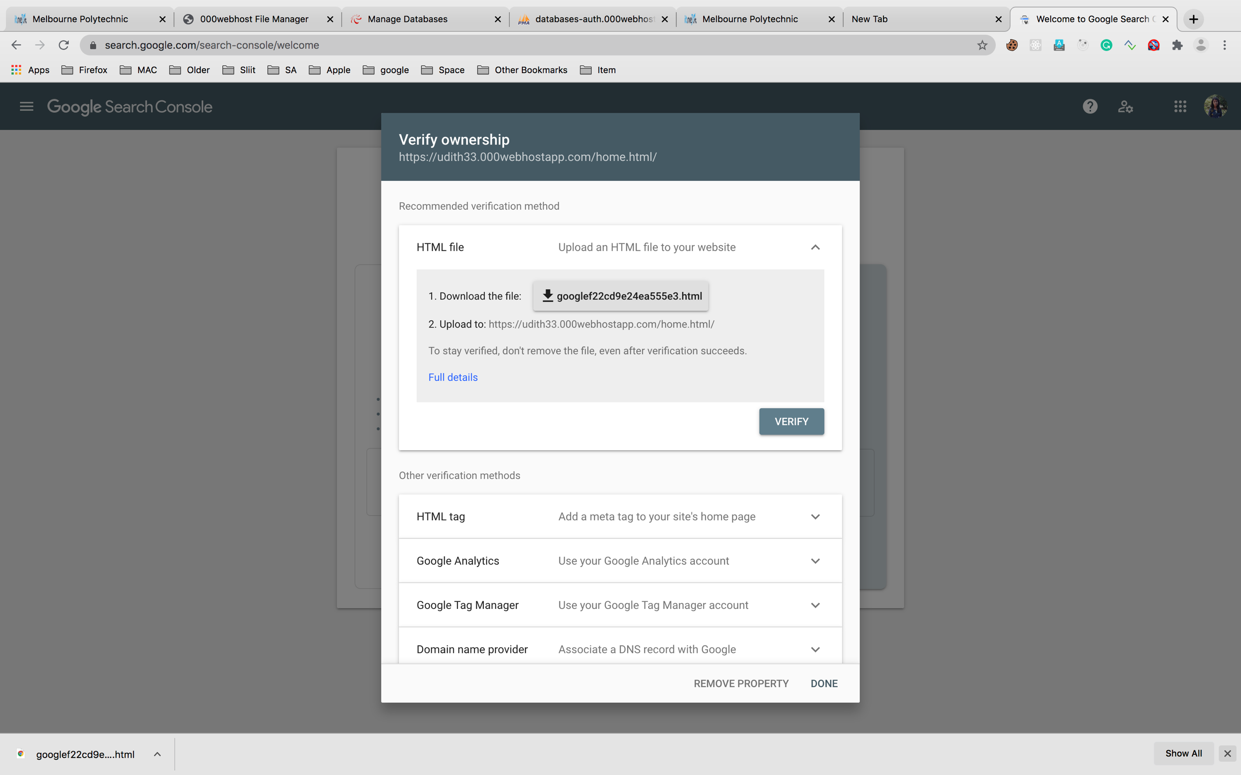

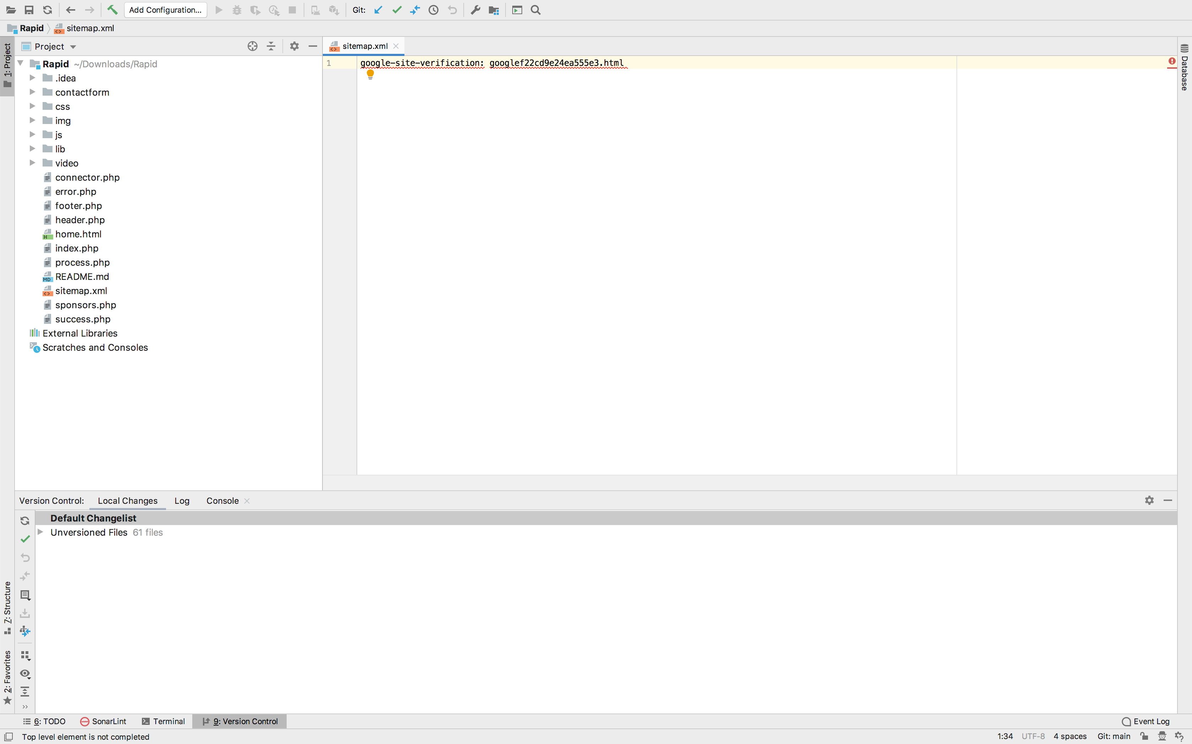

#contactform.js

jQuery(document).ready(**function**($) {  
 **"use strict"**;  
  
 *//Contact* $(**'form.contactForm'**).submit(**function**() {  
 **var** f = $(**this**).find(**'.form-group'**),  
 ferror = **false**,  
 emailExp = /^[^\s()<>@,;:\/]+@\w[\w\.-]+\.[a-z]{2,}$/i;  
  
 f.children(**'input'**).each(**function**() { *// run all inputs* **var** i = $(**this**); *// current input* **var** rule = i.attr(**'data-rule'**);  
  
 **if** (rule !== undefined) {  
 **var** ierror = **false**; *// error flag for current input* **var** pos = rule.indexOf(**':'**, 0);  
 **if** (pos >= 0) {  
 **var** exp = rule.substr(pos + 1, rule.length);  
 rule = rule.substr(0, pos);  
 } **else** {  
 rule = rule.substr(pos + 1, rule.length);  
 }  
  
 **switch** (rule) {  
 **case 'required'**:  
 **if** (i.val() === **''**) {  
 ferror = ierror = **true**;  
 }  
 **break**;  
  
 **case 'minlen'**:  
 **if** (i.val().length < parseInt(exp)) {  
 ferror = ierror = **true**;  
 }  
 **break**;  
  
 **case 'email'**:  
 **if** (!emailExp.test(i.val())) {  
 ferror = ierror = **true**;  
 }  
 **break**;  
  
 **case 'checked'**:  
 **if** (! i.is(**':checked'**)) {  
 ferror = ierror = **true**;  
 }  
 **break**;  
  
 **case 'regexp'**:  
 exp = **new** RegExp(exp);  
 **if** (!exp.test(i.val())) {  
 ferror = ierror = **true**;  
 }  
 **break**;  
 }  
 i.next(**'.validation'**).html((ierror ? (i.attr(**'data-msg'**) !== undefined ? i.attr(**'data-msg'**) : **'wrong Input'**) : **''**)).show(**'blind'**);  
 }  
 });  
 f.children(**'textarea'**).each(**function**() { *// run all inputs* **var** i = $(**this**); *// current input* **var** rule = i.attr(**'data-rule'**);  
  
 **if** (rule !== undefined) {  
 **var** ierror = **false**; *// error flag for current input* **var** pos = rule.indexOf(**':'**, 0);  
 **if** (pos >= 0) {  
 **var** exp = rule.substr(pos + 1, rule.length);  
 rule = rule.substr(0, pos);  
 } **else** {  
 rule = rule.substr(pos + 1, rule.length);  
 }  
  
 **switch** (rule) {  
 **case 'required'**:  
 **if** (i.val() === **''**) {  
 ferror = ierror = **true**;  
 }  
 **break**;  
  
 **case 'minlen'**:  
 **if** (i.val().length < parseInt(exp)) {  
 ferror = ierror = **true**;  
 }  
 **break**;  
 }  
 i.next(**'.validation'**).html((ierror ? (i.attr(**'data-msg'**) != undefined ? i.attr(**'data-msg'**) : **'wrong Input'**) : **''**)).show(**'blind'**);  
 }  
 });  
 **if** (ferror) **return false**;  
 **else var** str = $(**this**).serialize();  
 **var** action = $(**this**).attr(**'action'**);  
 **if**( ! action ) {  
 *// action = 'contactform/contactform.php';* }  
 $.ajax({  
 type: **"POST"**,  
 url: action,  
 data: str,  
 success: **function**(msg) {  
 *// alert(msg);* **if** (msg == **'OK'**) {  
 $(**"#sendmessage"**).addClass(**"show"**);  
 $(**"#errormessage"**).removeClass(**"show"**);  
 $(**'.contactForm'**).find(**"input, textarea"**).val(**""**);  
 } **else** {  
 $(**"#sendmessage"**).removeClass(**"show"**);  
 $(**"#errormessage"**).addClass(**"show"**);  
 $(**'#errormessage'**).html(msg);  
 }  
  
 }  
 });  
 **return false**;  
 });  
  
});

# udithStyles.css  
*/*--------------------------------------------------------------  
# General  
--------------------------------------------------------------*/***body** {  
 **background**: **#fff**;  
 **color**: **#444**;  
 **font-family**: **"Open Sans"**, **sans-serif**;  
 **background-image**: **url**(**'../img/intro-bg-1.jpg'**);  
 **background-repeat**: **no-repeat**;  
 **background-attachment**: **fixed**;  
 **width**: 100%;  
 **height**: 100**vh**;  
 **position**: **relative**;  
 }  
   
 **a** {  
 **color**: **#1bb1dc**;  
 **transition**: 0.5**s**;  
 }  
   
 **a**:**hover**,  
 **a**:**active**,  
 **a**:**focus** {  
 **color**: **#0a98c0**;  
 **outline**: **none**;  
 **text-decoration**: **none**;  
 }  
   
 **p** {  
 **padding**: 0;  
 **margin**: 0 0 30**px** 0;  
 }  
   
 **h1**,  
 **h2**,  
 **h3**,  
 **h4**,  
 **h5**,  
 **h6** {  
 **font-family**: **"Montserrat"**, **sans-serif**;  
 **font-weight**: 400;  
 **margin**: 0 0 20**px** 0;  
 **padding**: 0;  
 }  
   
 .**p-section-bg**{  
 **background**:**rgb**(40,38,70, 0.3);  
 **color**: **white** }  
 */* Back to top button */* .**back-to-top** {  
 **position**: **fixed**;  
 **display**: **none**;  
 **background**: **#1bb1dc**;  
 **color**: **#fff**;  
 **width**: 44**px**;  
 **height**: 44**px**;  
 **text-align**: **center**;  
 **line-height**: 1;  
 **font-size**: 16**px**;  
 **border-radius**: 50%;  
 **right**: 15**px**;  
 **bottom**: 15**px**;  
 **transition**: **background** 0.5**s**;  
 **z-index**: 11;  
 }  
   
 .**back-to-top i** {  
 **padding-top**: 12**px**;  
 **color**: **#fff**;  
 }  
   
 */* Prelaoder */* **#preloader** {  
 **position**: **fixed**;  
 **top**: 0;  
 **left**: 0;  
 **right**: 0;  
 **bottom**: 0;  
 **z-index**: 9999;  
 **overflow**: **hidden**;  
 **background**: **#fff**;  
 }  
   
 **#preloader**:**before** {  
 **content**: **""**;  
 **position**: **fixed**;  
 **top**: **calc**(50% - 30**px**);  
 **left**: **calc**(50% - 30**px**);  
 **border**: 6**px solid #f2f2f2**;  
 **border-top**: 6**px solid #1bb1dc**;  
 **border-radius**: 50%;  
 **width**: 60**px**;  
 **height**: 60**px**;  
 **-webkit-animation**: **animate-preloader** 1**s linear infinite**;  
 **animation**: **animate-preloader** 1**s linear infinite**;  
 }  
   
 **@-webkit-keyframes animate-preloader** {  
 **0%** {  
 **-webkit-transform**: **rotate**(0**deg**);  
 **transform**: **rotate**(0**deg**);  
 }  
   
 **100%** {  
 **-webkit-transform**: **rotate**(360**deg**);  
 **transform**: **rotate**(360**deg**);  
 }  
 }  
   
 **@keyframes animate-preloader** {  
 **0%** {  
 **-webkit-transform**: **rotate**(0**deg**);  
 **transform**: **rotate**(0**deg**);  
 }  
   
 **100%** {  
 **-webkit-transform**: **rotate**(360**deg**);  
 **transform**: **rotate**(360**deg**);  
 }  
 }  
   
 */*--------------------------------------------------------------  
 # Top Bar  
 --------------------------------------------------------------*/* **#topbar** {  
 **padding**: 0 0 10**px** 0;  
 **font-size**: 14**px**;  
 **transition**: **all** 0.5**s**;  
 }  
   
 **#topbar** .**social-links** {  
 **text-align**: **right**;  
 }  
   
 **#topbar** .**social-links a** {  
 **color**: **#535074**;  
 **padding**: 4**px** 12**px**;  
 **display**: **inline-block**;  
 **line-height**: 1**px**;  
 }  
   
 **#topbar** .**social-links a**:**hover** {  
 **color**: **#1bb1dc**;  
 }  
   
 **#topbar** .**social-links a**:**first-child** {  
 **border-left**: 0;  
 }  
   
 */*--------------------------------------------------------------  
 # Header  
 --------------------------------------------------------------*/* **#header** {  
 **height**: 110**px**;  
 **transition**: **all** 0.5**s**;  
 **z-index**: 997;  
 **transition**: **all** 0.5**s**;  
 **padding**: 20**px** 0;  
 **position**: **fixed**;  
 **left**: 0;  
 **top**: 0;  
 **right**: 0;  
 **transition**: **all** 0.5**s**;  
 **z-index**: 997;  
 }  
   
 **#header**.**header-scrolled**,  
 **#header**.**header-pages** {  
 **height**: 70**px**;  
 **padding**: 15**px** 0;  
 **background-color**: **#fff**;  
 **box-shadow**: 0**px** 0**px** 30**px rgba**(127, 137, 161, 0.3);  
 }  
   
 **#header**.**header-scrolled #topbar**,  
 **#header**.**header-pages #topbar** {  
 **display**: **none**;  
 }  
   
 **#header** .**logo h1** {  
 **font-size**: 36**px**;  
 **margin**: 0;  
 **padding**: 0;  
 **line-height**: 1;  
 **font-weight**: 400;  
 **letter-spacing**: 3**px**;  
 **text-transform**: **uppercase**;  
 }  
   
 **#header** .**logo h1 a**,  
 **#header** .**logo h1 a**:**hover** {  
 **color**: **#413e66**;  
 **text-decoration**: **none**;  
 }  
   
 **#header** .**logo img** {  
 **padding**: 0;  
 **margin**: 7**px** 0;  
 **max-height**: 26**px**;  
 }  
   
 .**main-pages** {  
 **margin-top**: 60**px**;  
 }  
   
 */*--------------------------------------------------------------  
 # Intro Section  
 --------------------------------------------------------------*/* **#intro** {  
 **width**: 100%;  
 **height**: 100**vh**;  
 **position**: **relative**;  
 */* background: #f5f8fd url("../img/intro-bg-1.jpg") center top no-repeat; */* **background-size**: **cover**;  
 }  
   
 **#intro** .**intro-info h2** {  
 **color**: **#413e66**;  
 **margin-bottom**: 40**px**;  
 **font-size**: 48**px**;  
 **font-weight**: 700;  
 }  
   
 **#intro** .**intro-info h2 span** {  
 **color**: **#1bb1dc**;  
 }  
   
 **#intro** .**intro-info** .**btn-get-started**,  
 **#intro** .**intro-info** .**btn-services** {  
 **font-family**: **"Montserrat"**, **sans-serif**;  
 **font-size**: 13**px**;  
 **font-weight**: 600;  
 **text-transform**: **uppercase**;  
 **letter-spacing**: 1**px**;  
 **display**: **inline-block**;  
 **padding**: 10**px** 32**px**;  
 **border-radius**: 4**px**;  
 **transition**: 0.5**s**;  
 **color**: **#fff**;  
 **background**: **#1bb1dc**;  
 **color**: **#fff**;  
 }  
   
 **#intro** .**intro-info** .**btn-get-started**:**hover**,  
 **#intro** .**intro-info** .**btn-services**:**hover** {  
 **background**: **#0a98c0**;  
 }  
   
 */*--------------------------------------------------------------  
 # Navigation Menu  
 --------------------------------------------------------------*/  
   
 /* Desktop Navigation */* .**main-nav**,  
 .**main-nav \*** {  
 **margin**: 0;  
 **padding**: 0;  
 **list-style**: **none**;  
 }  
   
 .**main-nav** > **ul** > **li** {  
 **position**: **relative**;  
 **white-space**: **nowrap**;  
 **float**: **left**;  
 }  
   
 .**main-nav a** {  
 **display**: **block**;  
 **position**: **relative**;  
 **color**: **#413e66**;  
 **padding**: 10**px** 15**px**;  
 **transition**: 0.3**s**;  
 **font-size**: 14**px**;  
 **font-family**: **"Open Sans"**, **sans-serif**;  
 **text-transform**: **uppercase**;  
 **font-weight**: 600;  
 }  
   
 .**main-nav a**:**hover**,  
 .**main-nav** .**active** > **a**,  
 .**main-nav li**:**hover** > **a** {  
 **color**: **#1bb1dc**;  
 **text-decoration**: **none**;  
 }  
   
 .**main-nav** .**drop-down ul** {  
 **display**: **block**;  
 **position**: **absolute**;  
 **left**: 0;  
 **top**: **calc**(100% - 30**px**);  
 **z-index**: 99;  
 **opacity**: 0;  
 **visibility**: **hidden**;  
 **padding**: 10**px** 0;  
 **background**: **#fff**;  
 **box-shadow**: 0**px** 0**px** 30**px rgba**(127, 137, 161, 0.25);  
 **transition**: **ease all** 0.3**s**;  
 }  
   
 .**main-nav** .**drop-down**:**hover** > **ul** {  
 **opacity**: 1;  
 **top**: 100%;  
 **visibility**: **visible**;  
 }  
   
 .**main-nav** .**drop-down li** {  
 **min-width**: 180**px**;  
 **position**: **relative**;  
 }  
   
 .**main-nav** .**drop-down ul a** {  
 **padding**: 10**px** 20**px**;  
 **font-size**: 14**px**;  
 **font-weight**: 500;  
 **text-transform**: **none**;  
 **color**: **#065e77**;  
 }  
   
 .**main-nav** .**drop-down ul a**:**hover**,  
 .**main-nav** .**drop-down ul** .**active** > **a**,  
 .**main-nav** .**drop-down ul li**:**hover** > **a** {  
 **color**: **#1bb1dc**;  
 }  
   
 .**main-nav** .**drop-down** > **a**:**after** {  
 **content**: **"\f107"**;  
 **font-family**: **FontAwesome**;  
 **padding-left**: 10**px**;  
 }  
   
 .**main-nav** .**drop-down** .**drop-down ul** {  
 **top**: 0;  
 **left**: **calc**(100% - 30**px**);  
 }  
   
 .**main-nav** .**drop-down** .**drop-down**:**hover** > **ul** {  
 **opacity**: 1;  
 **top**: 0;  
 **left**: 100%;  
 }  
   
 .**main-nav** .**drop-down** .**drop-down** > **a** {  
 **padding-right**: 35**px**;  
 }  
   
 .**main-nav** .**drop-down** .**drop-down** > **a**:**after** {  
 **content**: **"\f105"**;  
 **position**: **absolute**;  
 **right**: 15**px**;  
 }  
   
 */* Mobile Navigation */* .**mobile-nav** {  
 **position**: **fixed**;  
 **top**: 0;  
 **bottom**: 0;  
 **z-index**: 9999;  
 **overflow-y**: **auto**;  
 **left**: -260**px**;  
 **width**: 260**px**;  
 **padding-top**: 18**px**;  
 **background**: **rgba**(40, 38, 70, 0.8);  
 **transition**: 0.4**s**;  
 }  
   
 .**mobile-nav \*** {  
 **margin**: 0;  
 **padding**: 0;  
 **list-style**: **none**;  
 }  
   
 .**mobile-nav a** {  
 **display**: **block**;  
 **position**: **relative**;  
 **color**: **#fff**;  
 **padding**: 10**px** 20**px**;  
 **font-weight**: 500;  
 }  
   
 .**mobile-nav a**:**hover**,  
 .**mobile-nav** .**active** > **a**,  
 .**mobile-nav li**:**hover** > **a** {  
 **color**: **#8dc2fa**;  
 **text-decoration**: **none**;  
 }  
   
 .**mobile-nav** .**drop-down** > **a**:**after** {  
 **content**: **"\f078"**;  
 **font-family**: **FontAwesome**;  
 **padding-left**: 10**px**;  
 **position**: **absolute**;  
 **right**: 15**px**;  
 }  
   
 .**mobile-nav** .**active**.**drop-down** > **a**:**after** {  
 **content**: **"\f077"**;  
 }  
   
 .**mobile-nav** .**drop-down** > **a** {  
 **padding-right**: 35**px**;  
 }  
   
 .**mobile-nav** .**drop-down ul** {  
 **display**: **none**;  
 **overflow**: **hidden**;  
 }  
   
 .**mobile-nav** .**drop-down li** {  
 **padding-left**: 20**px**;  
 }  
   
 .**mobile-nav-toggle** {  
 **position**: **fixed**;  
 **right**: 0;  
 **top**: 0;  
 **z-index**: 9998;  
 **border**: 0;  
 **background**: **none**;  
 **font-size**: 24**px**;  
 **transition**: **all** 0.4**s**;  
 **outline**: **none !important**;  
 **line-height**: 1;  
 **cursor**: **pointer**;  
 **text-align**: **right**;  
 }  
   
 .**mobile-nav-toggle i** {  
 **margin**: 18**px** 18**px** 0 0;  
 **color**: **#065e77**;  
 }  
   
 .**mobile-nav-overly** {  
 **width**: 100%;  
 **height**: 100%;  
 **z-index**: 9997;  
 **top**: 0;  
 **left**: 0;  
 **position**: **fixed**;  
 **background**: **rgba**(40, 38, 70, 0.8);  
 **overflow**: **hidden**;  
 **display**: **none**;  
 }  
   
 .**mobile-nav-active** {  
 **overflow**: **hidden**;  
 }  
   
 .**mobile-nav-active** .**mobile-nav** {  
 **left**: 0;  
 }  
   
 .**mobile-nav-active** .**mobile-nav-toggle i** {  
 **color**: **#fff**;  
 }  
   
 */*--------------------------------------------------------------  
 # Sections  
 --------------------------------------------------------------*/  
   
 /* Sections Header  
 --------------------------------*/* .**section-header h3** {  
 **font-size**: 36**px**;  
 **color**: **#413e66**;  
 **text-align**: **center**;  
 **font-weight**: 700;  
 **position**: **relative**;  
 **font-family**: **"Montserrat"**, **sans-serif**;  
 }  
   
 .**section-header p** {  
 **text-align**: **center**;  
 **margin**: **auto**;  
 **font-size**: 15**px**;  
 **padding-bottom**: 60**px**;  
 **color**: **#535074**;  
 **width**: 50%;  
 }  
   
 */* Section with background  
 --------------------------------*/* .**section-bg** {  
 **background**: **#f5f8fd**;  
 }  
   
 */* About Us Section  
 --------------------------------*/* **#about** {  
 **padding**: 80**px** 0;  
 }  
   
 **#about** .**about-content** {  
 **padding-top**: 40**px**;  
 }  
   
 **#about** .**about-content h2** {  
 **color**: **#413e66**;  
 **font-family**: **"Montserrat"**, **sans-serif**;  
 **font-weight**: 700;  
 }  
   
 **#about** .**about-content h3** {  
 **color**: **#696592**;  
 **font-weight**: 400;  
 **font-size**: 22**px**;  
 **font-style**: **italic**;  
 }  
   
 **#about** .**about-content ul** {  
 **list-style**: **none**;  
 **padding**: 0;  
 }  
   
 **#about** .**about-content ul li** {  
 **padding-bottom**: 10**px**;  
 }  
   
 **#about** .**about-content ul li i** {  
 **font-size**: 20**px**;  
 **padding-right**: 4**px**;  
 **color**: **#1bb1dc**;  
 }  
   
 **#about** .**about-img** {  
 **position**: **relative**;  
 **margin**: 30**px** 30**px** 30**px** 30**px**;  
 }  
   
 **#about** .**about-img img** {  
 **width**: 100%;  
 **border**: 8**px solid #fff**;  
 **transition**: .5**s**;  
 }  
   
 **#about** .**about-img img**:**hover** {  
 **width**: 100%;  
 **-webkit-transform**: **scale**(1.03);  
 **transform**: **scale**(1.03);  
 }  
   
 **#about** .**about-img**::**before** {  
 **position**: **absolute**;  
 **left**: -31**px**;  
 **top**: -30**px**;  
 **width**: 90%;  
 **height**: 92%;  
 **z-index**: -1;  
 **content**: **''**;  
 **background-color**: **#ebf1fa**;  
 **transition**: .5**s**;  
 }  
   
 **#about** .**about-img**::**after** {  
 **position**: **absolute**;  
 **right**: -31**px**;  
 **bottom**: -30**px**;  
 **width**: 90%;  
 **height**: 92%;  
 **z-index**: -1;  
 **content**: **''**;  
 **background-color**: **#ebf1fa**;  
 **transition**: .5**s**;  
 }  
   
 */* Services Section  
 --------------------------------*/* **#services** {  
 **padding**: 60**px** 0 40**px** 0;  
 }  
   
 **#services** .**box** {  
 **padding**: 30**px**;  
 **position**: **relative**;  
 **overflow**: **hidden**;  
 **border-radius**: 10**px**;  
 **margin**: 0 10**px** 40**px** 10**px**;  
 **background**: **#fff**;  
 **box-shadow**: 0 10**px** 29**px** 0 **rgba**(68, 88, 144, 0.1);  
 **transition**: **all** 0.3**s ease-in-out**;  
 **text-align**: **center**;  
 }  
   
 **#services** .**box**:**hover** {  
 **-webkit-transform**: **scale**(1.1);  
 **transform**: **scale**(1.1);  
 }  
   
 **#services** .**icon** {  
 **margin**: 0 **auto** 15**px auto**;  
 **padding-top**: 12**px**;  
 **display**: **inline-block**;  
 **text-align**: **center**;  
 **border-radius**: 50%;  
 **width**: 60**px**;  
 **height**: 60**px**;  
 }  
   
 **#services** .**icon i** {  
 **font-size**: 36**px**;  
 **line-height**: 1;  
 }  
   
 **#services** .**title** {  
 **font-weight**: 700;  
 **margin-bottom**: 15**px**;  
 **font-size**: 18**px**;  
 }  
   
 **#services** .**title a** {  
 **color**: **#111**;  
 }  
   
 **#services** .**box**:**hover** .**title a** {  
 **color**: **#1bb1dc**;  
 }  
   
 **#services** .**description** {  
 **font-size**: 14**px**;  
 **line-height**: 28**px**;  
 **margin-bottom**: 0;  
 **text-align**: **left**;  
 }  
   
 */* Why Us Section  
 --------------------------------*/* **#why-us** {  
 **padding**: 60**px** 0;  
 }  
   
 **#why-us** .**why-us-content** .**features** {  
 **margin**: 0 0 15**px** 0;  
 **padding**: 0;  
 **transition**: 0.3**s ease-in-out**;  
 }  
   
 **#why-us** .**why-us-content** .**features i** {  
 **font-size**: 36**px**;  
 **float**: **left**;  
 }  
   
 **#why-us** .**why-us-content** .**features h4** {  
 **font-size**: 24**px**;  
 **font-weight**: 600;  
 **margin-left**: 56**px**;  
 **color**: **#413e66**;  
 **margin-bottom**: 5**px**;  
 }  
   
 **#why-us** .**why-us-content** .**features p** {  
 **font-size**: 16**px**;  
 **margin-left**: 56**px**;  
 **color**: **#555186**;  
 }  
   
 **#why-us** .**counters** {  
 **padding-top**: 40**px**;  
 }  
   
 **#why-us** .**counters span** {  
 **font-family**: **"Montserrat"**, **sans-serif**;  
 **font-weight**: **bold**;  
 **font-size**: 48**px**;  
 **display**: **block**;  
 **color**: **#555186**;  
 }  
   
 **#why-us** .**counters p** {  
 **padding**: 0;  
 **margin**: 0 0 20**px** 0;  
 **font-family**: **"Montserrat"**, **sans-serif**;  
 **font-size**: 14**px**;  
 **color**: **#8a87b6**;  
 }  
   
 */* Call To Action Section  
 --------------------------------*/* **#call-to-action** {  
 **background**: **#2d2b46**;  
 **background-size**: **cover**;  
 **padding**: 40**px** 0;  
 }  
   
 **#call-to-action** .**cta-title** {  
 **color**: **#fff**;  
 **font-size**: 28**px**;  
 **font-weight**: 700;  
 }  
   
 **#call-to-action** .**cta-text** {  
 **color**: **#fff**;  
 }  
   
 **#call-to-action** .**cta-btn** {  
 **font-family**: **"Montserrat"**, **sans-serif**;  
 **font-weight**: 700;  
 **font-size**: 16**px**;  
 **letter-spacing**: 1**px**;  
 **display**: **inline-block**;  
 **padding**: 8**px** 26**px**;  
 **border-radius**: 3**px**;  
 **transition**: 0.5**s**;  
 **margin**: 10**px**;  
 **border**: 3**px solid #fff**;  
 **color**: **#fff**;  
 }  
   
 **#call-to-action** .**cta-btn**:**hover** {  
 **background**: **#1bb1dc**;  
 **border**: 3**px solid #1bb1dc**;  
 }  
   
 */* Features Section  
 --------------------------------*/* **#features** {  
 **padding**: 80**px** 0;  
 }  
   
 **#features h4** {  
 **font-weight**: 600;  
 **font-size**: 24**px**;  
 }  
   
 */* Portfolio Section  
 --------------------------------*/* **#portfolio** {  
 **padding**: 60**px** 0;  
 }  
   
 **#portfolio #portfolio-flters** {  
 **padding**: 0;  
 **margin**: 5**px** 0 35**px** 0;  
 **list-style**: **none**;  
 **text-align**: **center**;  
 }  
   
 **#portfolio #portfolio-flters li** {  
 **cursor**: **pointer**;  
 **margin**: 15**px** 15**px** 15**px** 0;  
 **display**: **inline-block**;  
 **padding**: 6**px** 10**px**;  
 **font-size**: 16**px**;  
 **line-height**: 20**px**;  
 **color**: **#413e66**;  
 **margin-bottom**: 5**px**;  
 **transition**: **all** 0.3**s ease-in-out**;  
 }  
   
 **#portfolio #portfolio-flters li**:**hover**,  
 **#portfolio #portfolio-flters li**.**filter-active** {  
 **color**: **#1bb1dc**;  
 }  
   
 **#portfolio #portfolio-flters li**:**last-child** {  
 **margin-right**: 0;  
 }  
   
 **#portfolio** .**portfolio-item** {  
 **position**: **relative**;  
 **overflow**: **hidden**;  
 **margin-bottom**: 30**px**;  
 }  
   
 **#portfolio** .**portfolio-item** .**portfolio-wrap** {  
 **overflow**: **hidden**;  
 **position**: **relative**;  
 **margin**: 0;  
 }  
   
 **#portfolio** .**portfolio-item** .**portfolio-wrap**:**hover img** {  
 **opacity**: 0.4;  
 **transition**: 0.3**s**;  
 }  
   
 **#portfolio** .**portfolio-item** .**portfolio-wrap** .**portfolio-info** {  
 **position**: **absolute**;  
 **top**: 0;  
 **right**: 0;  
 **bottom**: 0;  
 **left**: 0;  
 **display**: **-webkit-box**;  
 **display**: **-webkit-flex**;  
 **display**: **-ms-flexbox**;  
 **display**: **flex**;  
 **-webkit-box-pack**: **center**;  
 **-webkit-justify-content**: **center**;  
 **-ms-flex-pack**: **center**;  
 **justify-content**: **center**;  
 **-webkit-box-align**: **center**;  
 **-webkit-align-items**: **center**;  
 **-ms-flex-align**: **center**;  
 **align-items**: **center**;  
 **-webkit-box-orient**: **vertical**;  
 **-webkit-box-direction**: **normal**;  
 **-webkit-flex-direction**: **column**;  
 **-ms-flex-direction**: **column**;  
 **flex-direction**: **column**;  
 **text-align**: **center**;  
 **opacity**: 0;  
 **transition**: 0.2**s linear**;  
 }  
   
 **#portfolio** .**portfolio-item** .**portfolio-wrap** .**portfolio-info h4** {  
 **font-size**: 22**px**;  
 **line-height**: 1**px**;  
 **font-weight**: 700;  
 **margin-bottom**: 14**px**;  
 **padding-bottom**: 0;  
 }  
   
 **#portfolio** .**portfolio-item** .**portfolio-wrap** .**portfolio-info h4 a** {  
 **color**: **#fff**;  
 }  
   
 **#portfolio** .**portfolio-item** .**portfolio-wrap** .**portfolio-info h4 a**:**hover** {  
 **color**: **#1bb1dc**;  
 }  
   
 **#portfolio** .**portfolio-item** .**portfolio-wrap** .**portfolio-info p** {  
 **padding**: 0;  
 **margin**: 0;  
 **color**: **#f8fcff**;  
 **font-weight**: 500;  
 **font-size**: 14**px**;  
 **text-transform**: **uppercase**;  
 }  
   
 **#portfolio** .**portfolio-item** .**portfolio-wrap** .**portfolio-info** .**link-preview**,  
 **#portfolio** .**portfolio-item** .**portfolio-wrap** .**portfolio-info** .**link-details** {  
 **display**: **inline-block**;  
 **line-height**: 1;  
 **text-align**: **center**;  
 **width**: 36**px**;  
 **height**: 36**px**;  
 **background**: **#1bb1dc**;  
 **border-radius**: 50%;  
 **margin**: 10**px** 4**px** 0 4**px**;  
 }  
   
 **#portfolio** .**portfolio-item** .**portfolio-wrap** .**portfolio-info** .**link-preview i**,  
 **#portfolio** .**portfolio-item** .**portfolio-wrap** .**portfolio-info** .**link-details i** {  
 **padding-top**: 6**px**;  
 **font-size**: 22**px**;  
 **color**: **#fff**;  
 }  
   
 **#portfolio** .**portfolio-item** .**portfolio-wrap** .**portfolio-info** .**link-preview**:**hover**,  
 **#portfolio** .**portfolio-item** .**portfolio-wrap** .**portfolio-info** .**link-details**:**hover** {  
 **background**: **#42c3e8**;  
 }  
   
 **#portfolio** .**portfolio-item** .**portfolio-wrap** .**portfolio-info** .**link-preview**:**hover i**,  
 **#portfolio** .**portfolio-item** .**portfolio-wrap** .**portfolio-info** .**link-details**:**hover i** {  
 **color**: **#fff**;  
 }  
   
 **#portfolio** .**portfolio-item** .**portfolio-wrap**:**hover** {  
 **background**: **#282646**;  
 }  
   
 **#portfolio** .**portfolio-item** .**portfolio-wrap**:**hover** .**portfolio-info** {  
 **opacity**: 1;  
 }  
   
 */*--------------------------------------------------------------  
 # Footer  
 --------------------------------------------------------------*/* **#footer** {  
 **padding**: 0 0 30**px** 0;  
 **font-size**: 14**px**;  
 **background**: **#fff**;  
 }  
   
 **#footer** .**footer-top** {  
 **padding**: 60**px** 0 30**px** 0;  
 **background**: **#f5f8fd**;  
 }  
   
 **#footer** .**footer-top** .**footer-info** {  
 **margin-bottom**: 30**px**;  
 }  
   
 **#footer** .**footer-top** .**footer-info h3** {  
 **font-size**: 34**px**;  
 **margin**: 0 0 20**px** 0;  
 **padding**: 2**px** 0 2**px** 0;  
 **line-height**: 1;  
 **font-family**: **"Montserrat"**, **sans-serif**;  
 **color**: **#413e66**;  
 **font-weight**: 400;  
 **letter-spacing**: 3**px**;  
 **text-transform**: **uppercase**;  
 }  
   
 **#footer** .**footer-top** .**footer-info p** {  
 **font-size**: 13**px**;  
 **line-height**: 24**px**;  
 **margin-bottom**: 0;  
 **font-family**: **"Montserrat"**, **sans-serif**;  
 **color**: **#535074**;  
 }  
   
 **#footer** .**footer-top** .**social-links a** {  
 **font-size**: 18**px**;  
 **display**: **inline-block**;  
 **background**: **#1bb1dc**;  
 **color**: **#fff**;  
 **line-height**: 1;  
 **padding**: 8**px** 0;  
 **margin-right**: 4**px**;  
 **border-radius**: 50%;  
 **text-align**: **center**;  
 **width**: 36**px**;  
 **height**: 36**px**;  
 **transition**: 0.3**s**;  
 }  
   
 **#footer** .**footer-top** .**social-links a**:**hover** {  
 **background**: **#0a98c0**;  
 **color**: **#fff**;  
 }  
   
 **#footer** .**footer-top h4** {  
 **font-size**: 14**px**;  
 **font-weight**: **bold**;  
 **color**: **#413e66**;  
 **text-transform**: **uppercase**;  
 **position**: **relative**;  
 **padding-bottom**: 10**px**;  
 }  
   
 **#footer** .**footer-top** .**footer-links** {  
 **margin-bottom**: 30**px**;  
 }  
   
 **#footer** .**footer-top** .**footer-links ul** {  
 **list-style**: **none**;  
 **padding**: 0;  
 **margin**: 0;  
 }  
   
 **#footer** .**footer-top** .**footer-links ul li** {  
 **padding**: 8**px** 0;  
 }  
   
 **#footer** .**footer-top** .**footer-links ul li**:**first-child** {  
 **padding-top**: 0;  
 }  
   
 **#footer** .**footer-top** .**footer-links ul a** {  
 **color**: **#696592**;  
 }  
   
 **#footer** .**footer-top** .**footer-links ul a**:**hover** {  
 **color**: **#1bb1dc**;  
 }  
   
 **#footer** .**footer-top** .**footer-contact** {  
 **margin-bottom**: 30**px**;  
 }  
   
 **#footer** .**footer-top** .**footer-contact p** {  
 **line-height**: 26**px**;  
 }  
   
 **#footer** .**footer-top** .**footer-newsletter** {  
 **margin-bottom**: 30**px**;  
 }  
   
 **#footer** .**footer-top** .**footer-newsletter input**[**type**=**"email"**] {  
 **border**: 0;  
 **padding**: 6**px** 8**px**;  
 **width**: 65%;  
 **border**: 1**px solid #d9dde6**;  
 }  
   
 **#footer** .**footer-top** .**footer-newsletter input**[**type**=**"submit1"**] {  
 **background**: **#1bb1dc**;  
 **border**: 1**px solid #1bb1dc**;  
 **width**: 35%;  
 **padding**: 6**px** 0;  
 **text-align**: **center**;  
 **color**: **#fff**;  
 **transition**: 0.3**s**;  
 **cursor**: **pointer**;  
 }  
   
 **#footer** .**footer-top** .**footer-newsletter input**[**type**=**"submit1"**]:**hover** {  
 **background**: **#0a98c0**;  
 }  
   
 **#footer** .**footer-top** .**form** .**form-group** {  
 **margin-bottom**: 15**px**;  
 }  
   
 **#footer** .**footer-top** .**form #sendmessage** {  
 **color**: **#fff**;  
 **background**: **#1bb1dc**;  
 **display**: **none**;  
 **text-align**: **center**;  
 **padding**: 15**px**;  
 **font-weight**: 600;  
 **margin-bottom**: 15**px**;  
 }  
   
 **#footer** .**footer-top** .**form #errormessage** {  
 **color**: **#fff**;  
 **display**: **none**;  
 **background**: **red**;  
 **text-align**: **center**;  
 **padding**: 15**px**;  
 **font-weight**: 600;  
 **margin-bottom**: 15**px**;  
 }  
   
 **#footer** .**footer-top** .**form #sendmessage**.**show**,  
 **#footer** .**footer-top** .**form #errormessage**.**show**,  
 **#footer** .**footer-top** .**form** .**show** {  
 **display**: **block**;  
 }  
   
 **#footer** .**footer-top** .**form** .**validation** {  
 **color**: **red**;  
 **display**: **none**;  
 **margin**: 0 0 20**px**;  
 **font-weight**: 400;  
 **font-size**: 13**px**;  
 }  
   
 **#footer** .**footer-top** .**form label** {  
 **color**: **#413e66**;  
 **font-weight**: 500;  
 }  
   
 **#footer** .**footer-top** .**form input**,  
 **#footer** .**footer-top** .**form textarea** {  
 **border-radius**: 0;  
 **box-shadow**: **none**;  
 **border**: 1**px solid #dce1ec**;  
 **font-size**: 14**px**;  
 }  
   
 **#footer** .**footer-top** .**form input**::**-webkit-input-placeholder**,  
 **#footer** .**footer-top** .**form textarea**::**-webkit-input-placeholder** {  
 **color**: **#a2a0bd**;  
 }  
   
 **#footer** .**footer-top** .**form input**::**-moz-placeholder**,  
 **#footer** .**footer-top** .**form textarea**::**-moz-placeholder** {  
 **color**: **#a2a0bd**;  
 }  
   
 **#footer** .**footer-top** .**form input**:**-ms-input-placeholder**,  
 **#footer** .**footer-top** .**form textarea**:**-ms-input-placeholder** {  
 **color**: **#a2a0bd**;  
 }  
   
 **#footer** .**footer-top** .**form input**::**placeholder**,  
 **#footer** .**footer-top** .**form textarea**::**placeholder** {  
 **color**: **#a2a0bd**;  
 }  
   
 **#footer** .**footer-top** .**form button**[**type**=**"submit1"**] {  
 **background**: **#1bb1dc**;  
 **border**: 0;  
 **border-radius**: 3**px**;  
 **padding**: 8**px** 30**px**;  
 **color**: **#fff**;  
 **transition**: 0.3**s**;  
 }  
   
 **#footer** .**footer-top** .**form button**[**type**=**"submit1"**]:**hover** {  
 **background**: **#0a98c0**;  
 **cursor**: **pointer**;  
 }  
   
 **#footer** .**copyright** {  
 **text-align**: **center**;  
 **padding-top**: 30**px**;  
 **color**: **#535074**;  
 **font-size**: 15**px**;  
 }  
   
 **#footer** .**credits** {  
 **text-align**: **center**;  
 **font-size**: 14**px**;  
 **padding-top**: 4**px**;  
 **color**: **#8582a8**;  
 }  
   
 **#footer** .**credits a** {  
 **color**: **#1bb1dc**;  
 }  
   
 **#footer** .**credits a**:**hover** {  
 **color**: **#0a98c0**;  
 }  
   
 */*--------------------------------------------------------------  
 # Responsive Media Queries  
 --------------------------------------------------------------*/* **@media** (**min-width**: 991**px**) {  
 **#call-to-action** .**cta-btn-container** {  
 **display**: **-webkit-box**;  
 **display**: **-webkit-flex**;  
 **display**: **-ms-flexbox**;  
 **display**: **flex**;  
 **-webkit-box-align**: **center**;  
 **-webkit-align-items**: **center**;  
 **-ms-flex-align**: **center**;  
 **align-items**: **center**;  
 **-webkit-box-pack**: **end**;  
 **-webkit-justify-content**: **flex-end**;  
 **-ms-flex-pack**: **end**;  
 **justify-content**: **flex-end**;  
 }  
 }  
   
 **@media** (**min-width**: 992**px**) {  
 **#intro** .**intro-info** {  
 **padding-top**: 80**px**;  
 }  
   
 **#testimonials** .**testimonial-item p** {  
 **width**: 80%;  
 }  
 }  
   
 **@media** (**max-width**: 991**px**) {  
 **#topbar** {  
 **display**: **none**;  
 }  
   
 **#header** {  
 **height**: 70**px**;  
 **padding**: 15**px** 0;  
 }  
   
 **#header** .**logo h1** {  
 **font-size**: 28**px**;  
 **padding**: 8**px** 0;  
 }  
   
 **#why-us** .**why-us-content** {  
 **padding-top**: 30**px**;  
 }  
   
 **#pricing** {  
 **padding-bottom**: 30**px**;  
 }  
   
 **#pricing** .**card** {  
 **margin-bottom**: 50**px**;  
 }  
 }  
   
 **@media** (**max-width**: 768**px**) {  
 .**back-to-top** {  
 **bottom**: 15**px**;  
 }  
   
 **#faq #faq-list a** {  
 **font-size**: 18**px**;  
 }  
   
 **#faq #faq-list i** {  
 **top**: 13**px**;  
 }  
 }  
   
 **@media** (**max-width**: 767**px**) {  
 **#intro** {  
 **height**: **auto**;  
 **padding**: 80**px** 0 60**px** 0;  
 }  
   
 **#intro** .**container** {  
 **height**: **auto !important**;  
 }  
   
 **#intro** .**intro-img** {  
 **width**: 80%;  
 }  
   
 **#intro** .**intro-info** {  
 **text-align**: **center**;  
 **padding-top**: 40**px**;  
 }  
   
 **#intro** .**intro-info h2** {  
 **font-size**: 34**px**;  
 **margin-bottom**: 30**px**;  
 }  
   
 .**section-header p** {  
 **width**: 100%;  
 }  
   
 **#testimonials** .**testimonial-item** {  
 **text-align**: **center**;  
 }  
   
 **#testimonials** .**testimonial-item** .**testimonial-img** {  
 **float**: **none**;  
 **margin**: **auto**;  
 }  
   
 **#testimonials** .**testimonial-item h3**,  
 **#testimonials** .**testimonial-item h4**,  
 **#testimonials** .**testimonial-item p** {  
 **margin-left**: 0;  
 }  
 }  
   
 **@media** (**max-width**: 574**px**) {  
 **#footer** .**footer-top** .**social-links a** {  
 **margin-bottom**: 25**px**;  
 }  
 }  
  
 **@media only screen and** (**max-width**: 768**px**) {  
 */* For mobile phones: */* [**class**\*=**"col-lg-6 col-md-6"**] {  
 **width**: 100%;  
 }  
 }  
  
 .**portfolio-video**{  
 **width**: 32**vw**;  
 }  
  
 **@media only screen and** (**max-width**: 768**px**) {  
 */* For mobile phones: */* .**portfolio-video** {  
 **width**: 100%;  
 }  
 }

# udithJavaScript.js

(**function** ($) {  
 **"use strict"**;  
  
 *// Preloader (if the #preloader div exists)* $(***window***).on(**'load'**, **function** () {  
 **if** ($(**'#preloader'**).**length**) {  
 $(**'#preloader'**).**delay**(100).**fadeOut**(**'slow'**, **function** () {  
 $(**this**).remove();  
 });  
 }  
 });  
  
 *// Back to top button* $(***window***).scroll(**function**() {  
 **if** ($(**this**).**scrollTop**() > 100) {  
 $(**'.back-to-top'**).**fadeIn**(**'slow'**);  
 } **else** {  
 $(**'.back-to-top'**).**fadeOut**(**'slow'**);  
 }  
 });  
 $(**'.back-to-top'**).click(**function**(){  
 $(**'html, body'**).animate({**scrollTop** : 0},1500, **'easeInOutExpo'**);  
 **return false**;  
 });  
  
 *// Initiate the wowjs animation library* **new WOW**().init();  
  
 *// Header scroll class* $(***window***).scroll(**function**() {  
 **if** ($(**this**).**scrollTop**() > 100) {  
 $(**'#header'**).addClass(**'header-scrolled'**);  
 } **else** {  
 $(**'#header'**).removeClass(**'header-scrolled'**);  
 }  
 });  
  
 **if** ($(***window***).**scrollTop**() > 100) {  
 $(**'#header'**).addClass(**'header-scrolled'**);  
 }  
  
 *// Smooth scroll for the navigation and links with .scrollto classes* $(**'.main-nav a, .mobile-nav a, .scrollto'**).on(**'click'**, **function**() {  
 **if** (***location***.**pathname**.replace(/^\//, **''**) == **this**.**pathname**.replace(/^\//, **''**) && ***location***.**hostname** == **this**.**hostname**) {  
 **var** target = $(**this**.**hash**);  
 **if** (target.**length**) {  
 **var** top_space = 0;  
  
 **if** ($(**'#header'**).**length**) {  
 top_space = $(**'#header'**).**outerHeight**();  
  
 **if** (! $(**'#header'**).hasClass(**'header-scrolled'**)) {  
 top_space = top_space - 40;  
 }  
 }  
  
 $(**'html, body'**).animate({  
 **scrollTop**: target.offset().**top** - top_space  
 }, 1500, **'easeInOutExpo'**);  
  
 **if** ($(**this**).parents(**'.main-nav, .mobile-nav'**).**length**) {  
 $(**'.main-nav .active, .mobile-nav .active'**).removeClass(**'active'**);  
 $(**this**).closest(**'li'**).addClass(**'active'**);  
 }  
  
 **if** ($(**'body'**).hasClass(**'mobile-nav-active'**)) {  
 $(**'body'**).removeClass(**'mobile-nav-active'**);  
 $(**'.mobile-nav-toggle i'**).toggleClass(**'fa-times fa-bars'**);  
 $(**'.mobile-nav-overly'**).**fadeOut**();  
 }  
 **return false**;  
 }  
 }  
 });  
  
 *// Navigation active state on scroll* **var** nav_sections = $(**'section'**);  
 **var** main_nav = $(**'.main-nav, .mobile-nav'**);  
 **var** main_nav_height = $(**'#header'**).**outerHeight**();  
  
 $(***window***).on(**'scroll'**, **function** () {  
 **var** cur_pos = $(**this**).**scrollTop**();  
   
 nav_sections.each(**function**() {  
 **var** top = $(**this**).offset().**top** - main_nav_height,  
 bottom = top + $(**this**).**outerHeight**();  
   
 **if** (cur_pos >= top && cur_pos <= bottom) {  
 main_nav.find(**'li'**).removeClass(**'active'**);  
 main_nav.find(**'a[href="#'**+$(**this**).attr(**'id'**)+**'"]'**).**parent**(**'li'**).addClass(**'active'**);  
 }  
 });  
 });  
  
 *// jQuery counterUp (used in Whu Us section)* $(**'[data-toggle="counter-up"]'**).counterUp({  
 **delay**: 10,  
 **time**: 1000  
 });  
  
 *// Porfolio isotope and filter* $(***window***).on(**'load'**, **function** () {  
 **var** portfolioIsotope = $(**'.portfolio-container'**).**isotope**({  
 **itemSelector**: **'.portfolio-item'** });  
 $(**'#portfolio-flters li'**).on( **'click'**, **function**() {  
 $(**"#portfolio-flters li"**).removeClass(**'filter-active'**);  
 $(**this**).addClass(**'filter-active'**);  
   
 portfolioIsotope.**isotope**({ **filter**: $(**this**).data(**'filter'**) });  
 });  
 });  
  
 *// Testimonials carousel (uses the Owl Carousel library)* $(**".testimonials-carousel"**).owlCarousel({  
 **autoplay**: **true**,  
 **dots**: **true**,  
 **loop**: **true**,  
 **items**: 1  
 });  
  
 *// Clients carousel (uses the Owl Carousel library)* $(**".clients-carousel"**).owlCarousel({  
 **autoplay**: **true**,  
 **dots**: **true**,  
 **loop**: **true**,  
 **responsive**: { 0: { **items**: 2 }, 768: { **items**: 4 }, 900: { **items**: 6 }  
 }  
 });  
  
})(jQuery);

# connector.php

**<?*php***$servername **= "localhost"**;  
$username **= "Udith"**;  
$password **= "UdithData12*"**;  
  
*// Create connection*$conn_to_udith **=** mysqli_connect($servername, $username, $password);  
  
*// Check connection***if** (**!**$conn_to_udith) {  
 **die**(**"Connection failed: " .** mysqli_connect_error());  
}  
echo **"Connected successfully"**;  
**?>**

# error.php

**<?*php****// define variables and set to empty values*$customer_id **=** $PIN **= ""**;  
  
**if** ($_SERVER[**"REQUEST_METHOD"**] **== "POST"**) {  
  
  
 **if** ($customer_id **= "" ||** $PIN **= ""**) {  
 $err **= "Login was unsuccessful"**;  
 }  
}  
**?>**

# footer.php

**<!*DOCTYPE html*>  
<*html lang*="en">  
<!--==========================  
 *Footer* ============================-->  
<*footer id*="footer" class="section-bg">  
 <*div* class="footer-top">  
 <*div* class="container">  
  
 <*div* class="row">  
  
 <*div* class="col-lg-6">  
  
 <*div* class="row">  
  
 <*div* class="col-sm-6">  
 <*div* class="footer-links">  
 <*h4*>*Useful Links*</*h4*>  
 <*ul*>  
 <*li*><*a href*="home.html">*Home*</*a*></*li*>  
 <*li*><*a href*="sponsors.html">*Sponsors*</*a*></*li*>  
 <*li*><*a href*="index.php">*Register*</*a*></*li*>  
 </*ul*>  
 </*div*>  
 </*div*>  
  
 </*div*>  
  
 </*div*>  
 <*div* class="col-sm-6">  
 <*div* class="footer-links">  
 <*h4*>*Contact Us*</*h4*>  
 <*p*>  
 *Unit 6*/*3 Sunline Ave* <*br*>  
 *Noble Park North VIC 3174*<*br*>  
 *Australia* <*br*>  
 <*strong*>*Phone***:**</*strong*> +*61 480 149 868*<*br*>  
 <*strong*>*Email***:**</*strong*> *udithbhanu*@*gmail*.*com*<*br*>  
 </*p*>  
 </*div*>  
 </*div*>  
 </*div*>  
  
 </*div*>  
 </*div*>  
  
 <*div* class="container">  
 <*div* class="copyright">  
 &*copy***; ***Copyright* <*strong*>*2020*-*10*-*11*</*strong*>. *All Rights Reserved* </*div*>  
 <*div* class="credits">  
 *Designed by* <*a href*="">*Webmaster Udith*</*a*>  
 </*div*>  
 </*div*>  
</*footer*><!--** *#footer -->***</*html*>**

# header.php

**<!*DOCTYPE html*>  
<*html lang*="en">  
<*meta charset*="utf-8">  
<*title*>*Melbourne Polytechnic*</*title*>  
<*meta content*="width=device-width, initial-scale=1.0" *name*="viewport">  
<*meta content*="" *name*="keywords">  
<*meta content*="" *name*="description">  
  
<!-- *Favicon* -->  
<*link href*="img/favicon1.png" *rel*="icon">  
<*link href*="img/apple-touch-icon1.png" *rel*="apple-touch-icon">  
  
<!-- *Google Fonts* -->  
<*link href*="https://fonts.googleapis.com/css?family=Open+Sans:300,300i,400,400i,500,600,700,700i|Montserrat:300,400,500,600,700" *rel*="stylesheet">  
  
<!-- *Bootstrap CSS File* -->  
<*link href*="lib/bootstrap/css/bootstrap.min.css" *rel*="stylesheet">  
  
<!-- *Libraries CSS Files* -->  
<*link href*="lib/font-awesome/css/font-awesome.min.css" *rel*="stylesheet">  
<*link href*="lib/animate/animate.min.css" *rel*="stylesheet">  
<*link href*="lib/ionicons/css/ionicons.min.css" *rel*="stylesheet">  
<*link href*="lib/owlcarousel/assets/owl.carousel.min.css" *rel*="stylesheet">  
<*link href*="lib/lightbox/css/lightbox.min.css" *rel*="stylesheet">  
  
<!-- *Main Stylesheet File* -->  
<*link href*="css/udithStyles.css" *rel*="stylesheet">  
  
</*html*>**

# home.html

<!DOCTYPE **html**>  
<**html lang="en"**>  
<**head**>  
 <**meta charset="utf-8"**>  
 <**title**>Melbourne Polytechnic</**title**>  
 <**meta content="width=device-width, initial-scale=1.0" name="viewport"**>  
 <**meta content="" name="keywords"**>  
 <**meta content="" name="description"**>  
  
 *<!-- Favicons -->* <**link href="img/favicon1.png" rel="icon"**>  
 <**link href="img/apple-touch-icon1.png" rel="apple-touch-icon"**>  
  
 *<!-- Google Fonts -->* <**link href="https://fonts.googleapis.com/css?family=Open+Sans:300,300i,400,400i,500,600,700,700i|Montserrat:300,400,500,600,700" rel="stylesheet"**>  
  
 *<!-- Bootstrap CSS File -->* <**link href="lib/bootstrap/css/bootstrap.min.css" rel="stylesheet"**>  
  
 *<!-- Libraries CSS Files -->* <**link href="lib/font-awesome/css/font-awesome.min.css" rel="stylesheet"**>  
 <**link href="lib/animate/animate.min.css" rel="stylesheet"**>  
 <**link href="lib/ionicons/css/ionicons.min.css" rel="stylesheet"**>  
 <**link href="lib/owlcarousel/assets/owl.carousel.min.css" rel="stylesheet"**>  
 <**link href="lib/lightbox/css/lightbox.min.css" rel="stylesheet"**>  
  
 *<!-- Main Stylesheet File -->* <**link href="css/udithStyles.css" rel="stylesheet"**>  
</**head**>  
  
<**body**>  
 *<!--==========================  
 Header  
 ============================-->* <**header id="header"**>  
  
 <**div class="container"**>  
  
 <**div class="logo float-left"**>  
 *<!-- Uncomment below if you prefer to use an image logo -->* <**h1 class="text-light"**><**img src="img/logo.png" alt="" class="img-fluid"**><**a href="home.html" class="scrollto"**><**span**>Melbourne Polytechnic Markets</**span**></**a**></**h1**>  
 </**div**>  
  
 <**nav class="main-nav float-right d-none d-lg-block"**>  
 <**ul**>  
 <**li class="active"**><**a href="home.html"**>Home</**a**></**li**>  
 <**li**><**a href="sponsors.php"**>Sponsors</**a**></**li**>  
 <**li**><**a href="index.php"**>Register</**a**></**li**>  
 </**ul**>  
 </**nav**>*<!-- .main-nav -->* </**div**>  
 </**header**>*<!-- #header -->* <**main id="main"**>  
 *<!--==========================  
 Intro Section  
 ============================-->* <**section id="intro" class="clearfix"**>  
 <**div class="container d-flex h-100"**>  
 <**div class="row justify-content-center align-self-center"**>  
 <**div class="col-md-6 intro-info order-md-first order-last"**>  
 <**h2**>Melbourne Polytechnic<**br**>for Your <**span**>Life!</**span**></**h2**>  
 <**div**>  
 <**a href="index.php" class="btn-get-started scrollto"**>Get Started</**a**>  
 </**div**>  
 </**div**>  
   
 <**div class="col-md-6 intro-img order-md-last order-first"**>  
 <**img src="img/intro-img.svg" alt="" class="img-fluid"**>  
 </**div**>  
 </**div**>  
  
 </**div**>  
 </**section**>*<!-- #intro -->* </**main**>  
  
 *<!--==========================  
 Footer  
 ============================-->* <**footer id="footer" class="section-bg"**>  
 <**div class="footer-top"**>  
 <**div class="container"**>  
  
 <**div class="row"**>  
  
 <**div class="col-lg-6"**>  
  
 <**div class="row"**>  
  
 <**div class="col-sm-6"**>  
 <**div class="footer-links"**>  
 <**h4**>Useful Links</**h4**>  
 <**ul**>  
 <**li**><**a href="home.html"**>Home</**a**></**li**>  
 <**li**><**a href="sponsors.php"**>Sponsors</**a**></**li**>  
 <**li**><**a href="index.php"**>Register</**a**></**li**>  
 </**ul**>  
 </**div**>  
 </**div**>  
  
 </**div**>  
  
 </**div**>  
 <**div class="col-sm-6"**>  
 <**div class="footer-links"**>  
 <**h4**>Contact Us</**h4**>  
 <**p**>  
 Unit 6/3 Sunline Ave <**br**>  
 Noble Park North VIC 3174<**br**>  
 Australia <**br**>  
 <**strong**>Phone:</**strong**> +61 480 149 868<**br**>  
 <**strong**>Email:</**strong**> udithbhanu@gmail.com<**br**>  
 </**p**>  
 </**div**>  
 </**div**>  
 </**div**>  
  
 </**div**>  
 </**div**>  
  
 <**div class="container"**>  
 <**div class="copyright"**>  
 **&copy;** Copyright <**strong**>2020-10-11</**strong**>. All Rights Reserved  
 </**div**>  
 <**div class="credits"**>  
 Designed by <**a href=""**>Webmaster Udith</**a**>  
 </**div**>  
 </**div**>  
</**footer**>*<!-- #footer -->* <**a href="#" class="back-to-top"**><**em class="fa fa-chevron-up"**></**em**></**a**>  
 *<!-- Uncomment below i you want to use a preloader -->  
  
 <!-- JavaScript Libraries -->* <**script src="lib/jquery/jquery.min.js"**></**script**>  
 <**script src="lib/jquery/jquery-migrate.min.js"**></**script**>  
 <**script src="lib/bootstrap/js/bootstrap.bundle.min.js"**></**script**>  
 <**script src="lib/easing/easing.min.js"**></**script**>  
 <**script src="lib/mobile-nav/mobile-nav.js"**></**script**>  
 <**script src="lib/wow/wow.min.js"**></**script**>  
 <**script src="lib/waypoints/waypoints.min.js"**></**script**>  
 <**script src="lib/counterup/counterup.min.js"**></**script**>  
 <**script src="lib/owlcarousel/owl.carousel.min.js"**></**script**>  
 <**script src="lib/isotope/isotope.pkgd.min.js"**></**script**>  
 <**script src="lib/lightbox/js/lightbox.min.js"**></**script**>  
  
 *<!-- Template Main Javascript File -->* <**script src="js/udithJavaScript.js"**></**script**>  
  
</**body**>  
</**html**>

# inde.php

**<!*DOCTYPE html*>  
<*html lang*="en">  
  
  
<?*php****// define variables and set to empty values*$customer_id **=** $PIN **=** $customerIdErr **=** $PINErr **=** $err **= ""**;  
  
**if** ($_SERVER[**"REQUEST_METHOD"**] **== "POST"**) {  
 $customer_id **=** test_input($_POST[**"customer_id"**]);  
 $PIN **=** test_input($_POST[**"PIN"**]);  
}  
**if** ($_SERVER[**"REQUEST_METHOD"**] **== "POST"**) {  
 **if** (empty($_POST[**"customer_id"**])) {  
 $customerIdErr **= "Contact Number is required"**;  
 } **else if** (strlen($_POST[**"customer_id"**]) **> *10* ||** strlen($_POST[**"customer_id"**]) **< *10***) {  
 $customerIdErr **= "Contact Number is 10 digits required"**;  
 } **else** {  
 $customer_id **=** test_input($_POST[**"customer_id"**]);  
 }  
  
 **if** (empty($_POST[**"PIN"**])) {  
 $PINErr **= "PIN is required"**;  
 } **else if** (strlen($_POST[**"PIN"**]) **> *4* ||** strlen($_POST[**"PIN"**]) **< *4***) {  
 $PINErr **= "PIN Number is 4 digits required"**;  
 } **else** {  
 $PIN **=** test_input($_POST[**"PIN"**]);  
 }  
  
 **if** ($customer_id **= "" ||** $PIN **= ""**) {  
 $err **= "Login was unsuccessful"**;  
 }**else**{  
 $err **= "Login was successful"**;  
 }  
}  
**function** test_input($data)  
{  
 $data **=** trim($data);  
 $data **=** stripslashes($data);  
 $data **=** htmlspecialchars($data);  
 **return** $data;  
}  
  
  
**?>  
  
<*head*>  
<?*php* include 'header.php'**;**?>  
<?*php* include 'error.php'**;**?>  
<?*php* include 'success.php'**;**?>  
</*head*>  
  
<*body*>  
 <!--==========================  
 *Header* ============================-->  
 <*header id*="header">  
  
 <*div* class="container">  
  
 <*div* class="logo float-left">  
 <!-- *Uncomment below* if *you prefer to* use** an image logo -->  
 <h1 class="text-light"><img src="img/logo.png" alt="" class="img-fluid"><a href="home.html" class="scrollto"><span>Melbourne Polytechnic Markets</span></a></h1>  
 </div>  
  
 <nav class="main-nav float-right d-none d-lg-block">  
 <ul>  
 <li class="active"><a href="home.html">Home</a></li>  
 <li><a href="sponsors.php">Sponsors</a></li>  
 <li><a href="index.php">Register</a></li>  
 </ul>  
 </nav><!-- .main-nav -->  
   
 </div>  
 </header><!-- *#header -->* <main id="main">  
 <!--==========================  
 Intro Section  
 ============================-->  
 <section id="intro" class="clearfix">  
 <div class="container d-flex h-100">  
 <div class="row justify-content-center align-self-center">  
 <div class="col-lg-6">  
  
 <div class="form">  
   
 <h4>Enter your details</h4>  
 <p><span class="error">* required field</span></p>  
 <form action="" method="post" role="form" class="contactForm" action="<?php echo htmlspecialchars($_SERVER["PHP_SELF"]);**?>">  
 <div class="*form*-*group*">  
 <input type="*number*" name="*customer_id*" class="*form*-*control*" id="*customer_id*" placeholder="*Your Contact Number*" data-rule="*minlen*:*10*" data-msg="*Please enter 10 digit contact number*" />  
 <div class="*validation*"></div><span class="*error*">* <?php echo $customerIdErr;?></span>  
 </div>  
 <div class="*form*-*group*">  
 <input type="*number*" class="*form*-*control*" name="*PIN*" id="*PIN*" placeholder="*Your PIN*" data-rule="*minlen*:*4*" data-msg="*Please enter a valid 4 digit PIN*" />  
 <div class="*validation*"></div><span class="*error*">* <?php echo $PINErr;?></span>  
 </div>  
  
 <div id="*errormessage*"></div>  
 <div id="*sendmessage*">* <?php echo $err;?></div>  
 <div class="*text*-*center*"><button type="*submit1*" style= "*background*:** *#1bb1dc;* border: ***0***;  
 ***border*-*radius*: *3px***;  
 padding: ***8px 30px***;  
 color: *#fff;* transition: ***0.3s***;**" title="*Submit Details*">Submit Details</button></div>  
 </form>  
  
 </div>  
 </div>  
   
 <div class="*col*-*md*-*6 intro*-*img order*-*md*-*last order*-*first*">  
 <img src="*img*/*intro*-*img*.*svg*" alt="" class="*img*-*fluid*">  
 </div>  
 </div>  
  
 </div>  
 </section><!-- #intro -->  
 </main>  
  
 <div><?php include 'footer.php';?></div>  
  
 <a href="***#" class="back-to-top"><em class="fa fa-chevron-up"></em></a>* **<!-- *Uncomment below i you want to* use** a preloader -->  
  
 <!-- JavaScript Libraries -->  
 <script src="lib/jquery/jquery.min.js"></script>  
 <script src="lib/jquery/jquery-migrate.min.js"></script>  
 <script src="lib/bootstrap/js/bootstrap.bundle.min.js"></script>  
 <script src="lib/easing/easing.min.js"></script>  
 <script src="lib/mobile-nav/mobile-nav.js"></script>  
 <script src="lib/wow/wow.min.js"></script>  
 <script src="lib/waypoints/waypoints.min.js"></script>  
 <script src="lib/counterup/counterup.min.js"></script>  
 <script src="lib/owlcarousel/owl.carousel.min.js"></script>  
 <script src="lib/isotope/isotope.pkgd.min.js"></script>  
 <script src="lib/lightbox/js/lightbox.min.js"></script>  
  
 <!-- Contact Form JavaScript File -->  
 <script src="contactform/contactform.js"></script>  
  
 <!-- Template Main Javascript File -->  
 <script src="js/udithJavaScript.js"></script>  
  
</body>  
</html>

# process.php

**<?*php****// define variables and set to empty values*$customer_id **=** $PIN **= ""**;  
  
**if** ($_SERVER[**"REQUEST_METHOD"**] **== "POST"**) {  
 $customer_id **=** test_input($_POST[**"customer_id"**]);  
 $PIN **=** test_input($_POST[**"PIN"**]);  
}  
**if** ($_SERVER[**"REQUEST_METHOD"**] **== "POST"**) {  
 **if** (empty($_POST[**"customer_id"**])) {  
 $customerIdErr **= "Contact Number is required"**;  
 } **else if** (strlen($_POST[**"customer_id"**]) **> *10* ||** strlen($_POST[**"customer_id"**]) **< *10***) {  
 $customerIdErr **= "Contact Number is 10 digits required"**;  
 } **else** {  
 $customer_id **=** test_input($_POST[**"customer_id"**]);  
 }  
  
 **if** (empty($_POST[**"PIN"**])) {  
 $PINErr **= "PIN is required"**;  
 } **else if** (strlen($_POST[**"PIN"**]) **> *4* ||** strlen($_POST[**"PIN"**]) **< *4***) {  
 $PINErr **= "PIN Number is 4 digits required"**;  
 } **else** {  
 $PIN **=** test_input($_POST[**"PIN"**]);  
 }  
  
 **if** ($customer_id **= "" ||** $PIN **= ""**) {  
 $err **= "Login was unsuccessful"**;  
 }**else**{  
 $err **= "Login was successful"**;  
 }  
}  
**function** test_input($data)  
{  
 $data **=** trim($data);  
 $data **=** stripslashes($data);  
 $data **=** htmlspecialchars($data);  
 **return** $data;  
}  
**?>**

# sponsors.php

**<!*DOCTYPE html*>  
<*html lang*="en">  
  
<*head*>  
<?*php* include 'header.php'**;**?>  
<?*php* include 'error.php'**;**?>  
<?*php* include 'success.php'**;**?>  
</*head*>  
  
<*body*>  
 <!--==========================  
 *Header* ============================-->  
 <*header id*="header">  
  
 <*div* class="container">  
  
 <*div* class="logo float-left">  
 <!-- *Uncomment below* if *you prefer to* use** an image logo -->  
 <h1 class="text-light"><img src="img/logo.png" alt="Logo" style="height: 10%; ***width*: *6*%**;**"  
 class="*img*-*fluid*"><a href="*index*.*php*" class="*scrollto*"><span>Melbourne Polytechnic  
 Markets</span></a></h1>  
 </div>  
  
 <nav class="*main*-*nav* float-*right d*-*none d*-*lg*-*block*">  
 <ul>  
 <li class="*active*"><a href="*home*.*html*">Home</a></li>  
 <li><a href="*sponsors*.*php*">Sponsors</a></li>  
 <li><a href="*index*.*php*">Register</a></li>  
 </ul>  
 </nav><!-- .main-nav -->  
  
 </div>  
 </header><!-- #header -->  
 <main id="*main*">  
 <!--==========================  
 Portfolio Section  
 ============================-->  
 <section id="*portfolio*" class="*clearfix*">  
 <div class="*container*">  
 <br>  
 <br>  
 <header class="*section*-*header*">  
 <h3 class="*section*-*title*">Our Portfolio</h3>  
 </header>  
  
 <div class="*row portfolio*-*container*">  
  
 <div class="*col*-*lg*-*6 col*-*md*-*6 portfolio*-*item*">  
 <a href="*https*:***//support.apple.com/kb/SP776?viewlocale=en_US&locale=en_LK">* **<*p*>*MacBook*** Pro (***15*-*inch***, ***2018***)**</*p*>  
 </*a*>  
 <*div* class="portfolio-wrap">  
 <*img src*="img/portfolio/web1.jpg" *style*="height: 34.5vh;" class="img-fluid"  
 *alt*="MacBook Pro">  
 <*div* class="portfolio-info">  
 <*h4*><*a href*="https://support.apple.com/kb/SP776?viewlocale=en_US&locale=en_LK">*MacBook  
 Pro 2018*</*a*></*h4*>  
 <*p*>*MacBook*** Pro (***15*-*inch***, ***2018***)  
 **<*br*>** Processor : ***2.2 GHz Intel Core i7* <*br*>** Memory : ***16 GB 2400 MHz DDR4* <*br*>** Graphics : ***Intel UHD Graphics 630 1536 MB* </*p*>  
 <*div*>  
 <*a href*="img/portfolio/web1.jpg" *data*-*lightbox*="portfolio"  
 *data*-*title*="MacBook Pro (15-inch, 2018)" class="link-preview" *title*="Preview"><*em* class="ion ion-eye"></*em*></*a*>  
 <*a href*="https://support.apple.com/kb/SP776?viewlocale=en_US&locale=en_LK"  
 class="link-details" *title*="More Details"><*em* class="ion ion-android-open"></*em*></*a*>  
 </*div*>  
 </*div*>  
 </*div*>  
 <*p* class="p-section-bg">*MacBook*** Pro (***15*-*inch***, ***2018***)  
 **<*br*>** Processor : ***2.2 GHz Intel Core i7* <*br*>** Memory : ***16 GB 2400 MHz DDR4* <*br*>** Graphics : ***Intel UHD Graphics 630 1536 MB* </*p*>  
 </*div*>  
 <*div* class="col-lg-6 col-md-6 portfolio-item">  
 <*a href*="https://www.youtube.com/user/Apple">  
 <*p*>*Apple MacBook Pro Channel*</*p*>  
 </*a*>  
 <*video* class='portfolio-video' *autoplay controls loop muted*>  
 <*source src*="https://udith33.000webhostapp.com/video/MackbookReview.mp4"  
 *type*="video/mp4">  
 *Your browser does not support the video tag*.  
 </*video*>  
 <*p* class="p-section-bg">  
 *Today***, ***Apple leads the world in innovation* <*br*>  
 *Apple’s four software platforms — iOS***, ***macOS***, ***watchOS* and *tvOS* <*br*>  
 *Apple provide seamless experiences across all Apple devices* <*br*>  
 *Breakthrough services are App Store***, ***Apple Music***, ***Apple Pay* and *iCloud* </*p*>  
 </*div*>  
 </*div*>  
 </*div*>  
 </*section*><!--** *#portfolio -->* **</*main*>  
  
 <*div*><?*php* include 'footer.php'**;**?></*div*>  
  
 <*a href*="#" class="back-to-top"><*em* class="fa fa-chevron-up"></*em*></*a*>  
 <!-- *Uncomment below i you want to* use** a preloader -->  
  
 <!-- JavaScript Libraries -->  
 <script src="lib/jquery/jquery.min.js"></script>  
 <script src="lib/jquery/jquery-migrate.min.js"></script>  
 <script src="lib/bootstrap/js/bootstrap.bundle.min.js"></script>  
 <script src="lib/easing/easing.min.js"></script>  
 <script src="lib/mobile-nav/mobile-nav.js"></script>  
 <script src="lib/wow/wow.min.js"></script>  
 <script src="lib/waypoints/waypoints.min.js"></script>  
 <script src="lib/counterup/counterup.min.js"></script>  
 <script src="lib/owlcarousel/owl.carousel.min.js"></script>  
 <script src="lib/isotope/isotope.pkgd.min.js"></script>  
 <script src="lib/lightbox/js/lightbox.min.js"></script>  
  
 <!-- Template Main Javascript File -->  
 <script src="js/udithJavaScript.js"></script>  
  
</body>  
  
</html>

# success.php

**<?*php****// define variables and set to empty values*$customer_id **=** $PIN **= ""**;  
  
**if** ($_SERVER[**"REQUEST_METHOD"**] **== "POST"**) {  
  
 **if** ($customer_id **!= "" ||** $PIN **!= ""**) {  
 $err **= "Login was successful"**;  
 }  
}  
  
**?>**