**User Research Outcomes**

**LAB SHEET 4**

**P.M.C.P.Paththinisekara | IT17056212 | SE3050 - UEE**

**Chamika Pathiraja**



**Profile Attributes  
Age:25  
Location:Kurunegala,Srilanka  
Occupation:Pharmacist  
Working at:Sahana Suwa pharmacy**

**Tech**

**Responsibilities:**

* Usually take care of the documenting medicines of the pharmacy.
* Keeptrack of the the Medicine inventory.
* Keeptrack of the companies that provides medicines.

**Goals:**

* Store medicine/drug information.
* Easier way to view medicines and their expire dates.
* View details on which medicine belong to which company.

**Pain Points:**

* Hard to find the way to delete the items on the list.
* Hard to edit items on the list without labels.

Mobile Applications

* Color theme is not comfortable.
* Keep track of medicine expiry dates.

Internet

Write Documents

Social Media

**Emotions and attitudes:**

* Mostly looking for a attractive designes.
* Likes to try new applications.
* Mostly unfamilier with new technologies.
* Likes plain and simple interface colors

**Task 2:User Stories**

* As a pharmacist I want to store medicine/drug information so that I can keep track of medicine information.
* As a pharmacist I want to Edit the added medicine details so that I can modify the information including price.
* As a pharmacist I want to delete the added medicine details easily so that I can change the medicine list.
* As a pharmacist I want to view all the stored medicines with their expiry date so that I can quickly identify medicines
* As a pharmacist I want to search through stored medicine list so that can find the a medicine quickly.
* As a pharmacist I want to view a stored medicine so that I can get the details of a specific medicine.

 **Task 3:User Journey**



**Edit medicine details**

**Search for a medicine page**

**Goes to Medicine page**

**Access Home Screen**

**Search for a medicine page**

**Delete medicine**

**Goes to Medicine page**

**Access Home Screen**

**Select add medicine**

**Fill Details**

**Goes to Medicine page**

**Access Home Screen**

**Customer**

**Customer**

**Customer**

**Task 4 :Wireframe 1**

User comments

* 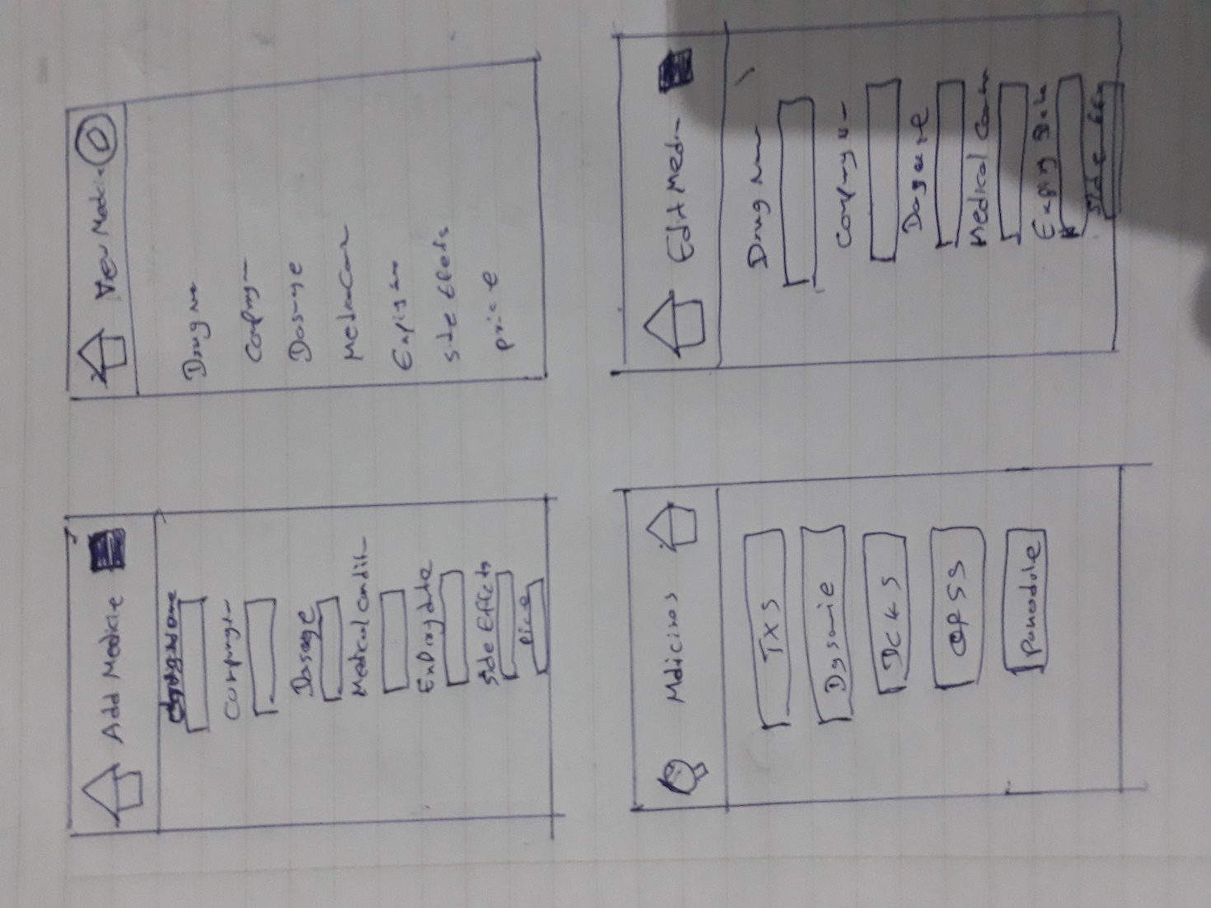Labels and text boxes are not in common places.
* Users can’t find the way to delete medicine items on the list.
* Save,edit icons are hard to find.
* Customer can only see the drug name on the list.

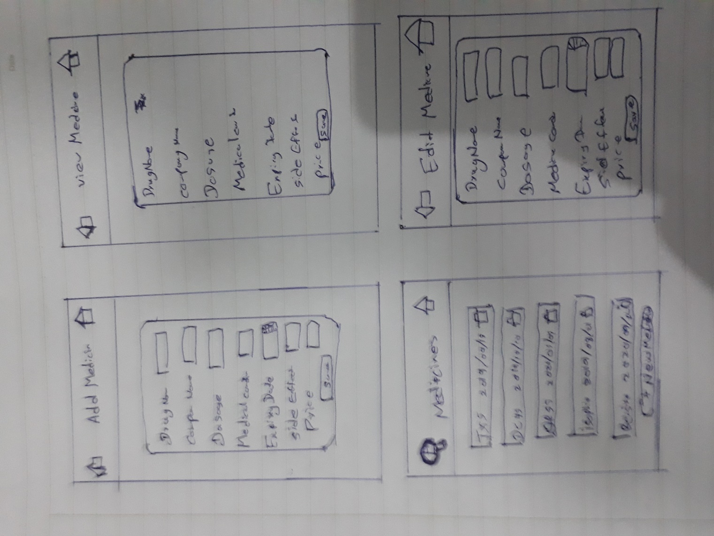**Wireframe 2**

User comments

* There is back button to go to previous page.
* Save,edit buttons are easy to find.
* Customer can see the drug name and expiry date on the list.
* Customer can easily delete items off the list.

**Task 4:Adobe XD design**

* Considering both wireframes the wireframe 2 is best for the function because of the user comfortable design and

easy usability.

