ML-Based Intrusion Detection, Attack Graph Representation, and Reinforcement Learning for Cyber Response: A Survey

Aiden Tomas George  1ds23cd004@dsce.edu.in  Dept. of CSE (Data Science)  Dayananda Sagar College of Engineering  Bengaluru, India | Kaushik Kishor  1ds23cd025@dsce.edu.in  Dept. of CSE (Data Science)  Dayananda Sagar College of Engineering  Bengaluru, India | Rohit  1ds24cd402@dsce.edu.in  Dept. of CSE (Data Science)  Dayananda Sagar College of Engineering  Bengaluru, India

Abstract—Detecting multi-stage cyber attacks remains one of the more persistently difficult problems in network security. Individual network events such as a port scan, a failed authentication attempt, or an unusual DNS query carry little significance when examined in isolation. Their true nature emerges only when they are considered collectively, across hosts and over time, revealing the structure of a coordinated campaign. In this survey, we examine four research areas that each address some part of this challenge: ML-based intrusion detection, kill chain modelling with MITRE ATT&CK, graph-based attack representation, and reinforcement learning for automated response. Drawing on fourteen primary works published between 2002 and 2025, we find that per-flow classifiers, post-hoc graph construction, and narrow RL observation spaces each represent partial solutions to a problem that demands simultaneous integration. No existing system achieves this. We further introduce ChainBreaker, a proposed streaming architecture designed to close these gaps through an Apache Kafka ingestion pipeline, a hybrid XGBoost and Isolation Forest inference engine operating over the CICIoT2023 dataset, and a continuously maintained Neo4j attack graph that serves both live forensic analysis and future reinforcement learning-based adaptive response. Initial results on 34 attack classes demonstrate 99% validation accuracy and a macro F1 score of 0.86.
Index Terms—intrusion detection, kill chain, MITRE ATT&CK, graph-based security, attack graphs, reinforcement learning, cyber defence, APT detection, ensemble classification, Neo4j, streaming analytics, Apache Kafka, anomaly detection, XGBoost, CICIoT2023.

I. Introduction
APTs are difficult to detect precisely because their individual components rarely look malicious in isolation. A port scan, a failed authentication, a handful of DNS queries to an unfamiliar domain: none of these is obviously an attack. What makes them dangerous is the sequence: the deliberate progression across machines and over time. Detection, as a result, cannot operate purely at the flow level. It must function at the campaign level, which is a substantially harder problem.
Four research areas each address different aspects of this. ML-based IDS has achieved strong per-flow classification accuracy on benchmarks like CICIDS2017 and NSL-KDD [3][4]. Kill chain frameworks, including Lockheed Martin’s Cyber Kill Chain [1] and MITRE ATT&CK [2], provide structured vocabularies for describing how attacks unfold stage by stage. Graph-based methods retain the relational structure that flat feature vectors discard: which host communicated with which, when, and in what order [8][9]. Reinforcement learning offers a framework for automated response, though its integration with graph-level network awareness remains largely underdeveloped [12][13].
We have organised this paper around those four areas. Section II covers ML-based IDS, including hybrid supervised and anomaly detection approaches. Section III addresses kill chain models and ATT&CK alignment. Section IV examines graph-based representations and discusses the rationale for live graph maintenance. Section V reviews RL for cyber response. Section VI identifies the cross-cutting gaps. Section VII presents the proposed ChainBreaker architecture. Section VIII provides a comparative analysis of IDS paradigms. Section IX discusses limitations and open challenges. Section X concludes.
II. Machine Learning for Intrusion Detection
A. Benchmark Performance and Dataset Currency
On standard benchmarks, the results are strong. Random Forest and gradient-boosted variants, alongside a range of deep learning architectures, have achieved high F1 scores on CICIDS2017 and NSL-KDD [3][4]. Ferrag et al. conducted a systematic comparison across RNNs, LSTMs, CNNs, and autoencoders, finding that accuracy gains hold reasonably well across model choices [4]. Lazzarini et al. took a different approach entirely, demonstrating that GNNs trained on host-level structural features outperform conventional per-flow classifiers on IoT intrusion data [5]. These results are substantive and worth noting.
Stojanovic et al. raise a concern that we think deserves more attention: CICIDS2017 is now considerably out of date [6]. Modern IoT attack tooling, including Mirai variants, C2 traffic routed over legitimate protocols, and distributed brute-force at scale, produces flow statistics that differ meaningfully from what the original 2017 scripts generated. CICIoT2023 and CICAPT-IIoT represent more recent efforts to close this gap, incorporating broader attack coverage and scenarios that include multi-stage APT behaviour. Neither is a complete solution, but both ask more demanding questions of the classifiers being evaluated.
B. The Per-Flow Structural Limitation
A classifier processing one network flow at a time retains no memory of what came before. A detection event at 14:30 on host A and another at 18:45 on host B are, from the model's perspective, entirely unrelated data points. There is no mechanism to connect them, no accumulated state, no means of recognising that they may represent consecutive stages of the same campaign rather than independent anomalies.
This is a structural problem, not a question of classifier quality. Even a hypothetically perfect per-flow classifier would fail to detect an APT campaign if the campaign-level pattern is absent from the input representation. Anomaly detection methods such as Isolation Forest offer a useful complement by identifying out-of-distribution flows without labelled attack data [3], but they share the same fundamental constraint: each flow is evaluated without context, and there is no continuity of state across events.
C. Hybrid Supervised and Anomaly Detection
A growing body of work suggests that relying on a single detection paradigm, whether supervised classification or unsupervised anomaly detection, is insufficient for production environments where both known and previously unseen attack patterns must be handled simultaneously [3][4]. Supervised classifiers such as XGBoost [15] achieve high precision on well-represented attack categories but degrade on rare or novel attack types that were absent during training. Isolation Forest [16], by contrast, learns a statistical profile of normal traffic without requiring labelled attack data and flags deviations from that profile as anomalous. This makes it well suited to catching zero-day attacks or novel variants that a supervised model would misclassify as benign by default.
Combining both approaches in a hybrid architecture addresses the weaknesses of each method individually. The supervised classifier provides granular multi-class attribution, while the anomaly detector acts as a secondary catch-all for out-of-distribution flows. The CICIoT2023 dataset [17], with its 34 attack classes and significant class imbalance (some classes contain fewer than 15 samples while others exceed 30,000), provides a particularly demanding testbed for evaluating such hybrid systems.
TABLE I
MODEL PERFORMANCE METRICS (CICIoT2023)
Metric | Value
Validation Accuracy | 99.0%
Macro F1 Score | 0.8628
Attack Classes | 34
Dataset | CICIoT2023
Training Samples | 5.3M
Test Samples | 1.3M
III. Kill Chain Models and MITRE ATT&CK Alignment
A. Kill Chain Taxonomy
Lockheed Martin's Cyber Kill Chain divides adversary campaign behaviour into seven stages, from initial reconnaissance through to actions on objectives [1]. MITRE ATT&CK extends this significantly, providing a detailed taxonomy of tactics, techniques, and sub-techniques indexed from TA0001 to TA0011. In our assessment, it has become a genuinely useful reference for labelling detection outputs and comparing coverage across different systems [2].
Wylde et al. examined how AI-based detection aligns with kill chain stages and found that stage-attributed outputs are more operationally informative than binary malicious/benign labels [7]. This finding aligns with our own reading of the literature. They also identify a pattern we observed repeatedly across the literature: systems typically treat each kill chain stage as an independent detection problem. There is no persistent state linking observations from one stage to the next; each stage is effectively detected from scratch, without accumulated context from prior stages.
B. Dataset Alignment
Training on kill chain stage labels requires datasets that actually provide them. CICAPT-IIoT 2024 does this for IoT environments, with labels mapped directly to ATT&CK tactics [6]. CICIoT2023 offers a 34-class label space spanning Mirai, ransomware, lateral movement, data exfiltration, and C2 traffic across multiple protocols, with 45 numeric flow features per record. Both represent an improvement over what was available a few years ago.
Yang et al. treated stage sequences as classification targets and demonstrated that stage-level attribution can be automated via learned sequence models [11]. The results are granular and operationally useful. However, the system does not propagate stage detections into a persistent network-level representation. The system determines that a sequence of stages occurred, but does not identify which host was involved in each stage, nor how those stages relate topologically across the network. This gap is worth naming clearly.
IV. Graph-Based Attack Representation
A. Attack Graphs
Graph-based modelling of attacker reachability has a long history. Sheyner et al. introduced automated generation of reachability graphs over known vulnerability relationships as far back as 2002 [8]. The core motivation remains valid: graphs preserve the relational structure of network activity, including host connections, communication paths, and chained vulnerabilities, in a way that flat alert lists cannot. It is precisely this structure that distinguishes a coordinated APT campaign from a collection of unrelated suspicious events.
B. Provenance and Correlation Graphs
More recent work has applied property graphs, Neo4j in particular, to network provenance and alert correlation. Poirot [9] encodes known APT campaign templates as query graphs and matches them against provenance graphs reconstructed from kernel audit logs, achieving strong detection results against named APT groups. Lazzarini et al. trained GNNs on host-level structural data and demonstrated measurable improvements over per-flow classifiers on IoT intrusion benchmarks [5]. Both contributions are technically substantive.
Levshun and Kotenko’s broad survey of AI-based security event correlation is informative on the state of the field [10]. They identify three recurring weaknesses: detection and forensic data stored in separate systems, correlation applied to log streams rather than graph structures, and multi-system joins required to reconstruct any given incident. These weaknesses are not coincidental; they follow directly from architectural decisions that treat the graph as an analytical output rather than as an actively maintained operational substrate.
C. The Post-Hoc Gap
Every graph-based system we examined, including Poirot [9], Lazzarini et al. [5], and the systems surveyed by Levshun and Kotenko [10], constructs its graph from historical logs or post-incident SIEM exports. This is adequate for forensic reconstruction after an incident has been contained, but it does not support queries during a live attack. By definition, such a graph reflects only what has already been processed, not what is currently occurring.
Supporting live forensic queries, including current blast radius, active stage progression, and real-time attack paths, requires a graph that is written to as detections arrive rather than one populated retrospectively. None of the systems we reviewed maintains such a structure. This is not a minor implementation detail; it reflects a fundamentally different architectural orientation.
D. Graph Database Selection: The Case for Neo4j
The choice of graph database is not incidental to attack graph performance. Relational databases can represent graph structures through join tables, but the cost of multi-hop traversals, the fundamental operation in attack path analysis, scales poorly as path depth increases. Document stores and key-value databases lack native graph traversal altogether. Neo4j, as a native graph database, stores relationships as first-class citizens in its storage engine rather than computing them at query time through joins [18]. For cyber security applications, this distinction matters in practice: a query such as "find all hosts reachable within three hops of a compromised node" executes in constant time per traversal step, regardless of total graph size.
The Cypher query language provides declarative pattern matching that maps naturally onto attack graph queries, such as identifying lateral movement paths, computing blast radius, or tracing kill chain progression across hosts. Property graphs, the data model underlying Neo4j, allow both nodes and relationships to carry arbitrary key-value attributes. This is well suited to attack graph modelling, where host nodes may carry properties such as compromise status, anomaly scores, and kill chain stage, while edges may encode protocol type, classification confidence, and temporal information.
E. The Importance of Live Graph Maintenance
The distinction between a graph constructed after an incident and one maintained during an incident is not merely a performance optimisation. It reflects a qualitatively different operational capability. Post-hoc graphs answer the question of what happened. Live graphs answer what is happening right now, and how far it has already spread. In a live graph architecture, each detection event is written to the graph within seconds of the underlying network flow being classified. At any point during an active incident, a security analyst or an automated response agent can query the current blast radius, the active attack paths, the kill chain stage distribution across hosts, and the lateral movement frontier.
None of these queries can be answered by a system that constructs its graph retrospectively from logs. By the time a post-hoc graph becomes available, the window for meaningful response actions, such as isolating hosts, blocking lateral movement, or disrupting command-and-control channels, may have already closed. For organisations operating under regulatory frameworks that mandate rapid incident response, the difference between a graph available in seconds and one available in hours is not academic. It is the difference between containment and breach.
V. Reinforcement Learning for Automated Response
A. Survey of RL-Based Cyber Defence
Nguyen and Reddi's survey of deep RL for cyber security identifies a consistent pattern across simulated environments: agents observe raw flow-level statistics and select from a limited set of binary containment actions [12]. Adawadkar and Kulkarni, surveying a broader body of work, report the same finding: RL-based defence systems routinely discard the relational context that a graph-level observation space would provide [13]. The agent sees individual flow statistics. It has no visibility into how many hosts are affected, what kill chain stage is currently active, or how a given containment action would propagate across the network.
B. Kill Chain-Aware Response
Among the systems we reviewed, Iturbe et al. comes closest to stage-conditioned response. Their RL agent tracks kill chain stage progression per host and selects containment actions accordingly [14], which is a meaningful step forward. Two limitations remain, however. Stage information is maintained per host in isolation, so the agent cannot reason about lateral movement or cross-host stage dependencies. Additionally, the full action space is presented at every decision step regardless of which stage is active, requiring the agent to learn action irrelevance through experience rather than having it encoded structurally.
C. The Observation Space Problem
Stage-conditioned action masking, which constrains the available action set to those appropriate for the currently active kill chain stage, does not appear in any system we reviewed. Combining such masking with a graph-level observation space that exposes blast radius, lateral spread, and cross-host stage relationships represents, in our assessment, the central unresolved design question at the intersection of RL and graph-based security research.
VI. Cross-Cutting Gaps and Research Directions
Across all four areas, we identify three structural problems that recur consistently. They are related, and we think it is useful to state them precisely.
The first is the per-flow limitation. ML classifiers process one network flow at a time with no accumulated context about prior activity elsewhere on the network. Kill chain sequence models such as those in [11] capture abstract stage progression but not network topology. Determining that stage N occurred provides no information about which host it occurred on, or how it arrived from stage N-1 via lateral movement.
The second is post-hoc graph construction. Every graph-based system we reviewed is built from historical data rather than maintained as a live structure updated as detections arrive. This makes the graph useful for retrospective analysis but unavailable for queries during an active incident; it is a tool for reconstruction after the fact, not for situational awareness in the moment.
The third is fragmented response context. RL agents observe raw flow features and lose the relational information, including blast radius, lateral movement paths, and stage-conditioned action relevance, that a live attack graph would expose. The observation space places a ceiling on what any agent can learn, regardless of the underlying algorithm.
All three gaps converge on the same missing component: a live attack graph, maintained by the detection pipeline and queryable in real time by both a forensic engine and an RL agent operating under stage-conditioned action constraints. Such an architecture would close all three simultaneously. No reviewed work addresses more than one of these gaps in isolation. Building this unified system is, in our assessment, the central open problem at the intersection of the areas surveyed here.
VII. The Proposed ChainBreaker Architecture
The gaps identified in Sections II through VI, namely per-flow classification without network context, post-hoc graph construction, and fragmented RL observation spaces, motivate the design of ChainBreaker, a streaming cyber threat analytics platform that maintains a live attack graph updated in real time by a hybrid ML inference engine. This section describes the architecture and its constituent components.
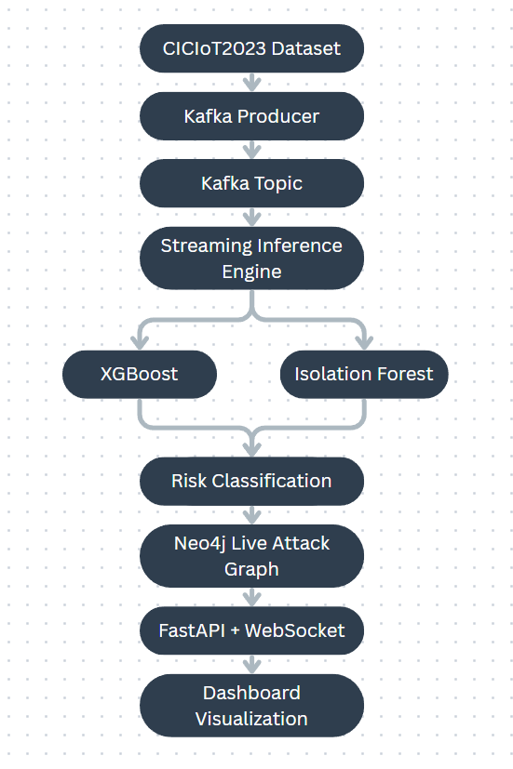
A. Streaming Ingestion via Apache Kafka
Raw network flow data enters the system through a Kafka topic, where each message represents a single network flow record encoded as JSON. A dedicated consumer group processes messages in configurable batches (currently 500 flows per batch) and forwards parsed flows to the ML inference pipeline. Kafka’s consumer group protocol provides natural backpressure handling: if the inference pipeline falls behind, unconsumed messages accumulate in the topic partition and are processed when capacity becomes available, without data loss [19]. This decouples the data production rate from the inference rate, a property that matters particularly during DDoS conditions when flow volumes increase by orders of magnitude.
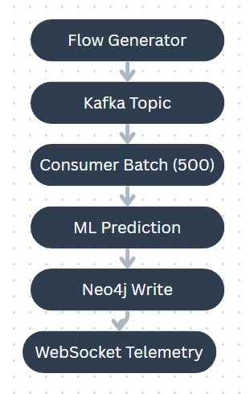
B. Hybrid ML Inference Pipeline
Each batch of parsed flows is scored by two models operating in tandem. An XGBoost multi-class classifier, trained on the CICIoT2023 dataset with 45 numeric flow features, assigns each flow to one of 34 attack categories with an associated confidence score. An Isolation Forest, trained exclusively on benign traffic, provides an independent anomaly score for the same flow. The final disposition is determined by a decision function. It prioritises the XGBoost prediction when confidence exceeds a configurable threshold, falls back to the anomaly score when the classifier is uncertain, and labels the flow as benign only when both models agree.
Model artifacts are stored in timestamped directories and the inference engine dynamically loads the most recent version at startup, enabling model updates without code changes or service restarts. Each prediction is annotated with the model version, a UTC timestamp, and the inference latency in seconds, providing a complete audit trail for every classification decision.
C. Neo4j Live Attack Graph
Classified flows are written to a Neo4j property graph in batched UNWIND operations, creating Host nodes for source and destination IPs, Flow relationships encoding network communication metadata, and AttackEvent nodes for flows classified as malicious or suspicious. The graph schema includes composite indexes on Host(ip) and temporal indexes on AttackEvent(timestamp) to support efficient traversal queries during active incidents. The key architectural decision is that the graph is written to continuously rather than constructed after the fact from exported logs.
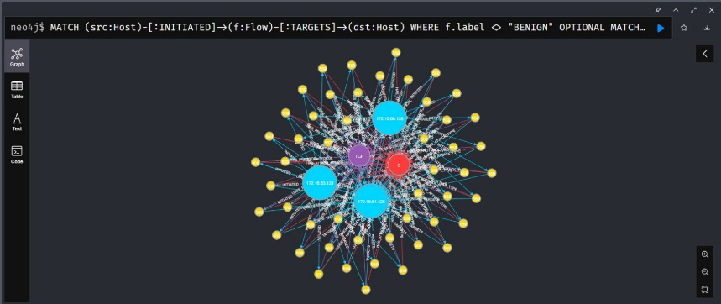D. Dashboard Telemetry and Visualization
A FastAPI backend exposes the evolving graph state to a browser-based dashboard via WebSocket connections. Each classified flow triggers a telemetry event containing the source and destination hosts, the assigned risk status (benign, suspicious, or attack), the anomaly score, and the classification confidence. Raw attack labels are deliberately masked from the dashboard payload to prevent information leakage to the presentation layer, since the frontend operates exclusively on abstract risk states rather than specific attack class names. Complete classification detail is retained internally in Neo4j for forensic queries and administrative review.
E. Toward Reinforcement Learning-Based Adaptive Response
The live attack graph maintained by ChainBreaker is designed to serve a dual purpose: real-time forensic substrate and structured observation space for a future RL-based response agent. The planned agent would observe graph-level features including current blast radius, active kill chain stages per host, and the lateral movement frontier, then select containment actions such as host isolation, traffic throttling, or credential rotation under stage-conditioned action masking. This remains a planned extension; the current system provides the architectural foundation but does not yet include a trained RL agent. We regard this as the natural next phase of the work.
VIII. Comparative Analysis
To situate ChainBreaker within the broader landscape of intrusion detection approaches, Table II compares three paradigms: traditional per-flow IDS, graph-based IDS with post-hoc construction, and real-time graph-based IDS as proposed in this work. The comparison highlights the trade-offs between detection granularity, contextual awareness, response latency, and architectural complexity.
TABLE II
COMPARISON OF IDS PARADIGMS
Criterion | Traditional Per-Flow IDS | Graph-Based IDS (Post-Hoc) | Real-Time Graph IDS (ChainBreaker)
Detection Scope | Individual flows | Flow + graph structure | Flow + live graph structure
Graph Construction | None | Post-incident from logs | Continuous, real-time
Contextual Awareness | None (stateless) | Retrospective only | Live blast radius, lateral spread
Response Latency | Per-flow (ms) | Hours to days | Seconds (streaming)
Multi-Stage Correlation | Not supported | Partial (historical) | Full (live kill chain tracking)
Anomaly Detection | Optional (standalone) | Rarely integrated | Hybrid (IsoForest + XGBoost)
RL Readiness | No graph obs. space | Static graph only | Live graph observation space
Example Systems | Khraisat et al. [3], Ferrag et al. [4] | Poirot [9], Lazzarini et al. [5] | ChainBreaker (proposed)
The principal advantage of the real-time graph paradigm lies not in any single capability but in its integration. Detection, correlation, forensic query, and response all operate on the same continuously updated data structure. This eliminates the multi-system joins and export-import cycles that Levshun and Kotenko identified as recurring architectural weaknesses in existing deployed systems [10].
IX. Limitations and Open Challenges
Several limitations of the current work and the broader approach deserve explicit acknowledgement. First, the CICIoT2023 dataset, while substantially more contemporary than CICIDS2017 or NSL-KDD, remains a synthetic benchmark. The traffic was generated in a controlled testbed environment, and it is an open question whether classifiers trained on such data generalise to production network traffic with its characteristic noise, protocol diversity, and encryption prevalence. Transfer learning and domain adaptation techniques may be necessary for deployment in real-world SOC environments.
Second, the class imbalance in CICIoT2023 is severe: some attack classes contain fewer than 15 samples while others exceed 30,000. Although balanced sample weighting partially addresses this during training, the macro F1 score of 0.86, compared to 99% accuracy, reflects the reality that rare attack classes remain difficult to classify reliably. This is a well-known challenge in network intrusion detection and is not unique to our approach, but it does constrain the system’s effectiveness on uncommon attack types.
Third, the per-flow classification paradigm, even when augmented with a live graph, cannot capture temporal dependencies within individual flow sequences. Sequence-aware models such as RNNs or Transformers, operating over ordered flow windows, could complement the current architecture at the cost of higher inference latency. Fourth, the RL-based response component remains a planned extension rather than an implemented and evaluated system. Until the agent is trained, evaluated, and tested against realistic attack scenarios, claims about its effectiveness would be premature.
Finally, graph scalability presents a practical concern. In a high-throughput production environment generating millions of flows per hour, the Neo4j graph will grow rapidly. Retention policies, graph pruning strategies, and tiered storage (hot graph for active incidents, cold storage for historical forensics) will be necessary to maintain query performance over extended operational periods.
X. Conclusion
We have reviewed ML-based intrusion detection, kill chain and ATT&CK alignment, graph-based attack representation, and RL-based cyber response across fourteen primary works. The progress in each area is real and should not be understated. Per-flow classification accuracy is high on contemporary benchmarks, kill chain taxonomies have been operationalised and mapped to ATT&CK, graph representations have been shown to outperform flat features, and RL has been demonstrated in simulated response environments with meaningful stage-level awareness.
What remains unachieved, however, is integration. No existing system maintains a live graph that accumulates network state as an attack unfolds, serves as the forensic substrate for real-time queries, and provides a structured, stage-conditioned observation space for an RL response agent. Each system we reviewed closes one of the three structural gaps from Section VI. A unified architecture that addresses all three within a single operational boundary remains, as far as we can determine, the central contribution still waiting to be made.
The ChainBreaker architecture presented in Section VII represents our attempt to address this integration challenge. By coupling a streaming Kafka ingestion pipeline with a hybrid XGBoost and Isolation Forest inference engine and a continuously maintained Neo4j attack graph, the system provides a unified substrate for detection, correlation, and forensic analysis, with the architectural scaffolding in place for future RL-based automated response. Initial results on CICIoT2023 are encouraging, with 99% accuracy and a macro F1 of 0.86 across 34 classes. The limitations discussed in Section IX, namely dataset generalisability, class imbalance, and the absence of a trained RL agent, remain open challenges that subsequent work must address.
The broader lesson is that progress in intrusion detection, attack graph research, and automated response has been substantial but compartmentalised. Each research community has advanced its own subproblem without building the connective infrastructure that allows the others to benefit. A live, queryable attack graph, maintained by the detection pipeline and consumed by both forensic tools and response agents, is the architectural element that ties these threads together.
References
[1] E. M. Hutchins, M. J. Cloppert, and R. M. Amin, "Intelligence-driven computer network defense informed by analysis of adversary campaigns and intrusion kill chains," Lockheed Martin Corp., 2011.
[2] MITRE Corporation, "MITRE ATT&CK: A knowledge base of adversary tactics and techniques," https://attack.mitre.org, 2024.
[3] A. Khraisat, I. Gondal, P. Vamplew, and J. Kamruzzaman, "Survey of intrusion detection systems: techniques, datasets and challenges," Cybersecurity, vol. 2, no. 1, pp. 1–2, 2019.
[4] M. A. Ferrag et al., "Deep learning for cyber security intrusion detection: Approaches, datasets, and comparative study," J. Inf. Secur. Appl., vol. 50, p. 102419, 2020.
[5] R. Lazzarini, H. Tianfield, and V. Charissis, "A composition of graph neural networks for intrusion detection systems," Comput. Secur., 2024.
[6] B. Stojanovic, A. Hofer-Schmitz, and U. Kleb, "APT dataset and attack modeling for automated detection systems: A review," Comput. Secur., vol. 92, p. 101734, 2020.
[7] A. Wylde et al., "An overview of artificial intelligence on the cyber kill chain," Heliyon, vol. 10, 2024.
[8] O. Sheyner, J. Haines, S. Jha, R. Lippmann, and J. M. Wing, "Automated generation and analysis of attack graphs," in Proc. IEEE Symp. Security Privacy, 2002.
[9] K. Yang et al., "Poirot: Aligning attack behavior with kernel audit records for cyber threat hunting," IEEE Trans. Dependable Secure Comput., vol. 19, no. 6, pp. 3870–3883, 2022.
[10] D. Levshun and I. Kotenko, "A survey on artificial intelligence techniques for security event correlation," Artif. Intell. Rev., 2023.
[11] M. Yang et al., "APT detection via stage sequence learning," Comput. Electr. Eng., vol. 100, 2022.
[12] T. T. Nguyen and V. J. Reddi, "Deep reinforcement learning for cyber security," IEEE Trans. Neural Netw. Learn. Syst., vol. 34, no. 8, pp. 3779–3795, 2023.
[13] K. M. Adawadkar and N. Kulkarni, "Cyber-security and reinforcement learning — a brief survey," Eng. Appl. Artif. Intell., vol. 114, 2022.
[14] M. Iturbe, U. Zurutuza, and I. Garitano, "Reinforcement learning for APT response: A stage-aware approach," Comput. Secur., 2025.
[15] T. Chen and C. Guestrin, "XGBoost: A scalable tree boosting system," in Proc. ACM SIGKDD Int. Conf. Knowledge Discovery Data Mining, 2016, pp. 785–794.
[16] F. T. Liu, K. M. Ting, and Z.-H. Zhou, "Isolation forest," in Proc. IEEE Int. Conf. Data Mining, 2008, pp. 413–422.
[17] E. C. P. Neto et al., "CICIoT2023: A real-time dataset and benchmark for large-scale attacks in IoT environment," Sensors, vol. 23, no. 13, 2023.
[18] I. Robinson, J. Webber, and E. Eifrem, Graph Databases: New Opportunities for Connected Data, 2nd ed. O’Reilly Media, 2015.
[19] J. Kreps, N. Narkhede, and J. Rao, "Kafka: A distributed messaging system for log processing," in Proc. NetDB Workshop, 2011.

