Graph-Driven Cyber Incident Detection, Forensic Analysis
and Automated Kill Chain Interruption
Aiden Tomas George  1ds23cd004@dsce.edu.in  Dept. of CSE (Data Science)  Dayananda Sagar College of Engineering  Bengaluru, India | Kaushik Kishor  1ds23cd025@dsce.edu.in  Dept. of CSE (Data Science)  Dayananda Sagar College of Engineering  Bengaluru, India | Rohit  1ds24cd402@dsce.edu.in  Dept. of CSE (Data Science)  Dayananda Sagar College of Engineering  Bengaluru, India

Abstract — APT detection based on per-flow classification has a structural limitation: individual flows are rarely indicative of a multi-stage campaign, and classifiers that work on isolated flows do not build a global state. By treating the network as a live Neo4j property graph instead of a sequence of independent classification targets, ChainBreaker addresses this. The classifier is XGBoost and anomaly detection uses Isolation Forest. They consume CICIoT2023 flows. Each detection is mapped to one of the nine MITRE ATT&CK kill chain stages. Detections insert AttackEvent and KillChainStage nodes into the graph. The structural record of attack progression is built up over time. A parallel Apache Spark temporal layer identifies coordinated patterns like password spraying and distributed flooding that are invisible at the per-flow level. Forensic capabilities operate as Cypher traversals on the identical Neo4j instance receiving live detections. There is no separate log store and no parallel correlation pipeline. A complete record of the incident is one connected graph that can be retrieved with a single traversal starting from the earliest AttackEvent. Assessing our model on CICIoT2023 that consists of 34 attack classes and has 5.3M/1.3M train-test split we get the following results. 99% validation accuracy with XGBoost and macro F1 of 0.86.
Index Terms— Advanced Persistent Threats, Attack Graph, Cyber Kill Chain, Graph-Based Intrusion Detection, MITRE ATT&CK, Neo4j, Network Intrusion Detection System, XGBoost, Isolation Forest, CICIoT2023, Apache Spark, Temporal Aggregation, Forensic Analysis, Kill Chain Interruption.
I. INTRODUCTION
Visualise the arrangement of data by APT on the wire. The first day, there will be a few BruteForce attemps that will flow from an external IP. All along with tens of thousands of normal and legitimate authentications. Day three is dull. The fifth day: A PortScan activity appears from an internal host. The host was not scanning anything last week. This is a little odd but not too odd. Day 8: Low volume of internal DNS requests to an unusual domain outside the emule network. None of these events triggers a conventional IDS alert, nor do they appear overly suspicious when analyzed in isolation. Overall, they are consistent with a threat actor who got in, went quiet, enumerated the network, and turned C2. A classifier per flow sees 7 independent events. An analyst who can visualize all seven on one graph would witness a kill chain.
ChainBreaker aims to fill this gap. ML accuracy per flow has recently improved considerably[4]. While we accept those numbers, detecting APTs does not rely on per-flow accuracy. Absent is the accumulated network state, a persistent structure linking what happened on host A 3 hours ago with what’s happening on host B now. SIEM platforms do this via log correlation. Correlation refers to an operation on detection outputs; that is, it is noticed when the fact has already happened, not through a live, queryable graph of network relationships [9].
ChainBreaker is built around one major design decision: the graph is not an output of detection — it is what detection writes into. A Neo4j property graph is seeded with host nodes at startup. Every ML detection, whether from XGBoost or Isolation Forest, writes an AttackEvent node and upserts a KillChainStage node linked to the relevant hosts. As lateral movement occurs, COMMUNICATES_WITH edges accumulate suspicious flags. Stage transitions produce PROGRESSED_TO edges carrying dwell times. At any point, a Cypher traversal from the earliest AttackEvent can recover the full incident record — stage progression per host, lateral movement path, blast radius, affected assets. No external store needs to be consulted.
II. RELATED WORK
A. The Live Graph Problem
A consistent limitation runs through graph-based IDS research: graphs are built and used solely for analysis, and not for operation. M. Zhong et al. [1] demonstrate convincingly that host-level graph structure carries information that flat per-flow feature vectors may discard, and that GNNs trained on these graphs outperform conventional classifiers on the same data. S. M. Milajerdi et al. [8] go further, encoding known APT campaign templates as query graphs and matching them against provenance graphs with strong detection results. Both systems validate the use of the graph representation. However, neither maintains one live. In [1], the graph is a training artefact that is discarded after model fitting. In [8], the provenance graph is reconstructed offline from pre-collected endpoint logs, requiring separate collection infrastructure and producing no real-time or queryable state. Yang et al. [10] takes a completely different method, treating kill chain stage sequences as temporal classification targets — but once again does not use a persistent spatial structure: the system knows a sequence of stages occurred, not where on the network each one landed.
B. Per-Flow Classification and Dataset Limitations
Deep learning IDS survey by Ferrag et al. [4] evaluates RNN, LSTM, CNN, and autoencoder architectures on the benchmark CICIDS2017 and related datasets. Though accuracy numbers are high, all these architectures share the same structural limitation. Each flow is classified separately, one by one. A detection at 14:30 on one host has no connection in any of these systems to a detection at 18:45 on another.
Stojanovic et al. [7] bring up a separate but important point: The attack tooling of CICIDS2017 does not match contemporary IoT-targeted threats, whose attackers have since evolved. The attack scripts from 2017 have traffic signatures that are markedly different from what Mirai variants, protocol-level C2 channels and current distributed brute-force campaigns generate. Thus, we employ the CICIoT2023 dataset from this very Institution.
C. Reinforcement Learning for Intrusion Response
An extensive survey of deep reinforcement learning intrusion response has recently been carried out by Nguyen and Reddi [2] and Adawadkar and Kulkarni [3].
There is a basic similarity in the pattern across the systems covered in the literature. The agents observe the raw flow statistics and take binary containment actions. There is no real graph-level awareness of the blast radius, lateral spread, or even host stage progression. Iturbe et al. [5] is the most relevant single prior work to our project — their RL agent tracks kill chain stage progression per host and selects responses accordingly, which aligns with our final goal in the major phase. The gap between them is that in Iturbe’s method, as the information is unlinked across hosts, there is no network graph, and the full action space is exposed at every time step regardless of which stage is active. This imposes an extra inefficacy and risk, as some actions are not applicable across stages. Levshun and Kotenko[9] note three structural weaknesses in existing correlation systems: the fact that detection outputs and forensic data are kept apart in different stores, correlation is only applied to log streams and not the resulting graph representation, and final incident reconstruction requires joins to be made across multiple systems. Kazmierczak et al. [6] discovered the same gap independently: the majority of automated defence systems only deal with separate kill chain stages in isolation, with no persistent cross-stage graph state. Both views refer to the same underlying issue. ChainBreaker's single-graph architecture Fixes the Problem.
III. THREAT MODEL
We assume an adversary capable of executing a full nine-stage APT campaign against a monitored IP network segment: Initial Access, Persistence, Command and Control, Discovery, Credential Access, Lateral Movement, Defense Evasion, Exfiltration, and Denial of Service. The adversary may operate slowly — distributing activity across multiple time windows and source IPs to stay below per-flow detection thresholds. Coordinated multi-source attacks, specifically password spraying and distributed flooding, are explicitly in scope.
The defender has passive flow-level visibility across the monitored segment. No host-level process or file system telemetry is available — detection is restricted entirely to network flow features. Host nodes are created on first encounter via idempotent MERGE operations — any IP seen as source or destination is upserted into the graph before ML inference runs on that flow.
We consider the following out of scope for this phase: encrypted payload analysis, physical network access, supply chain attacks, and adversarial flow injection intended to manipulate the graph. Active automated containment is the major phase.
IV. SYSTEM ARCHITECTURE
ChainBreaker has four layers — ingestion, detection, graph, and forensics — built around a single shared Neo4j instance. A FastAPI backend exposes REST and WebSocket endpoints. A React frontend renders the live attack graph and forensic outputs.
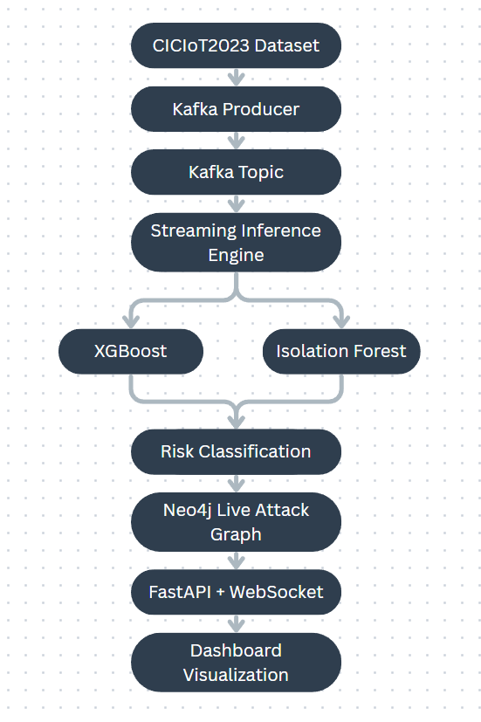
Fig. 1. ChainBreaker system architecture. Four layers share a single Neo4j instance; no secondary store exists.

A. Ingestion
We support two ingestion paths. In streaming mode, a Kafka consumer reads flow records from a Kafka topic in real time. In offline mode, a CSV batch processor replays CICIoT2023 flow files through the same downstream pipeline. Both paths emit 45-column feature vectors aligned to the CICIoT2023 schema. The Kafka consumer accumulates flows in batches of 100, runs vectorised ML inference across the batch via NIDSPredictor.predict_batch, and writes results to Neo4j in a single UNWIND Cypher operation per batch.
A Spark Structured Streaming layer runs in parallel with per-flow classification. SparkAggregator groups flows in sliding windows watermarked at five minutes, partitioned by source IP, destination IP, and destination port, computing aggregate statistics including flow counts, byte totals, and unique source and destination counts. SprayDetector groups flows per source IP over five-minute windows and flags any source reaching at least 5 distinct destination IPs with at least 10 total attempts — the classic password spray signature. A distributed attack detector groups per destination IP over ten-minute windows and flags convergence from at least 3 distinct sources generating a minimum of 15 total flows. Port scan detection flags sources reaching at least 20 distinct destination ports within ten minutes. None of these patterns surface in per-flow features.
B. Detection and Graph Writing
The NIDSPredictor module deals with inference. The isolation forest assigns a score to every data point. A flow is labelled as ATTACK in the graph, if the XGBoost produces a non-benign label at a confidence of at least 0.5, while it is marked as SUSPICIOUS if the raw score of the Isolation Forest is below the stored iso_threshold in order to add this information to the graph. Flows that fall below both thresholds are dropped.
For events that get identified as ATTACK and SUSPICIOUS, the attack_writer resolves the MITRE technique IDs through a tactic_aligner and writes an AttackEvent node via CREATE. Each detection will give rise to a new node with a new UUID. The Kill Chain Writer will upsert a KillChainStage node per (host IP, stage) via MERGE. Dwell times of existing nodes will be updated and a PROGRESSED_TO edge will be written recording the stage transition. The destination host status is updated to compromised and the source host status is updated to suspected in a single operation.
C. Investigation engine
All of the forensic engine’s functionality runs as async Cypher queries against the live graph. At no point is there recourse to a secondary store. Our three capabilities — attack path tracing, blast radius analysis, and attack source attribution — are summarised in Section VII.
D. Implementation Tool Stack
Backend employs Python combined with FastAPI asyncio for performing non-blocking Neo4j writes, also handling API requests and structured JSON logging using structlog.
Metrics involving Prometheus record each flow and detection in the endpoint /metrics. The infrastructure utilizes Docker Compose for Neo4j, Zookeeper, and a Kafka broker.
The live attack graph is rendered by a React frontend with Cytoscape.js. The colour code of hosts depends on compromise status. The graphical view has a kill chain stage timeline and alert feed along with a host detail panel. Through a WebSocket, Graph state is pushed to connected clients; currently, this is a telemetry simulation stream.
V. ML DETECTION PIPELINE
A. Dataset
We use CICIoT2023 as the dataset, released by the Canadian Institute for Cybersecurity.
CICIoT2023 was selected for two main reasons. First, it covers a broad IoT-targeted attack surface across 34 labelled classes. Second, Stojanovic et al. [7] documented the declining usefulness of CICIDS2017, the traditional IDS dataset, for contemporary IoT-targeted attack tooling — a gap that CICIoT2023 directly addresses. The dataset was introduced by Neto et al. [11] and provides 45 numeric flow features per record. Class imbalance in the dataset is quite substantial with some classes containing fewer than 15 samples while some others exceed 30,000 samples.
B. Label-to-Stage Mapping
Raw CICIoT2023 labels are normalised and mapped to nine kill chain stages by our stage_mapper module, covering 34 distinct attack classes.
The mapping is as follows:
- BruteForce, Mirai, Injection, XSS, and CISA map to Initial_Access; Backdoor and Trojan to Persistence
- HTTP and DNS-based C2 to Command_and_Control; Reconnaissance, PortScan, and VulnerabilityScan to Discovery
- PrivilegeEscalation and CredentialTheft to Credential_Access; LateralMovement and remote access protocols (FTP, SSH, SMB, RDP) to Lateral_Movement
- Evasion to Defense_Evasion
- Ransomware and DataTheft to Exfiltration
- DDoS and DoS to Denial_of_Service
The mapper applies case-insensitive exact matching with a partial-match fallback for label variants that were not seen during development. Eight of the nine stages carry MITRE ATT&CK tactic IDs at write time (TA0001–TA0011) with Denial_of_Service not yet emitting TA0040 (Impact), which remains a known gap.
C. XGBoost Classifier
XGBoost [12] is configured with the multi:softprob objective, producing a full probability distribution over different classes rather than a hard prediction of a singular class. This permits confidence-threshold filtering during inference rather than fixed argmax acceptance.
Configuration: 500 estimators, max depth 7, learning rate 0.05, row and column subsampling at 0.8, min_child_weight 5, gamma 0.1, L1 alpha 0.1, L2 lambda 1.0, histogram tree method.
Class imbalance toward BenignTraffic is handled via sklearn's compute_sample_weight. Synthetic oversampling approaches such as SMOTE were rejected since they tend to introduce artefacts in large tabular datasets. Early stopping uses patience of 20 rounds on mlogloss. Only non-benign predictions at confidence ≥ 0.5 are written to the graph to keep the graph readable.
D. Isolation Forest
We train Isolation Forest [13] exclusively on BenignTraffic samples from the training split — no attack samples are seen during fitting. If the model sees attack samples during training, it learns to distinguish attack subtypes rather than model the benign distribution, which defeats its purpose as a zero-day detector. We use 200 trees with contamination 0.05 and max_samples set to "auto" (capped at 256 samples per tree by sklearn's default), which controls per-tree memory cost on the large benign training set.
The anomaly threshold is derived empirically rather than set as an absolute value. After fitting, we score all benign training samples and take the 5th percentile of those scores as iso_threshold. Any flow scoring below this at inference is flagged SUSPICIOUS, regardless of XGBoost's output. The two models are not votecombined — XGBoost drives primary classification, Isolation Forest is an independent anomaly channel that can surface out-of-distribution flows that XGBoost confidently labels benign.

E. Feature Schema
The 45 features span six groups: flow metrics (flow_duration, Header_Length, Duration, Rate, Srate, Drate), TCP flag numbers (fin, syn, rst, psh, ack, ece, cwr), cumulative flag counts (ack_count, syn_count, fin_count, urg_count, rst_count), protocol presence indicators (HTTP, HTTPS, DNS, Telnet, SMTP, SSH, IRC, TCP, UDP, DHCP, ARP, ICMP, IPv, LLC), packet statistics (Tot sum, Min, Max, AVG, Std, Tot size, IAT, Number), and statistical flow features (Magnitude, Radius, Covariance, Variance, Weight). One column name — "Magnitue" — is preserved exactly as it appears in the raw CICIoT2023 CSV; correcting the typo would silently misalign columns at inference. Missing columns are zero-filled; inf and NaN values are replaced with 0.0 before input.
VI. NEO4J GRAPH MODEL
A. Node Types
We define six node types in our graph
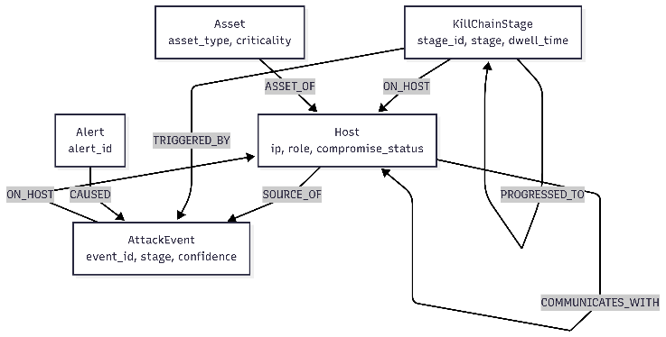
Fig. 2. Neo4j property graph schema. Node types and edge relationships maintained by ChainBreaker's single shared instance.
- Host nodes in the graph serve as its structural backbone. Each host node has an IP address (unique constraint), hostname, network role (defaulted to unknown), compromise status in {clean, suspected, compromised, contained}, and first and last seen timestamps. When being ingested, all nodes are created on first encounter via MERGE.
- The AttackEvent nodes are an indication of a unique detection event. Each node has a UUID event_id, predicted kill chain stage, XGBoost confidence, source and destination IPs, raw attack label, originating model name and a UTC timestamp. CREATE generates a new node for each detection. This layer does not enforce duplication prevention.
- KillChainStage nodes keep track of the stage progression on a per-host basis by the composite stage_id (IP_stage with unique constraint) with status in {active, contained, completed, unknown}, dwell_time_seconds and MITRE tactic IDs.
- The Asset nodes are the most important targets that have an asset_type in {db_server, domain_controller, web_server, file_server, engineering_workstation}. Also, it has a criticality in {low, medium, high, critical}.
- Alert nodes pack similar AttackEvents into an incident.
- The schema defines AgentAction nodes for actions performed by the agent. These agent action nodes are reserved for major phase only.
B. Types of Edge
- Host nodes are connected by COMMUNICATES_WITH edges. Using MERGE, the Kafka batch ingest path gathers flow_count, first_seen, and last_seen on these edges. The edges that are CONNECTED_TO one another have a suspicious flag set due to writes happening in the attack event. However, correlation of lateral movement relies largely on graph traversal at query time and not the flag alone.
- TRIGGERED_BY links KillChainStage to the AttackEvent that activated it.
- ON_HOST links both AttackEvent and KillChainStage nodes to their associated Host.
- PROGRESSED_TO connects sequential KillChainStage nodes, carrying from_stage, to_stage, timestamp, and dwell_time_seconds — the primary temporal artefact for forensic timeline reconstruction.
- SOURCE_OF links Host to its originated AttackEvents.
- CAUSED links Alert to its constituent AttackEvents.
- ASSET_OF links Asset to Host.
- PRECEDED_BY between AgentAction nodes is reserved for the major phase.
C. Indexing Strategy
The graph applies unique constraints against the primary keys Host.ip, AttackEvent.event_id, KillChainStage.stage_id, Asset.asset_id, Alert.alert_id pkey together to ensure key uniqueness across the graph.
The MERGE clause is used by the Host and KillChainStage writer and both are completely idempotent (updates the node if node is already present in graph). When AttackEvent writes are created using CREATE with new UUID, duplicates cannot be inserted due to a constraint, but repeated processing of the same flow would not prevent detection of attack events as we are not inserting events with the same identifier. This provides idempotent writes in simultaneous handling of API requests. Furthermore, this ensures no duplicate node is created during Kafka consumer retry of batch on intermittent failure.
The major query patterns are covered by composite indexes. For blast radius queries, they are Host.compromise_status and Host.role. For detection queries, they are AttackEvent.stage, AttackEvent.timestamp, and AttackEvent.confidence. Also, KillChainStage.stage, KillChainStage.status, and KillChainStage.host_ip are for stage progression.
Relationship indexes on COMMUNICATES_WITH.first_seen and PROGRESSED_TO.timestamp facilitate temporal ordering.
D. Design of the single graph
A Neo4j graph instance serves all layers. The machine learning pipeline writes to it, the forensic engine reads from it and the React dashboard queries it through FastAPI. There’s no separate alert store. No record keeping of logs. No database for parallel correlation is consulted.
This alters the way forensic reconstruction is carried out. In a typical security architecture, the process of reconstructing an incident involves coordinating alert records from a detection database against log entries from a SIEM against asset records from a CMDB. This is an operation across three databases and requires all three data stores to be consistent and queryable at the same time. In ChainBreaker, there is one Cypher traversal that takes place. The traversal starts at an AttackEvent node. Then follow the PROGRESSED_TO edges in the stage advancement on a host. Follow the COMMUNICATES_WITH edges in the lateral movement to other hosts. Then collect the Asset nodes that are linked to it in order to assess the impact. The whole episode exhibits one connected subgraph. We think this is in direct response to the correlation infrastructure problem Levshun and Kotenko [9] view as the key unsolved problem in AI based security event correlation.
VII. FORENSIC ENGINE
We implement three forensic capabilities, all as async Cypher queries against the live Neo4j instance. No secondary store is touched in any of them.
A. Attack Path Tracing
Our primary attack path query, trace_attack_path, traverses COMMUNICATES_WITH edges up to five hops from a specified source IP. This query filters for intermediate hosts having an associated AttackEvent or KillChainStage node ,returning ordered tuples of (source IP, destination IP, hop index, kill chain stage, stage status, attack label, XGBoost confidence, event timestamp). This provides us with a hop-by-hop account of how the attack has propagated across the network from the initial access point.
A complementary query, trace_full_attack_path starts from an Alert node following CAUSED, SOURCE_OF, ON_HOST, and TRIGGERED_BY edges to reconstruct the complete event chain for a specific incident by backward traversal.
find_attack_source identifies the most recent source hosts via SOURCE_OF edges linked to AttackEvents on the compromised host, then applies Neo4j's shortestPath algorithm on COMMUNICATES_WITH edges to trace the lateral movement path outward from each candidate origin.
B. Blast Radius Analysis
The blast radius query returns all Host nodes where compromise_status is in {compromised, suspected}. For each host it returns the linked counts of AttackEvent and Alert nodes, the current set of active kill chain stages, communicable neighbour counts that are directly reachable via COMMUNICATES_WITH, and the IDs of linked Asset nodes. Severity scoring adds event counts across compromised hosts, weighting any host with linked Asset nodes twice as much. Thresholds are expressed as four levels: LOW < 5, MEDIUM 5–19, HIGH 20–49, CRITICAL ≥50. A second query returns the affected Asset nodes sorted by level of criticality, used to prioritise SOC risk.
C. Forensic Report
The ForensicReportGenerator composits attack path tracing, blast radius, and kill chain summary into a structured JSON report that is served via FastAPI endpoint and rendered into the React dashboard without any caching or secondary store. All content is fetched from Neo4j at query time. The report contains blast radius metrics with severity level, kill chain stage distribution over all active hosts, affected asset inventory (sorted by criticality), and MITRE ATT&CK tactic mapping over all active stages. Per-host timelines are accessible via a separate host report endpoint using an additional call to build_host_timeline to reconstruct all relevant events at the host level.
VIII. EVALUATION AND FUTURE WORK
A. ML Detection
We use CICIoT2023 to train XGBoost and Isolation Forest. We load the train and validation CSVs (about 5.3M and 1.3M rows). We then combine them and do a stratified 80/20 internal split. This gives us about 5.3M training and 1.3M test samples. The results given show a full-dataset CLI training run. The server’s auto-train path uses at most 200K rows for faster startup. We use balanced sample weights to account for class imbalance towards BenignTraffic. Evaluation uses per-class precision, recall, and F1 returned from sklearn classification_report, in addition to macro-averaged F1. Isolation Forest training uses only the BenignTraffic subset of the training split, so there is no data leakage. iso_threshold is the 5th percentile of benign training scores.

Metric | Value
Validation Accuracy | 99.0%
Macro F1 Score | 0.86
Attack Classes | 34
Dataset | CICIoT2023
Training Samples | 5.3M
Test Samples | 1.3M
TABLE I. XGBoost classification results on CICIoT2023 test split (1.3M samples, 34 attack classes).
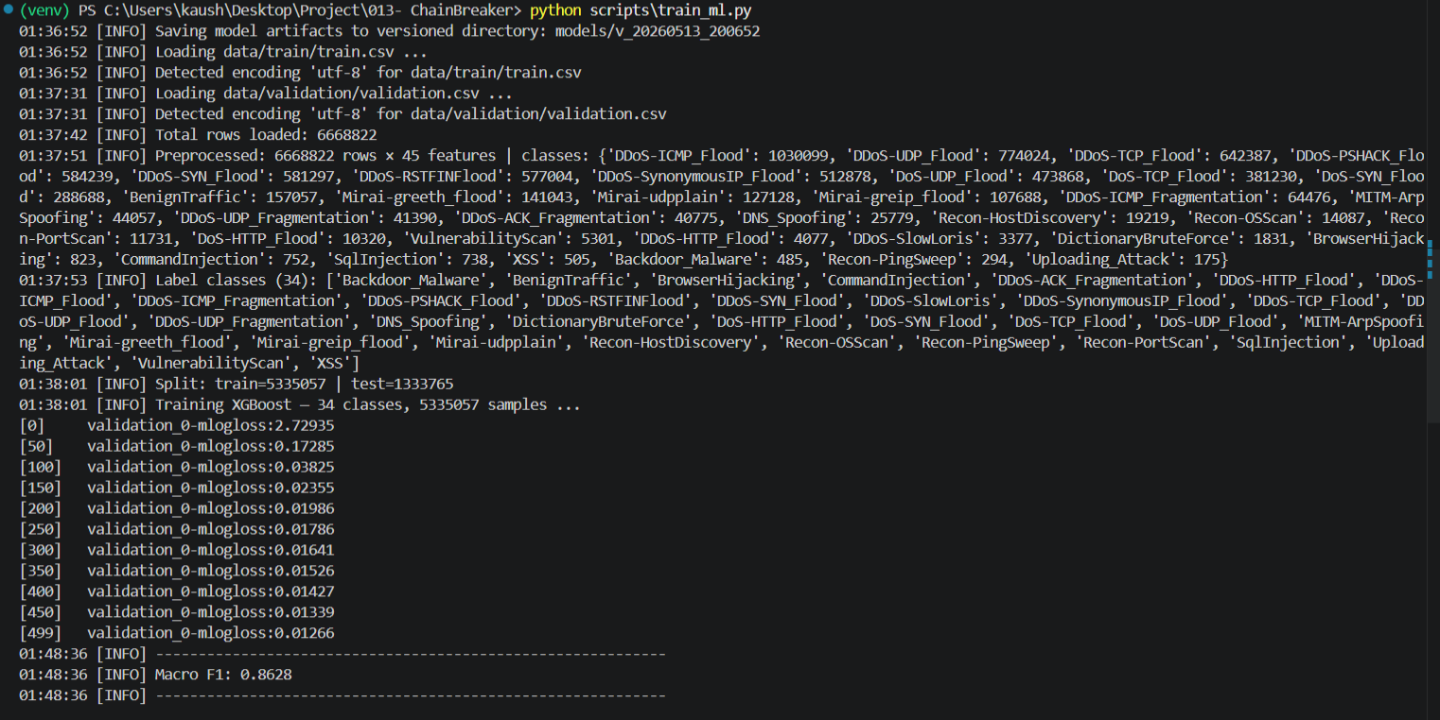
Fig. 3. XGBoost training terminal output.
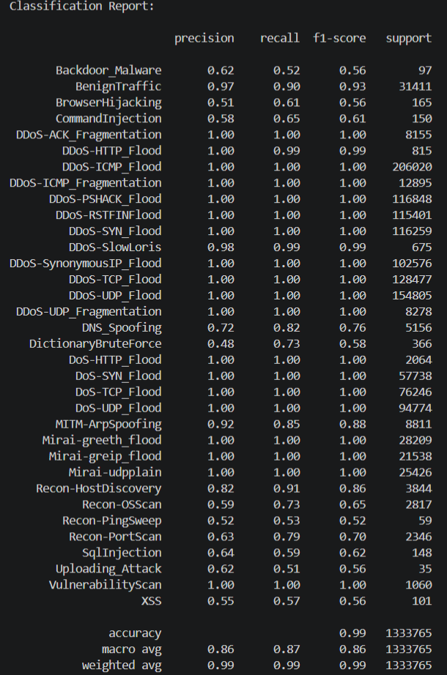
Fig. 4. Per-class precision, recall, and F1 across all 34 CICIoT2023 attack classes (1,333,765 test samples).
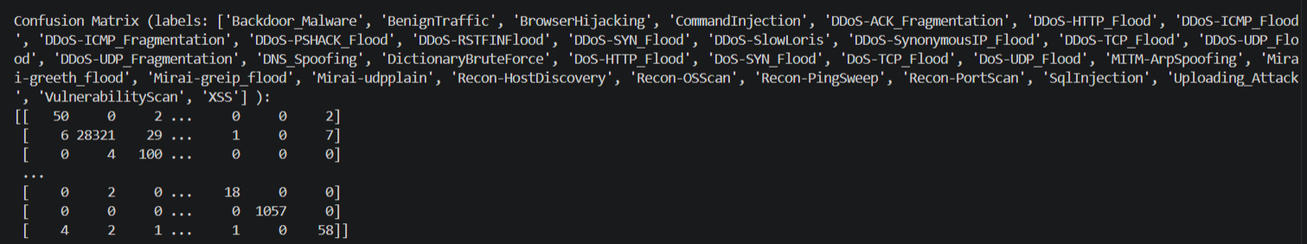
Fig. 5. Raw confusion matrix terminal output (truncated) across 34 ordered class labels.
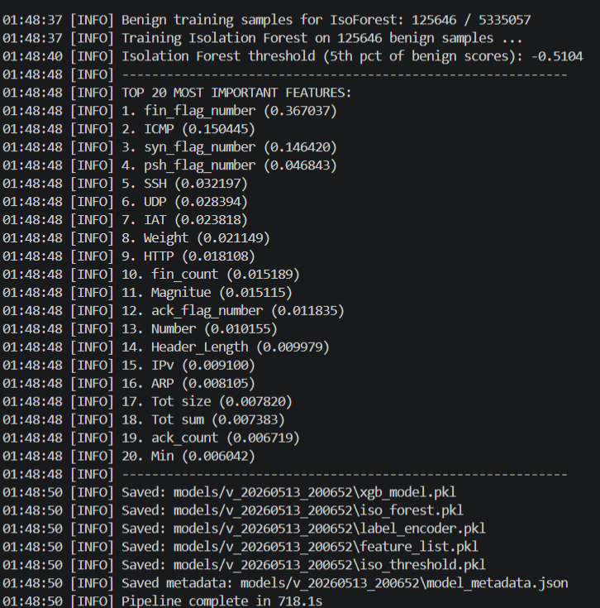
Fig. 6. Isolation Forest training log
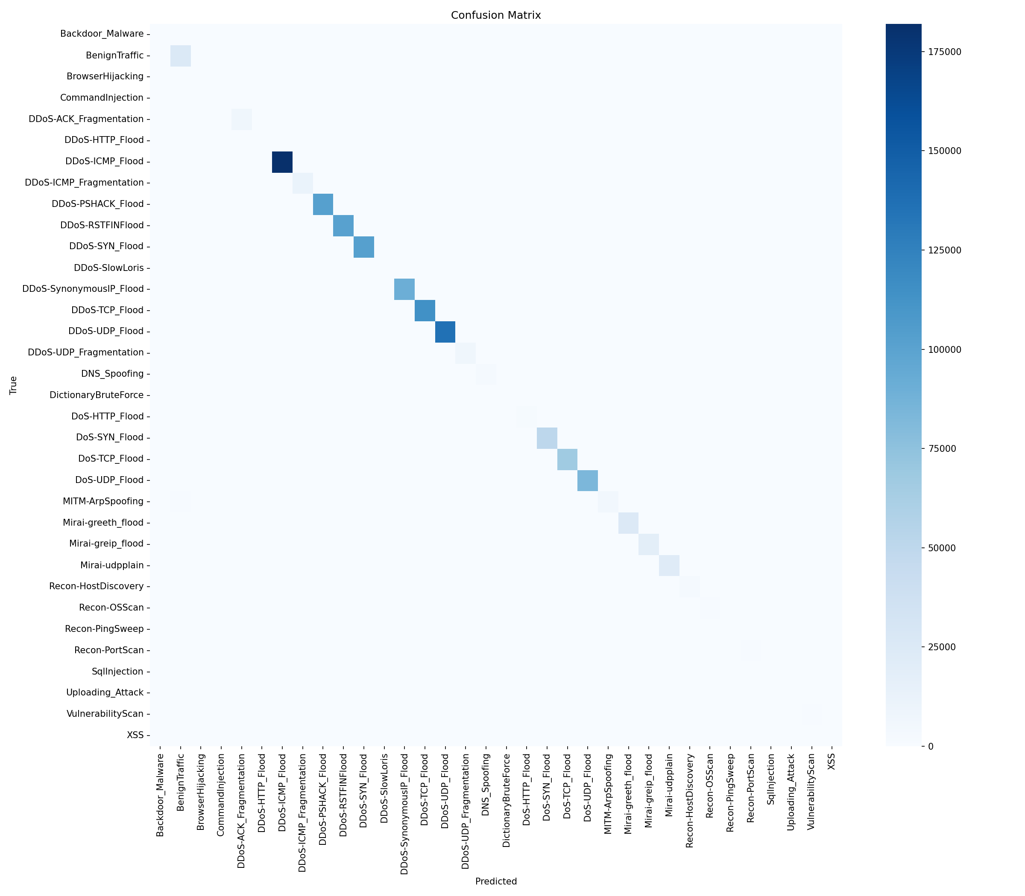
Fig. 7. Confusion matrix heatmap over all 34 CICIoT2023 classes (1,333,765 test samples).
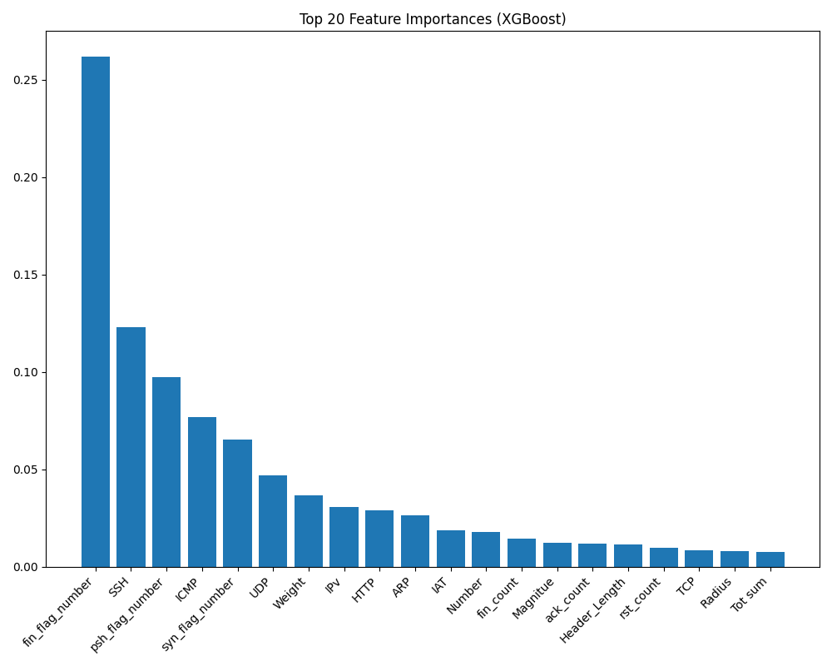
Fig. 8. Top 20 XGBoost feature importances (gain)

B. Temporal Layer Thresholds
All the temporal parameters in Spark can be configured by changing the ChainBreaker YAML settings during operation, with no need to retrain the model.
A watermarked five-minute window is applied to spot password spray using unique_targets_threshold (default 5) and failed_auth_threshold (default 10) that can be adjusted as needed. A time-frame of ten minutes is used for distributed attack detection, with min_source_count (default 3) configurable. For port scan detection, thirty unique destination ports within ten minutes is the default port_scan_threshold, also customizable. these defaults are appropriate for typical enterprise network segments.
C. Graph Query Performance
Neo4j's native graph storage offers traversal in time bounded by local connectivity instead of the total graph size, a property that is advantageous for multi-hop attack path query. Attack path tracing is depth-bounded at five hops and blast radius uses one-hop neighbourhood traversal. The depth bounds are guided by the forensic use case: following lateral movement, an analyst rarely needs to traverse beyond five hops before locating the origin host. Host and KillChainStage writes use idempotent MERGE-based Cypher, safe to run concurrently from Kafka consumer threads. AttackEvent writes use CREATE. Empirical query latency measurements under simulated production load are postponed to major phase evaluation.
D. Future Work
During the major phase of the project, we will add an RL Agent to ChainBreaker in order to automate the process of interrupting a kill chain. The RL Agent will use real-time topology metrics of the graph to observe and apply stage-dependent containment actions; each stage of a kill chain will have a different set of actions available for the agent to use in terms of containment actions based on the current active kill chain stage. The decision made by the agent will also be recorded in the graph as a node called AgentAction so that the full history of containment actions can be included on a forensic basis along with the record used for detect/trace events.
IX. CONCLUSION
We sought to address an identified structural gap: the gap that exists between per-flow ML-based detection and the actual level of situational awareness required for responding to APTs, which is at the graph level. The solution we developed to address this is called ChainBreaker — it is a single platform where detection, graph evolution and forensic reconstruction all occur on a single instance of Neo4j, with no separate stores for detection and forensic data and no correlation pipeline running in parallel.
From a detection standpoint, we combine multiclass classification using XGBoost [12] with anomaly detection using Isolation Forest [13] on a schema of 45 features defined by the CICIoT2023 [11] dataset, with nine stages mapping flows to the kill chain based on the MITRE ATT&CK framework. Using 6.6M total samples (34 attack types), XGBoost has a 99% validation accuracy and a macro F1 of 0.86. The Spark temporal layer allows us to extend coverage to coordinated attacks that would not be detected using per-flow classification.
Forensic processing (attack path tracing, blast radius analysis, incident timeline reconstruction) is performed as a series of Cypher traversals on the same graph used for receiving detections, allowing for the entire incident record to be presented as one single connected subgraph.
The components of the solution (e.g., XGBoost classification, Neo4j graph database, Spark time-based aggregation) have all independently been around for a long time. The primary contribution is that they have all been brought together as one operational platform, which includes a ‘live’ graph that continues to accumulate real-time network state data as attacks happen, in addition to a ‘forensic’ engine that directly reads the state from the graph (instead of having to join across external systems).
The major phase will add automated containment response on top of this substrate.
REFERENCES
[1] M. Zhong, M. Lin, C. Zhang, and Z. Xu, "A Survey on Graph Neural Networks for Intrusion Detection Systems: Methods, Trends and Challenges," Computers & Security, vol. 141, 2024.
[2] T. T. Nguyen and V. J. Reddi, "Deep Reinforcement Learning for Cyber Security," IEEE Trans. Neural Networks and Learning Systems, vol. 34, no. 8, pp. 3779–3795, 2023.
[3] K. M. Adawadkar and N. Kulkarni, "Cyber-Security and Reinforcement Learning — A Brief Survey," Engineering Applications of Artificial Intelligence, vol. 114, 2022.
[4] M. A. Ferrag et al., "Deep Learning for Cyber Security Intrusion Detection: Approaches, Datasets, and Comparative Study," Journal of Information Security and Applications, vol. 50, 2020.
[5] E. Iturbe, A. Rego, O. Llorente-Vazquez, E. Rios et al., "Reinforcement Learning in Action: Powering Intelligent Intrusion Responses to Advanced Cyber Threats in Realistic Scenarios," Expert Systems with Applications, Elsevier, 2025.
[6] M. Kazimierczak, N. Habib, J. H. Chan, and T. Thanapattheerakul, "Impact of AI on the Cyber Kill Chain: A Systematic Review," Heliyon, vol. 10, 2024.
[7] B. Stojanovic, A. Hofer-Schmitz, and U. Kleb, "APT Dataset and Attack Modeling for Automated Detection Systems: A Review," Computers & Security, vol. 92, 2020.
[8] S. M. Milajerdi, B. Eshete, R. Gjomemo, and V. N. Venkatakrishnan, "POIROT: Aligning Attack Behavior with Kernel Audit Records for Cyber Threat Hunting,", Proc. ACM SIGSAC Conf. Computer and Communications Security (CCS '19), pp. 1813–1830, 2019.
[9] D. Levshun and I. Kotenko, "A Survey on Artificial Intelligence Techniques for Security Event Correlation," Artificial Intelligence Review, 2023.
[10] M. Yang et al., "APT Detection via Stage Sequence Learning," Computers and Electrical Engineering, vol. 100, 2022.
[11] E. C. P. Neto et al., "CICIoT2023: A real-time dataset and benchmark for large-scale attacks in IoT environment," Sensors, vol. 23, no. 13, p. 5941, 2023.
[12] T. Chen and C. Guestrin, "XGBoost: A scalable tree boosting system,", Proc. 22nd ACM SIGKDD Int. Conf. Knowledge Discovery and Data Mining, San Francisco, CA, 2016, pp. 785–794.
[13] F. T. Liu, K. M. Ting, and Z.-H. Zhou, "Isolation forest,", Proc. 8th IEEE Int. Conf. Data Mining (ICDM), Pisa, Italy, 2008, pp. 413–422.
[14] Z. Cheng, Q. Lv, J. Liang, Y. Wang, D. Sun, T. Pasquier, and X. Han, "KAIROS: Practical Intrusion Detection and Investigation Using Whole-System Provenance," in Proc. 2024 IEEE Symp. Security and Privacy (SP), San Francisco, CA, USA, May 2024, pp. 3533–3551, doi: 10.1109/SP54263.2024.00005.
[15] D. H. Tran and M. Park, "Graph Embedding for Graph Neural Network in Intrusion Detection System," in Proc. 2024 Int. Conf. Information Networking (ICOIN), Ho Chi Minh City, Vietnam, Jan. 2024, pp. 395–397.
[16] C. Smiliotopoulos, G. Kambourakis, and C. Kolias, "Detecting Lateral Movement: A Systematic Survey," Heliyon, vol. 10, no. 4, p. e26317, Feb. 2024.
[17] A. A. M. Bahar, K. S. Ferrahi, M.-L. Messai, H. Seba, and K. Amrouche, "CONTINUUM: Detecting APT Attacks through Spatial-Temporal Graph Neural Networks," arXiv preprint arXiv:2501.02981, Jan. 2025.
[18] M. Janati and F. Messaoudi, "An XGBoost-Based Intrusion Detection Framework with Interpretability Analysis for IoT Networks," Applied Sciences, vol. 16, no. 2, p. 980, Jan. 2026.
[19] P. Zhou, "A Survey of Streaming Data Anomaly Detection in Network Security," PeerJ Computer Science, Aug. 2025, doi: 10.7717/peerj-cs.3066.
[20] L. Sadlek, M. M. Yamin, P. Čeleda, and B. Katt, "Severity-Based Triage of Cybersecurity Incidents Using Kill Chain Attack Graphs," Journal of Information Security and Applications, vol. 89, Mar. 2025, doi: 10.1016/j.jisa.2024.103956.
[21] M. Rabbani, L. Rashidi, and A. A. Ghorbani, "A Graph Learning-Based Approach for Lateral Movement Detection," IEEE Trans. Network and Service Management, Oct. 2024, doi: 10.1109/TNSM.2024.3414267.
[22] L. Li and W. Chen, "ConGraph: Advanced Persistent Threat Detection Method Based on Provenance Graph Combined with Process Context in Cyber-Physical System Environment," Electronics, vol. 13, no. 5, p. 945, Feb. 2024, doi: 10.3390/electronics13050945.
[23] F. Xu, Q. Zhao, X. Liu, N. Wang, M. Gao, X. Wen, and D. Zhang, "Advanced Persistent Threat Detection via Mining Long-Term Features in Provenance Graphs," Frontiers of Computer Science, vol. 19, no. 10, 2025, doi: 10.1007/s11704-024-40610-8.
[24] M. d. M. Rahman, S. A. Shakil, and M. Rahman, "A Survey on Intrusion Detection System in IoT Networks," Cyber Security and Applications, vol. 3, 2025, doi: 10.1016/j.csa.2024.100082.
[25] H. Xiang, X. Zhang, X. Xu, A. Beheshti, L. Qi, Y. Hong, and W. Dou, "Federated Learning-Based Anomaly Detection with Isolation Forest in the IoT-Edge Continuum," ACM Transactions on Multimedia Computing, Communications and Applications, Nov. 2024, doi: 10.1145/3702995.

