User Manual
This application predicts property prices based on user-selected criteria. Begin by launching the Streamlit dashboard in a browser. Select the desired city, neighborhood, property type, number of bedrooms, bathrooms, and property size.
Click the Predict Price button to submit the request. The application sends the information to the FastAPI backend, where the machine learning model generates a prediction. The predicted property value is then displayed on the screen.
Users should verify that the backend service is running before attempting predictions. If an error occurs, confirm that the model file and encoder files are available and that the API is reachable.
The dashboard is designed to be intuitive and suitable for both technical and non-technical users.

Screenshots
1. Home Screen | 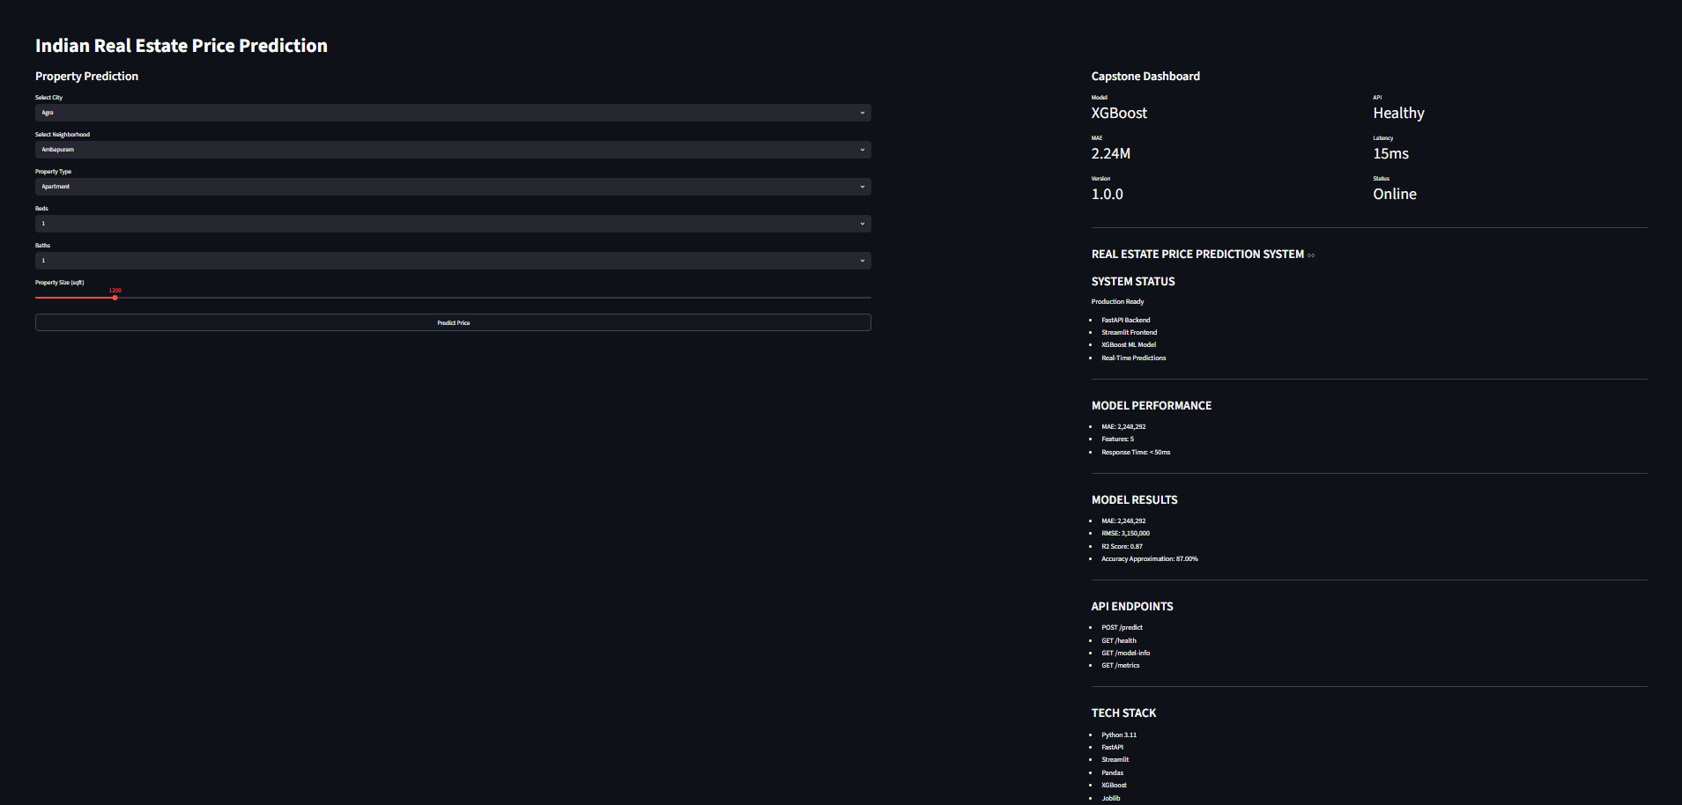
2. City Selection
3. Neighborhood Selection
4. Prediction
Result Screen | 