|  |
| --- |
| TIGER ANALYTICS |
| Project Name: Cat Chekr – Elimination Classification |
|  |
|  |
| **Kaushik Agrawal** |

|  |
| --- |
|  |

# Background:

This project is a Machine Learning which can classify between Elimination and Non-Elimination Activity for a cat which is using a smart cat litter box, with four sensors functioning at 40 Hz.

This model can Further classify if Activity was Elimination, then it was Urination or Defecation.

# Data Folder Structure:

1. Download all files inside Repository, and store them in a same folder.
2. In the same folder with Create a new folder, Name it ‘Raw_data’.
3. Under that new folder Add the Data folder Extracted from different devices.
4. Under Device_ID folder, add the data extracted from your device.
5. Data of each activity to classify should have 2 files with extensions of ‘.csv’ and ‘.json’, and file names of both of them should be event name (name which can Uniquely identify that activity like or Unique Event ID).
6. **Format of data in the files should be strictly match with Format Of Data given below.**

# Procedure to use this model:

Note: Only after Placing Data Folder properly proceed to this step.

1. Open ‘Data Preparation and Basic Feature Engineering.ipynb’ in Jupyter Notebook.
2. Run All cells.
3. After all cells get completely processed, close the file.
4. Open ‘Activity Prediction.ipynb’ in Jupyter Notebook.
5. Run All cells.
6. After all cells get completely processed, close the file.
7. A new file ‘result.csv’ will get generated in the same folder.
8. This csv file will have activity predictions.

# Format Of Data:

All ‘.csv’ files is Event Load Sensor Data and all ‘.json’ files is Tags Data:

* Event Load Sensor Data: Event named load sensor data containing timesteps and Load Sensor values. Theschema of these files looks as below. *Note: File name is event name here* 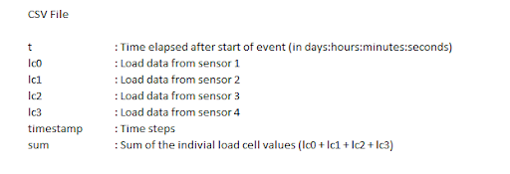

***Event Load Sensor Data Sample-***

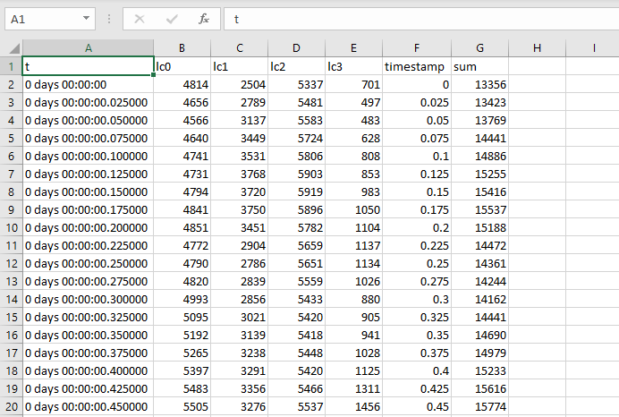

* Tags Data: Event named label/tag data containing the information about the event such as cat name, event tags, free text etc. 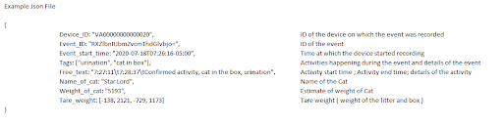

***Tags*** ***Data Sample-***

