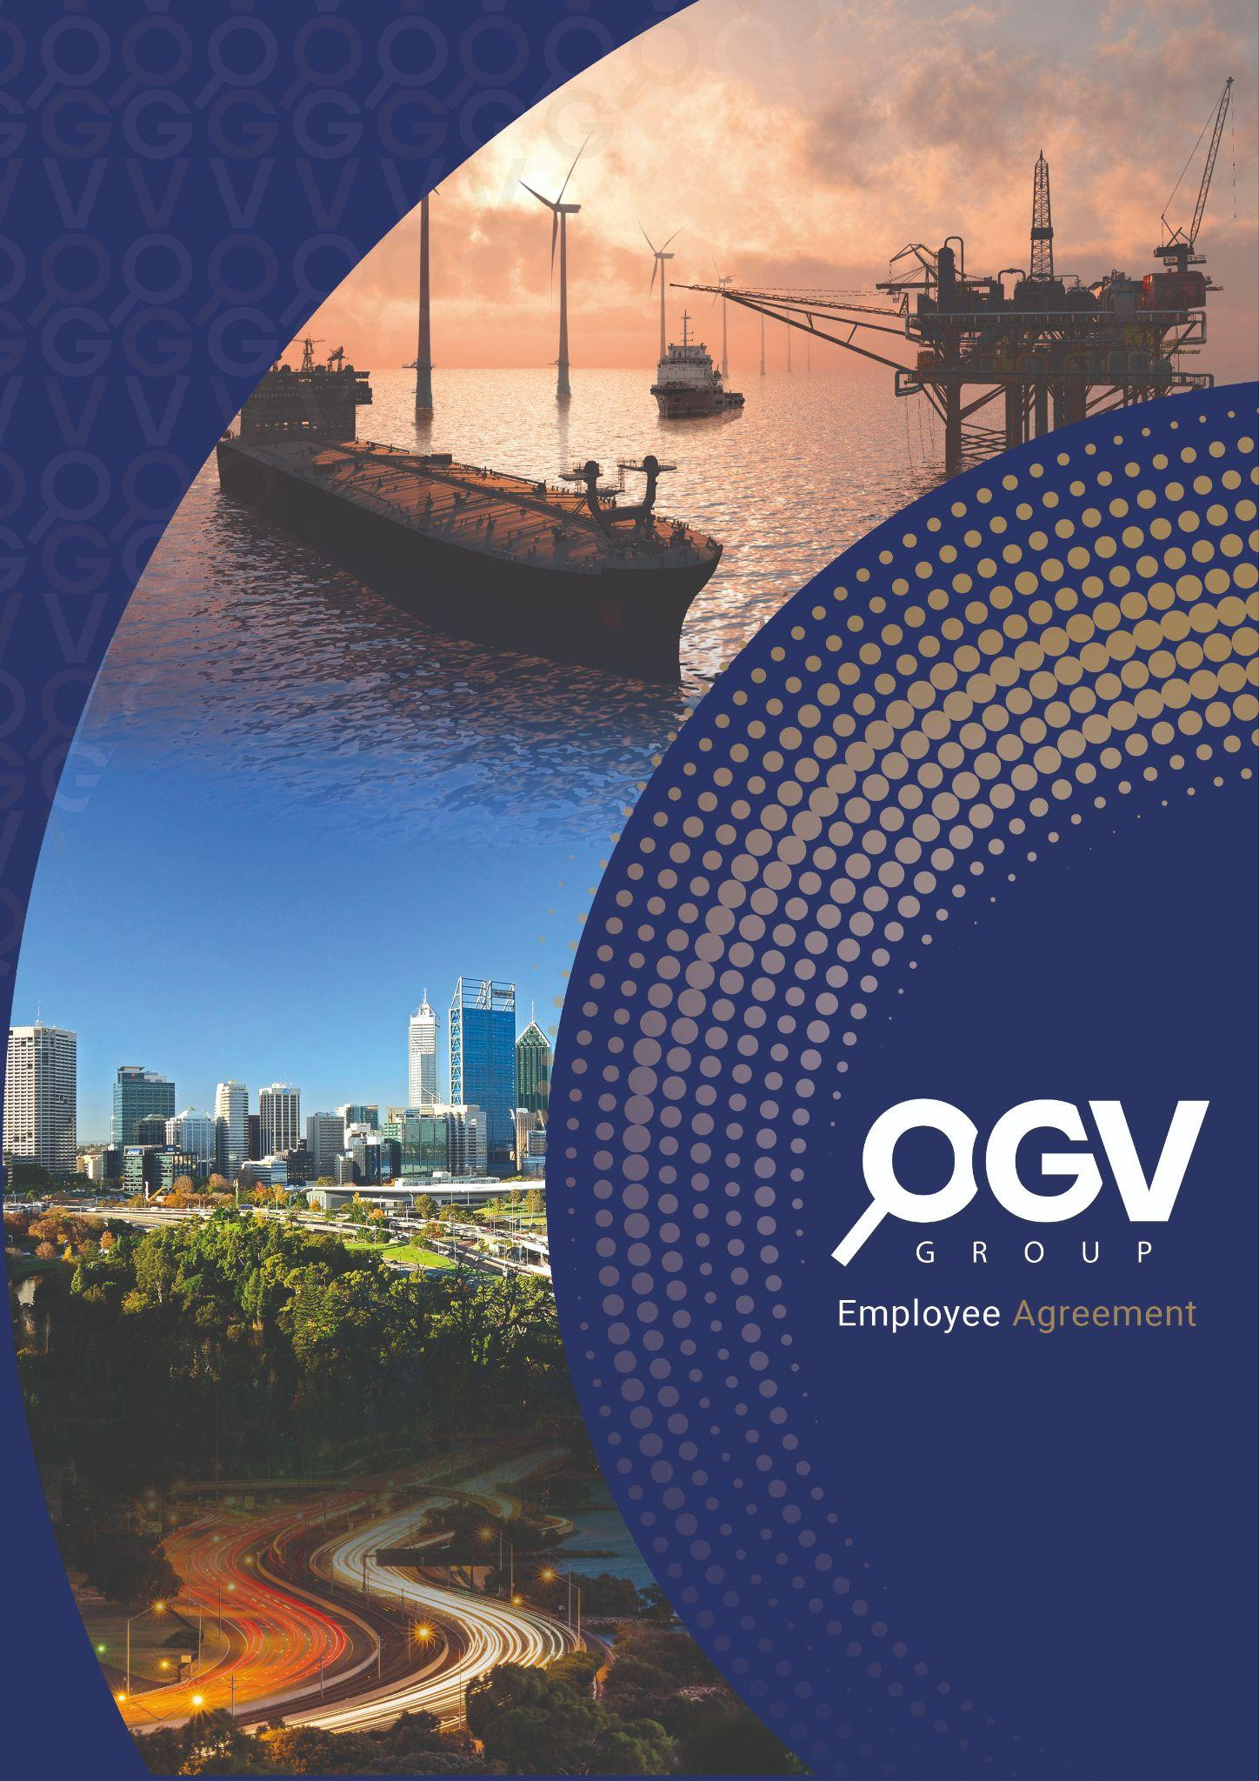

**Business Model Canvas** Australia 2024

Table of Contents

1. Customer Segments 3

2. Value Propositions 3

3. Channels 3

4. Customer Relationships 4

5. Revenue Streams 4

6. Key Resources 5

7. Key Activities 5

8. Key Partnerships 6

9. Cost Structure 6

# 1. Customer Segments

OGV Group Australia's customer segments are divided into primary and secondary categories based on the nature of their business operations and needs.

## Primary Customers:

* **Energy supply chain companies**: This includes small startups, medium enterprises, and large corporations seeking to expand into the Australian market.
* **Companies aiming for visibility**: Businesses looking to increase their visibility in the energy sector, whether locally or globally, and grow their customer base.

## Secondary Customers:

* **UK-based energy companies**: Firms with operations in the UK that are either currently in Australia or considering expansion into the Australian market.
* **Event sponsors and advertisers**: Companies that are looking to reach a highly targeted audience within the energy sector through event sponsorships and advertising opportunities.

## Summary:

OGV’s primary customer base includes energy sector companies seeking visibility and growth in Australia. Additionally, OGV attracts UK-based firms and advertisers aiming for market expansion and targeted exposure in the energy sector.

# 2. Value Propositions

OGV Group Australia’s value propositions are centred around providing a comprehensive and integrated marketing solution for energy sector companies.

## Unique Value Offering:

* A one-stop platform combining digital marketing, print publications, in-person networking events, and marketing design and video services.
* Proven success in the UK market, leveraging a strong client base and international network.
* Facilitation of business development and recruitment services through in-depth industry knowledge and extensive industry connections.

## Differentiation:

* OGV offers a combination of services that most competitors provide separately, such as digital marketing, print media, events, and recruitment services. This integrated experience allows clients to enhance their visibility and build networks across different channels.

Summary:  
OGV provides a unified, multi-service platform that combines marketing and business development support for energy companies, offering a solution that addresses visibility, networking, and business growth across various media channels.

# 3. Channels

OGV Group Australia reaches its customers through several direct and indirect channels:

## Primary Channels:

* **Website and Social Media**: Content is distributed via newsletters, SEO-driven campaigns, and platforms like LinkedIn, Instagram, and other industry-specific social media.
* **Print Publications**: Bi-monthly publications complement the digital offering, helping companies increase their visibility in the energy market.
* **Events**: OGV manages industry expos and networking events, providing clients with valuable face-to-face opportunities to connect with key stakeholders in the energy sector.

## Secondary Channels:

* **Partnerships with Industry Associations**: OGV collaborates with industry networks to promote its services.
* **Direct Sales**: OGV’s sales teams target energy sector businesses in both Australia and the UK for personalised outreach and service offerings.

Summary:  
OGV uses a blend of digital, print, and event-based channels to reach customers, ensuring comprehensive exposure across multiple touchpoints. These channels are supported by direct sales efforts and strategic partnerships with industry bodies.

# 4. Customer Relationships

OGV Group Australia fosters strong relationships with its clients through various types of engagement:

## Type of Relationship:

* **Dedicated Personal Assistance**: OGV’s Australian office provides clients with a dedicated team to manage their marketing, events, and business development needs.
* **Community Engagement**: OGV’s events foster a sense of community, helping clients build long-term relationships with industry professionals.

## Retention Strategy:

* **Feedback Loops**: Continuous feedback from clients after events and regular reviews of services ensure that OGV meets client expectations.
* **Frequent Touchpoints**: Regular updates through newsletters, event invitations, and industry trends help keep clients engaged and informed.

Summary:  
OGV maintains a high level of personal engagement with its clients through dedicated support and a strong focus on community-building within the energy sector. Regular feedback and industry insights help retain customers.

# 5. Revenue Streams

OGV Group Australia’s revenue streams are generated through several core and additional services:

Core Revenue Streams:

* **Advertising**: Revenue from digital and print advertising sales.
* **Event Management and Subletting**: Revenue from subletting exhibition spaces at major industry expos and charging clients for participation.

## Additional Revenue Streams:

* **Recruitment Services**: Providing recruitment support to energy companies by leveraging extensive industry data.
* **Video Production and Marketing Design**: Offering content creation and marketing design services as an additional revenue source.

Summary:  
OGV’s primary revenue is derived from advertising and event management, with additional income generated from recruitment services and marketing content production.

# 6. Key Resources

The key resources that OGV Group Australia relies on include human, physical, and digital assets:

## Human Resources:

* OGV’s core team is led by Emma Davidson and includes media and design teams from the UK. This team is crucial for content creation and client service.
* Local sales and event management teams in Australia support client acquisition and event operations.

## Physical Resources:

* OGV’s office facilities in Perth and event spaces for hosting industry expos.

## Digital Resources:

* OGV’s digital infrastructure includes its website, social media platforms, and CRM systems that manage client relationships and content delivery.

**Summary**:  
OGV’s key resources include a highly skilled team, physical office and event facilities, and a robust digital platform that enables efficient client management and content distribution.

# 7. Key Activities

OGV Group Australia’s key activities revolve around its core business of marketing and events:

## Core Activities:

* **Event Management**: Securing and managing exhibition spaces at international energy expos and subletting them to energy companies.
* **Content Creation and Marketing**: Developing digital and print marketing campaigns and industry publications to boost client visibility.

## Supporting Activities:

* **Business Development**: Building relationships with UK and Australian clients to drive customer acquisition and retention.
* **Customer Support**: Providing tailored assistance to ensure clients' needs are met throughout their engagement with OGV.

Summary:  
OGV’s core activities include managing industry events and creating marketing content, with strong support from business development and customer service efforts.

# 8. Key Partnerships

OGV Group Australia builds on several strategic partnerships to enhance its offerings:

* **Industry Associations and Trade Bodies**: Collaborations with organisations like the Energy Industries Council (EIC) to boost credibility and attract new clients.
* **Expo Organisers**: Partnerships with international expo organisers to secure prime exhibition spaces.
* **Technology Partners**: Collaborations with technology providers to improve digital marketing, web analytics, and CRM systems.

Summary:  
OGV’s key partnerships are instrumental in providing credibility, securing valuable industry connections, and enhancing its digital and event management capabilities.

# 9. Cost Structure

OGV Group Australia’s cost structure includes fixed and variable costs:

## Fixed Costs:

* **Employee Salaries**: Key personnel in Australia and the UK, including event managers, sales teams, and content creators.
* **Office Rent**: Maintaining physical office space in Perth.

## Variable Costs:

* **Event Organisation**: Costs related to securing expo spaces, marketing, and on-site logistics.
* **Print and Distribution**: Producing bi-monthly publications and distributing them to key stakeholders.
* **Marketing and Advertising**: Paid campaigns to drive awareness and generate traffic.
* **Travel and Accommodation**: For team members attending and managing international expos.

Summary:  
OGV’s cost structure includes a combination of fixed operational costs (salaries, office rent) and variable expenses related to event management, content production, and marketing.

## Business Model Canvas Overview

The Business Model Canvas for OGV Group Australia highlights how its customer-focused strategy, combined with its integrated marketing solutions, creates a cohesive and scalable business model. OGV effectively combines digital marketing, print publications, and event management to cater to the needs of energy companies looking to expand their visibility and market reach.

OGV's strong customer relationships, diverse revenue streams, and strategic partnerships ensure long-term growth and success, while its cost structure allows it to scale operations efficiently. By leveraging its UK experience and expanding into the Australian market, OGV is well-positioned to become a leader in the energy sector’s marketing and business development space.