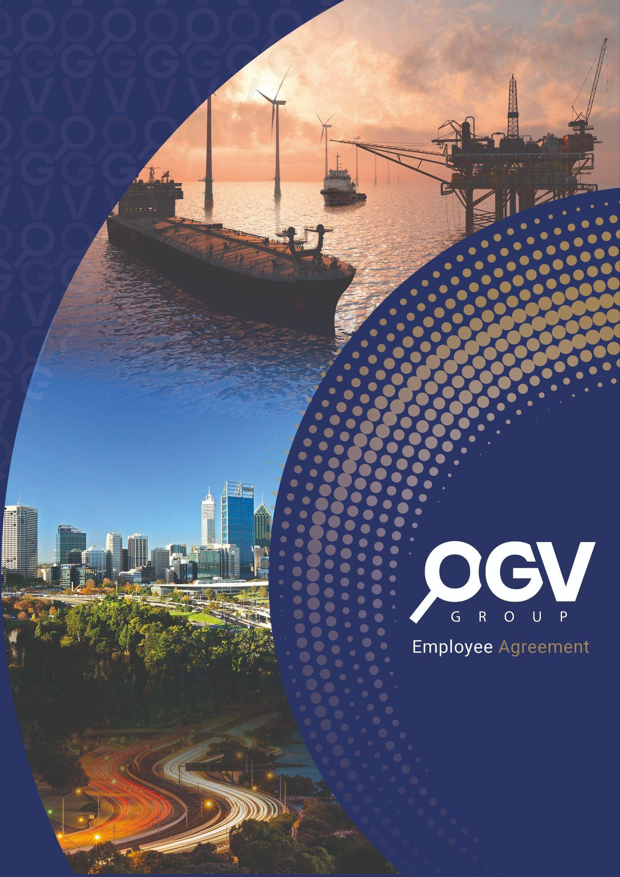

**Decision Making Unit**Australia 2024

Table of Contents

End User 3

Champion 3

Primary Economic Buyer 4

Influencers 5

Secondary Economic Buyer 6

Person with Veto Power 7

Purchasing Department 9

Overview of the Decision-Making Unit (DMU) 10

# End User

## Marketing and Business Development Teams in Energy Companies

## Key Characteristics:

* Primarily composed of professionals like Sarah (Marketing Manager) and members of David's (Energy Sector Entrepreneur) team
* Responsible for implementing marketing strategies, managing campaigns, and driving business growth
* Directly utilise OGV's digital marketing tools, attend networking events, and leverage print publications
* Seek measurable results and efficient ways to increase company visibility in the energy sector

## Needs and Preferences:

* User-friendly, integrated marketing solutions that combine digital and traditional channels
* Access to industry-specific networks and events for business development
* Tools and platforms that provide clear performance metrics and ROI data
* Resources to help navigate both local (Australian) and global energy markets

## Influence on Purchase Decision:

* While not the final decision-makers, their feedback and preferences significantly influence the selection of marketing and business development partners
* They evaluate the practical usability and effectiveness of OGV's services in meeting their day-to-day marketing and networking needs

## Summary:

The End Users of OGV Group Australia's services are the marketing and business development teams within energy companies. These professionals directly interact with OGV's platforms, attend events, and utilise the marketing services. Their experiences and feedback play a crucial role in shaping the company's decision to engage with OGV, making their satisfaction a key factor in the purchasing process.

# Champion

## Head of Marketing or Business Development

## Key Characteristics:

* Senior professional, similar to Sarah (Marketing Manager) but potentially at a higher level in the organisation
* Has a comprehensive understanding of the company's marketing needs and growth strategies
* Recognises the value of integrated marketing solutions and industry-specific networking opportunities
* Possesses the authority to influence decision-makers and drive change within the organisation

## Motivations:

* Seeking innovative ways to enhance the company's visibility and competitiveness in the energy sector
* Eager to demonstrate the impact of marketing initiatives on business growth
* Interested in solutions that can streamline operations and provide measurable results
* Values the combination of digital marketing, print media, and networking events offered by OGV

## Actions and Influence:

* Actively researches and evaluates marketing solutions like OGV's offerings
* Presents the benefits of OGV's services to other stakeholders in the organisation
* Organises demos or trial periods to showcase OGV's capabilities
* Builds internal support for adopting OGV's services by highlighting potential ROI and competitive advantages

## Challenges:

* Convincing other decision-makers of the value of a comprehensive solution like OGV
* Overcoming potential resistance to change or budget constraints
* Demonstrating how OGV's services align with both local and global marketing strategies

## Summary:

The Champion for OGV Group Australia is likely to be a senior marketing or business development professional who recognises the unique value of OGV's integrated approach. This individual actively promotes OGV's services within their organisation, leveraging their understanding of the company's needs and the benefits of OGV's offerings. Their enthusiasm and ability to influence others play a crucial role in moving the purchase decision forward.

# Primary Economic Buyer

## CEO or Managing Director

## Key Characteristics:

* Senior executive, similar to Mark (the Expat CEO) or David (the Energy Sector Entrepreneur)
* Has ultimate responsibility for company growth, market positioning, and financial performance
* Possesses a strategic view of the company's needs in both Australian and international markets
* Makes decisions based on potential ROI, competitive advantage, and alignment with overall business strategy

## Decision-making Criteria:

* Measurable impact on business growth and market share
* Cost-effectiveness and efficiency of marketing and networking solutions
* Ability to support both local (Australian) and global business objectives
* Potential for long-term partnership and scalability of services

## Concerns and Priorities:

* Ensuring that marketing investments translate into tangible business results
* Maintaining a strong competitive position in a crowded energy market
* Balancing the need for comprehensive solutions with budget constraints
* Mitigating risks associated with adopting new marketing and networking platforms

## Influence on Purchase Decision:

* Has the final say on budget allocation and service adoption
* Evaluates OGV's offerings in the context of overall business strategy and financial implications
* May delegate initial research and recommendations to marketing or business development teams, but retains ultimate decision-making authority

## Preferred Communication Approach:

* Concise, high-level presentations focusing on strategic benefits and ROI
* Evidence-based proposals with clear metrics and success stories
* Direct engagement from OGV's senior leadership to address strategic concerns

## Summary:

The Primary Economic Buyer for OGV Group Australia's services is likely to be the CEO or Managing Director of the client company. This individual has the authority to make the final purchasing decision and allocate budget. They evaluate OGV's offerings based on strategic fit, potential ROI, and ability to drive business growth in both Australian and international markets. Their decision is influenced by the recommendations of their marketing and business development teams, but ultimately rests on how well OGV's services align with the company's overall objectives and financial considerations.

# Influencers

1. Chief Financial Officer (CFO) Key Characteristics:

* Focuses on financial implications and ROI of marketing investments
* Evaluates the cost-effectiveness of OGV's services compared to alternatives
* Influences decisions based on budgetary considerations and financial forecasts

1. Regional Managers or Directors Key Characteristics:

* Provide insights into specific market needs (e.g., Australian vs. UK markets)
* Evaluate how OGV's services can support regional growth strategies
* Influence decisions based on local market conditions and competitive landscapes

1. IT Department Head Key Characteristics:

* Assesses the technical aspects of OGV's digital marketing solutions
* Evaluates integration capabilities with existing systems
* Influences decisions based on data security, user management, and technical support

1. Industry Peers and Network Key Characteristics:

* Other professionals in the energy sector who have experience with similar services
* Provide informal recommendations and share experiences
* Influence decisions through word-of-mouth and industry reputation

1. External Marketing Consultants Key Characteristics:

* Provide expert opinions on marketing trends and best practices
* Evaluate OGV's offerings in the context of the broader marketing landscape
* Influence decisions through professional recommendations and market analysis

## Influence on Purchase Decision:

* Provide diverse perspectives that help shape the overall evaluation of OGV's services
* Raise potential concerns or highlight benefits that might be overlooked by primary decision-makers
* Contribute to a more comprehensive understanding of the implications of adopting OGV's solutions

## Preferred Communication Approach:

* Tailored information addressing specific areas of expertise or concern
* Case studies and peer testimonials demonstrating success in similar contexts
* Opportunities for direct engagement with OGV's specialists to address specific queries

## Summary:

The Influencers in the decision to adopt OGV Group Australia's services include a range of internal stakeholders (CFO, Regional Managers, IT Department Head) and external voices (Industry Peers, Marketing Consultants). Each brings a unique perspective to the evaluation process, considering financial, regional, technical, and industry-specific factors. While they don't make the final decision, their input significantly shapes the overall assessment of OGV's offerings and influences the Primary Economic Buyer's decision.

# Secondary Economic Buyer

## Chief Marketing Officer (CMO) or Head of Business Development

## Key Characteristics:

* Senior executive, possibly overseeing professionals like Sarah (Marketing Manager)
* Has significant budget authority for marketing and business development initiatives
* Deeply understands the company's marketing needs and growth strategies
* Reports to the CEO or Managing Director (Primary Economic Buyer)

## Decision-making Involvement:

* Responsible for allocating marketing and business development budgets
* Evaluates the strategic fit of OGV's services within the overall marketing plan
* Makes recommendations to the Primary Economic Buyer regarding the adoption of OGV's services

## Key Concerns:

* Ensuring OGV's services provide a comprehensive solution for both digital and traditional marketing needs
* Maximising the impact of marketing investments on business growth and visibility
* Balancing the need for local (Australian) marketing efforts with global brand consistency
* Demonstrating clear ROI and performance metrics to justify marketing expenditures

## Evaluation Criteria:

* Ability of OGV's services to enhance market presence and drive business development
* Integration capabilities with existing marketing tools and strategies
* Flexibility to support both event-based networking and ongoing digital marketing efforts
* Cost-effectiveness compared to managing these functions in-house or through multiple vendors

## Influence on Purchase Decision:

* Provides detailed analysis and recommendations to the Primary Economic Buyer
* May have authority to approve the purchase within certain budget limits
* Plays a crucial role in defining the scope of services and negotiating terms

## Preferred Communication Approach:

* Comprehensive presentations detailing how OGV's services address specific marketing challenges
* Detailed breakdowns of costs, expected outcomes, and performance metrics
* Proposals that demonstrate an understanding of the company's unique market position and growth objectives

Summary:   
The Secondary Economic Buyer for OGV Group Australia's services is likely to be the Chief Marketing Officer or Head of Business Development. This individual has significant budget authority and plays a crucial role in evaluating and recommending OGV's services. They are deeply involved in the decision-making process, providing detailed analysis to the Primary Economic Buyer and potentially having the authority to approve the purchase within certain limits. Their focus is on ensuring that OGV's offerings align with the company's marketing strategy, provide measurable results, and offer a comprehensive solution for both digital and traditional marketing needs.

# Person with Veto Power

## Board of Directors or Chief Risk Officer (CRO)

## Key Characteristics:

* Highest level of authority in the company, overseeing strategic decisions and risk management
* May not be involved in day-to-day operations but has final say on significant investments or strategic shifts
* Focuses on long-term company vision, shareholder value, and risk mitigation

## Areas of Concern:

* Alignment of OGV's services with overall company strategy and market positioning
* Potential risks associated with data security and brand reputation
* Financial implications and long-term ROI of adopting OGV's comprehensive marketing solutions
* Compliance with industry regulations and corporate governance standards

## Veto Considerations:

* Excessive financial commitment or perceived overspending on marketing services
* Misalignment with the company's core values or strategic direction
* Significant changes to established business processes or company culture
* Potential conflicts with existing partnerships or agreements

## Influence on Purchase Decision:

* Has the power to halt the adoption of OGV's services even if approved by other decision-makers
* May request additional information, risk assessments, or strategic justifications before approving the purchase
* Could influence the scope or terms of engagement with OGV to align with broader company objectives

## Preferred Communication Approach:

* High-level, strategic presentations focusing on long-term value and risk mitigation
* Clear articulation of how OGV's services support the company's overall vision and market position
* Transparency about potential challenges and proposed solutions
* Involvement of OGV's top leadership in addressing any concerns or reservations

## Mitigation Strategies for OGV:

* Provide comprehensive risk assessment and mitigation plans
* Offer flexible contract terms that allow for periodic review and adjustment
* Demonstrate commitment to data security and compliance with industry standards
* Showcase case studies of successful long-term partnerships with similar companies in the energy sector

## Summary:

The Person with Veto Power for OGV Group Australia's services is likely to be the Board of Directors or Chief Risk Officer. This entity or individual has the authority to block the purchase decision based on strategic, financial, or risk-related concerns. Their focus is on ensuring that the adoption of OGV's services aligns with the company's long-term vision, complies with governance standards, and does not expose the company to undue risk. While they may not be involved in the initial decision-making process, their approval is crucial for the final go-ahead. OGV should be prepared to address high-level strategic concerns and demonstrate long-term value to secure approval from this stakeholder.

# Purchasing Department

## Procurement Team led by a Procurement Manager

## Key Responsibilities:

* Managing the formal procurement process for OGV's services
* Negotiating contract terms, pricing, and service level agreements
* Ensuring compliance with company purchasing policies and industry regulations
* Coordinating with legal and finance departments to finalise agreements

## Involvement in Decision-making:

* Typically enters the process after initial approval from key decision-makers
* Focuses on optimising the terms of engagement rather than deciding on the service itself
* May influence the final decision based on contractual or compliance issues

## Key Concerns:

* Cost-effectiveness and value for money of OGV's services
* Flexibility of contract terms and ability to scale services as needed
* Alignment with existing vendor management and procurement processes
* Compliance with data protection and industry-specific regulations

## Evaluation Criteria:

* Competitive pricing and payment terms
* Clear service level agreements and performance metrics
* Vendor stability and track record in the industry
* Flexibility to accommodate future changes in service requirements

## Influence on Purchase Decision:

* Moderate to high influence, particularly in the final stages of the decision process
* Can significantly impact the timing and terms of the engagement with OGV
* Provides critical input on vendor risk and contract management considerations

## Challenges:

* Balancing the unique nature of OGV's integrated services with standard procurement processes
* Ensuring the contract allows for scalability and flexibility as the company's needs evolve
* Managing potential conflicts between OGV's offerings and existing vendor relationships
* Aligning procurement timelines with the urgent needs of marketing and business development teams

## Key Considerations:

* Contract duration and renewal terms
* Service level agreements and performance metrics
* Pricing structure and payment terms
* Intellectual property rights and data ownership
* Termination clauses and exit strategies

## Summary:

The Purchasing Department plays a critical role in formalising the engagement with OGV Group Australia. Their focus on compliance, risk management, and favourable contract terms can significantly influence the final shape of the partnership. OGV must be prepared to navigate complex procurement processes, demonstrate flexibility in contract negotiations, and provide clear documentation of their service offerings and performance guarantees to successfully engage with this stakeholder.

# Overview of the Decision-Making Unit (DMU)

The DMU for engaging OGV Group Australia's services in an energy sector company involves a complex interplay of roles, each contributing unique perspectives and priorities to the decision-making process:

1. End User (Marketing Manager/Business Development Executive): Provides hands-on feedback on the usability and effectiveness of OGV's services, influencing ongoing satisfaction and retention.
2. Champion (Head of Marketing/Business Development Director): Advocates for OGV's solutions, building internal consensus and presenting the business case to other decision-makers.
3. Primary Economic Buyer (CEO/CFO/CMO): Makes the final financial decision, focusing on strategic alignment and ROI of OGV's services.
4. Influencers (Various Department Heads): Offer diverse perspectives on how OGV's services impact different areas of the business, shaping the overall evaluation.
5. Secondary Economic Buyer (Finance Director): Scrutinises the financial implications, providing critical analysis and potentially suggesting alternative financing options.
6. Person with Veto Power (CEO/Managing Director): Holds ultimate authority to approve or reject the engagement, focusing on strategic fit and long-term impact.
7. Purchasing Department: Manages the formal procurement process, negotiating contract terms and ensuring compliance with company policies.

The decision-making process typically flows from the End Users and Champion identifying the need and value of OGV's services, through the Influencers providing diverse input, to the Economic Buyers evaluating the financial and strategic implications. The Person with Veto Power may become involved if the decision is particularly significant or contentious. Throughout this process, the Purchasing Department works to formalise the engagement and negotiate terms.

## To successfully navigate this DMU, OGV Group Australia must:

1. Demonstrate clear value and ROI to address the concerns of Economic Buyers
2. Provide comprehensive support and training for End Users
3. Equip the Champion with strong, data-driven arguments to build internal consensus
4. Address the diverse concerns of Influencers across different departments
5. Align their offering with the company's strategic vision to satisfy the Person with Veto Power
6. Work flexibly with the Purchasing Department to navigate procurement processes and negotiate favourable terms

By understanding and addressing the needs and concerns of each role in the DMU, OGV can significantly increase its chances of successfully engaging with energy sector companies in the Australian market.