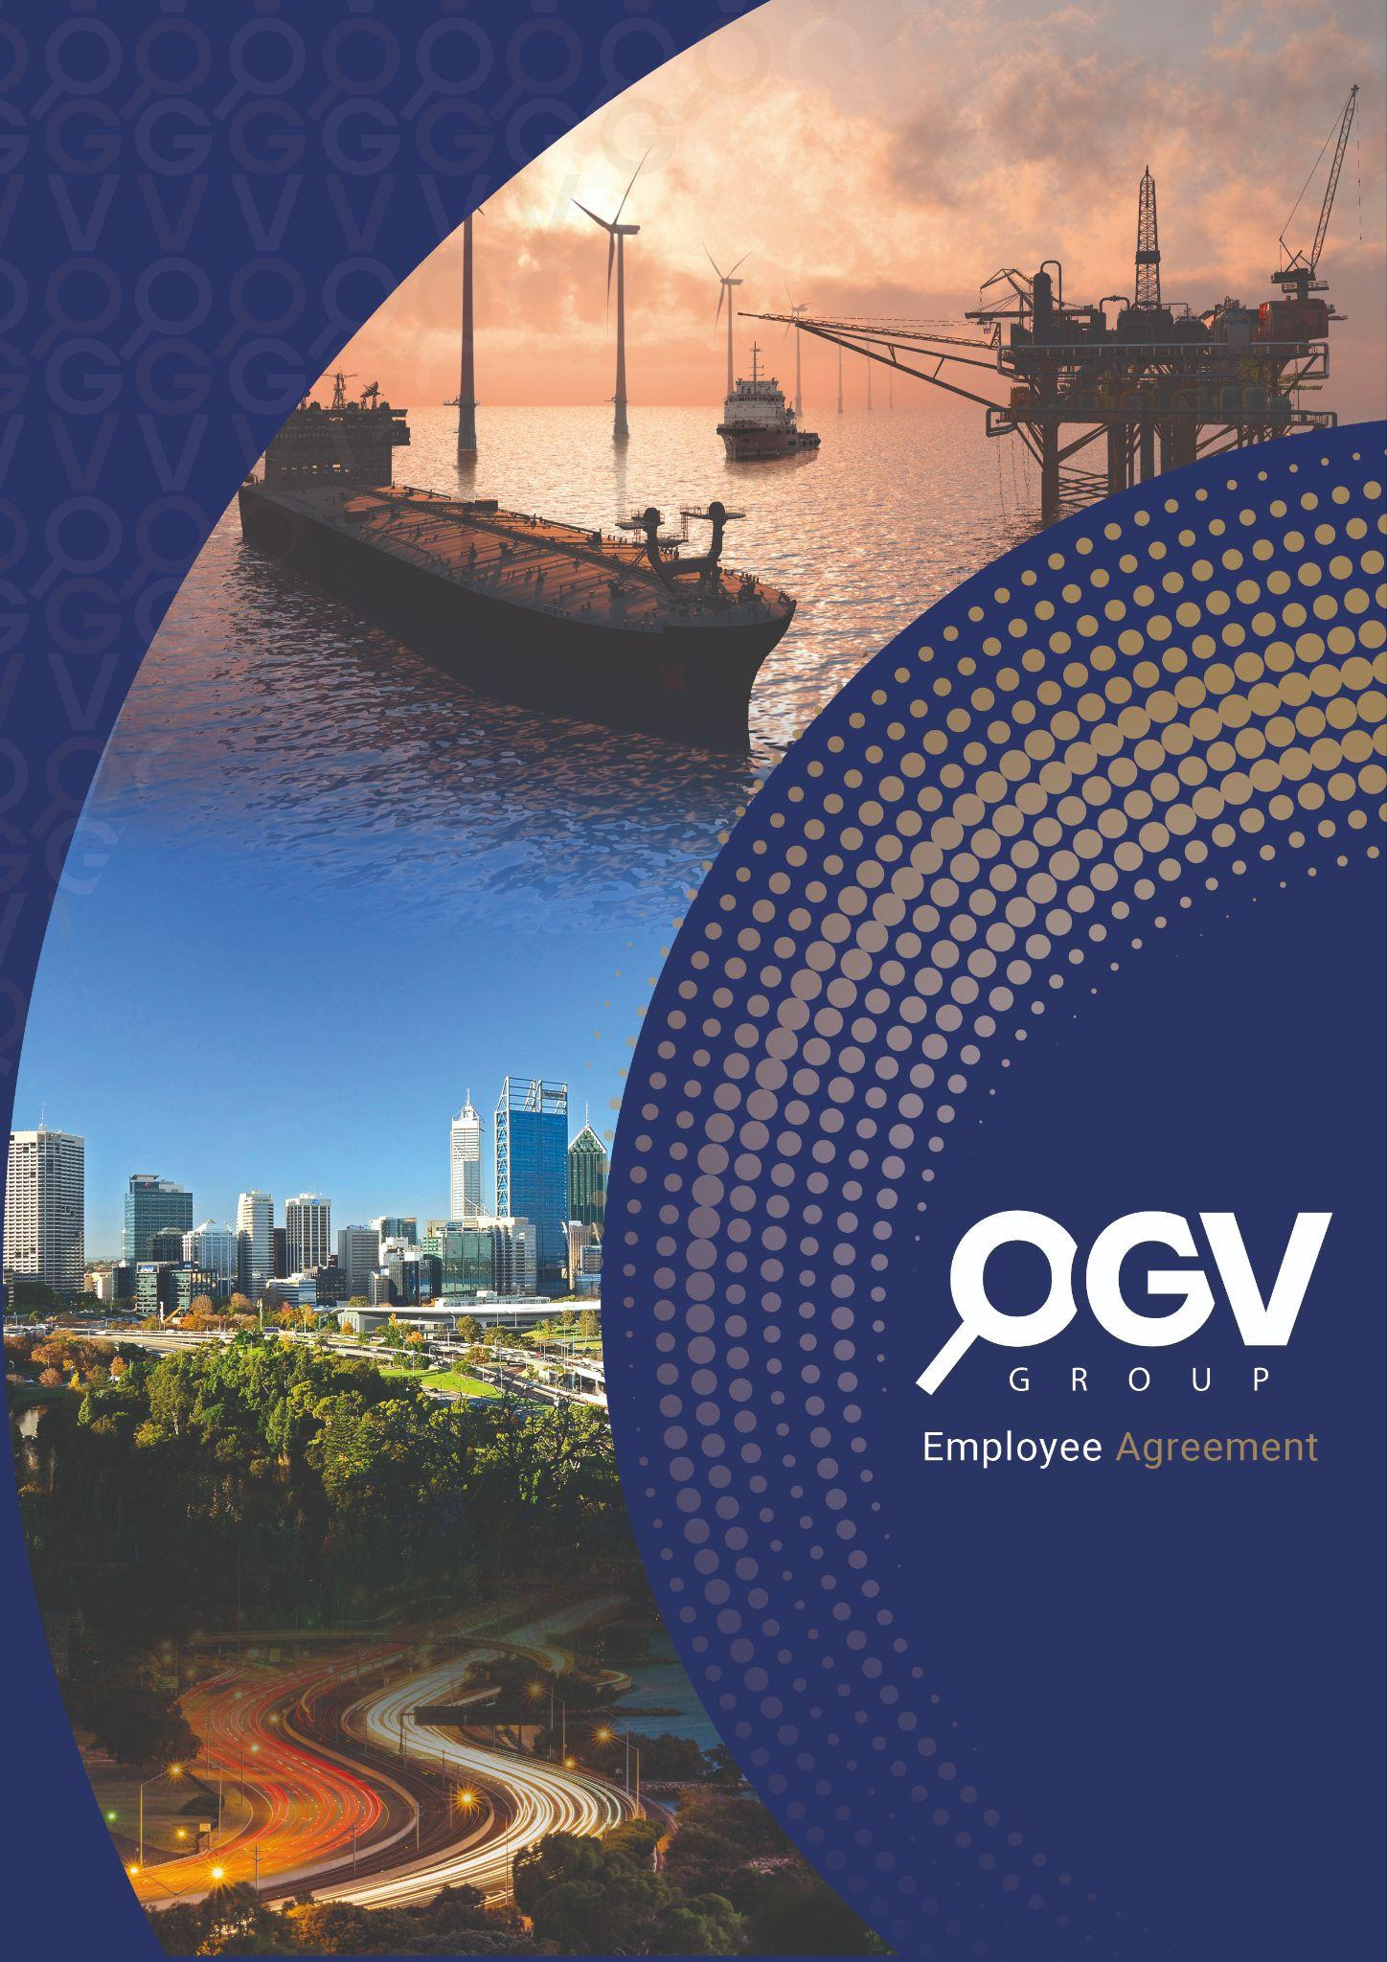

**Value Proposition Canvas** Australia 2024

Table of Contents

1. Customer Jobs 3

Persona 1: 3

Persona 2: 3

Persona 3: 3

2. Gains 3

3. Pains 4

4. Products & Services 5

5. Gain Creators 5

6. Pain Relievers 5

# 1. Customer Jobs

Customer Jobs refer to the tasks, problems, or needs that OGV’s customers want to address.

# Persona 1:

## David, the Energy Sector Entrepreneur (Founder & CEO)

* **Business Development**: Establishing a dominant position in the Australian energy market by expanding his business and securing new clients.
* **Visibility**: Enhancing his company’s visibility through comprehensive marketing strategies.
* **Networking**: Finding reliable partners and opportunities to network at industry events, particularly in a competitive environment.
* **International Presence**: Maintaining and growing his company's presence in both the Australian and global markets.

# Persona 2:

## Sarah, the Marketing Manager (Head of Communications & Branding)

* **Brand Building**: Ensuring the company's brand is visible and resonates in both local and global markets.
* **Campaign Integration**: Managing integrated marketing campaigns across digital and offline platforms.
* **Performance Tracking**: Demonstrating the ROI of marketing initiatives through clear performance metrics.

# Persona 3:

## Mark, the Expat CEO (CEO of a Multinational Energy Services Company)

* **Global Expansion**: Growing his company’s reach across multiple regions, particularly Australia and the UK.
* **Operational Efficiency**: Ensuring streamlined operations across different geographical areas.
* **Strategic Partnerships**: Finding reliable partners who understand the complexities of managing a multinational business and can support growth through events and marketing solutions.

# 2. Gains

Gains are the positive outcomes or benefits that customers desire.

## Persona 1:

## David, the Energy Sector Entrepreneur (Founder & CEO)

* **Increased Market Share**: Achieving a leading position in the Australian energy sector.
* **Business Growth**: Securing new clients and expanding operations into new regions.
* **Brand Recognition**: Enhancing visibility to attract industry attention and differentiate from competitors.

## Persona 2:

## Sarah, the Marketing Manager (Head of Communications & Branding)

* **Efficient Campaigns**: Streamlining local and global marketing campaigns to save time and resources.
* **Measurable Success**: Obtaining detailed performance reports that show the success of her marketing strategies.
* **Integrated Solutions**: Finding an all-in-one solution that covers both digital and offline marketing needs.

## Persona 3:

## Mark, the Expat CEO (CEO of a Multinational Energy Services Company)

* **Seamless Global Operations**: Simplifying international operations through strong partnerships.
* **Expanded Network**: Strengthening global relationships through high-level networking events.
* **Global Presence**: Maximising his company’s visibility at international energy expos and ensuring operational efficiency across multiple markets.

# 3. Pains

Pains refer to the challenges, obstacles, or risks that customers face in achieving their goals.

## Persona 1:

## David, the Energy Sector Entrepreneur (Founder & CEO)

* **Crowded Market**: Struggling to stand out from competitors in a saturated energy market.
* **Resource Constraints**: Limited resources for managing marketing, recruitment, and events.
* **Maintaining International Presence**: Difficulty in managing his company’s international presence while growing in Australia.

## Persona 2:

## Sarah, the Marketing Manager (Head of Communications & Branding)

* **Balancing Local and Global Needs**: Difficulty in balancing global marketing strategies with local campaign requirements.
* **Lack of Measurable Results**: Uncertainty in demonstrating ROI for marketing investments due to insufficient performance tracking.
* **Finding a Comprehensive Partner**: Challenges in finding a partner who can provide both digital and event marketing solutions.

## Persona 3:

## Mark, the Expat CEO (CEO of a Multinational Energy Services Company)

* **Regulatory Hurdles**: Navigating different regulatory environments across regions.
* **Partner Alignment**: Difficulty in finding partners who understand the nuances of operating in multiple international markets.
* **Time Constraints**: Balancing frequent travel with managing operations in both Australia and the UK.

# 4. Products & Services

These are the products and services OGV Group Australia provides to help customers address their jobs, alleviate their pains, and achieve their desired gains.

* **Digital Marketing Solutions**: Comprehensive online marketing through SEO, newsletters, and social media platforms like LinkedIn and Instagram.
* **Print Publications**: Bi-monthly industry publications that enhance brand visibility and reach.
* **Event Management**: Organising and hosting industry expos and networking events to provide clients with direct access to key stakeholders.
* **Business Development Support**: Leveraging OGV’s extensive industry knowledge and contacts to facilitate recruitment and business development.
* **Video Production and Marketing Design**: Content creation services to help companies produce compelling marketing materials, whether digital or offline.
* **Recruitment Services**: Assistance with recruitment in the energy sector, helping clients find top talent.

# 5. Gain Creators

Gain Creators describe how OGV's products and services create positive outcomes and generate desired gains for customers.

* **Enhanced Visibility**: OGV’s combination of digital marketing, print publications, and events provides multiple avenues for clients to increase their visibility within the energy sector, both locally and internationally.
* **Seamless Networking Opportunities**: Through events and expos, OGV facilitates valuable connections with industry leaders, providing David, Sarah, and Mark the opportunity to expand their networks and forge new partnerships.
* **Proven ROI**: OGV offers performance tracking, analytics, and post-event reports, helping customers like Sarah demonstrate clear ROI on their marketing investments.
* **International Presence**: With its established UK base, OGV helps businesses like David's and Mark's maintain a strong international presence while expanding into new markets like Australia.

# 6. Pain Relievers

Pain Relievers describe how OGV’s solutions address the pains and challenges customers face.

* **Integrated Marketing Platform**: OGV’s ability to deliver both digital and offline marketing solutions provides Sarah with the comprehensive tools she needs to streamline her efforts and ensure campaign success.
* **Event and Recruitment Support**: By handling event management and recruitment services, OGV alleviates David's pain of managing these tasks internally, allowing him to focus on business growth.
* **Regulatory Expertise**: OGV’s understanding of both UK and Australian markets helps Mark navigate the regulatory complexities of operating internationally, ensuring smoother global operations.
* **Customised Client Support**: Personalised account management and strategic advice help alleviate the burden on all personas, providing them with the confidence to execute their business strategies effectively.

## Overview of the Value Proposition Canvas

The Value Proposition Canvas for OGV Group Australia showcases how its comprehensive platform aligns with the needs, goals, and challenges of its target customer personas.

* **David, the Energy Sector Entrepreneur (Founder & CEO)** seeks enhanced visibility, business growth, and networking opportunities to dominate the Australian energy sector. OGV's event management, recruitment support, and comprehensive marketing strategies are key in addressing his challenges and delivering the gains he seeks.
* **Sarah, the Marketing Manager (Head of Communications & Branding)** is focused on streamlining her company’s marketing efforts and proving ROI. OGV's integrated marketing services and detailed performance reports help her achieve her goals and address her pain points regarding local and global campaign alignment.
* **Mark, the Expat CEO (CEO of a Multinational Energy Services Company)** requires seamless operations across global markets and reliable partnerships. OGV's expertise in managing international operations and providing targeted networking opportunities ensures he can maintain operational efficiency and expand his company's global presence.

Together, these tailored solutions not only alleviate customer pain points but also create value by enhancing visibility, fostering networking, and supporting business growth. OGV is positioned as an indispensable partner for energy sector companies aiming to expand their reach in Australia and beyond.