**Observation and report**

Date: 05/04/2024

Program Title: Write a python program to import and export data using Pandas library functions.

Algorithm - snapshot from observation

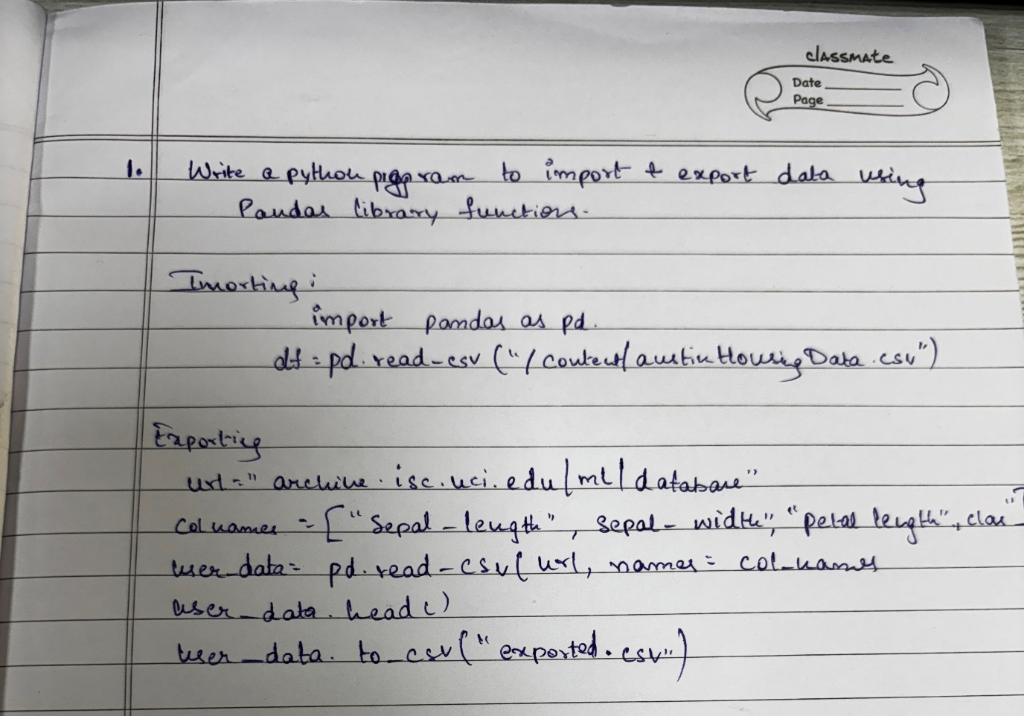

Code :

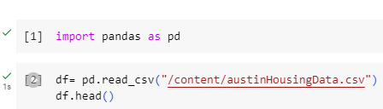

Output:

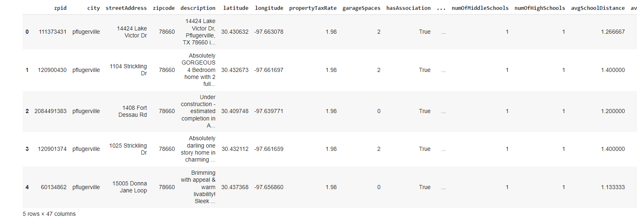

Code :

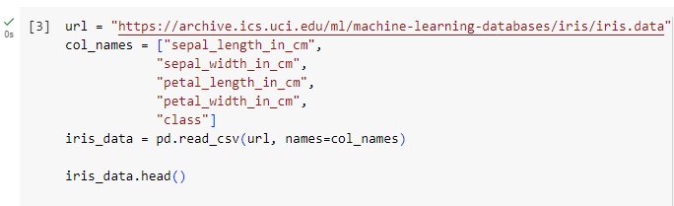



Output:

