Manual Procedure For Ingesting Error Record

- Go to location where Response file is there. Copy that file at same place and change its extension to .ORIGINAL
- Cut errored records from that xml file and keep it in notepad
- Check for which package, we had an issue with pdf using MailPieceId notified by Print Vendor. You will find MailPieceId from provided pdf file name{MailPieceId_ActualPdfFileName.pdf) and PrintTrailBatchId which is nothing but submitted BatchId
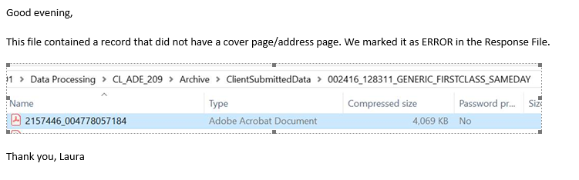
- Take MailPieceId, PrintTrailBatchId and Error Description(Provided in response file) and replace with existing variable in below script and execute.

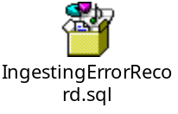
- Validate records after update and then execute COMMIT TRAN in above script. If you find any issue with data update then execute ROLLBACK TRAN in above script.
- After some time you will see Batch Suspended error due to Reprint code.(As logic is implemented to suspend batch if any Reprint code found)
- Execute script -a for checking suspended batches after receiving suspended email. Then after reviewing suspended batch execute script – b.
  - SELECT * FROM PnS.BatchSummary WHERE PrintBatch IN (SELECT Distinct JobId FROM PnS.MRDFRequest WHERE PrintTrailBatchId={PrintTrailBatchId}) AND PipelineStatus='Suspended'
  - UPDATE PnS.BatchSummary SET PipelineStatus='ReportPrepped', SuspendedOn=NULL WHERE PrintBatch IN (SELECT Distinct JobId FROM PnS.MRDFRequest WHERE PrintTrailBatchId={PrintTrailBatchId)) AND PipelineStatus='Suspended'

