Manual Procedure For Resubmitting Cover Letter Issue Package

- Check for which package, we had an issue of label issue using MailPieceId notified by Print Vendor. You will find MailPieceId from provided pdf file name{MailPieceId_ActualPdfFileName.pdf).
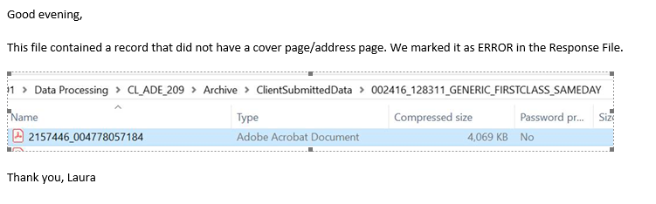
- Check its shipping method
  - SELECT * FROM AM.MailPieces P INNER JOIN dbo.v_DocTypes D ON P.DocTypeId=D.Id AND P.PnSConfigDetailid=D.PnSConfigDetailId WHERE P.Id={MailPieceId}

- Generate Shipping label through various app
  - For USPS IMB
  - For USPS Priority / Express
  - For FedEx
- Copy updated tracking number generated in step-3 and update it AM.MailPieces table
  - UPDATE AM.MailPieces SET TrackingNo={TrackingNo} WHERE Id={MailPieceId}
- Take pdf which was processed via PnSService {Path}
  - Pick pdf from PCIRequest folder only
- Open pdfsam or any other pdf editing tool and remove already merged cover letter from that pdf
  - 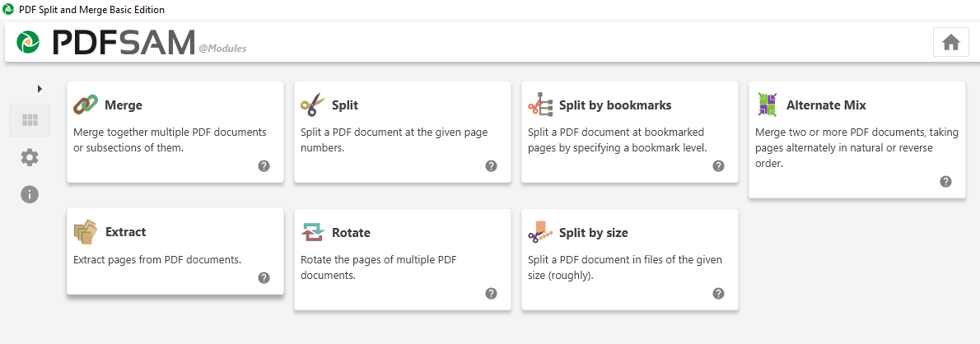
  - Enter 2- in extract pages to remove cover page from pdf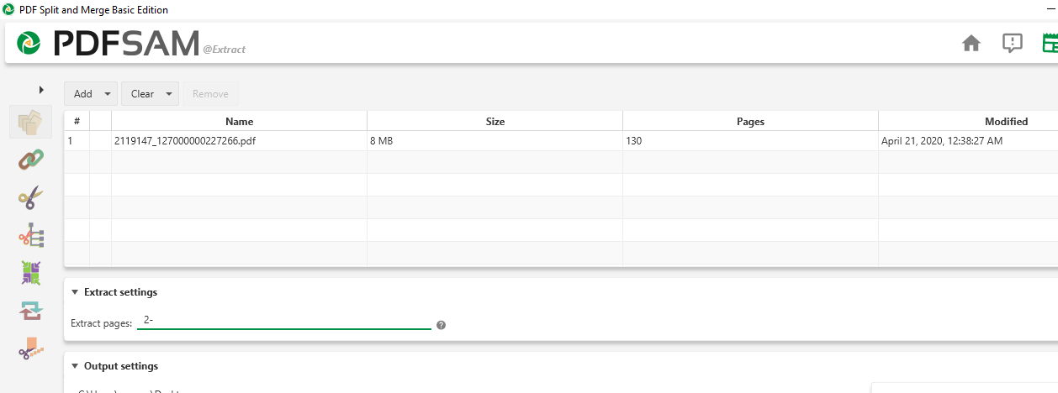
- Now merge newly generated label and pdf without cover page created in step -6
  - Add newly generated label first(generated in step-3) and then add pdf without cover page generated in step-6
  - Keep file name as it is.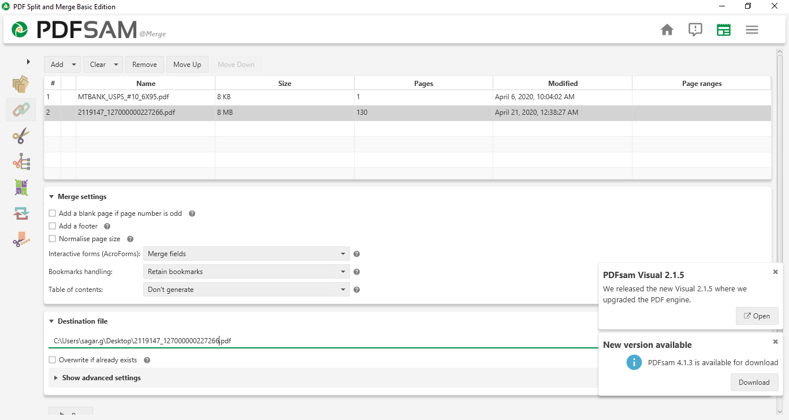
- Copy already generated XML / mrdf file and remove all records except errored one.
- Set new BatchId (which starts with 11K for resubmitting batch) for that new XML / MRDF and create a zip
- Upload newly created zip into PrintVendor’s location using FileZilla / winScp or any other software.

