**NumPy Lab-16**

Name: Kaushik Parmar

ID: AF0448761

1. 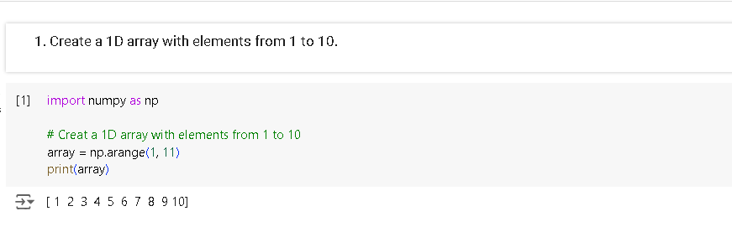Create a 1D array with elements from 1 to 10.
2. Create a 2D array of size 3x3 filled with zeros.

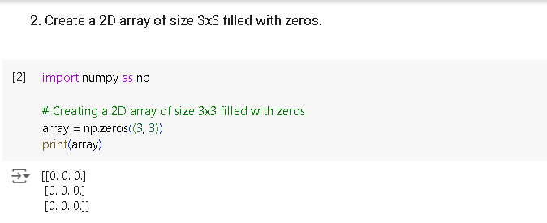

1. 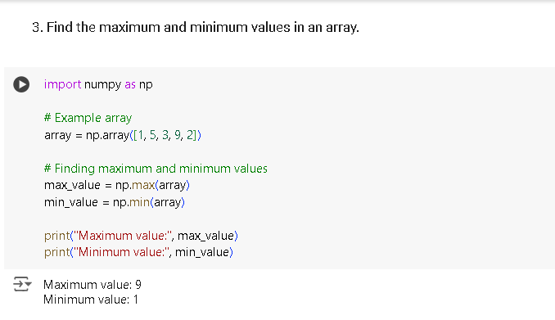Find the maximum and minimum values in an array.
2. Reshape a 1D array into a 2D array of shape 2x5.

