Installation of Python

Name: Kaushik Parmar

ID: AF048761

* Download python

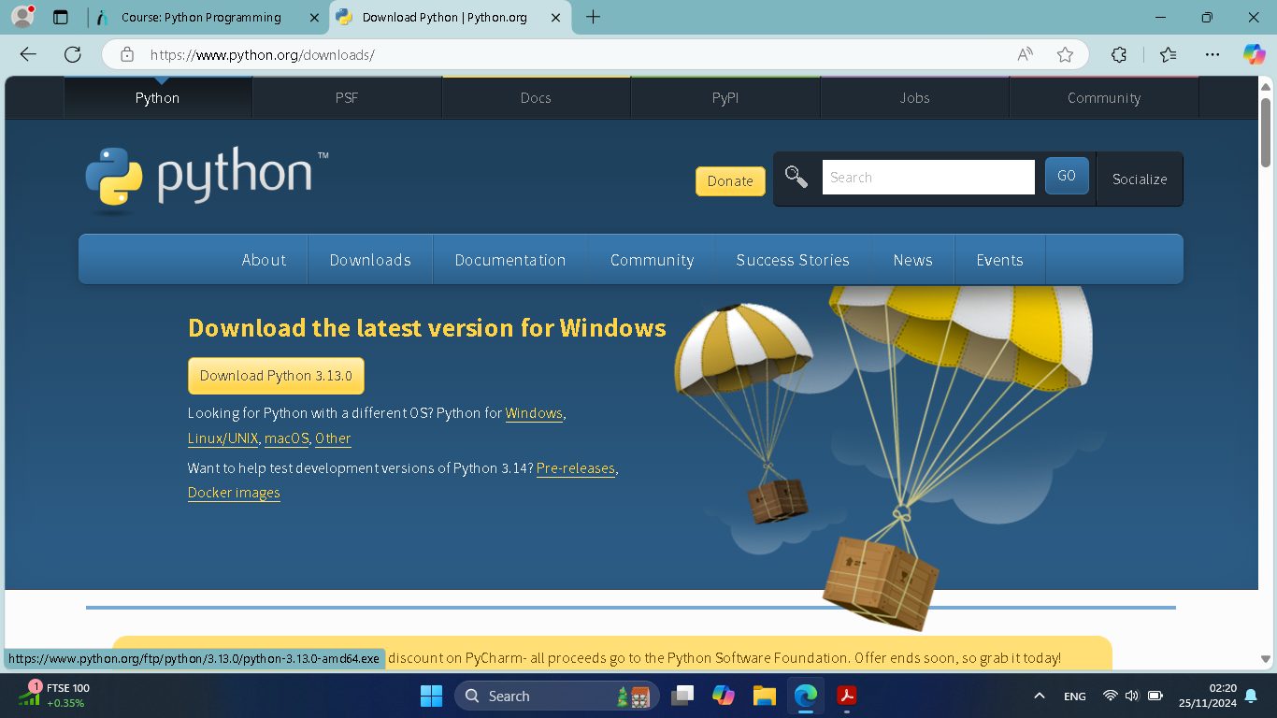

* Installing 1.1:

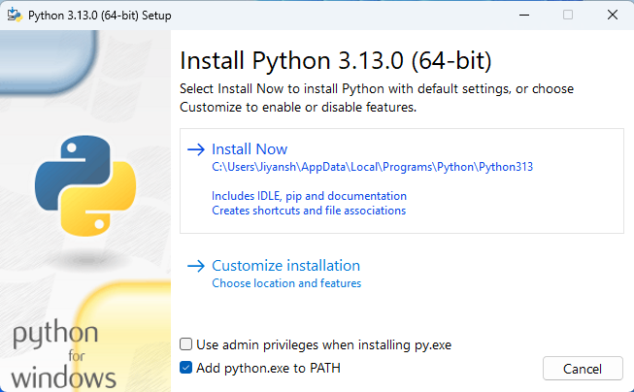

* 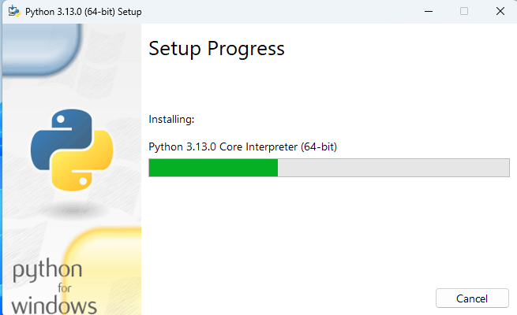Installing 1.2:
* Installed Successfully: 