Operators Lab-2

Name: Kaushik Parmar

ID: AF0448761

1. 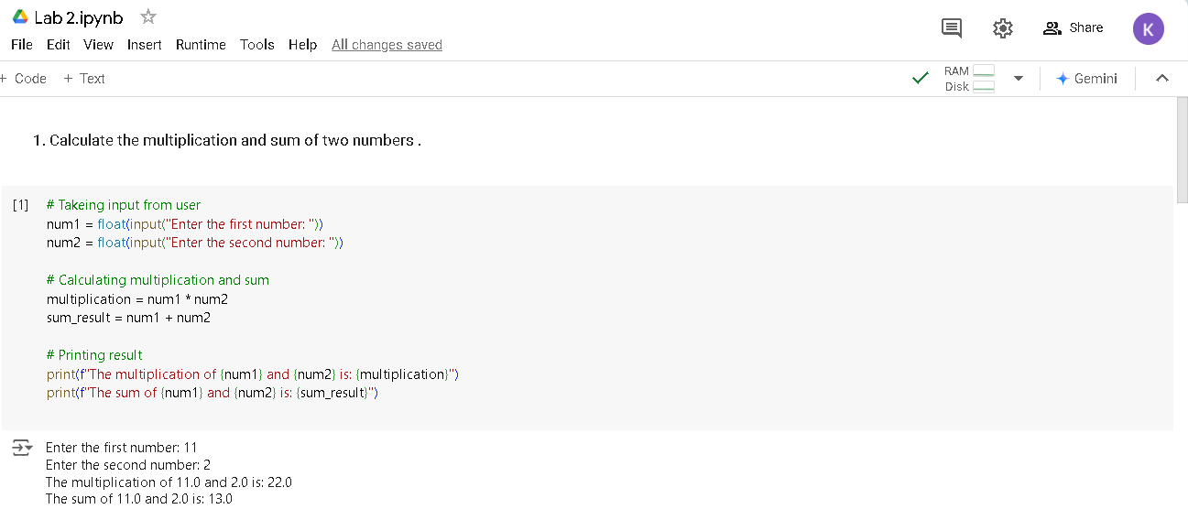Calculate the multiplication and sum of two numbers .
2. 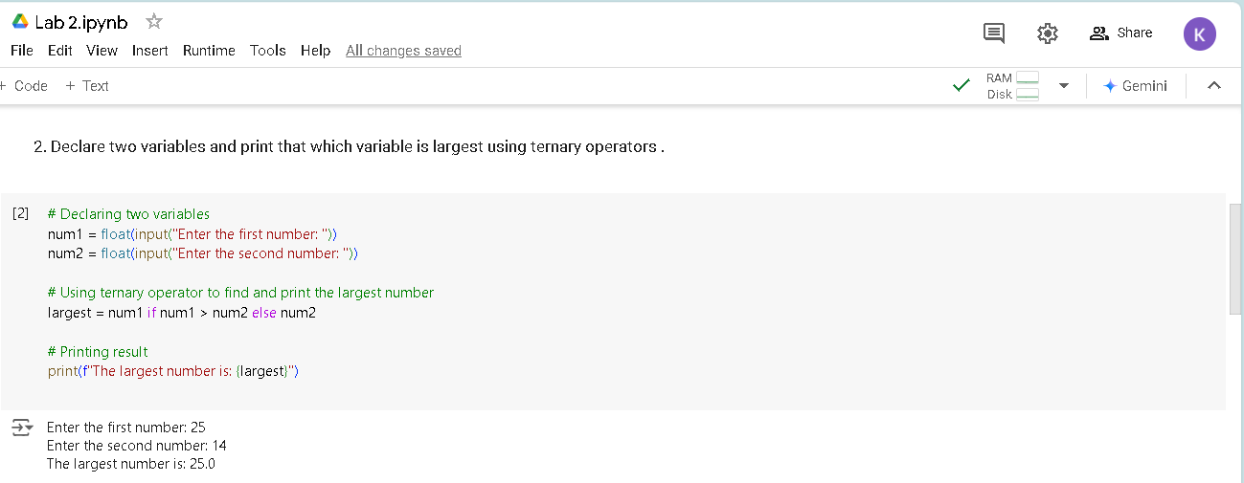Declare two variables and print that which variable is largest using ternary operators .
3. 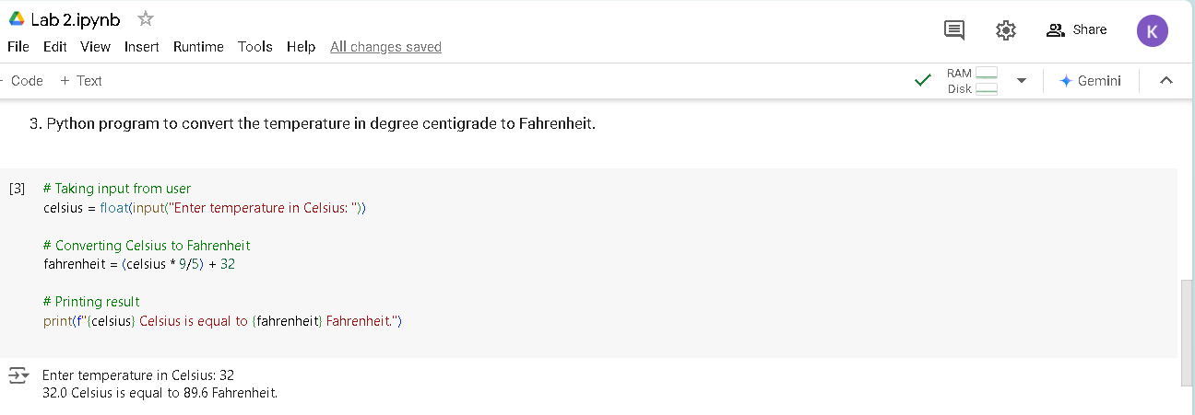Python program to convert the temperature in degree centigrade to Fahrenheit.

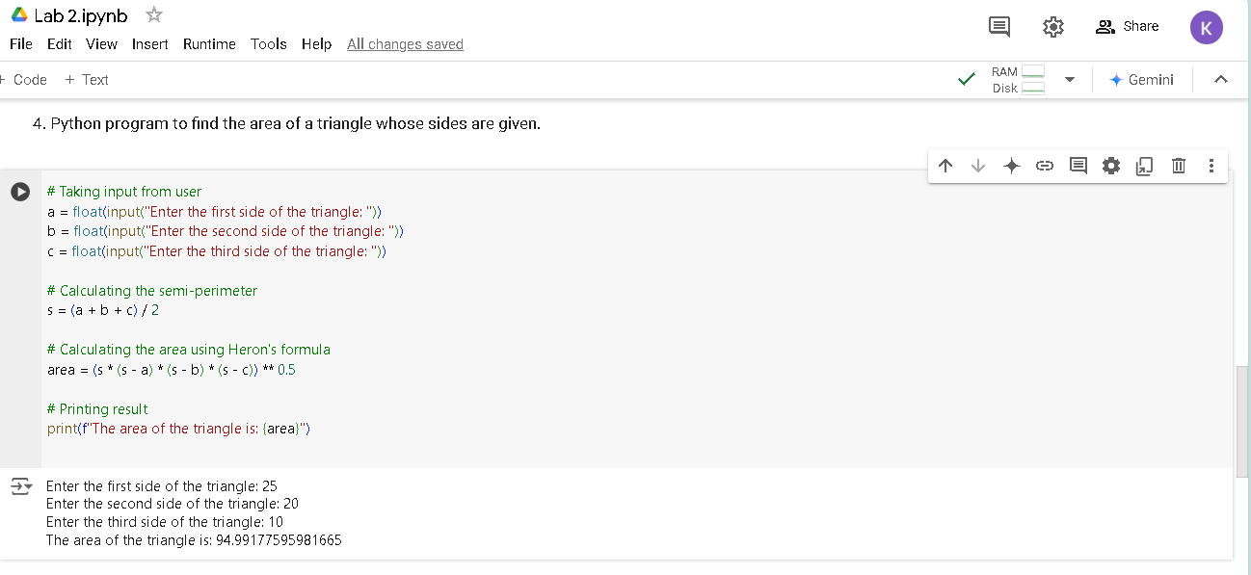4. Python program to find the area of a triangle whose sides are given.