Control Statement Lab- 4

Name: Kaushik Parmar

ID: AF048761

1. 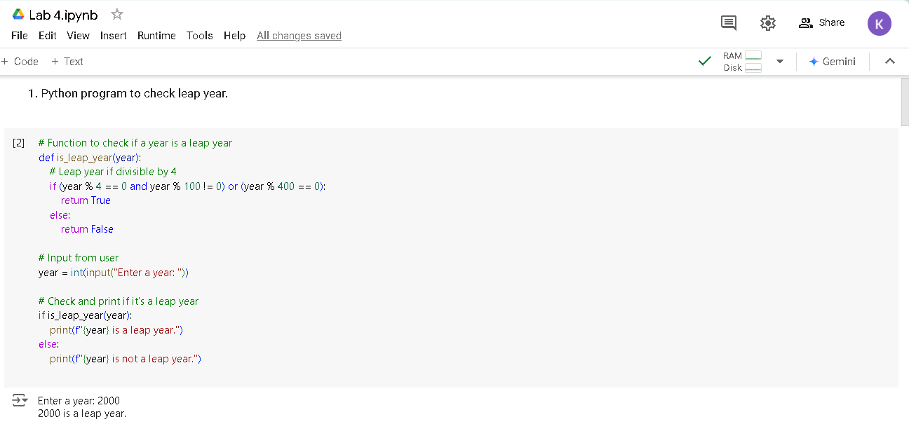Python program to check leap year.
2. 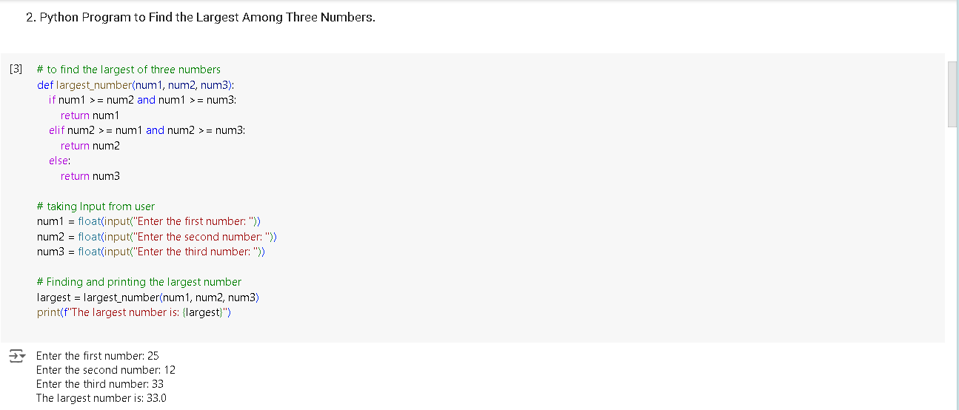Python Program to Find the Largest Among Three Numbers.
3. 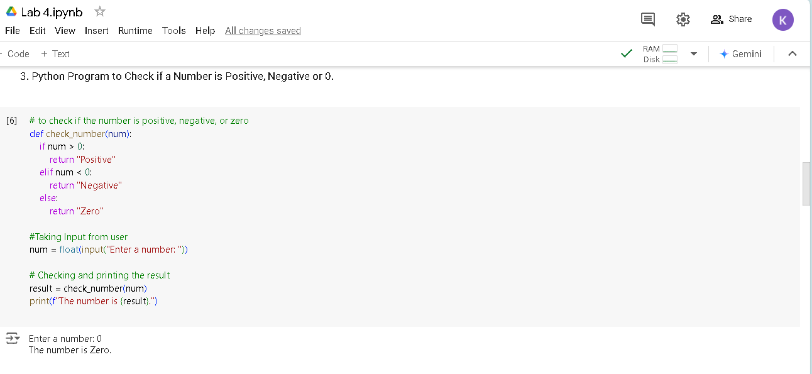Python Program to Check if a Number is Positive, Negative or 0.
4. 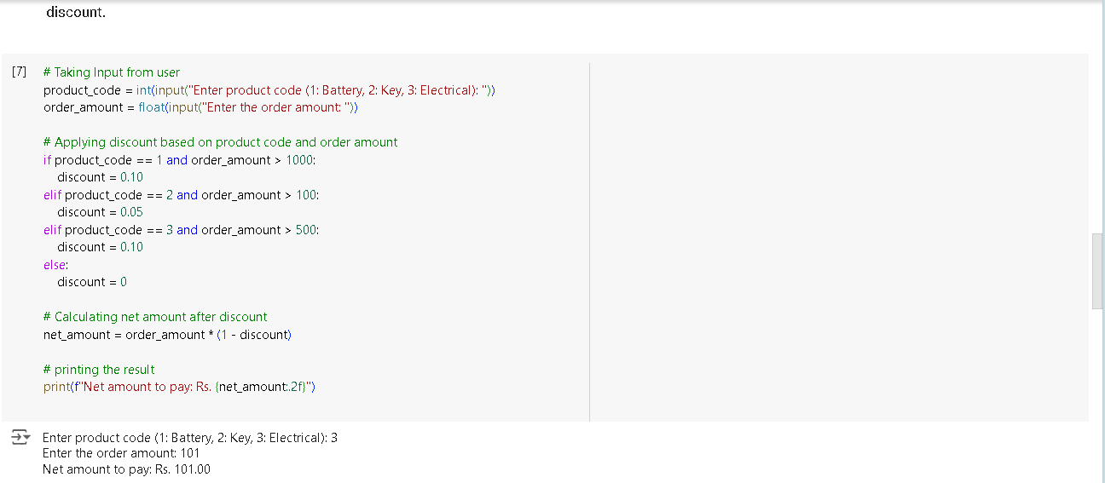A toy vendor supplies three types of toys: Battery Based Toys, Key-based Toys, and Electrical Charging Based Toys. The vendor gives a discount of 10% on orders for battery-based toys if the order is for more than Rs. 1000. On orders of more than Rs. 100 for key-based toys, a discount of 5% is given, and a discount of 10% is given on orders for electrical charging based toys of value more than Rs. 500. Assume that the numeric codes 1,2 and 3 are used for battery based toys, key-based toys, and electrical charging based toys respectively. Write a program that reads the product code and the order amount and prints out the net amount that the customer is required to pay after the discount.

5. A transport company charges the fare according to following table:

Distance   Charges

1-50            8 Rs./Km

51-100         10 Rs./Km

> 100            12 Rs/Km

Write a python program to calculate the transport distance entered by user.

