**String Lab-8**

Name: Kaushik Parmar

ID: AF0448761

1. Write a Python program to count the occurrences of each word in a given sentence

string = “To change the overall look of your document. To change the look available in the gallery”

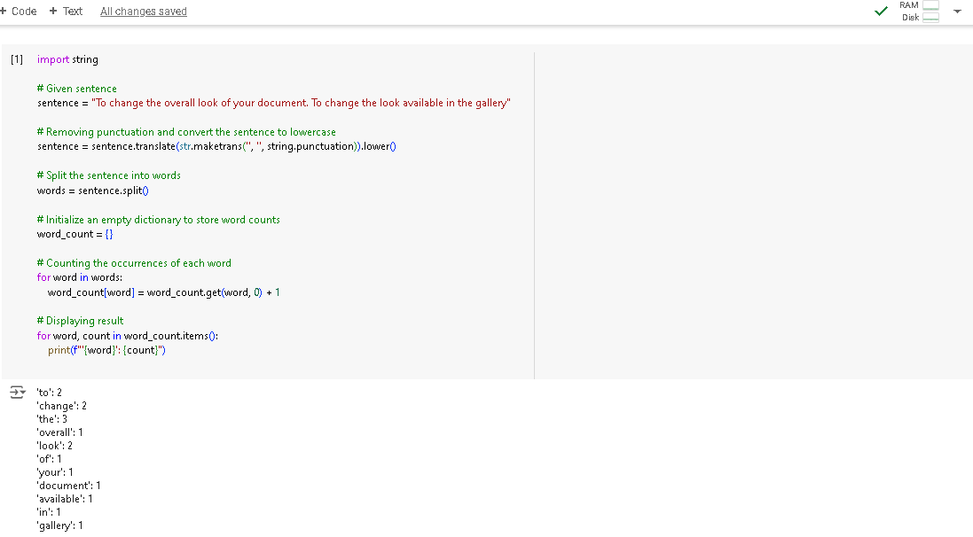

2. Write a Python program to remove a newline in Python

String = "\nBest \nDeeptech \nPython \nTraining\n"

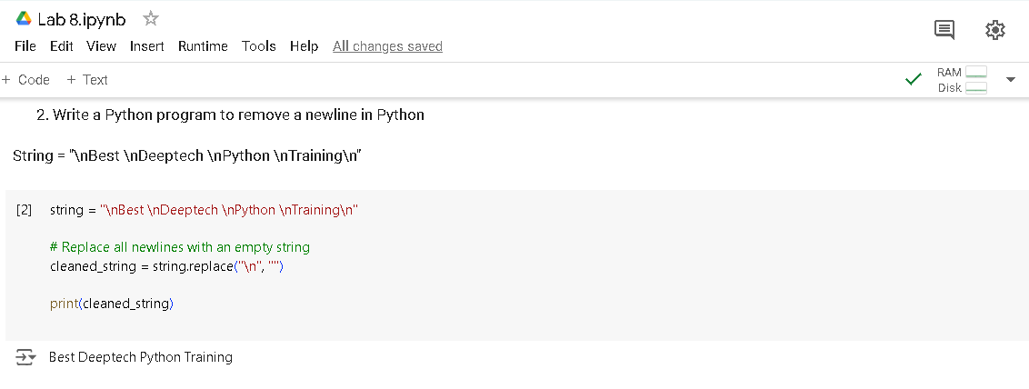

3. Write a Python program to reverse words in a string

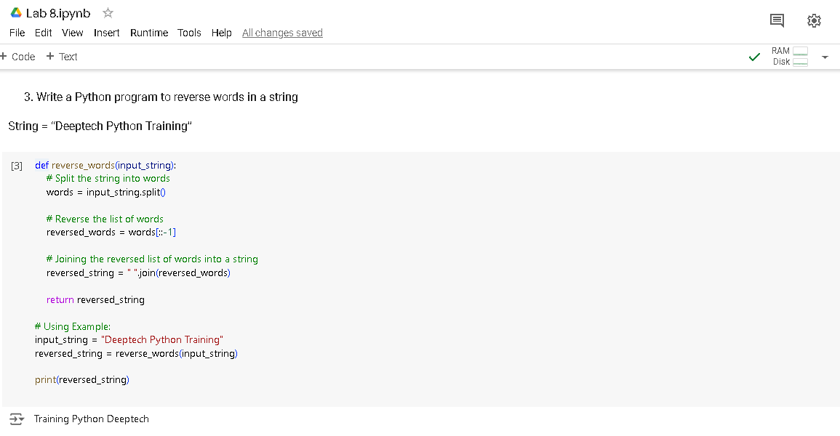String = “Deeptech Python Training”

4. Write a Python program to count and display the vowels of a given text

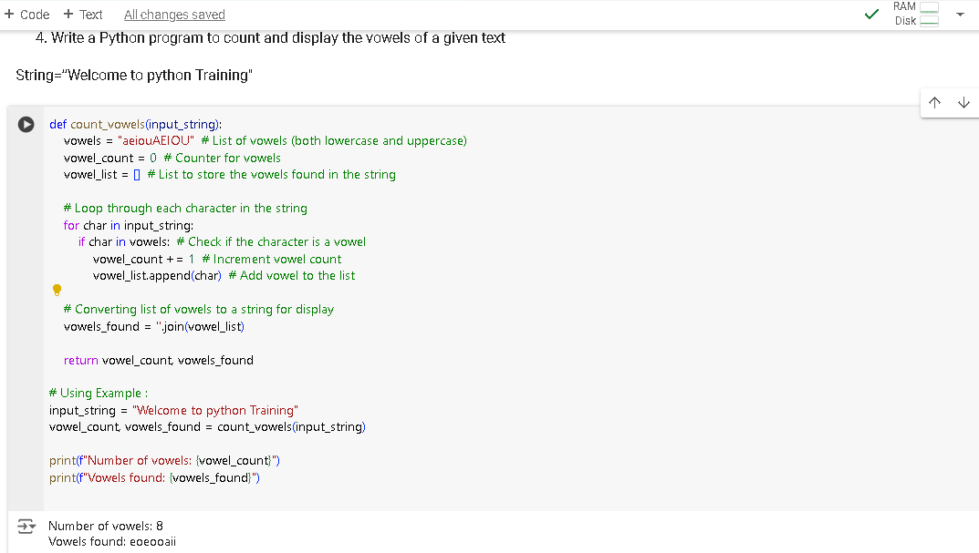String=”Welcome to python Training"