MLOps End-to-End Pipeline: Heart Disease Prediction

**Student Name:** Kaushik Adiraju
**Program:** BITS Pilani M.Tech WILP
**Repository Link:** https://github.com/KaushikAdiraju/herat-disease-mlops

---

1. Setup and Installation Instructions

This project is designed to be fully reproducible. The environment utilizes Python for model development, Docker for containerization, and a local Kubernetes cluster for orchestration.

### Prerequisites
* **Python 3.10+**
* **Docker Desktop** (with "Enable Kubernetes" checked in settings)
* **Git**

Step 1: Environment Initialization

Clone the repository and set up an isolated Python virtual environment to install the project dependencies.

```cmd
git clone https://github.com/KaushikAdiraju/herat-disease-mlops.git
cd heart-disease-mlops
python -m venv venv
venv\Scripts\activate
pip install -r requirements.txt

Step 2: Model Training & Experiment Tracking

The project uses MLflow for tracking experiments. Run the training module to build the models (Logistic Regression, Random Forest, Gradient Boosting) and generate the serialization artifacts (.joblib).

python -m src.train
mlflow ui

Access the MLflow dashboard at: http://localhost:5000

Step 3: Production Deployment & Monitoring

A single Windows batch script (start.bat) is provided to automate the entire production deployment. This script will:

Deploy the FastAPI application to the local Kubernetes cluster.

Expose the API service.

Spin up the Prometheus container for metrics collection.

Spin up the Grafana container for observability.

start.bat

Service Access Endpoints
Once the deployment script completes, the infrastructure will be accessible at the following local endpoints:

FastAPI Swagger UI: http://localhost:8081/docs

Grafana Dashboard: http://localhost:3001

Prometheus Targets: http://localhost:9090/targets

MLflow Tracking: http://localhost:5000

To cleanly shut down the Kubernetes deployments and monitoring containers, run the automated teardown script:

stop.bat

2. Exploratory Data Analysis (EDA) and Modelling Choices

Exploratory Data Analysis (EDA) Highlights

Before constructing the predictive models, a thorough Exploratory Data Analysis was conducted on the Heart Disease dataset to understand feature distributions and relationships:
* **Target Variable Distribution:** The target variable (presence or absence of heart disease risk) was evaluated to ensure a relatively balanced dataset, preventing the model from becoming biased toward a majority class.
* **Feature Correlation:** A correlation matrix was utilized to identify relationships between the independent variables and the target. Features such as `cp` (chest pain type), `thalach` (maximum heart rate achieved), and `exang` (exercise-induced angina) demonstrated significant correlations with the target outcome.
* **Missing Values & Outliers:** The dataset was audited for null values and anomalous data points. Imputation strategies and outlier clipping were applied where necessary to maintain data integrity.

Data Preprocessing Pipeline

To ensure optimal model performance, the raw data was processed through a structured pipeline before training:
1. **Feature Scaling:** Numerical features with varying scales (such as `chol` and `trestbps`) were normalized using `StandardScaler` to ensure algorithms relying on distance metrics or gradient descent converged efficiently and equitably.
2. **Categorical Encoding:** Discrete categorical variables were appropriately encoded to prevent the models from misinterpreting nominal categories as ordinal rankings.
3. **Data Splitting:** The dataset was partitioned into an 80/20 train-test split to allow for robust training while withholding sufficient unseen data for objective evaluation.

Modelling Rationale
Three distinct machine learning algorithms were selected to establish a performance baseline and capture both linear and non-linear relationships:

1. **Logistic Regression (Baseline Model):**
* *Why we chose it:* Serves as a highly interpretable, linear baseline. It is computationally inexpensive and provides clear probabilistic outputs and feature coefficients to understand which clinical metrics drive the predictions.
2. **Random Forest Classifier:**
* *Why we chose it:* An ensemble method utilizing bagging to construct multiple decision trees. It is highly robust to outliers, effectively captures non-linear interactions between clinical features, and helps prevent overfitting compared to a single deep decision tree.
3. **Gradient Boosting Classifier (Winning Model):**
* *Why we chose it:* An advanced ensemble technique that builds trees sequentially, with each new tree correcting the residual errors of the previous ones. This model ultimately achieved the highest ROC-AUC and F1-Score during our MLflow experiments, making it the optimal choice for production deployment.

3. Experiment Tracking Summary

In standard machine learning workflows, keeping track of different model iterations, hyperparameters, and evaluation metrics across multiple runs can become disorganized. To solve this and ensure strict reproducibility, **MLflow** was integrated into the training pipeline (`src/train.py`) as the centralized experiment tracking and model registry server.

3.1 Tracking Implementation & Setup

The MLflow tracking server was configured to run locally. During the execution of the training pipeline, an MLflow "Experiment" named `Heart_Disease_Prediction` was established. For every algorithm tested, a distinct MLflow "Run" was initiated to log three critical components:

1. **Parameters (The Inputs):** Model-specific hyperparameters were logged to track complexity and configuration.
* *Logistic Regression:* Regularization strength (`C`), solver type.
* *Random Forest:* Number of trees (`n_estimators`), maximum tree depth (`max_depth`).
* *Gradient Boosting:* Learning rate, number of estimators, and max depth.
2. **Metrics (The Outputs):** To evaluate generalizability on the 20% holdout test set, the following metrics were recorded for every run:
* `Test_Accuracy`
* `F1_Score` (Crucial for balancing false positives/negatives in medical diagnoses)
* `ROC_AUC` (The primary metric used to determine the winning model)
3. **Artifacts (The Assets):** The fitted models, bundled with their preprocessing steps (e.g., `StandardScaler`), were serialized and saved directly to the MLflow artifact store as `.joblib` files.

3.2 Model Comparison and Selection

By utilizing the MLflow Tracking UI's comparison features (including the scatter-plot matrix and parallel coordinates chart), the three models were evaluated side-by-side.

* **Baseline:** Logistic Regression established a solid baseline but struggled to capture complex, non-linear interactions between clinical features like maximum heart rate and chest pain type.
* **Contender:** Random Forest improved upon the baseline by reducing variance through ensemble bagging, showing a marked increase in the F1-Score.
* **Champion:** **Gradient Boosting Classifier** yielded the highest overall performance, maximizing the ROC-AUC score. Because it sequentially corrects residual errors from previous trees, it proved most adept at predicting heart disease risk in this dataset.

3.3 Artifact Registration for CI/CD
Upon identifying the Gradient Boosting model as the optimal candidate, its specific MLflow Run ID was noted. The serialized `best_model_pipeline.joblib` artifact from this exact run was extracted and placed into the deployment pipeline to be containerized by Docker and served via FastAPI.

Gradient Boosting Run Details:

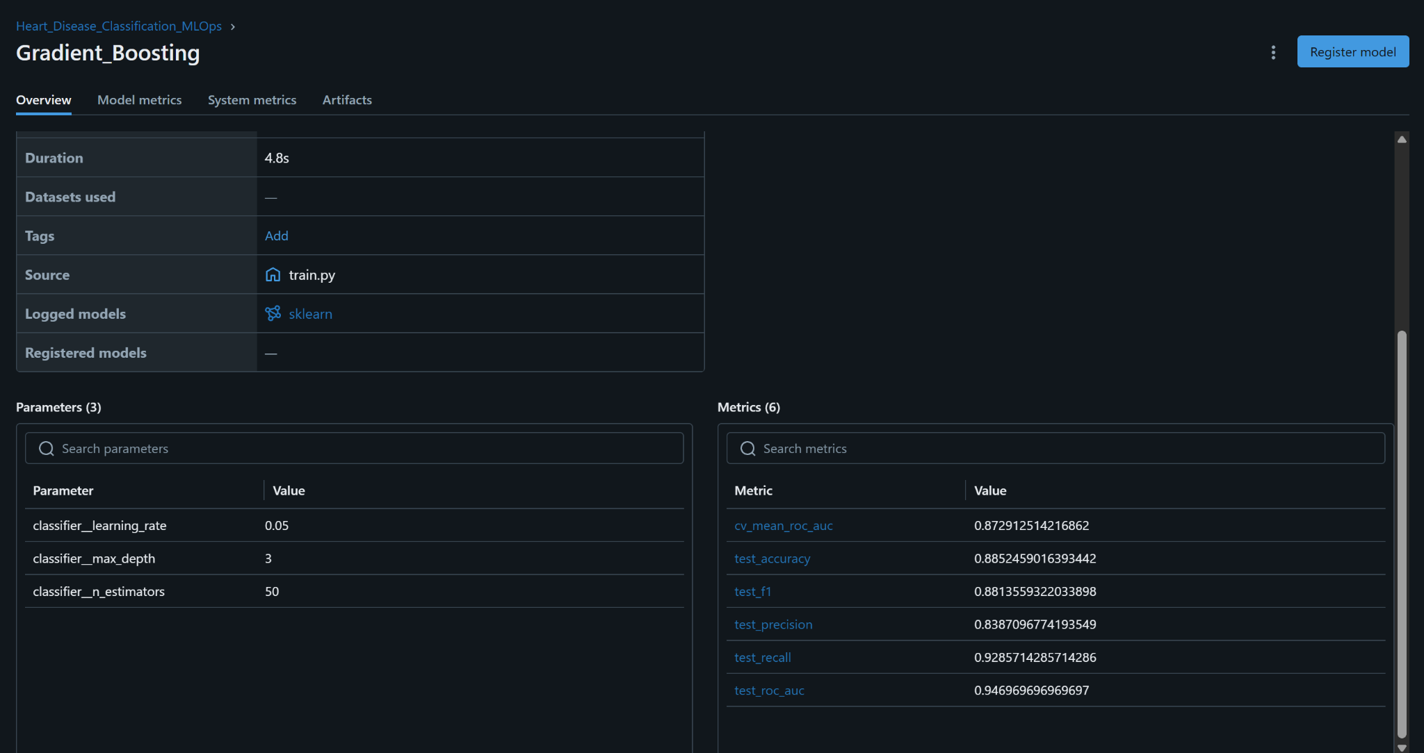

Random Forest Run Details:

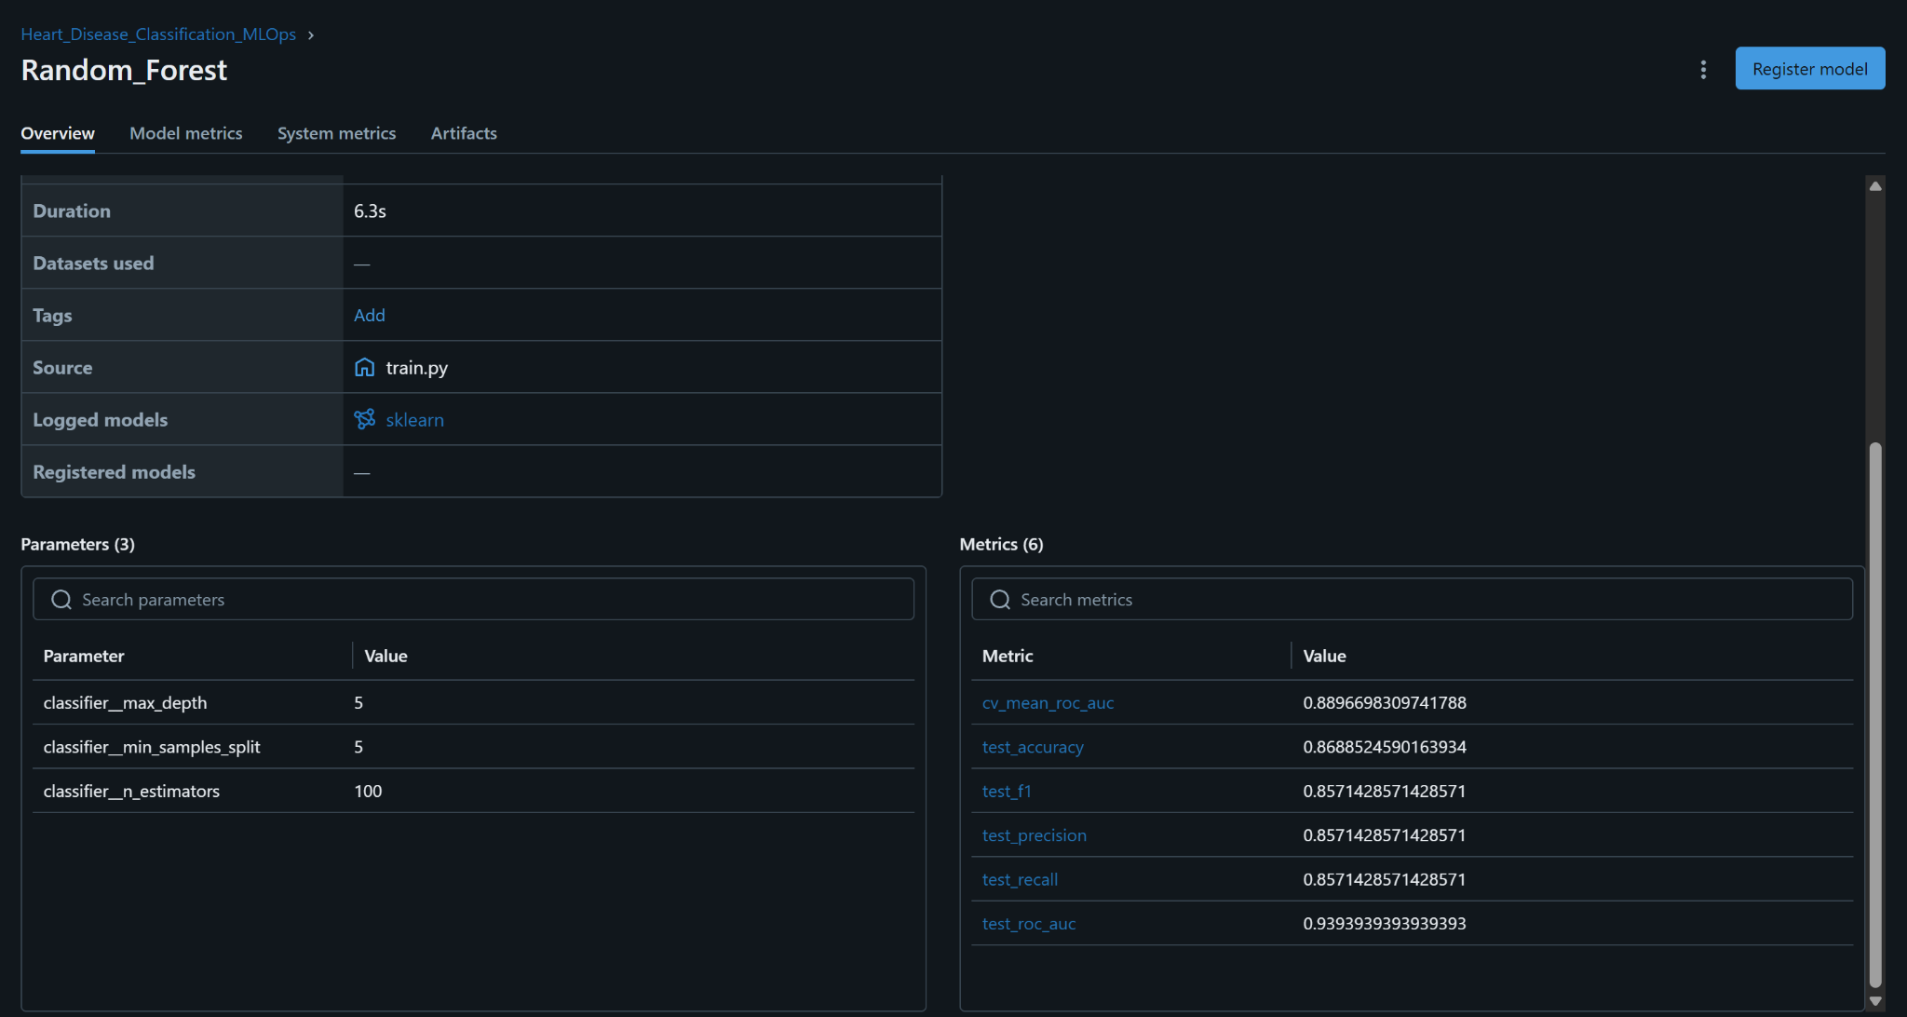

Logistic Regression Run Details:

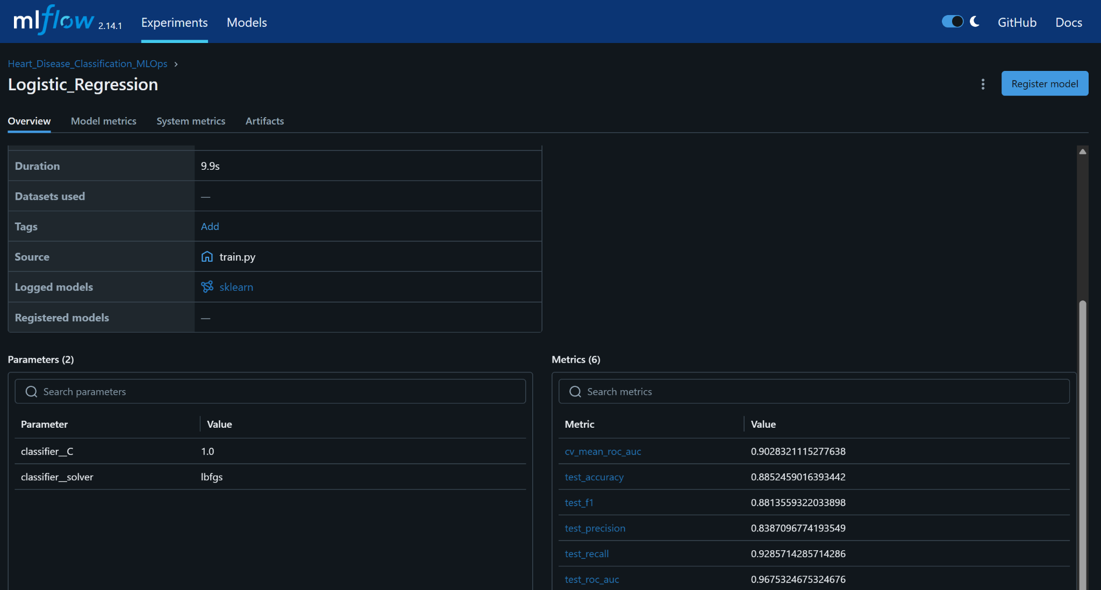

Architecture Diagram:

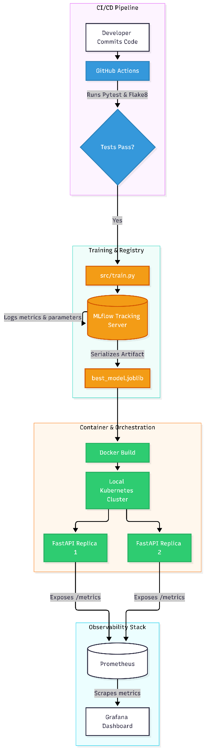

5. CI/CD and Deployment Workflow

A production MLOps pipeline requires strict automation to bridge the gap between model exploration and reliable serving. The workflow implemented here guarantees automated quality enforcement, containerized packaging, orchestrated scaling, and real-time observability.

---

5.1 Continuous Integration (GitHub Actions)

To prevent code degradation, dependency divergence, and regression bugs, an automated Continuous Integration (CI) pipeline was engineered using GitHub Actions (`.github/workflows/ci_cd_pipeline.yml`). Every `push` or `pull_request` targeting the `main` branch spins up an isolated `ubuntu-latest` runner that executes sequential verification stages:

1. **Environment Setup & Dependency Caching:** Provisions Python 3.10 and installs all frozen dependencies from `requirements.txt`.
2. **Static Code Analysis (Flake8):** Audits code quality, enforces PEP-8 compliance, and blocks anti-patterns or unresolved syntax issues before runtime.
3. **Automated Unit & Integration Testing (PyTest):** Executes tests verifying:
* Data loading and transformation pipeline integrity.
* Model artifact deserialization and inference functionality.
* FastAPI routing, request validation schemas (Pydantic), and HTTP response status codes.

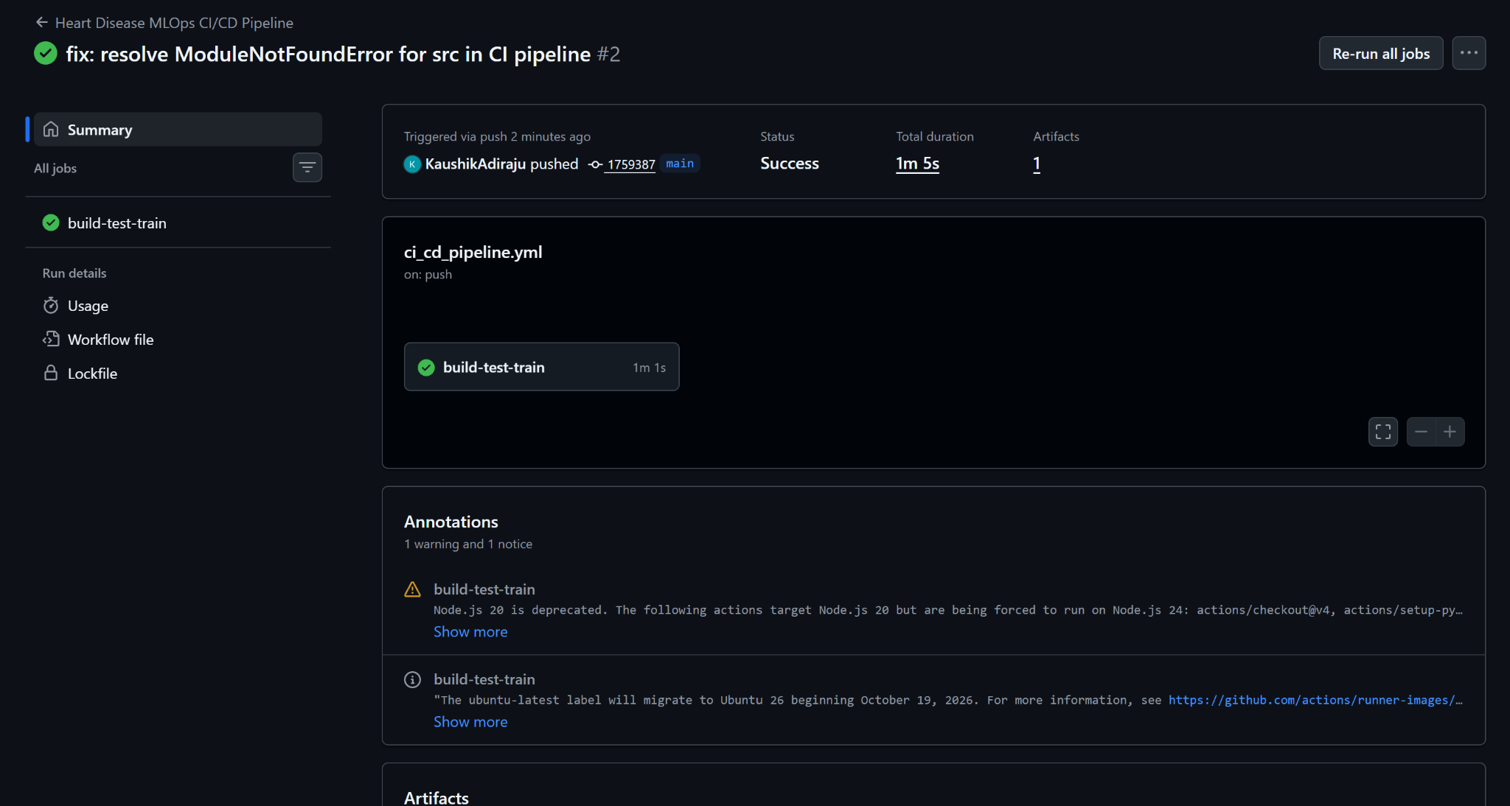

---

5.2 Containerization & Orchestration (Docker & Kubernetes)

Once the code passes automated CI validation, the application enters the deployment lifecycle:

Containerization with Docker
The FastAPI application, dependencies, inference schemas, and the serialized Gradient Boosting model artifact (`best_model_pipeline.joblib`) are packaged into a lightweight, standalone container image (`heart-disease-mlops-api:v1`). Containerization isolates OS dependencies and guarantees reproducible execution across both local developer environments and cloud instances.

Kubernetes Orchestration
The container is deployed to a local Kubernetes cluster using declarative manifests:
* **`k8s_deployment.yaml`:** Manages a Deployment controller configured with `replicas: 2`. This provides high availability and automatic pod self-healing; if one pod fails or terminates unexpectedly, the ReplicaSet immediately provisions a replacement pod.
* **`k8s_service.yaml`:** Provisions a Kubernetes `Service` abstraction that acts as an internal load balancer, evenly routing incoming prediction requests across the healthy API pod replicas and exposing the application on port `8081`.

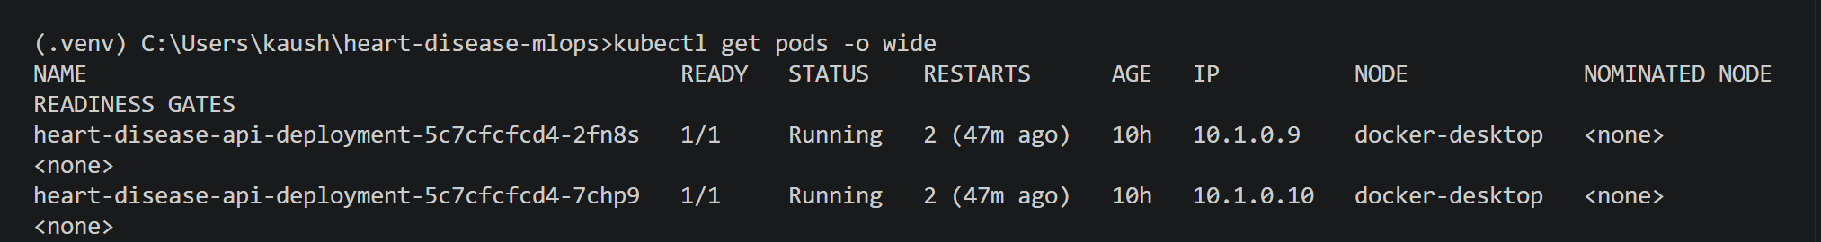
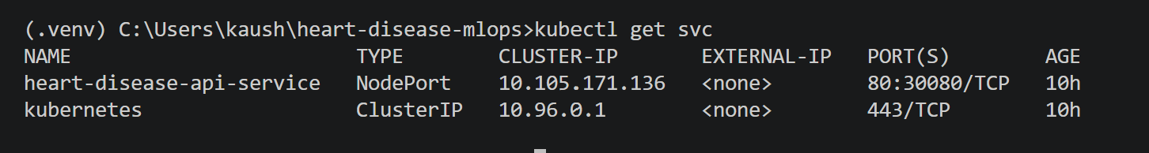

5.3 Live Inference & Observability Stack

Model deployment is incomplete without continuous monitoring. The system uses Prometheus for time-series metric collection and Grafana for operational visualization:

1. **Instrumentation:** The FastAPI application uses custom Prometheus middleware to track HTTP traffic, endpoint latencies, and prediction throughput via the `/metrics` endpoint.
2. **Prometheus Scraping:** Configured via `monitoring/prometheus.yml`, Prometheus queries the API target on a fixed scrape interval to pull performance statistics.
3. **Grafana Dashboard:** Grafana queries Prometheus as a primary data source, graphing metrics such as `http_requests_total` to track API request volume, error rates, and load distribution under simulated traffic.

