Final Project - Technical Report

“AppFusion: Where Apps Align with Your Desires”

*Team members:*

Anushree Kolhe (apkolhe)

Kaushik Parvathaneni (kaparvat)

Shubhangi Dabral (sdabral)

*Application:*

The application is hosted on Streamlit: <https://appfusionadt.streamlit.app/>

(The code is hosted on a different repository, Streamlit couldn’t be deployed through IU Github enterprise repository. The link to the code repository: <https://github.com/KaushikParvathaneni/AppFusionADT> )

*GitHub*:

GitHub link to the code(data preprocessing, database creation, data insertion and application deployment) and documentation: <https://github.iu.edu/kaparvat/AppFusionADT>

## Introduction

In this project, our primary objective is to pioneer the development of an app recommendation system. Our initiative leverages an extensive dataset of meticulously curated records from the Apple App Store, generously provided by Kaggle.

Central to our efforts is creating a robust and dynamic database system that revolutionizes how users discover and receive app recommendations. Our strategy is firmly rooted in data-driven methodologies, utilizing the wealth of information. The database system we have constructed is designed to deliver personalized app suggestions with a precision that sets it apart. Users can finely tune their preferences, incorporating genre, content rating, and other pertinent app attributes.

The distinguishing feature of our system lies in its commitment to elevating user engagement and ensuring well-informed suggestions in the realm of mobile apps. We aim to create a platform that outperforms conventional recommendations by empowering users to communicate their preferences with granularity. Our project places a premium on customization, aspiring to be the go-to resource for those seeking personalized app recommendations. Through this project, we envisage an improvement in app discovery and a paradigm shift in how users interact with and experience mobile applications.

## 

## Objectives

The primary focus of our project is to engineer a personalized app recommendation system dedicated to refining the app discovery experience within the Apple App Store. Our objectives are crafted to address the following key areas:

1. Personalization: Develop a system that tailors app recommendations individually, allowing users to receive suggestions aligned with their specific preferences, encompassing app genre, content rating, and pricing.
2. Data Utilization: Optimize suggestions by harnessing the extensive Apple App Store dataset, ensuring a sophisticated and accurate recommendation process.
3. Diverse Recommendations: Provide myriad app suggestions to broaden users' horizons and introduce them to applications outside their usual preferences. This diversity ensures a richer and more comprehensive app discovery experience.

## Usefulness

Our database-driven app recommendation system holds significant utility for a variety of user groups, offering a multifaceted solution to address their distinct needs:

1. Personalized Discovery: Solves the challenge of finding apps aligned with individual preferences, offering a user-friendly and enriching experience.
2. Informed Decision-Making: Empowers users with comprehensive app information, including reviews and statistics, facilitating well-informed selections.
3. Technology Appeal: Utilizes the Apple App Store dataset, making it attractive to developers, researchers, and casual users seeking personalized recommendations.
4. User-Friendly Exploration: Offers an intuitive interface for effortless app exploration, catering to enthusiasts and regular users.

In summary, our project's objectives and utility converge to create a cutting-edge solution that addresses the current challenges in app discovery and sets a new standard for personalized, data-driven, and user-centric recommendation systems within the App Store.

## 

## Methodology

#### Data:

The dataset for this app recommendation system was obtained from Kaggle (<https://www.kaggle.com/datasets/gauthamp10/apple-appstore-apps/data> ). It comprises comprehensive records sourced from the Apple App Store, forming the foundation for our recommendation system.

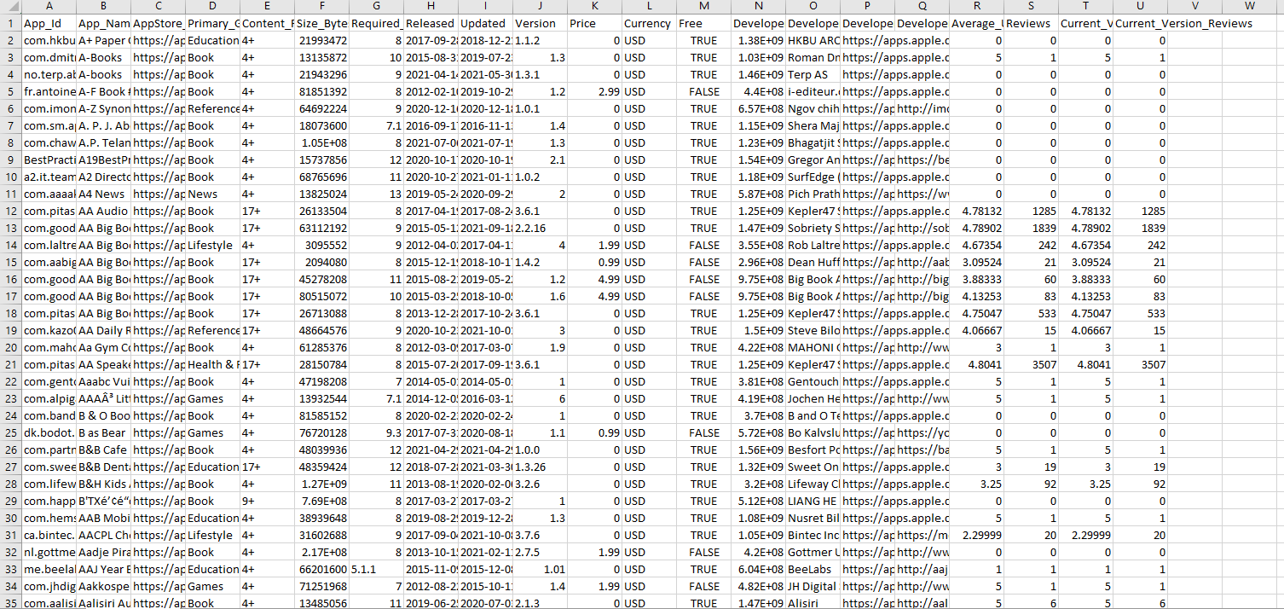

Preprocessing was conducted using Python, involving several crucial steps to ensure data quality and relevance. This included handling null values, dropping unnecessary columns, converting data into the required data types, efficiently sampling the data, and implementing various transformations. These steps collectively contributed to refining the dataset for practical use in our app recommendation system.

The refined dataset was seamlessly integrated into the database using a combination of SQL and Python. This process involved meticulous attention to detail to maintain the integrity and consistency of the data within the database.

#### Functionalities:

The app recommendation system provides a suite of user functionalities to enhance the overall user experience:

1. **Common Queries**: Users can access predefined queries such as "Free Applications" and "Top Developers," offering quick insights into popular categories and app developers.
2. **CRUD Operations**: Users have the flexibility to perform CRUD operations—Create, Read, Update, and Delete—on app records. Strict adherence to integrity constraints ensures the accuracy and reliability of the database during record creation and deletion.
3. **Filtering**: A notable feature is the ability for users to filter and receive app recommendations based on specific criteria such as Genre, Average User Rating, and App Size. This enhances user customization and streamlines the app discovery process.

The application is deployed using Streamlit, providing a user-friendly and interactive interface. Streamlit's capabilities were harnessed to ensure a seamless and intuitive user experience navigating the app recommendation system.

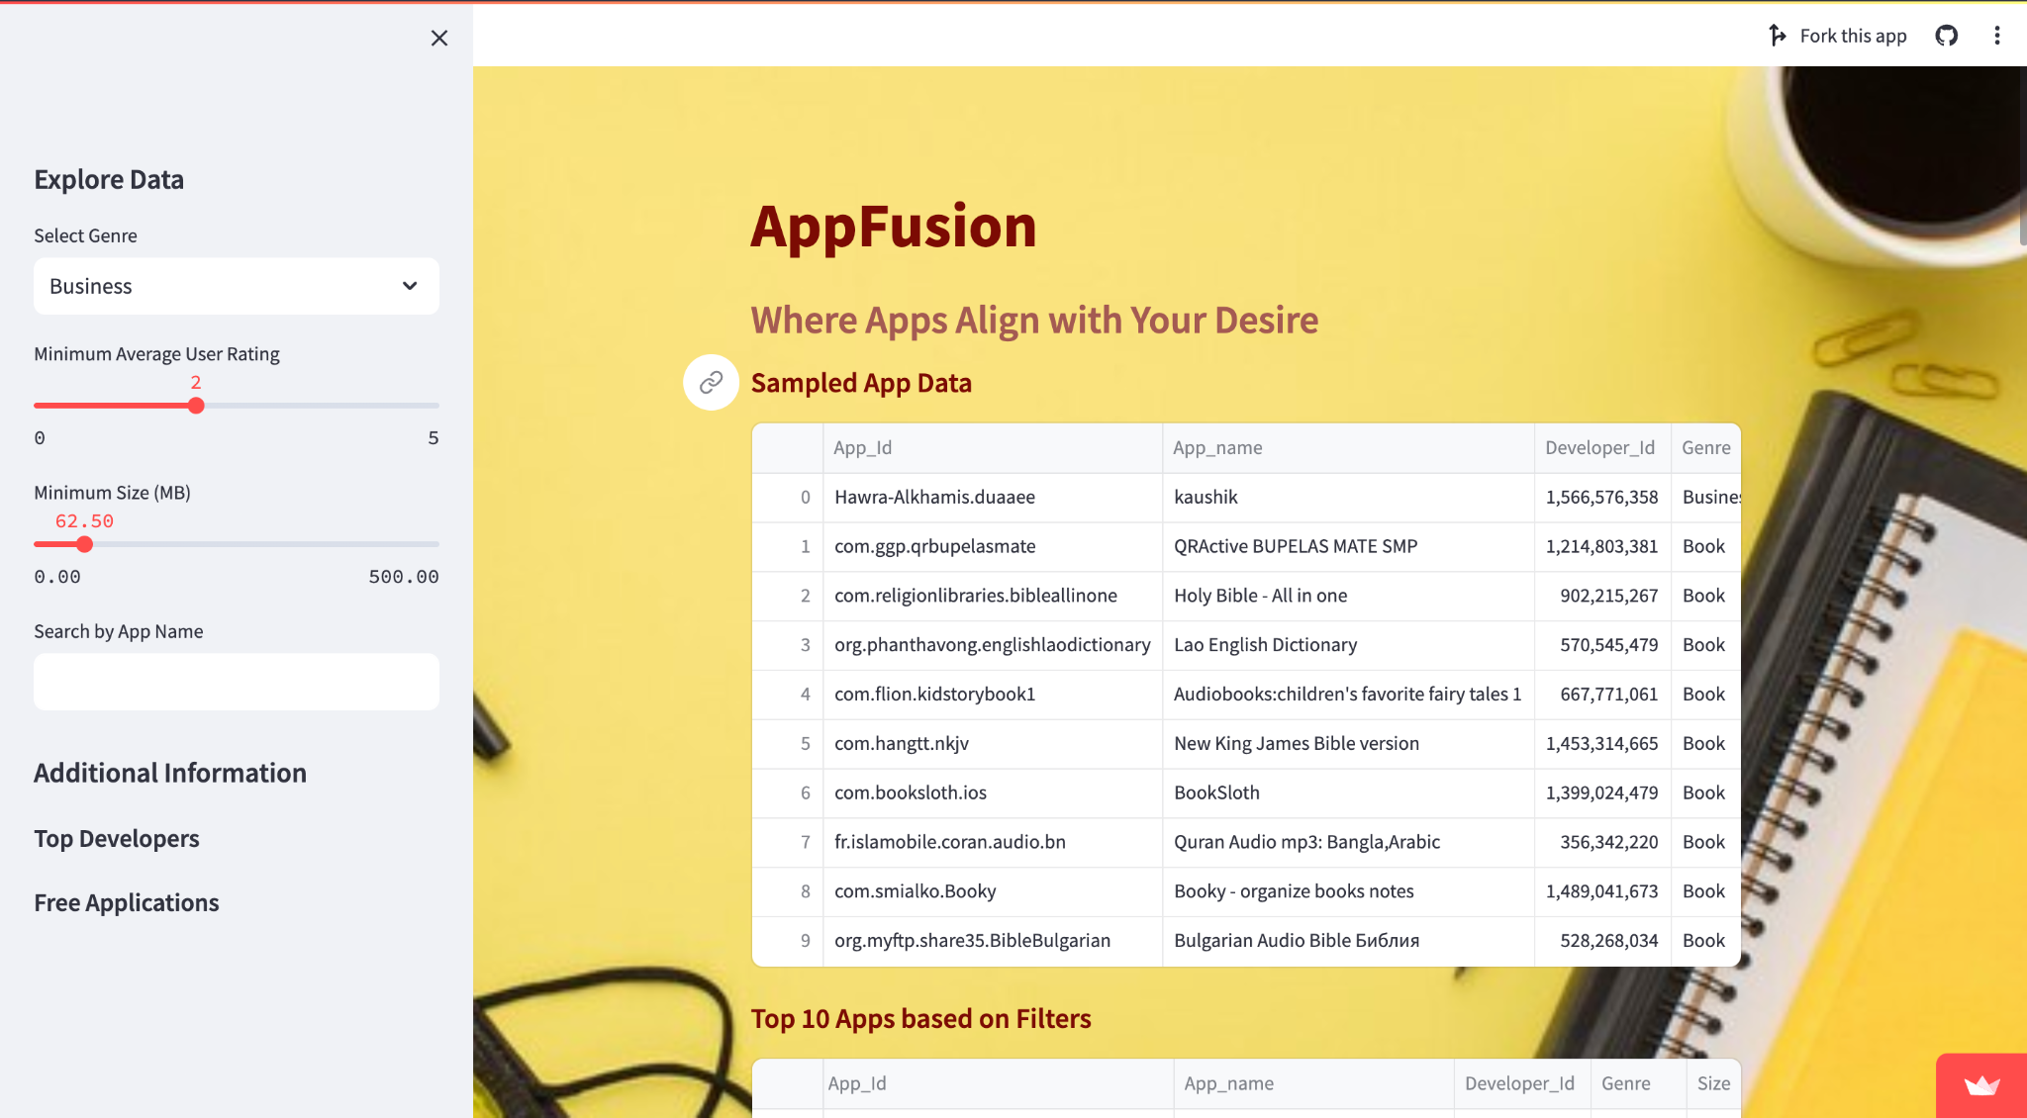

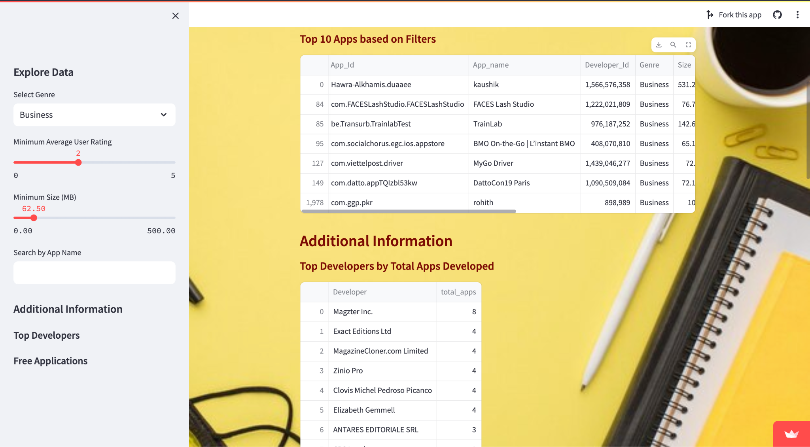

#### Tools used:

*Front End:* Streamlit

*Back End:* Python, SQL

*Database:* SQLite

*Tools:* Jupyter Notebooks, Visual Studio Code, GitHub

## Issues

We faced deployment challenges using Streamlit's cloud service initially through IU GitHub, realizing later that private organization deployment was not supported. Switching to our personal GitHub resolved the issue, and the team successfully completed the project despite this initial setback.

## Individual Contributions

| Name | Contribution |
| --- | --- |
| Anushree | Ideated and designed the schema structure.  Designed and created Entity Relationship diagram.  Worked on the documentation aspect of the project. Formulated constraints to reduce data redundancy.  Contributed to data cleaning & preprocessing. Performed CRUD on the database and designed user views to aid in faster retrieval of data of the most common queries. Worked on the deployment & technical report. |
| Kaushik | Helped in the ideation of the creation of tables.  I have preprocessed and cleaned the data in the CSV file that we are using to populate the database. The file contained a lot of null values, along with some unknown characters that could have resulted in difficulties while populating the database. To ensure smooth insertion of the data in the database, this step was necessary. Designed user view.  I have also helped in the creation of the app using streamlit and also deployed the app. |
| Shubhangi | Discussed the schema structure Formulated data cleaning and processing steps.  Code for data sampling, cleaning and storing the processed data in the csv file. Designed user view.  Worked on the UI/UX of our application.  Enhanced the existing CRUD operations to function across all tables within our schema. Furthermore, ensured the preservation of various constraints during the execution of these CRUD operations. |

## Conclusion

In conclusion, our project successfully developed a refined application recommendation system, leveraging a rich dataset from Kaggle. Meticulous data preprocessing, seamless SQL and Python data insertion, and user-friendly functionalities, including CRUD operations and advanced filtering, define our approach. The deployment through Streamlit ensures accessibility.

Our project showcases the fusion of technical creation and user experience. We've created a dynamic and tailored system that aims to surpass user expectations, providing an intuitive and personalized approach to navigating the diverse landscape of mobile applications.