Steps to install Git-Flow for Windows

Pre-requisite:

1. Mysysgit.
2. Powershell is configured to use git command.

* Copy the Dependencies folder from the below path

\\172.18.100.253\MoneyGram\Documents\GitFlow.

* Copy the Dependencies folder content into C:\Program Files (x86)\Git\bin
* Clone the git-flow sources from GitHub (C:\ drive)
  1. git clone ­–recursive git://github.com/nvie/gitflow.git
  2. Change Directory to gitflow folder (cd gitflow)
* Open command prompt as Administrator and run the below command
  1. cd gitflow/contrib/
  2. msysgit-install.cmd "C:\Program Files (x86)\Git"
* Now run command “git flow” in PowerShell. If you see the below output then “Git Flow” installation is successful on your machine.

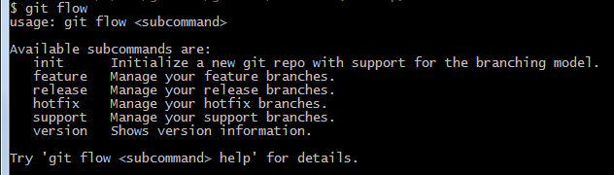

Steps to use Git Flow:

* Open Windows Power Shell as Administrator.
* Then go to the working project directory.
* Before running the below command check the current branch using command “**git branch”.**
* Also check if there are any commits pending in develop branch (develop branch is the base working branch).
* Then run following command “**git flow init**” and continue pressing enter till you see the below output.

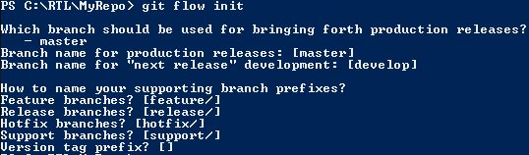

* Then run following command to start a feature branch “**git flow feature start MYFEATURE**”. This command creates the feature branch from develop branch.

E.g.: **git flow feature start AL-130**.

* After finishing the development of a feature in the feature branch run the following command “**git flow feature finish MYFEATURE**”. This command removes the MYFEATURE branch and merges back to develop branch.

E.g.: **git flow feature finish AL-130.**

* If you are developing a feature in common (i.e. more than one developer is working on same user story/ module). Publish a feature to the remote server so it can be used by other users.
  1. Command to publish “**git flow feature publish MYFEATURE**”.
  2. Command to get a published feature branch “**git flow feature pull feature/MYFEATURE**”.
* To start a release branch, use the git flow release command. It creates a release branch created from the 'develop' branch. “**git flow release start RELEASE**”.
* Finish a release by running the command “**git flow release finish RELEASE**”, this command merges the release branch back into 'master', Tags the release with its name, Back-merges the release into 'develop' and Removes the release branch.
* Similarly, for HotFix branch as well.

For further reference:

Reference Link: <http://danielkummer.github.io/git-flow-cheatsheet/>