EXPERIMENT NO. 3
DATA CONNECTION AND ANALYSIS USING ADVANCED VISUALIZATIONS
Kaushik Sakre
262240016

Aim
To perform data connection and analysis by applying various plots and visualization techniques on numerical and categorical data to identify patterns, relationships, and insights.

Objectives
- To connect to the dataset and identify its numerical and categorical columns.
- To compare a numerical variable across different categories.
- To compare several variables of each category together.
- To show relationships and flows between categorical variables.
- To visualize categorical data in three dimensions.

Theory
Data analysis through visualization means plotting the numerical and categorical columns of a dataset to find patterns, relationships and insights. Basic charts (bar, pie, histogram) show one column at a time, while advanced plots combine several variables in a single view. The advanced plots used in this experiment are:
- Violin Plot: shows the full distribution (shape) of a numerical variable for each category. A swarm overlay adds the individual records as dots.
- Radar (Spider) Chart: places several variables on axes arranged in a circle. Each category becomes a closed shape, so groups can be compared at a glance.
- Sankey Diagram: shows how records flow from one category to the next. The width of each band is proportional to the number of records.
- 3D Bar Chart: places two categorical variables on the X and Y axes and shows a numerical value (count) as the height of each bar.

Dataset
The cleaned Data Science Jobs in India dataset produced in Experiment 2 (cleaned_ds_jobs_india.csv) is used. It has 11,991 job postings and 16 columns.
Original source: https://www.kaggle.com/datasets/anandhuh/data-science-jobs-in-india
Column | Type | Meaning
Role | Categorical | Job role group (Data / Business Analyst, Data Engineer, Data Scientist, ML / AI Engineer, Software Developer)
Main_City | Categorical | Main city of the job
Experience_Level | Categorical | Fresher (0-1), Junior (2-3), Mid (4-6), Senior (7+)
Min_Exp, Max_Exp | Numerical | Minimum and maximum experience required (years)
Avg_Exp | Numerical | Average of Min_Exp and Max_Exp
Needs_Python … Needs_Aws | Boolean | 7 True/False flags: Python, SQL, Machine Learning, Excel, Power BI, Tableau, AWS

Implementation

Step 1 — Connect to the Data
- Import pandas, NumPy, Matplotlib, Seaborn and Plotly.
- Load cleaned_ds_jobs_india.csv into a DataFrame and check its shape and first rows.
- Separate the columns into numerical (Min_Exp, Max_Exp, Avg_Exp, Skill_Count), categorical (Role, Main_City, Experience_Level) and skill flag columns.

Step 2 — Prepare the Data for Plotting
- Remove the mixed "Other" role to keep comparisons clear (10,773 rows remain).
- Order roles by their median experience, and experience levels from Fresher to Senior.
- Keep the top 6 cities by number of jobs: Bengaluru, Hyderabad, Pune, Mumbai, Gurugram and Chennai.

Step 3 — Plot 1: Violin Plot with Swarm Overlay
- Draw a violin of Avg_Exp for each role, with a box inside showing the median and quartiles.
- Overlay a swarm of 600 randomly sampled jobs as dots.
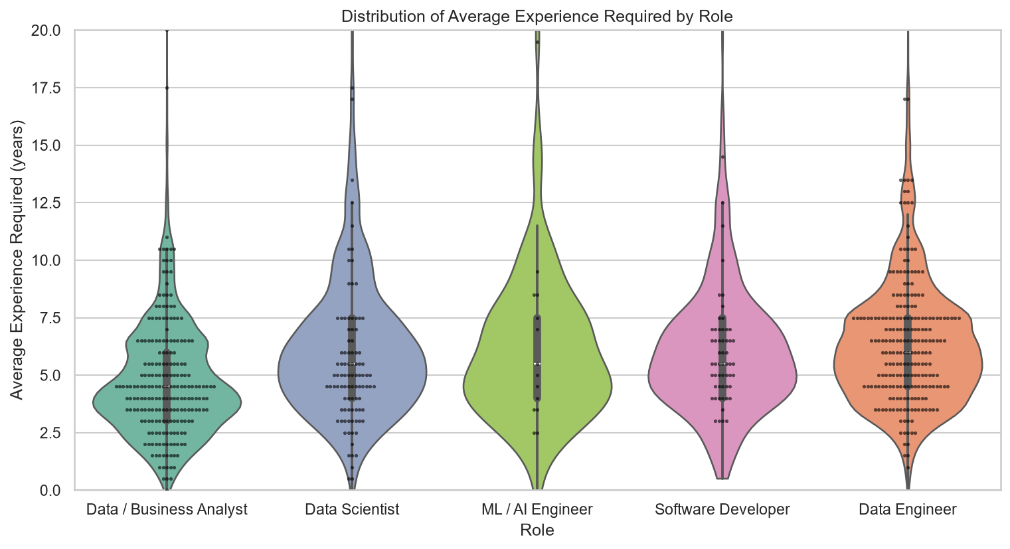
Figure 1 — Distribution of Average Experience Required by Role
Observation: Data / Business Analyst jobs ask for the least experience (median 4.5 years) and are the most entry-friendly, while Data Engineer asks for the most (median 6.0 years). All roles have a long upper tail from a few senior posts asking for 15+ years.

Step 4 — Plot 2: Radar Chart
- Calculate the percentage of jobs in each role that need each of the 7 skills.
- Draw one closed shape per role on a polar (circular) axis.
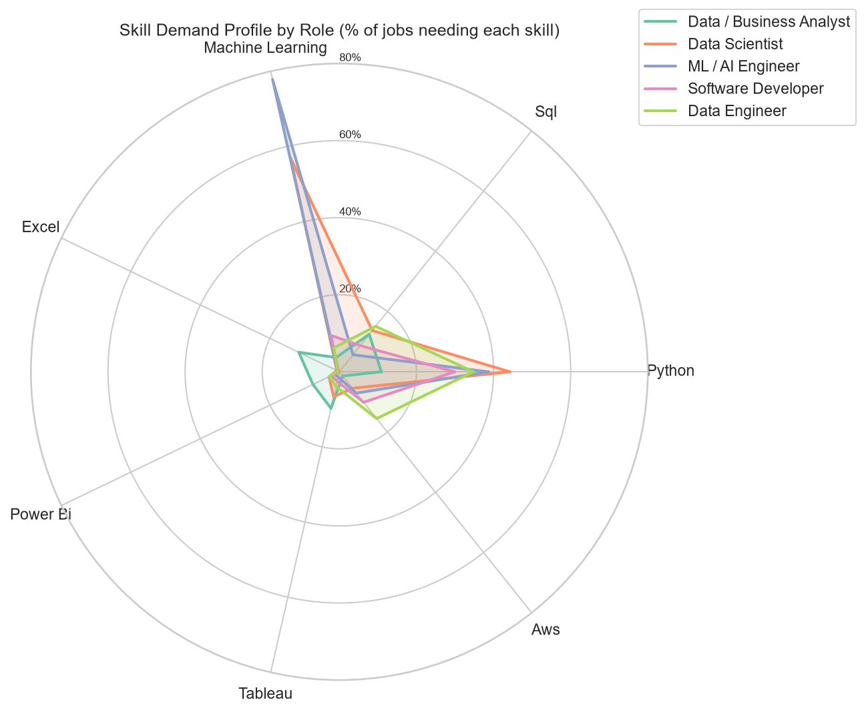
Figure 2 — Skill Demand Profile by Role
Observation: Machine Learning dominates for ML / AI Engineer (77.8%) and Data Scientist (57.0%). Python is common to all technical roles (30–44%) but only 10.9% for analysts, whose shape leans towards Excel (11.7%), Tableau (9.7%) and Power BI (7.6%). Data Engineer is the only role with notable AWS demand (15.5%).

Step 5 — Plot 3: Sankey Diagram
- Group cities outside the top 6 as "Other Cities".
- Count the jobs for every Experience_Level → Role and Role → City pair, and draw the flows with Plotly.
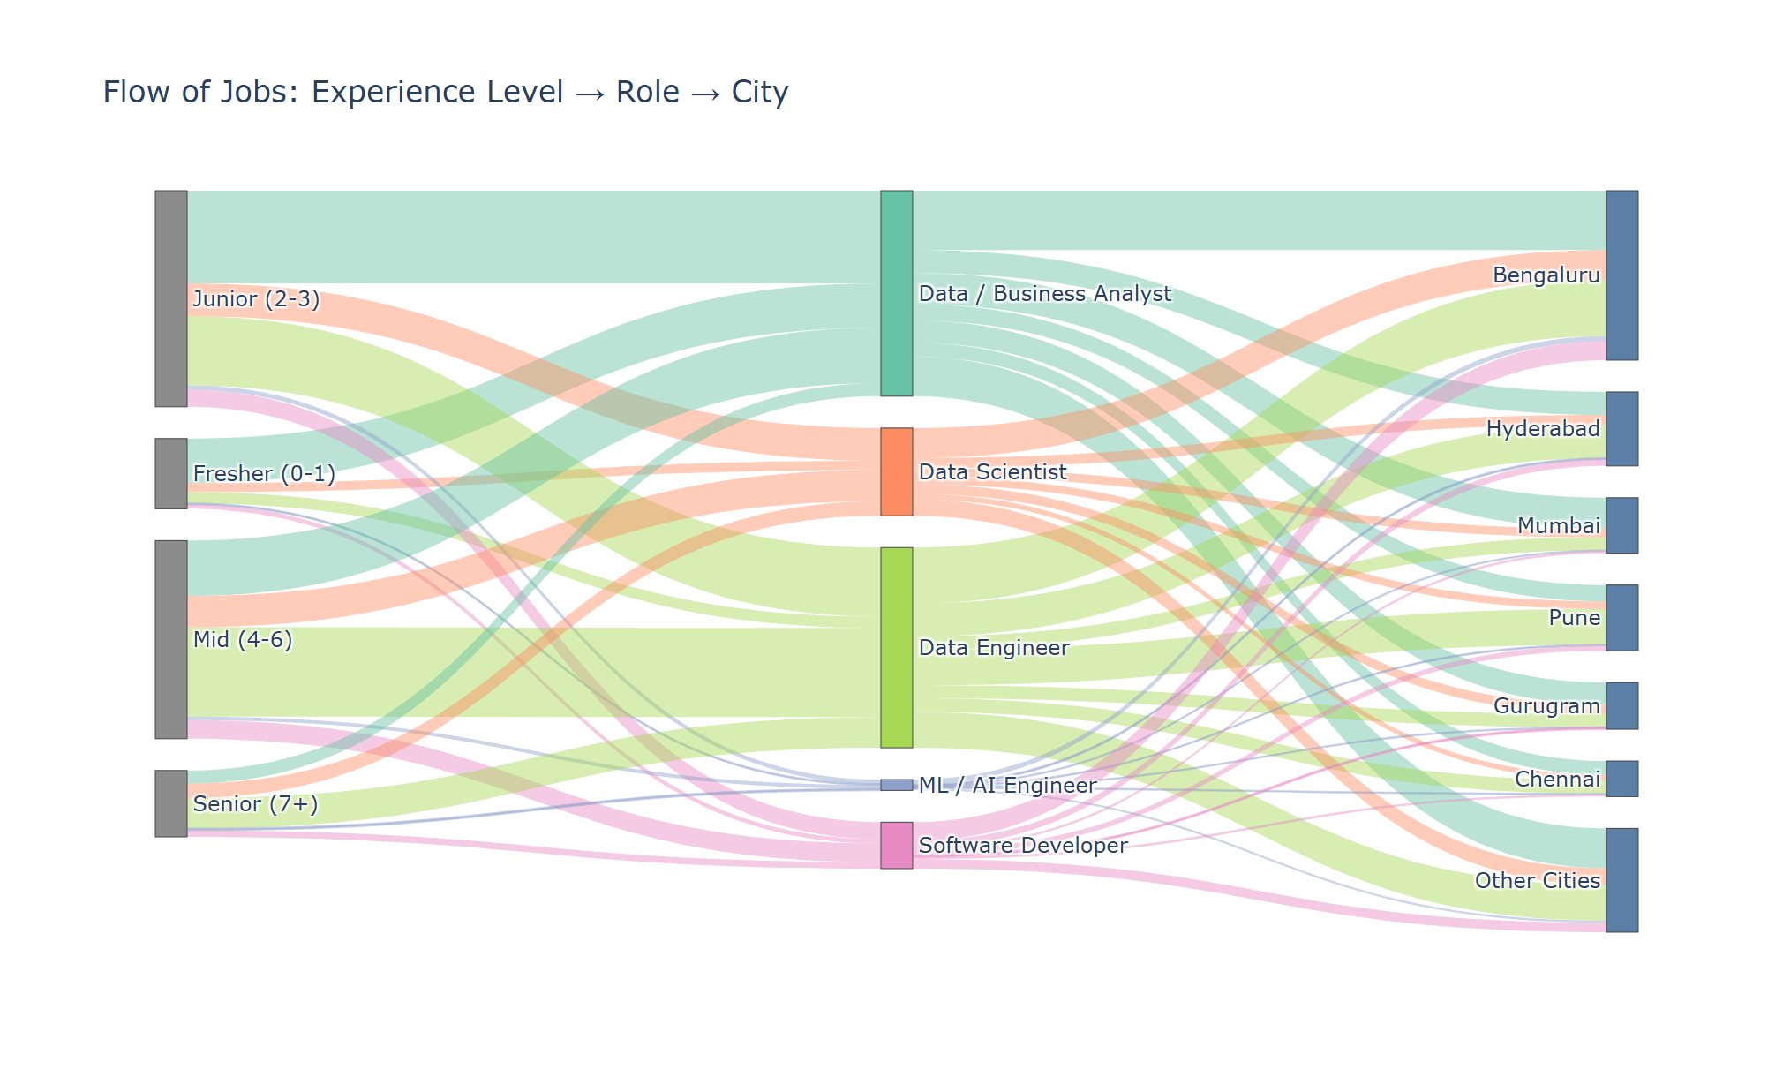
Figure 3 — Flow of Jobs: Experience Level → Role → City
Observation: Most jobs need 2–6 years of experience (Junior and Mid bands are thickest). About 63% of fresher jobs (868 of 1,374) flow into Data / Business Analyst, while 46% of senior jobs flow into Data Engineer. Bengaluru receives the widest band from every role and holds about 31% of the jobs.

Step 6 — Plot 4: 3D Bar Chart
- Build a City × Role table of job counts for the top 6 cities.
- Draw one 3D bar per (city, role) pair using bar3d(), coloured by role.
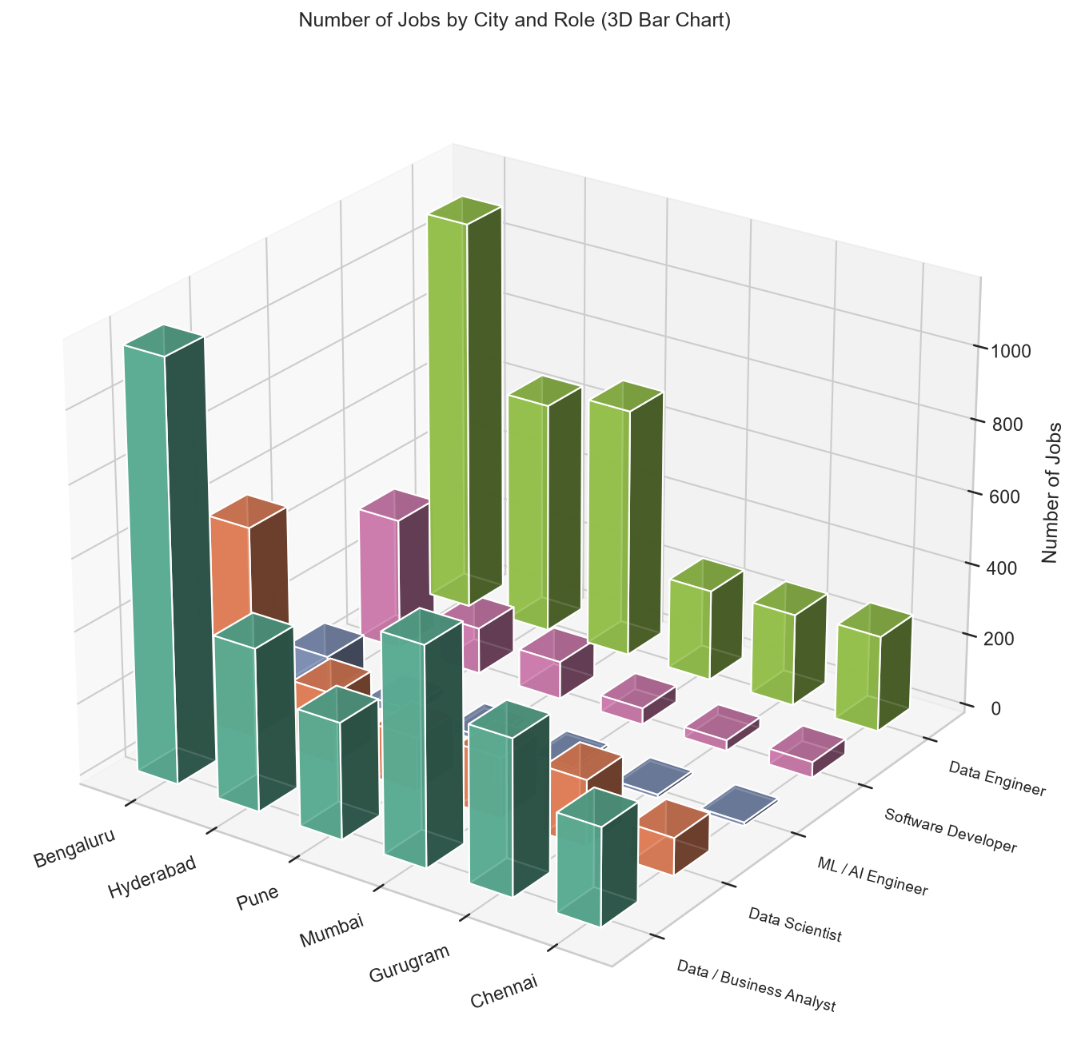
Figure 4 — Number of Jobs by City and Role
Observation: Bengaluru has the tallest bar for every role. Mumbai and Gurugram lean towards analyst jobs (605 vs 254 and 431 vs 257 data engineer jobs), while Pune and Hyderabad lean towards Data Engineer (696 vs 322 and 647 vs 450). ML / AI Engineer bars are small in every city.

Conclusion
In this experiment, the cleaned job dataset from Experiment 2 was connected and analysed using advanced visualizations. The violin plot compared a numerical column across categories and showed that analyst roles are the most entry-friendly. The radar chart compared seven skill flags at once and showed a clear skill pattern for each role. The Sankey diagram connected three categorical columns and showed that fresher jobs flow mostly into analyst roles and that Bengaluru leads for every role. The 3D bar chart showed two categories and a count together and revealed city specialities: Mumbai and Gurugram for analysts, Pune and Hyderabad for data engineers. These plots revealed patterns and relationships that basic one-column charts cannot show.

