EXPERIMENT NO. 1
DATA VISUALIZATION TASK
Credit Card Details Dataset

Aim
To explore a dataset and create appropriate visualizations for understanding patterns, distributions, trends, and relationships in the data.

Objectives
- To understand different types of data.
- To select appropriate visualization techniques.
- To generate graphical representations of data.
- To interpret patterns and relationships from visualizations.
- To justify the selection of visualization techniques.

Theory

Data Visualization
"Data visualization uses charts, graphs and maps to present information clearly and simply. It turns complex data into visuals that are easy to understand.
Why data visualization is important:
- Simplifies Complex Data: "It turns large and complicated data into visual formats like charts and graphs, making the information easier to understand."
- Reveals Patterns and Trends: "It helps identify trends, relationships and patterns that are not easily seen in raw data or tables."
- Saves Time: "Visuals allow quicker interpretation of data, helping users spot key information at a glance instead of manually scanning through numbers."
- Improves Communication: "It makes it easier to explain data insights to others, especially those who may not be familiar with the technical details."
- Tells a Clear Story: "Data visuals guide the audience through the information step-by-step, making it easier to reach conclusions and make informed decisions."

Types of Data
- Qualitative / Categorical data: "Information about something that can be sorted into different categories that can't be described directly by numbers." [2]
- Quantitative / Numerical data: "Information about something that is described by numbers." [2]

Plots Used in this Experiment
1. Count Plot (Bar Graph)
- "Bar graphs are used [to] show the distribution of qualitative (categorical) data. It shows the frequency of values in the data. Frequency is the amount of times that value appeared in the data." [3]
- In seaborn, a count plot is used to "Show the counts of observations in each categorical bin using bars." It can be thought of as "a histogram across a categorical, instead of quantitative, variable." [4]
2. Histogram
- "A histogram is a widely used graph to show the distribution of quantitative (numerical) data." [5]
- Bins are "The intervals of values", and bin width is "the length of an interval." [5]
- seaborn's histplot "can add a smooth curve obtained using a kernel density estimate" (KDE). [6]
3. Box Plot
- "A Box Plot is also known as a Box and Whisker Plot and it is a graphical tool used to understand the distribution of numerical data." [7]
- Minimum: "The smallest non-outlier value shown at the lower whisker end" [7]
- First Quartile (Q1): "The value below which 25% of the data lies" [7]
- Median (Q2): "The middle value that splits the data into two equal halves" [7]
- Third Quartile (Q3): "The value below which 75% of the data lies" [7]
- Maximum: "The largest non-outlier value shown at the upper whisker end" [7]
- IQR: The box "covers the middle 50% of the data, making it a strong measure of spread that is resistant to extreme values." [7]
- Outliers: "Any value below the lower limit or above the upper limit is treated as an outlier and shown as a separate point", where lower limit = Q1 − 1.5 × IQR and upper limit = Q3 + 1.5 × IQR. [7]
4. Scatter Plot
- "A scatter plot, also called a scatter graph, scattergram, scatter chart, or XY graph, uses dots to describe two different numeric variables." [8]
- Positive correlation: "The value on the y-axis increases on moving from left to right." [8]
- Negative correlation: "The value on the y-axis decreases on moving from left to right." [8]
- No correlation: "Values are scattered all over the graph." [8]
5. Correlation Heatmap
- "A correlation heatmap is a 2D graphical representation of a correlation matrix between multiple variables. It uses colored cells to indicate correlation values, making patterns and relationships within data visually interpretable." [9]
- "The correlation coefficient measures the relationship between two variables." It "can never be less than -1 or higher than 1." [10]
- 1: "there is a perfect linear relationship between the variables"; 0: "there is no linear relationship between the variables"; −1: "there is a perfect negative linear relationship between the variables". [10]

Dataset
Each row of the dataset is one person who applied for a credit card. It contains their personal details (gender, income, education, family size, job, house type, etc.) and whether their application was approved or rejected.
The data comes as two CSV files:
- Credit_card.csv: details of each applicant.
- Credit_card_label.csv: the result of each application (label: 0 = Approved, 1 = Rejected).
Both files have a common column Ind_ID (applicant ID), so they are joined on this column to make one table.
Source: https://www.kaggle.com/datasets/rohitudageri/credit-card-details

Task 1 — Load and Inspect the Dataset
The two CSV files were loaded with pandas and joined on Ind_ID. The data was then inspected using:
- shape: number of rows and columns.
- head(): the first 5 rows, to see what the data looks like.
- info(): each column's name, number of filled (non-empty) values, and data type.
Observation: The merged dataset has 1,548 rows and 19 columns. Some columns have fewer than 1,548 filled values, which means they have missing values. These are handled in Task 3.
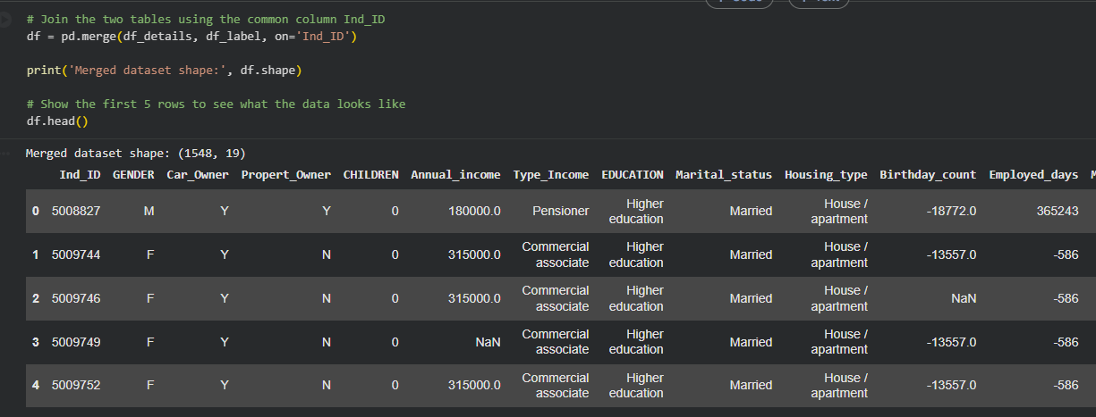

Task 2 — Identify Numerical and Categorical Attributes
- Numerical attributes are numbers that are measured or counted, where maths makes sense (e.g. income, number of children).
- Categorical attributes put a person into a group or category (e.g. gender, education level).
This matters because the type of data decides the type of chart. Numerical data suits histograms, box plots and scatter plots, while categorical data suits bar charts and count plots.
Type | Columns
Numerical | Annual_income, Birthday_count, Employed_days, CHILDREN, Family_Members
Categorical (stored as text) | GENDER, Car_Owner, Propert_Owner, Type_Income, EDUCATION, Marital_status, Housing_type, Type_Occupation
Categorical (stored as 0/1 numbers) | Mobile_phone, Work_Phone, Phone, EMAIL_ID, label
Identifier (not analysed) | Ind_ID

Note: Mobile_phone, Work_Phone, Phone, EMAIL_ID and label are stored as numbers, but they are really Yes/No categories. For example, the average of label has no real meaning, so these columns are treated as categorical.
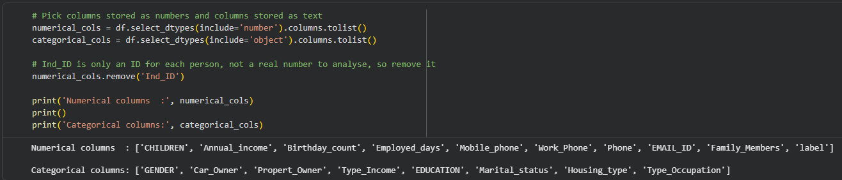

Task 3 — Basic Pre-processing
Before making charts, the data was checked for duplicate rows and missing values, so that the charts are based on clean data.
Attribute / Check | Result | Action | Reason
Duplicate rows | 0 | Nothing needed | No duplicate rows were found.
Type_Occupation | 488 (31.52%) | Filled with "Unknown" | Almost one-third of the rows are missing. Deleting them would lose too much data.
Annual_income | 23 (1.49%) | Filled with the median | The mean (≈ 1,91,000) is higher than the median (1,66,500) because a few people earn very high incomes. The median (middle value) is not affected by these extreme values.
Birthday_count | 22 (1.42%) | Filled with the median | Same reason: the median is a safe middle value.
GENDER | 7 (0.45%) | Filled with "Unknown" | A person's gender should not be guessed.

No rows were deleted, so all 1,548 applicants were kept.
New columns created for easier reading:
- Age: Birthday_count is in negative days, which is hard to read, so it was converted to years: Age = −Birthday_count ÷ 365.
- Status: label (0/1) was converted to the words Approved / Rejected so the charts are easier to read.
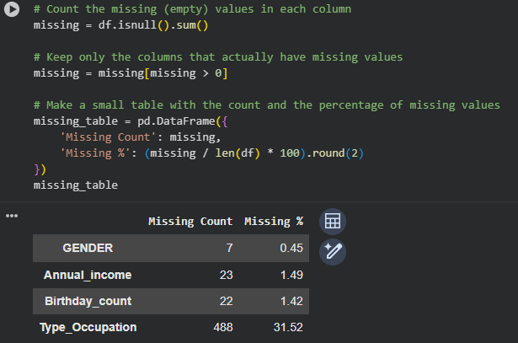

Tasks 4, 5, 6 — Visualizations, Interpretation, and Justification
Six charts were created. Each one answers a different question and was chosen according to the type of data:
# | Chart | Column(s) | Data type | Question it answers
1 | Count plot | Status | Categorical | How many applications were approved vs rejected?
2 | Histogram | Annual_income | Numerical | How are incomes spread out?
3 | Box plot | Annual_income | Numerical | Are there unusually high incomes (outliers)?
4 | Horizontal count plot | EDUCATION | Categorical | What education levels do applicants have?
5 | Scatter plot | Age vs Annual_income | Numerical vs Numerical | Is there a relationship between age and income?
6 | Heatmap | CHILDREN, Family_Members, Annual_income, Age, label | Numerical | Which columns are related to each other?

Visualization 1 — Approved vs Rejected Applications (Count Plot)
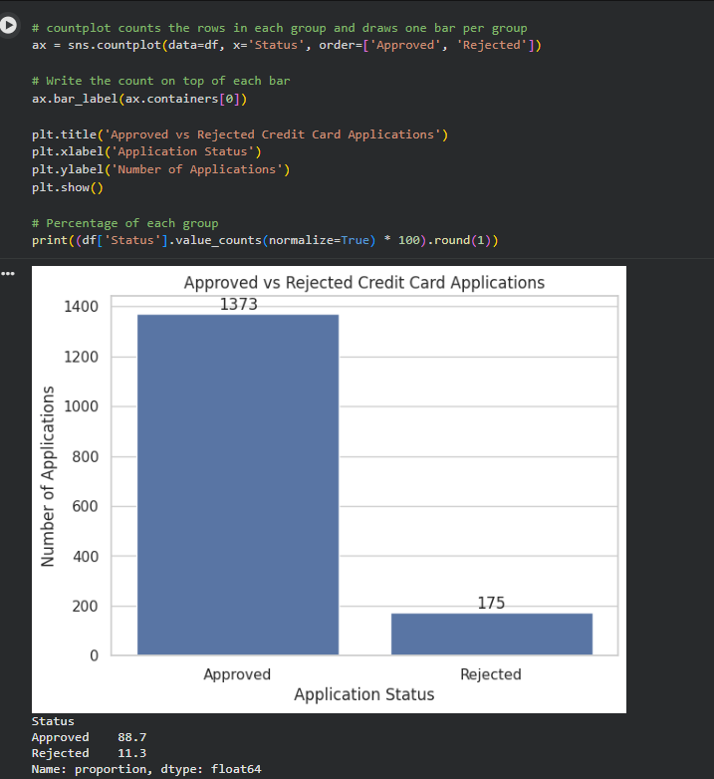
Why this visualization? Status is a categorical column with only two groups. A count plot draws one bar per group, and the bar height is the number of applications, so the two groups can be compared at a glance.
Interpretation: 1,373 applications (88.7%) were approved and only 175 (11.3%) were rejected. The two groups are very unequal in size, so the data is imbalanced: approved cases are about 8 times more common than rejected ones.

Visualization 2 — Distribution of Annual Income (Histogram)
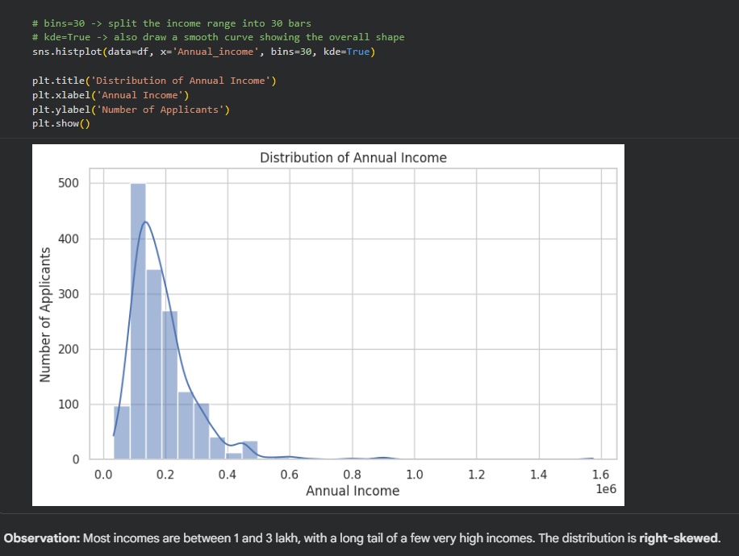
Why this visualization? Annual_income is a numerical column. A histogram divides incomes into ranges (called bins) and shows how many people fall in each range, so it shows where most incomes lie. The smooth line on top (KDE) traces the overall shape of the bars.
Interpretation: Most applicants earn roughly 1,00,000 to 3,00,000. A few people earn much more (up to 15,75,000), which creates a long tail on the right side. This shape is called right-skewed. It also explains why the mean income is higher than the median: the few high earners pull the mean up.

Visualization 3 — Box Plot of Annual Income
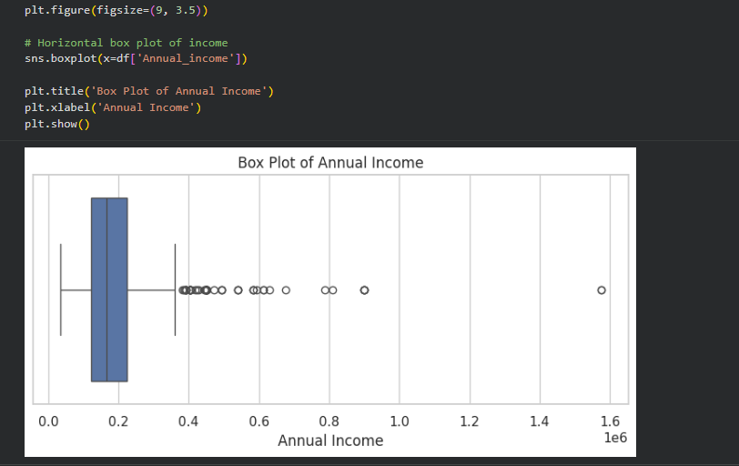
Why this visualization? A box plot summarises a numerical column in one picture and clearly shows outliers (unusually high or low values). It adds to the histogram by marking exactly which values are extreme.
How to read a box plot:
- The box covers the middle 50% of people, from Q1 (25% of people earn less than this) to Q3 (75% of people earn less than this).
- The line inside the box is the median.
- The whiskers (lines on both sides) show the normal range.
- The dots beyond the whiskers are outliers.
IQR rule for outliers: IQR (Inter-Quartile Range) = Q3 − Q1, which is the width of the box. Any income above Q3 + 1.5 × IQR is an outlier. The lower limit (Q1 − 1.5 × IQR) is negative here, so no income is a low outlier.
Interpretation: The middle 50% of applicants earn between 1,21,500 (Q1) and 2,25,000 (Q3), so IQR = 1,03,500. Any income above 3,80,250 is an outlier, and 73 applicants are above this limit. These outliers were not removed, because high incomes are real and possible. They belong to genuine applicants and are not typing mistakes.

Visualization 4 — Education Levels (Horizontal Count Plot)
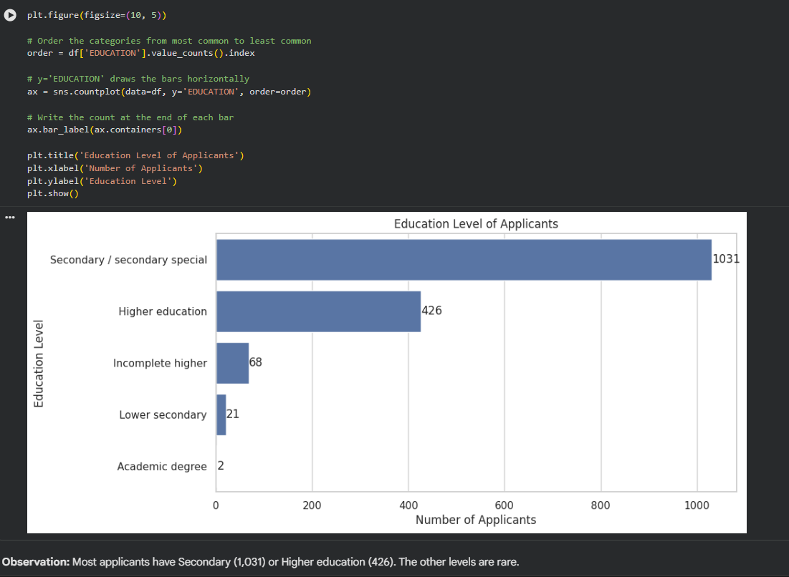
Why this visualization? EDUCATION is a categorical column, so a count plot is used to compare how many people are in each category. The bars are horizontal because the category names are long and would overlap on the x-axis, and they are sorted from most to least common so the chart is easy to read.
Interpretation: Most applicants have Secondary / secondary special education (1,031, about 67%), followed by Higher education (426, about 28%). The other categories are small: Incomplete higher (68), Lower secondary (21), and Academic degree (only 2). So the applicants mainly come from two education groups.

Visualization 5 — Age vs Annual Income (Scatter Plot)
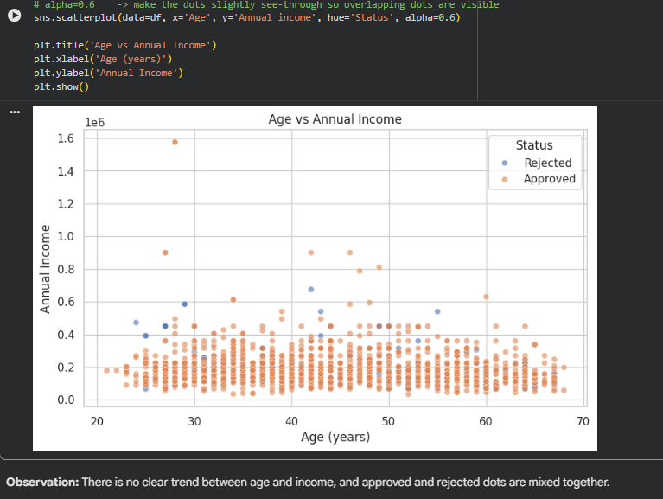
Why this visualization? A scatter plot shows whether two numerical columns are related. Each dot is one applicant, with age on the x-axis and income on the y-axis. The dots are also coloured by Status (Approved / Rejected) to check whether the two groups fall in different areas of the chart.
Interpretation: Applicants are between about 21 and 68 years old. The dots are spread out with no clear upward or downward trend, so income does not clearly increase or decrease with age. The Approved and Rejected dots are mixed together in the same areas, so age and income alone cannot tell whether an application will be approved.

Visualization 6 — Correlation Heatmap
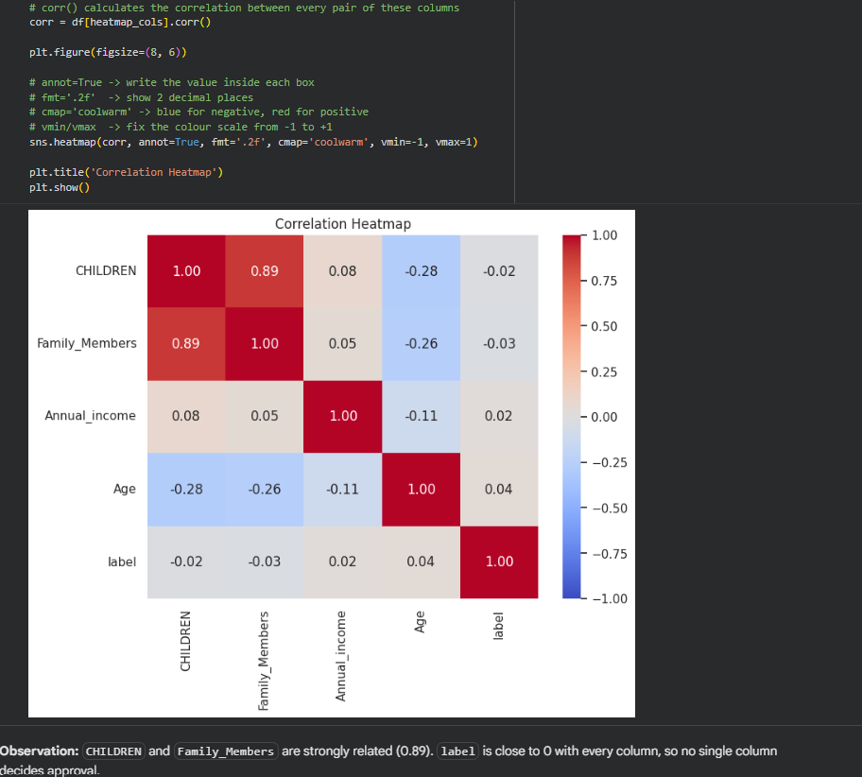
Why this visualization? A heatmap shows the relationship between many pairs of numerical columns at once, in one grid. Each box shows a correlation value between −1 and +1:
- Close to +1: when one column goes up, the other also goes up.
- Close to −1: when one column goes up, the other goes down.
- Close to 0: no clear relationship.
The colours make strong relationships easy to spot: dark red means strongly positive and dark blue means strongly negative. Mobile_phone was left out because every applicant has the value 1. A column that never changes cannot be related to anything, so it would appear blank in the heatmap.
Interpretation:
- CHILDREN and Family_Members have a strong positive correlation (0.89). This makes sense, because more children means a bigger family.
- Age has a weak negative correlation with CHILDREN (−0.28) and Family_Members (−0.26), so older applicants tend to have fewer children living with them.
- label (approval result) is close to 0 with every column. No single column on its own decides whether an application is approved or rejected.

Task 7 — Summary of Important Insights
- The dataset has 1,548 applicants and 19 columns, and no duplicate rows were found.
- Four columns (Type_Occupation, Annual_income, Birthday_count, GENDER) had missing values. They were filled with "Unknown" or the median instead of deleting rows, so no data was lost.
- 88.7% of applications were approved and 11.3% were rejected, so the data is imbalanced.
- Annual income is right-skewed: most people earn 1–3 lakh and a few earn much more. 73 applicants are high-income outliers by the IQR rule.
- Most applicants have Secondary / secondary special or Higher education.
- Age and income show no clear relationship, and approved and rejected applicants are mixed together in the scatter plot.
- CHILDREN and Family_Members are strongly related (0.89).
- No single numerical column clearly decides approval or rejection.

Conclusion
In this experiment, a real-world credit card application dataset was loaded and inspected, its numerical and categorical columns were identified, and it was cleaned by handling missing values. Six charts were then created, each chosen according to the type of data:
- Count plots for categorical data (application status, education).
- Histogram and box plot for the spread and outliers of a numerical column (income).
- Scatter plot for the relationship between two numerical columns (age and income).
- Heatmap to compare many numerical columns at once.
Visualization made the data much easier to understand than raw numbers. At a glance, it showed that most applications are approved, that income is uneven with a few very high earners, and that no single column decides approval. The main lesson of this experiment is that choosing the right chart for the right type of data makes patterns quick and easy to find.

References
[1] GeeksforGeeks, "What is Data Visualization and Why is it Important?" https://www.geeksforgeeks.org/what-is-data-visualization-and-why-is-it-important/
[2] W3Schools, "Statistics - Data Types." https://www.w3schools.com/statistics/statistics_data_types.php
[3] W3Schools, "Statistics - Bar Graphs." https://www.w3schools.com/statistics/statistics_bar_graphs.php
[4] seaborn documentation, "seaborn.countplot." https://seaborn.pydata.org/generated/seaborn.countplot.html
[5] W3Schools, "Statistics - Histograms." https://www.w3schools.com/statistics/statistics_histograms.php
[6] seaborn documentation, "seaborn.histplot." https://seaborn.pydata.org/generated/seaborn.histplot.html
[7] GeeksforGeeks, "Box Plot." https://www.geeksforgeeks.org/box-plot/
[8] GeeksforGeeks, "Scatter Plot." https://www.geeksforgeeks.org/maths/scatter-plot/
[9] GeeksforGeeks, "How to create a seaborn correlation heatmap in Python?" https://www.geeksforgeeks.org/python/how-to-create-a-seaborn-correlation-heatmap-in-python/
[10] W3Schools, "Data Science - Statistics Correlation." https://www.w3schools.com/datascience/ds_stat_correlation.asp
[11] Kaggle, "Credit Card Details" dataset. https://www.kaggle.com/datasets/rohitudageri/credit-card-details

