EXPERIMENT NO. 1

Aim
To explore a dataset and create appropriate visualizations for understanding patterns, distributions, trends, and relationships in the data.

Objectives
- To understand different types of data.
- To select appropriate visualization techniques.
- To generate graphical representations of data.
- To interpret patterns and relationships from visualizations.
- To justify the selection of visualization techniques.

Theory

Data Visualization
"Data visualization uses charts, graphs and maps to present information clearly and simply. It turns complex data into visuals that are easy to understand."
Why data visualization is important:
- Simplifies Complex Data: "It turns large and complicated data into visual formats like charts and graphs, making the information easier to understand."
- Reveals Patterns and Trends: "It helps identify trends, relationships and patterns that are not easily seen in raw data or tables."
- Saves Time: "Visuals allow quicker interpretation of data, helping users spot key information at a glance instead of manually scanning through numbers."
- Improves Communication: "It makes it easier to explain data insights to others, especially those who may not be familiar with the technical details."
- Tells a Clear Story: "Data visuals guide the audience through the information step-by-step, making it easier to reach conclusions and make informed decisions."

Types of Data
- Qualitative / Categorical data: "Information about something that can be sorted into different categories that can't be described directly by numbers."
- Quantitative / Numerical data: "Information about something that is described by numbers."

Dataset
Each row of the dataset is one person who applied for a credit card. It contains their personal details (gender, income, education, family size, job, house type, etc.) and whether their application was approved or rejected.
The data comes as two CSV files:
- Credit_card.csv: details of each applicant.
- Credit_card_label.csv: the result of each application (label: 0 = Approved, 1 = Rejected).
Source: https://www.kaggle.com/datasets/rohitudageri/credit-card-details

Task 1 — Load and Inspect the Dataset
The two CSV files were loaded with pandas and joined on Ind_ID
Observation: The merged dataset has 1,548 rows and 19 columns.
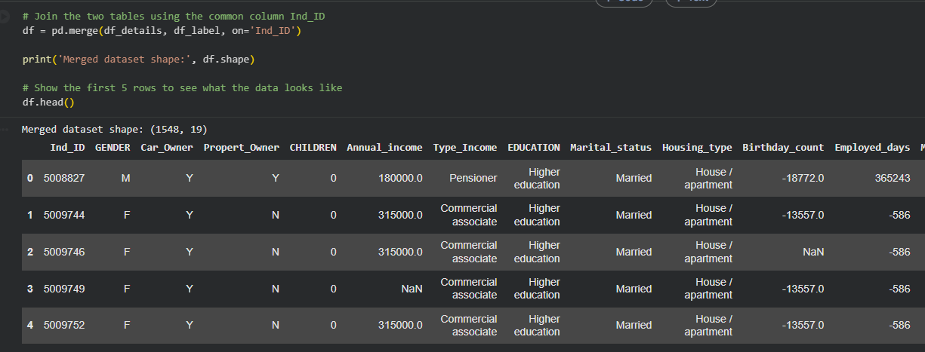

Task 2 — Identify Numerical and Categorical Attributes

Type | Columns
Numerical | Annual_income, Birthday_count, Employed_days, CHILDREN, Family_Members
Categorical (stored as text) | GENDER, Car_Owner, Propert_Owner, Type_Income, EDUCATION, Marital_status, Housing_type, Type_Occupation
Categorical (stored as 0/1 numbers) | Mobile_phone, Work_Phone, Phone, EMAIL_ID, label
Identifier (not analysed) | Ind_ID

Note: Mobile_phone, Work_Phone, Phone, EMAIL_ID and label are stored as numbers, but they are really Yes/No categories.
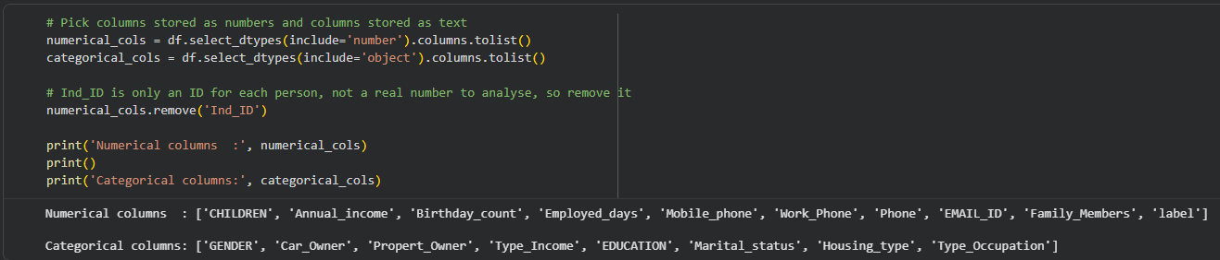

Task 3 — Basic Pre-processing

Attribute / Check | Result
Duplicate rows | 0
Type_Occupation | 488 (31.52%)
Annual_income | 23 (1.49%)
Birthday_count | 22 (1.42%)
GENDER | 7 (0.45%)

New columns created:
- Age: Birthday_count is in negative days, so it was converted to years: Age = −Birthday_count ÷ 365.
- Status: label (0/1) was converted to the words Approved / Rejected.
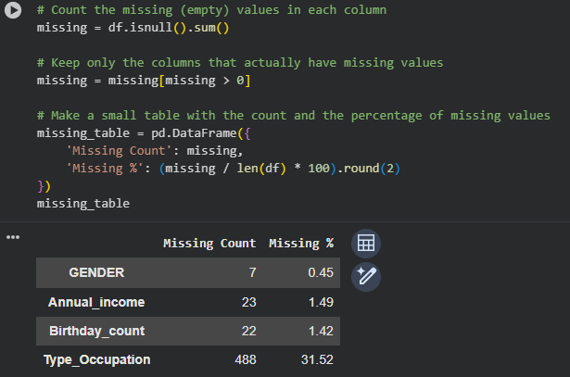

Tasks 4, 5, 6 — Visualizations, Interpretation, and Justification
# | Chart | Column(s) | Data type
1 | Count plot | Status | Categorical
2 | Histogram | Annual_income | Numerical
3 | Box plot | Annual_income | Numerical
4 | Horizontal count plot | EDUCATION | Categorical
5 | Scatter plot | Age vs Annual_income | Numerical vs Numerical
6 | Heatmap | CHILDREN, Family_Members, Annual_income, Age, label | Numerical

Visualization 1 — Approved vs Rejected Applications (Count Plot)
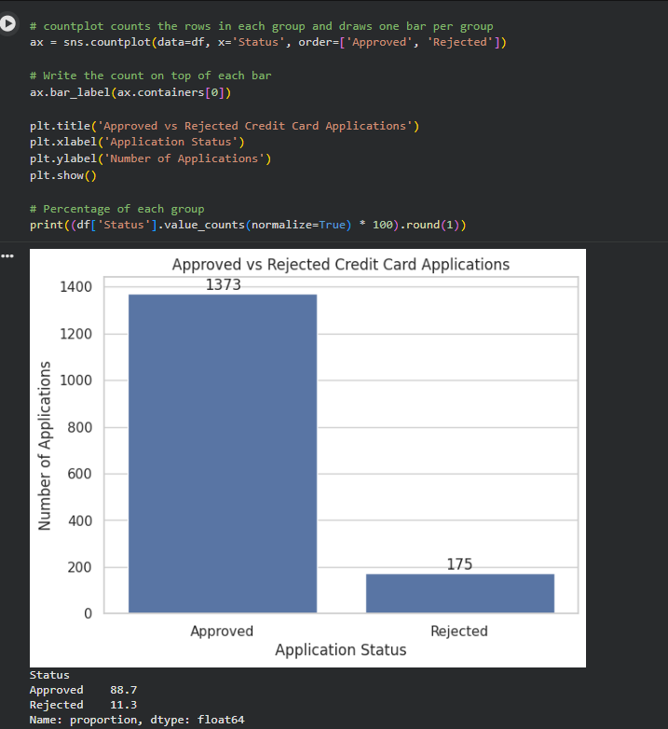

Visualization 2 — Distribution of Annual Income (Histogram)
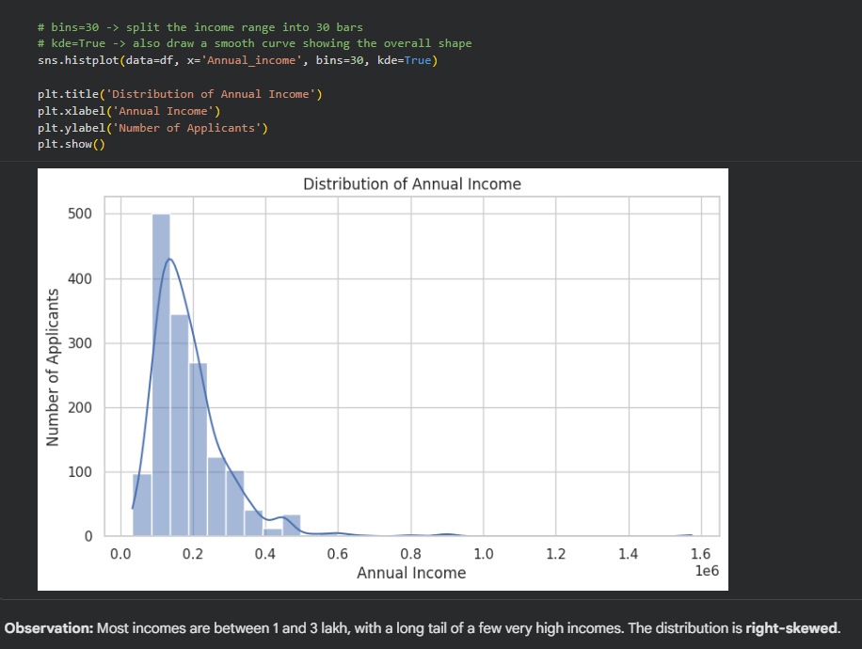

Visualization 3 — Box Plot of Annual Income
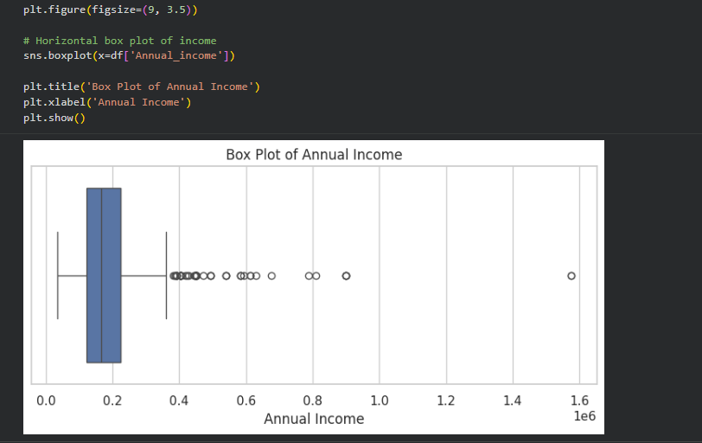

Visualization 4 — Education Levels (Horizontal Count Plot)
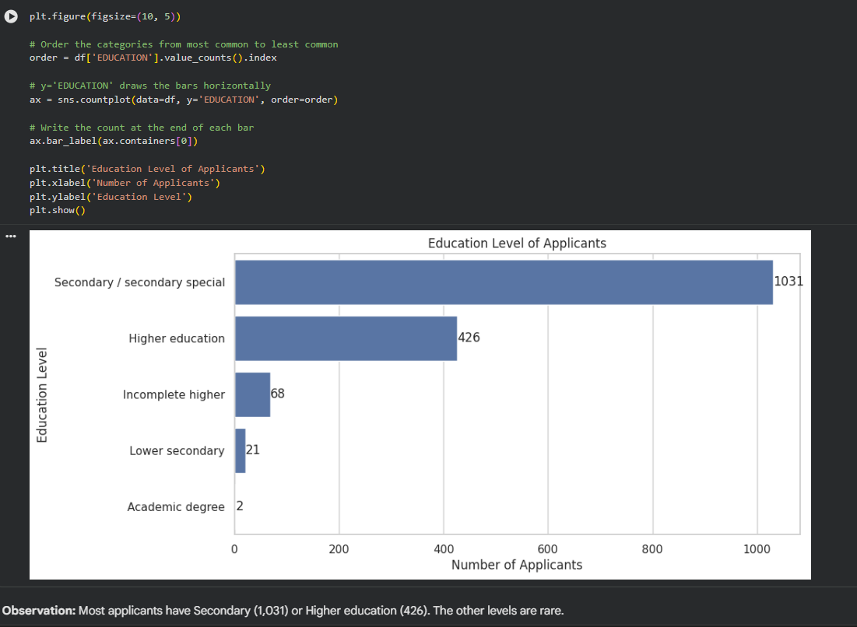

Visualization 5 — Age vs Annual Income (Scatter Plot)
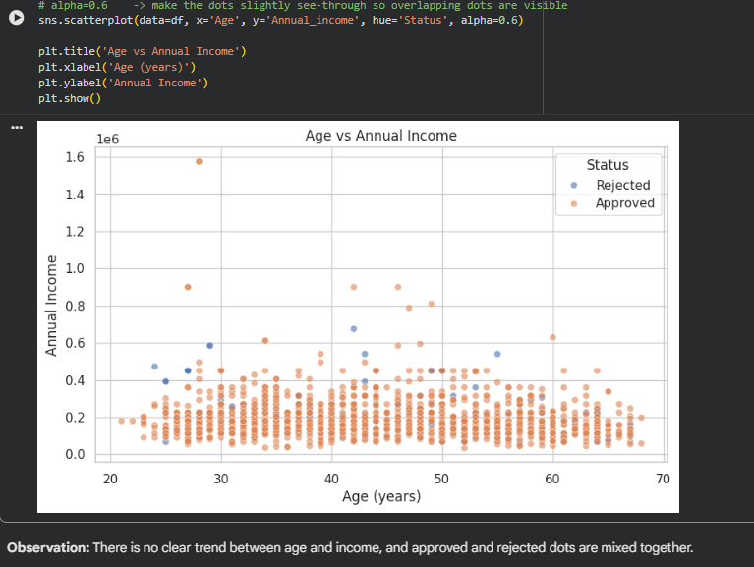

Visualization 6 — Correlation Heatmap
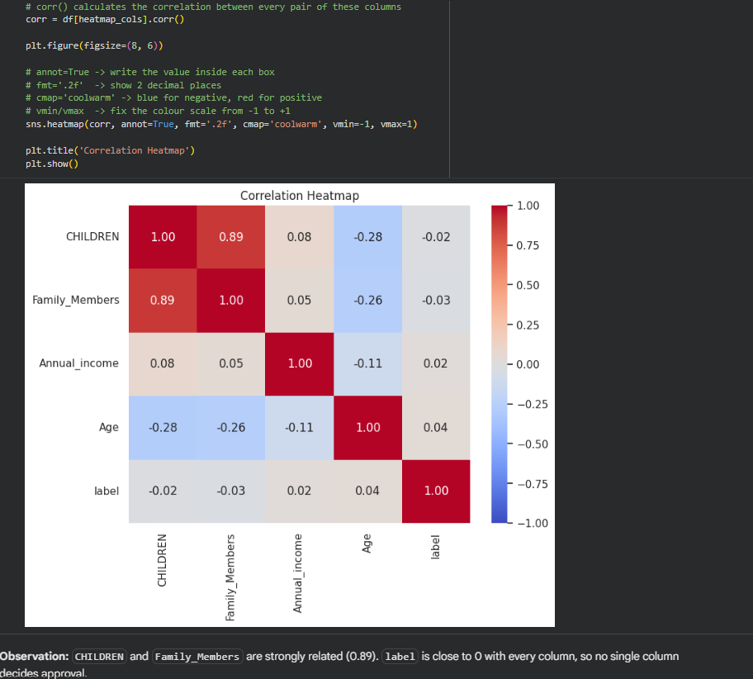

Why this visualization?
1. Approved vs Rejected Applications (Count Plot)
Status is a categorical column with only two groups. A count plot draws one bar per group, and the bar height is the number of applications, so the two groups can be compared.
2. Distribution of Annual Income (Histogram)
Annual_income is a numerical column. A histogram divides incomes into ranges (called bins) and shows how many people fall in each range, so it shows where most incomes lie. The smooth line on top (KDE) traces the overall shape of the bars.
3. Box Plot of Annual Income
A box plot summarises a numerical column in one picture and clearly shows outliers (unusually high or low values).
4. Education Levels (Horizontal Count Plot)
EDUCATION is a categorical column, so a count plot is used to compare how many people are in each category.
5. Age vs Annual Income (Scatter Plot)
A scatter plot shows whether two numerical columns are related. Each dot is one applicant, with age on the x-axis and income on the y-axis. The dots are also coloured by Status (Approved / Rejected) to check whether the two groups fall in different areas of the chart.
6. Correlation Heatmap
A heatmap shows the relationship between many pairs of numerical columns at once, in one grid. The colours make strong relationships easy to spot: dark red means strongly positive and dark blue means strongly negative.

Interpretation
1. Approved vs Rejected Applications (Count Plot)
1,373 applications (88.7%) were approved and only 175 (11.3%) were rejected. The two groups are very unequal in size, so the data is imbalanced: approved cases are about 8 times more common than rejected ones.
2. Distribution of Annual Income (Histogram)
Most applicants earn roughly 1,00,000 to 3,00,000. A few people earn much more (up to 15,75,000), which creates a long tail on the right side. This shape is called right-skewed. It also explains why the mean income is higher than the median: the few high earners pull the mean up.
3. Box Plot of Annual Income
The middle 50% of applicants earn between 1,21,500 (Q1) and 2,25,000 (Q3), so IQR = 1,03,500. Any income above 3,80,250 is an outlier, and 73 applicants are above this limit. These outliers were not removed, because high incomes are real and possible. They belong to genuine applicants and are not typing mistakes.
4. Education Levels (Horizontal Count Plot)
Most applicants have Secondary / secondary special education (1,031, about 67%), followed by Higher education (426, about 28%). The other categories are small: Incomplete higher (68), Lower secondary (21), and Academic degree (only 2). So the applicants mainly come from two education groups.
5. Age vs Annual Income (Scatter Plot)
Applicants are between about 21 and 68 years old. The dots are spread out with no clear upward or downward trend, so income does not clearly increase or decrease with age. The Approved and Rejected dots are mixed together in the same areas, so age and income alone cannot tell whether an application will be approved.
6. Correlation Heatmap
- CHILDREN and Family_Members have a strong positive correlation (0.89). This makes sense, because more children means a bigger family.
- Age has a weak negative correlation with CHILDREN (−0.28) and Family_Members (−0.26), so older applicants tend to have fewer children living with them.
- label (approval result) is close to 0 with every column. No single column on its own decides whether an application is approved or rejected.

Task 7 — Summary of Important Insights
- The dataset has 1,548 applicants and 19 columns, and no duplicate rows were found.
- Four columns (Type_Occupation, Annual_income, Birthday_count, GENDER) had missing values. They were filled with "Unknown" or the median instead of deleting rows, so no data was lost.
- 88.7% of applications were approved and 11.3% were rejected, so the data is imbalanced.
- Annual income is right-skewed: most people earn 1–3 lakh and a few earn much more. 73 applicants are high-income outliers by the IQR rule.
- Most applicants have Secondary / secondary special or Higher education.
- Age and income show no clear relationship, and approved and rejected applicants are mixed together in the scatter plot.
- CHILDREN and Family_Members are strongly related (0.89).
- No single numerical column clearly decides approval or rejection.

Conclusion
In this experiment, a real-world credit card application dataset was loaded and inspected, its numerical and categorical columns were identified, and it was cleaned by handling missing values. Six charts were then created, each chosen according to the type of data:
- Count plots for categorical data (application status, education).
- Histogram and box plot for the spread and outliers of a numerical column (income).
- Scatter plot for the relationship between two numerical columns (age and income).
- Heatmap to compare many numerical columns at once.

Colab: Notebook

