EXPERIMENT NO. 2
DATA FILTERING, TRANSFORMATION AND PREPROCESSING
Kaushik Sakre
262240016

Aim
To perform data filtering, transformation, and preprocessing for better visualization.

Objectives
- To filter data based on specific conditions.
- To select required rows and columns.
- To handle missing or unwanted data.
- To transform data into a suitable format.
- To create new / derived columns.
- To prepare the transformed dataset for visualization.

Theory

1. Data Preprocessing
Data preprocessing is the process of cleaning, filtering, transforming, and organizing raw data before it is used for analysis or visualization. Raw datasets may contain missing values, duplicate records, irrelevant columns, incorrect data types, or inconsistent formats. Preprocessing improves data quality and ensures that visualizations accurately represent the underlying information.

2. Data Filtering
Data filtering is used to select only those records that satisfy specific conditions. It helps remove irrelevant observations and focus the analysis on a particular subset of the data.
Examples:
- Selecting students with marks greater than 70.
- Selecting products belonging to a particular category.
- Selecting sales records for a specific month.
In Python, filtering can be performed using conditions on a Pandas DataFrame.
filtered_data = df[df["Marks"] > 70]

3. Selecting Rows and Columns
A dataset often contains many rows and columns, but only some may be required for analysis. Selecting specific rows and columns helps create a smaller and more relevant dataset.
# Select specific columns
df_selected = df[["Name", "Marks", "Department"]]
# Select specific rows
df_selected = df.iloc[0:10]

4. Handling Missing and Unwanted Data
Missing data occurs when one or more values are not available in a dataset. Missing or unwanted records can affect analysis and visualization.
Common approaches include:
- Removing missing records
df.dropna()
- Replacing missing values
df.fillna(0)
- Removing duplicate records
df.drop_duplicates()
The appropriate method depends on the nature and importance of the missing data.

5. Data Transformation
Data transformation involves converting data from its original form into a format that is more suitable for analysis and visualization.
Examples include:
- Converting data types.
- Converting text to lowercase.
- Changing date formats.
- Scaling numerical values.
For example:
df["Name"] = df["Name"].str.upper()

6. Creating Derived Columns
A derived column is a new column calculated from existing columns. Derived columns can provide additional information useful for analysis.
For example, if a dataset contains Price and Quantity, the total amount can be calculated as:
df["Total"] = df["Price"] * df["Quantity"]
Similarly, a categorical column can be created based on conditions:
df["Result"] = df["Marks"].apply(
lambda x: "Pass" if x >= 40 else "Fail")

7. Preparing Data for Visualization
Before creating charts or graphs, the dataset should be organized into a suitable structure. The data should have:
- Relevant rows and columns.
- Correct data types.
- Consistent values and formats.
- Missing or invalid values appropriately handled.
- Required derived columns created.
- Unnecessary data removed.
A well-prepared dataset makes visualization more accurate, meaningful, and easier to interpret.

Dataset
The dataset contains 12,000 data science job postings in India, collected from Naukri.com. Each row is one job posting.
Source: https://www.kaggle.com/datasets/anandhuh/data-science-jobs-in-india
Column | Meaning | Example
Job_Role | Job title | Senior Data Scientist
Company | Company name | Walmart
Location | City / cities of the job | Bangalore/Bengaluru, Mumbai (All Areas)
Job Experience | Experience required (years) | 3-6
Skills/Description | Skills asked for, separated by commas | Python, Machine learning, SQL, Azure

Implementation
The cleaning and transforming steps are done before selecting and filtering, because filters such as "fresher jobs" or "jobs that need Python" only work after the experience text has been converted to numbers and the skill columns have been created.

Step 1 — Load and Inspect the Dataset
- Load the CSV file with pandas.
- Check the shape, data types, first rows, missing values and duplicate rows.
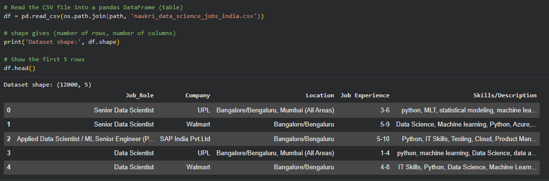
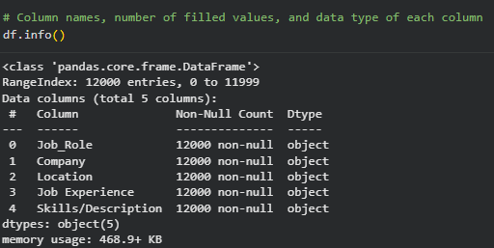

Step 2 — Handle Missing or Unwanted Data
- Rename the columns to short, simple names (Job_Title, Company, Location, Experience, Skills).
- Find the experience values that are not in "min-max" years format and mark them as missing (NaN).
- Remove these rows with dropna(), because their experience cannot be guessed.
- Find duplicate rows that differ only in capital letters or extra spaces, and remove them.
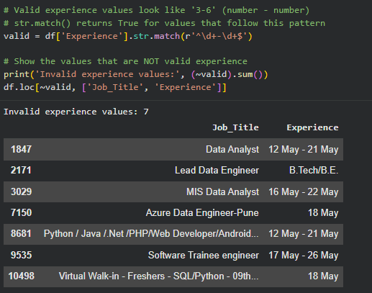

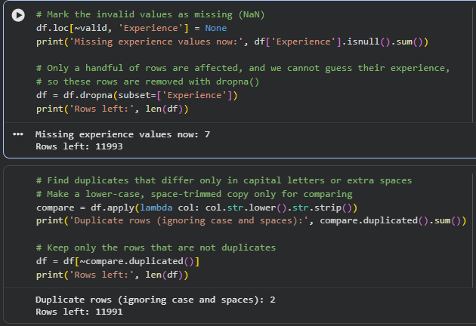

Step 3 — Transform Data into a Suitable Format
- Split "Experience" (e.g. "3-6") into two number columns: Min_Exp and Max_Exp, and convert them from text to numbers with astype(int).
- Standardise city names using a dictionary (e.g. "Bangalore/Bengaluru" and "Bengaluru" → "Bengaluru"; "Mumbai (All Areas)", "Navi Mumbai" → "Mumbai").
- Convert the skills text into a clean list: lower case, extra spaces removed, and the general "it skills" tag removed.
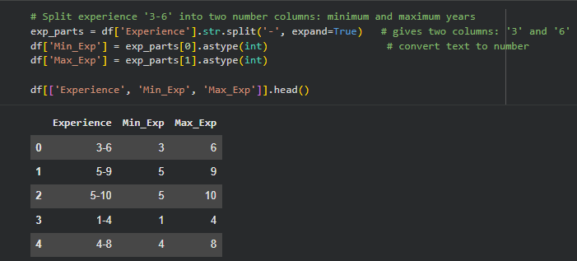

Step 4 — Create New / Derived Columns
- Avg_Exp: average of the minimum and maximum experience.
- Experience_Level: Fresher (0-1), Junior (2-3), Mid (4-6) or Senior (7+), created by binning the minimum experience with pd.cut().
- Role: thousands of job titles grouped into 6 roles (Data / Business Analyst, Data Engineer, Data Scientist, ML / AI Engineer, Software Developer, Other) using keywords in the title.
- Main_City: the first city listed for the job.
- Skill_Count: number of skills listed in the job.
- Needs_Python, Needs_Sql, Needs_Machine_Learning, Needs_Excel, Needs_Power_Bi, Needs_Tableau, Needs_Aws: True/False columns showing whether the job asks for that skill.
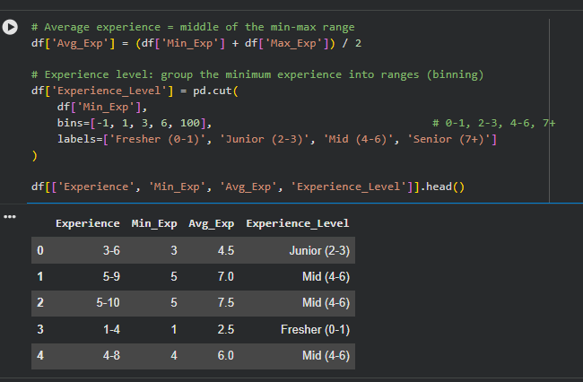

Step 5 — Select Required Rows and Columns
- Select only the columns needed for analysis by their names, using loc[].
- Select rows and columns by their position, using iloc[].
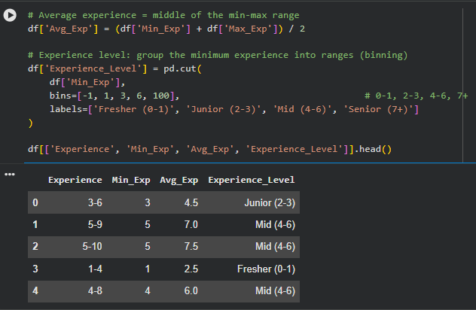
Result: loc[] kept 10 useful columns by name. iloc[0:5, 0:3] selected the first 5 rows and first 3 columns by position.

Step 6 — Filter Data Based on Specific Conditions
- Jobs open to freshers (minimum experience 0 or 1 year).
- Jobs that list Mumbai as one of their cities.
- Jobs that need both Python and SQL (using &).
- Data / Business Analyst jobs whose main city is Mumbai or Pune (using isin()).
- Fresher jobs whose main city is Mumbai (using query()).
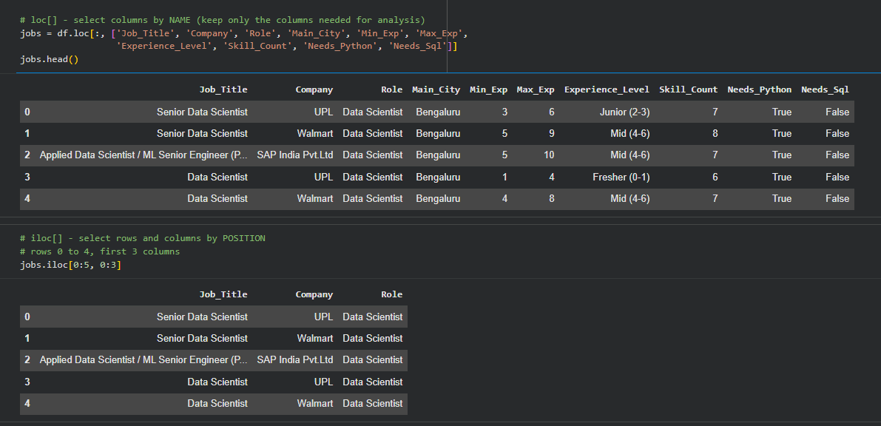

Step 7 — Prepare the Transformed Dataset for Visualization
- Keep only the useful columns, sort the rows by minimum experience, and save the final clean dataset as cleaned_ds_jobs_india.csv (11,991 rows, 16 columns).
- Create charts that were wrong or not possible with the raw data.
Chart 1 — Jobs by City: Before vs After Cleaning
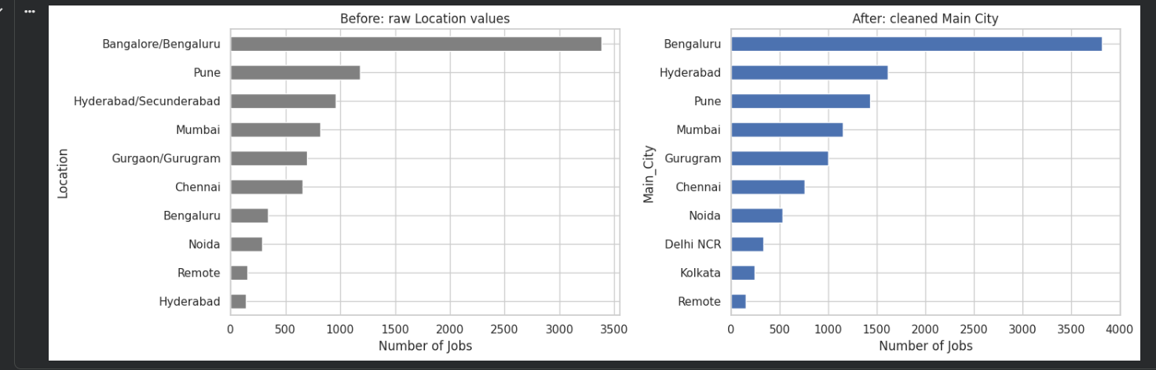
Chart 2 — Top 15 Skills in Demand
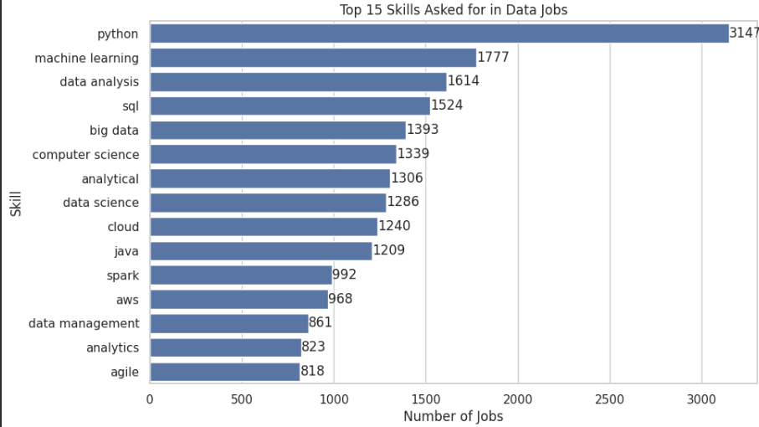
Chart 3 — Jobs by Role
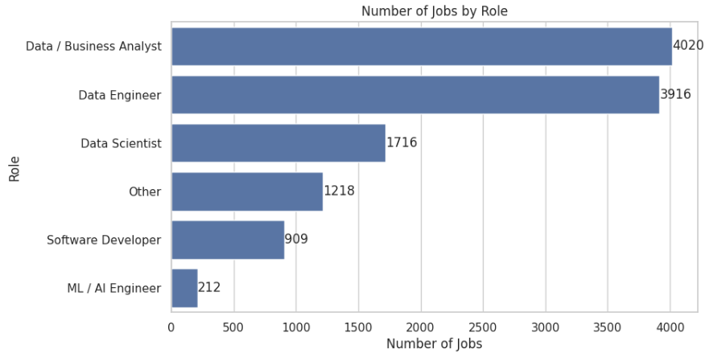
Chart 4 — Jobs by Experience Level
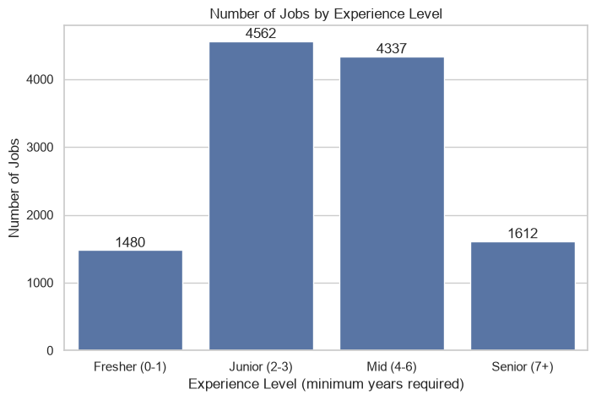
Chart 5 — Top 10 Skills for Fresher Jobs
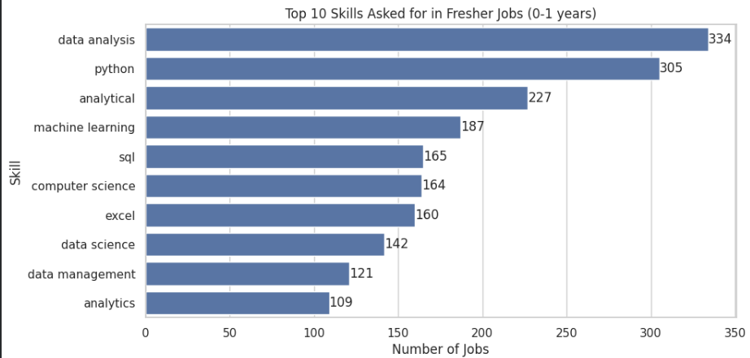

Conclusion
In this experiment, raw job-posting data was turned into a clean, analysis-ready dataset. Wrong experience values and duplicate rows were removed, text was transformed into numbers and lists, different spellings of the same city were merged, and new columns such as Role, Experience_Level and the skill flags were created. The data was then selected with loc[] and iloc[], and filtered with conditions, isin() and query().

