“Mamá, mamá! I want to show you the pose I invented! It’s called Idracandasana, *Branch Pose*. There are two ways you can do it. You can do it with blocks together, like this.

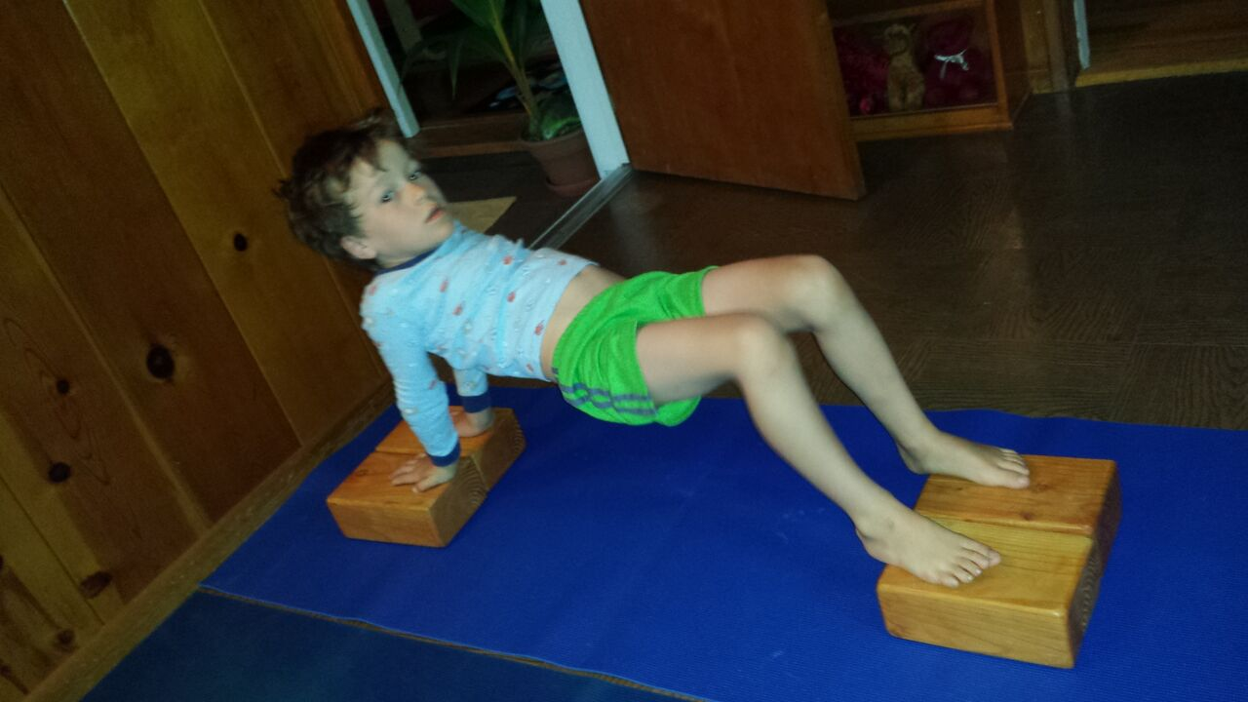

Or with blocks apart, like that. This is Idracandasana 1.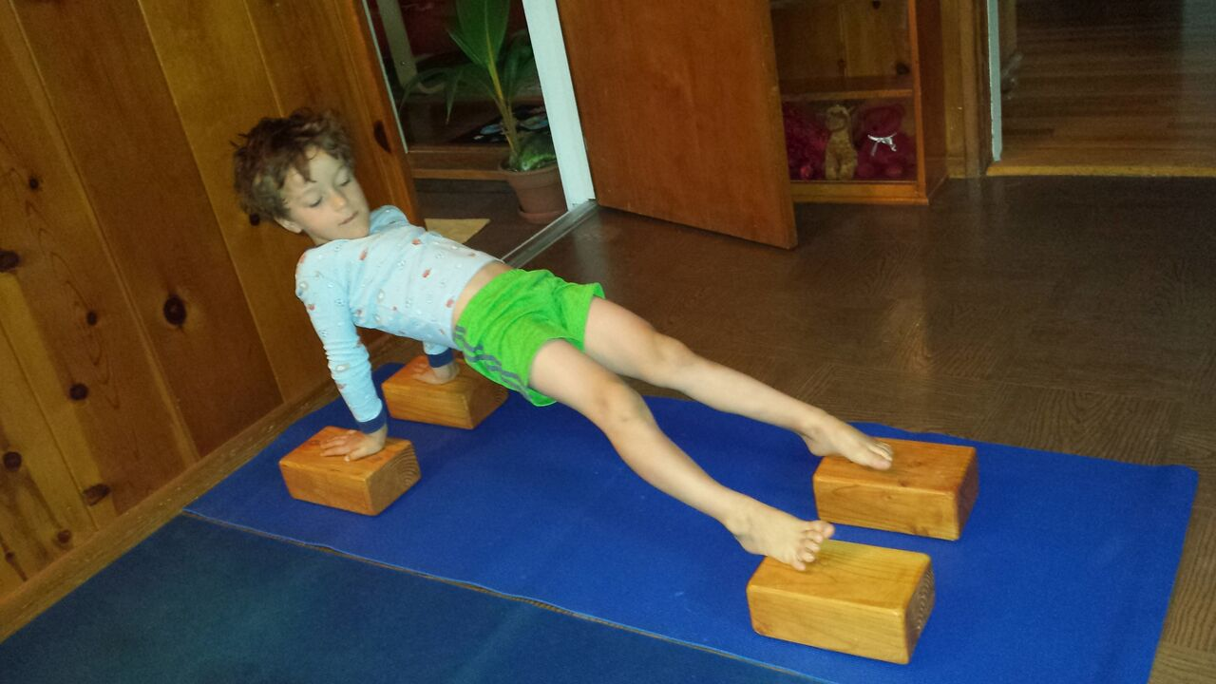

Now, this one is called Idracandasana II, *Dead Branch Pose”*.

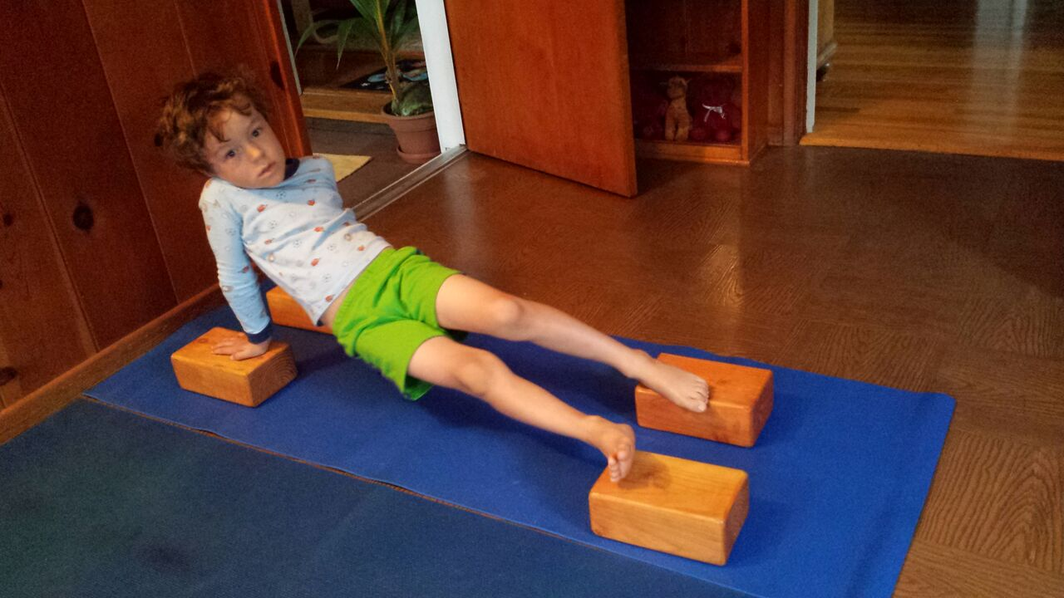

Guruji leaned his head back and laughed harder than I imagined he would as he was sitting on the bench, in front of the entrance to RIMYI. I presented him with these pictures in September 2013 when I went to Pune and told him the story of my son, Galileo, inventing these poses. I gave him the pictures in a humble montage that I put together; it was my present to him… I thought he made it possible for my son to do that, and so the pictures must be with him. My son had never seen me teaching and yet he knew what to do, he knew what was intuitive to him. I guess Guruji taught intuitively, in a way that made sense to the soul, to the body… in a way that made sense to a 5 year old boy. Perhaps, Guruji, too, saw the world with the eyes of a child... Innocent, full of wonder and full of inexplicable wisdom.

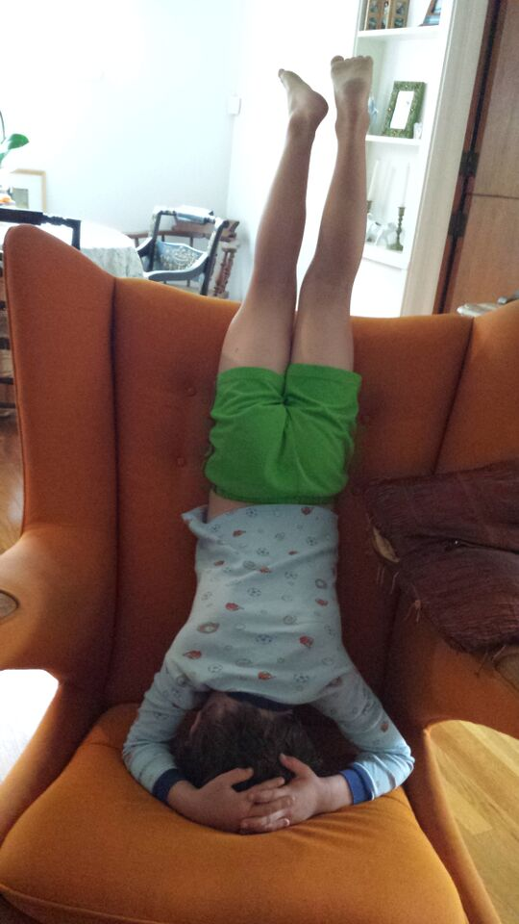

Then, I showed him the picture of my son doing Sirsasana but the expression on his face changed to one of disapproval. I quickly explained that as soon as I saw my son doing it I told him not to: that it wasn’t safe or good for him… that Guruji said children should not do it. I got greedy and wanted to get Guruji’s smile back! He softened his expression and I was relieved. He kept the pictures with him and took them to the practice hall. A few minutes later, I was thrilled to see the pictures I had given him on the windowsill where he used to practice.

That day I got Guruji’s smile, I got his laugh, I got his serious look. And, oh, was I shaking inside! But I learned from that interaction that he really walked the walk, that he was always true to himself and his believes… No matter if he had just been charmed by a woman from Puerto Rico who brought pictures of her 5 year old boy “inventing” Idracandasana.

Thank you, Guruji!