**Guidelines**

* Create all your resources in SharePoint folder shared with you over mail.  
  Follow below nomenclature for your file name:  
  *{GDTC_EMAIL_WITHOUT_DOMAIN}_SQL_Hands_On_{DD_MM_YY}.docx*  
  Example:   
  *Your Email*: [abc.def@godigitaltc.com](mailto:abc.def@godigitaltc.com)*File Name*: abc.def_SQL_Hands_On_10_06_25.docx
* Once document is created, copy view link of the file and enter the document link in below mentioned Sheet across your name:  
  {Insert Sheet Link}
* You will be using below Online SQL Editor to perform all your hands-on training  
  [Online SQL Editor](https://www.programiz.com/sql/online-compiler)
* Once your editor is opened, you need to run queries from two scripts in expected order
  + [DDL Script](https://godigitaltcllp.sharepoint.com/:u:/s/GDTC-InternsProcessDocumentation-PanelUpdates/EY1zAjKEuf9LlNut3G6BofsB9gxqSJb-tYiKSwYKYaAQLw?e=x3Q9ZQ): This is a DDL script which creates table needed for your hands-on to be executed first
  + [DML Script](https://godigitaltcllp.sharepoint.com/:u:/s/GDTC-InternsProcessDocumentation-PanelUpdates/EZjxLvRyHGNJnw_ipL3yNocBuxEn3CRh4Mlli4drwOB5yA?e=PVeENh): This is a DML script which creates table needed for your hands-on to be executed second

Tip: Copy all from the script, paste it in editor and click on “Run All”

Note: You may need to do this action every time you reload the editor page

* Once data is loaded, you can proceed with solving each question.
* For each question, you are expected to provide the query and the output.

Note: In some questions you may be asked to query for data based on certain data value which may or not match with actual data, you are expected to improvise and use data value as present in our data in that scenario.

**Hands-On Questions**

1. List all customers:

Query: Select * from customers  
Output: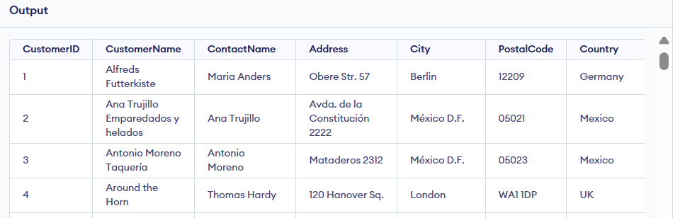

2. List all products:

Query: Select * from products  
Output: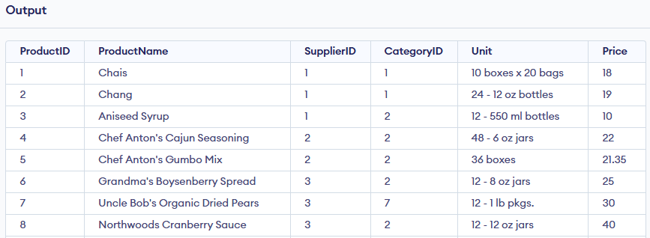

3. List all orders:

Query: Select * from orders  
Output: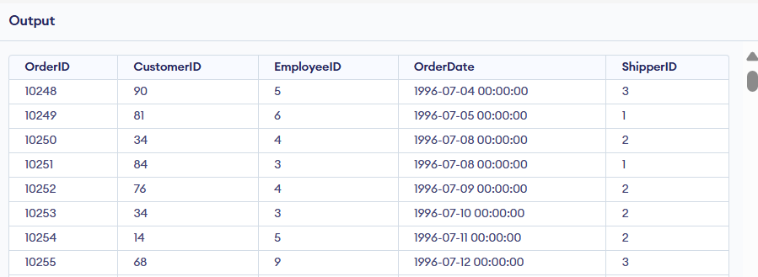

4. List all suppliers:

Query: Select * from suppliers  
Output: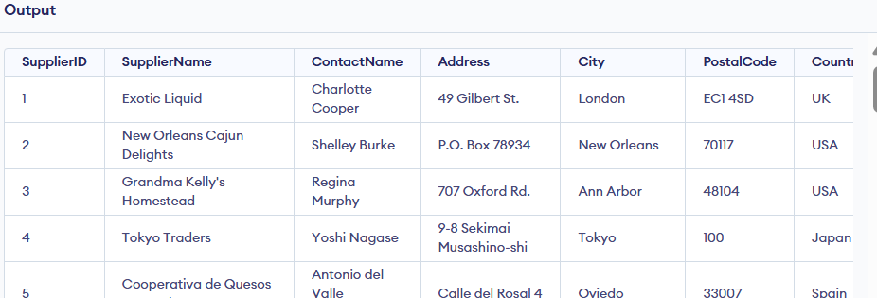

5. List all categories:

Query: Select * from categories  
Output: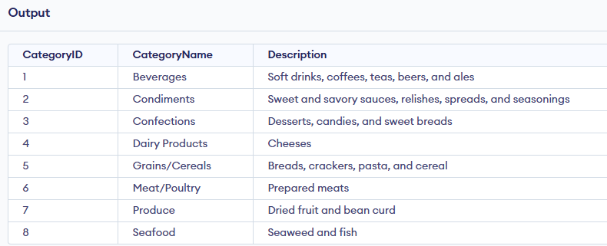

6. List all employees:

Query: Select * from employees  
Output: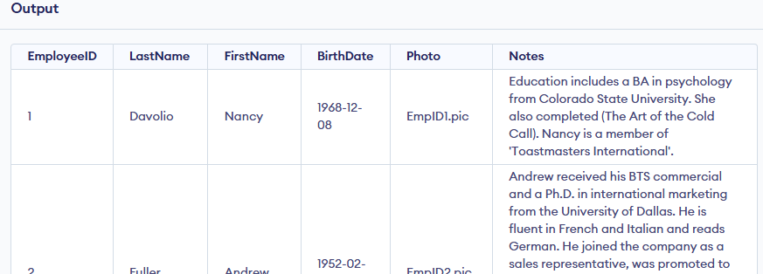

7. List all shippers:

Query: Select * from shippers  
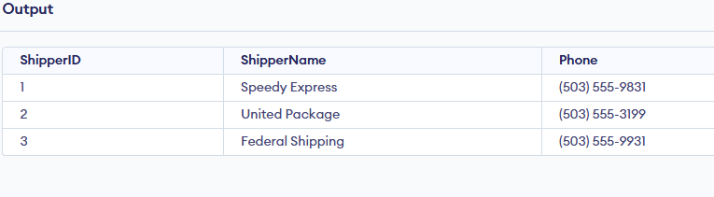

8. List all order details:

Query: Select * from orderDetails

Output: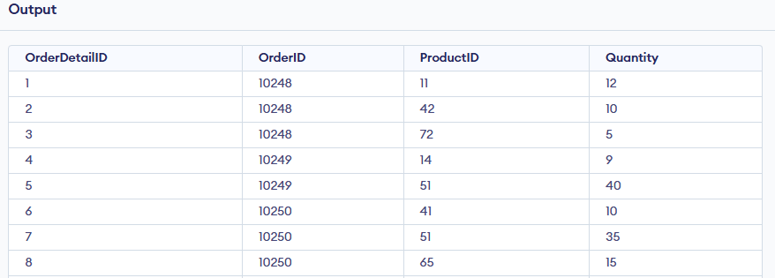

9. List all orders with customer details:

Query: Select * from orders as o

join customers as c on

o.CustomerID = c.CustomerID  
Output: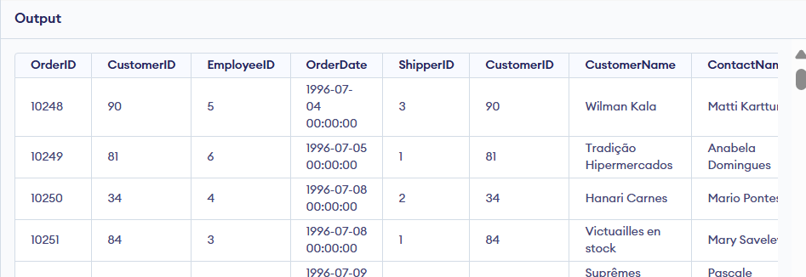

10. List all orders with employee details:

Query:

Select * from orders as o

join employees as e on

o.EmployeeID = e.EmployeeID  
Output: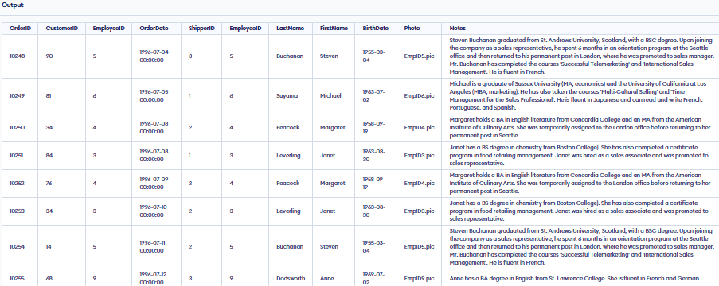

11. List all orders with shipper details:

Query:Select * from orders as o

join Shippers as e on

o.ShipperID = e.ShipperID

Output:

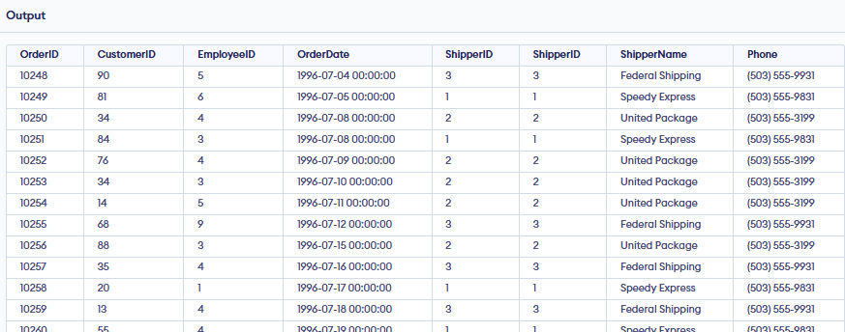

12. List all products along with their supplier and category:

Query:

Select * from products as p

join Suppliers as s

on p.SupplierID = s.SupplierID

join Categories as c

on p.CategoryID = c.CategoryID  
Output:  
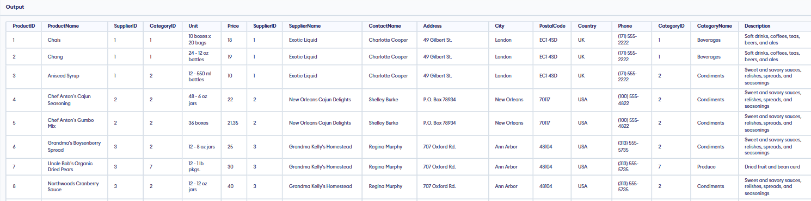

13. List all order details with product and category information:

Query:

Select * from OrderDetails as o

join Products as p

on p.ProductID = o.ProductID

join Categories as c

on p.CategoryID = c.CategoryID  
Output:

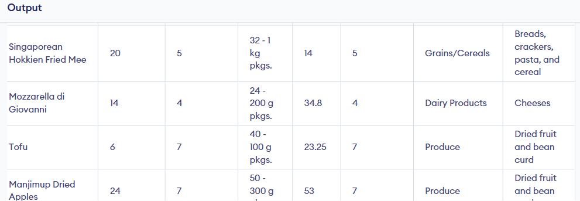

14. List all customers with their orders and the employees who handled them:

Query:

Select * from Customers as c

join Orders as o

on c.CustomerID = o.CustomerID

join Employees as e

on o.EmployeeID = e.EmployeeID  
Output: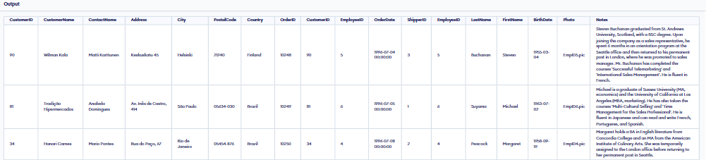

15. List all orders with product and supplier details:

Query:

Select * from Orders as o

join OrderDetails as d

on o.OrderID = d.OrderID

join Products as p

on d.ProductID = p.ProductID

join Suppliers as s

on p.SupplierID = s.SupplierID  
Output:

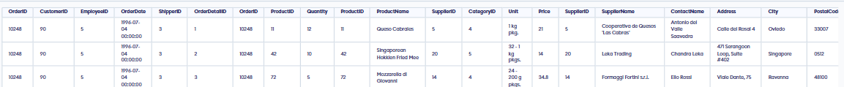

16. List all orders with customer, employee, and shipper details:

Query:

Select * from Orders as o

join Customers as d

on o.CustomerID = d.CustomerID

join Employees as e

on o.EmployeeID = e.EmployeeID

join Shippers as s

on o.ShipperID = s.ShipperID  
Output:  
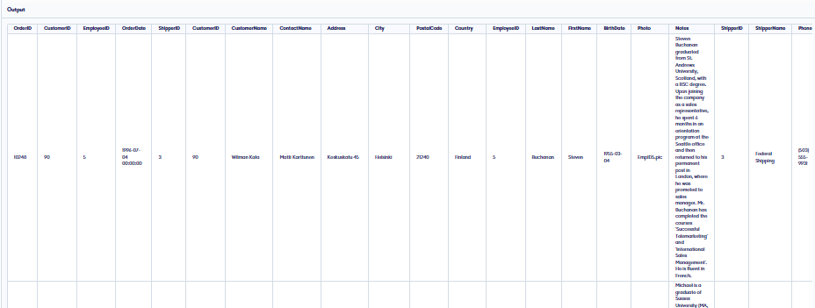

17. Count total number of orders:

Query: Select count(OrderID) from Orders   
Output: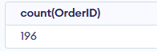

18. Count total number of products:

Query: Select count(ProductID) from Products   
Output:

19. Count total number of customers:

Query: Select count(CustomerID) from Customers   
Output: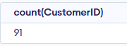

20. Find the total quantity of each product ordered:

Query: SELECT ProductID, SUM(Quantity) AS TotalQuantityOrdered

FROM OrderDetails

GROUP BY ProductID;  
Output: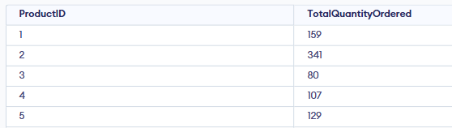

21. Find the total sales amount for each product:

Query: SELECT p.ProductName,SUM(od.Quantity * p.Price) AS TotalSalesAmount

FROM OrderDetails od

JOIN Products p ON od.ProductID = p.ProductID

GROUP BY p.ProductName;  
Output: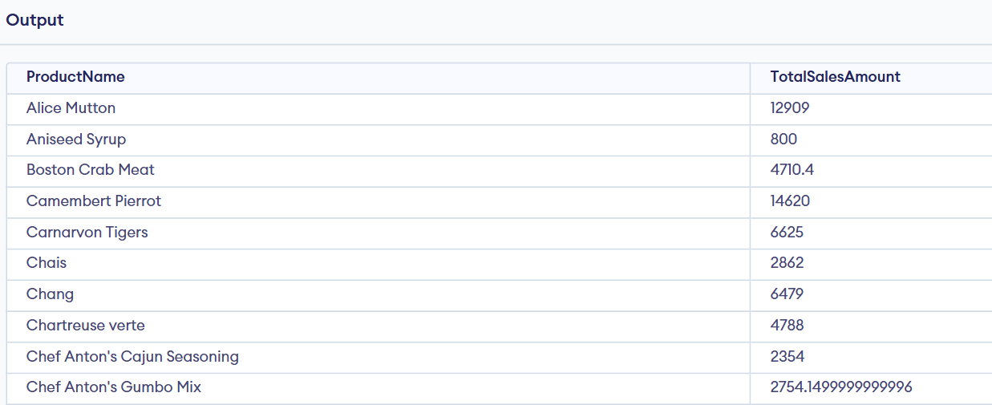

22. Find the average order total:

Query: SELECT avg(TotalSalesAmount)

from (select od.orderid, SUM(od.Quantity * p.Price) AS TotalSalesAmount

FROM OrderDetails od

JOIN Products p ON od.ProductID = p.ProductID

GROUP BY od.orderid) as orderTotal ;  
Output: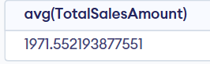

23. Find the maximum and minimum order quantities:

Query: select max(Quantity), min(Quantity) from OrderDetails  
Output:

24. Find the total revenue generated by each employee:

Query:

select e.EmployeeID,e.FirstName, e.LastName, sum(od.Quantity*p.Price) as TotalRevenue

from employees as e

join orders as o on e.EmployeeID = o.EmployeeID

join OrderDetails as od on o.OrderID = od.OrderID

join Products as p on od.ProductID = p.ProductID

GROUP BY e.EmployeeID, e.FirstName, e.LastName;  
Output: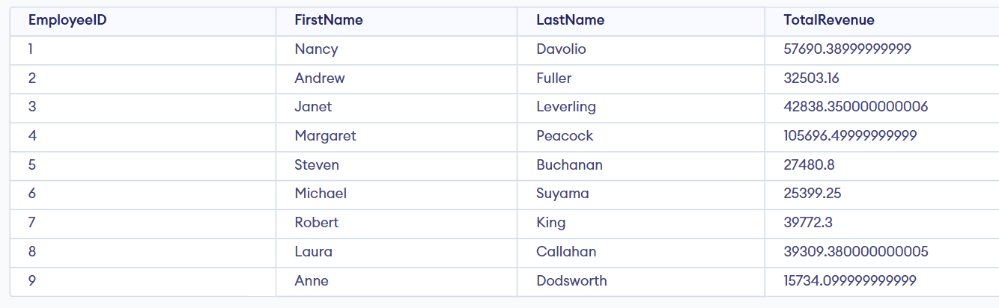

25. Find the number of orders placed by each customer:

Query: SELECT c.CustomerID, c.CustomerName,COUNT(o.OrderID) AS NumberOfOrders

FROM Customers c

LEFT JOIN Orders o ON c.CustomerID = o.CustomerID

GROUP BY c.CustomerID, c.CustomerName;  
Output: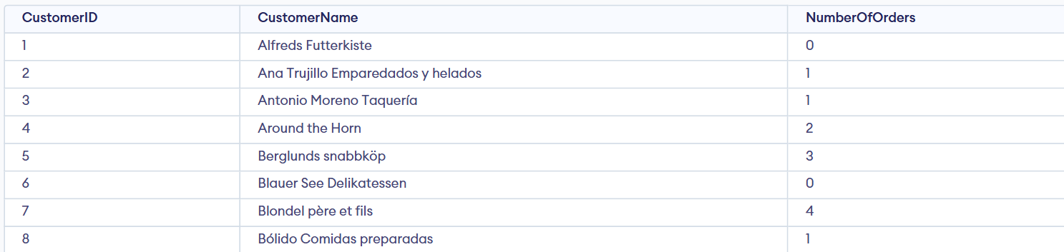

26. Find the number of products supplied by each supplier:

Query: SELECT s.SupplierID, s.SupplierName,COUNT(p.ProductID) AS NumberOfProduct

FROM Suppliers s

LEFT JOIN Products as p ON s.SupplierID = p.SupplierID

GROUP BY s.SupplierID, s.SupplierName;  
Output: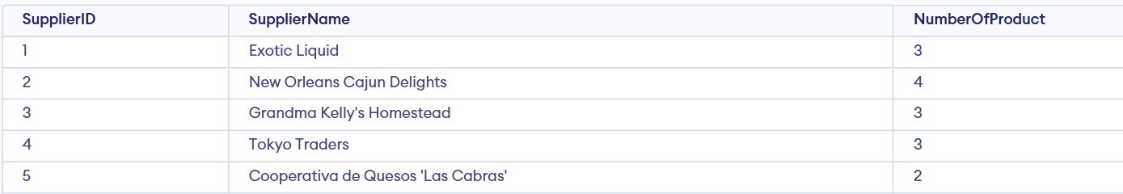

27. Find the total number of products in each category:

Query: SELECT c.CategoryID, c.CategoryName,COUNT(p.ProductID) AS NumberOfProduct

FROM Categories c

LEFT JOIN Products as p ON c.CategoryID = p.CategoryID

GROUP BY c.CategoryID, c.CategoryName;  
Output: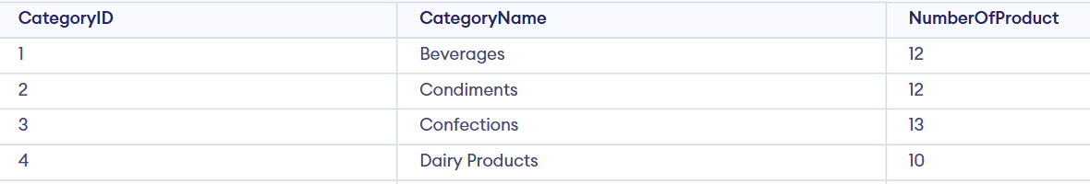

28. Find the total number of orders handled by each employee:

Query: SELECT e.EmployeeID,e.FirstName, e.LastName,COUNT(o.OrderID) AS NumberOfOrders

FROM Employees e

LEFT JOIN Orders as o ON e.EmployeeID = o.EmployeeID

GROUP BY e.EmployeeID,e.FirstName, e.LastName;  
Output: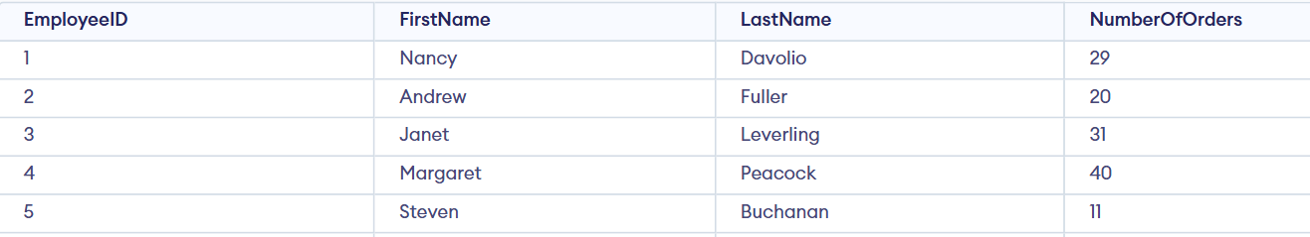

29. Find the average number of items per order:

Query: select avg(totalitem) from

(select OrderID, Sum(Quantity) as totalitem from OrderDetails

group by OrderID)  
Output: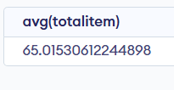

30. Find the highest and lowest order totals:

Query: select max(totalitem),min(totalitem) from

(select OrderID, Sum(Quantity) as totalitem from OrderDetails

group by OrderID)  
Output: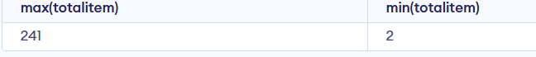

31. Find the total revenue generated by each supplier:

Query: select p.SupplierID,s.SupplierName , sum(p.Unit*p.Price) as totalrevenue

from Products as p

join Suppliers as s on p.SupplierID = s.SupplierID

group by s.SupplierID,s.SupplierName  
Output: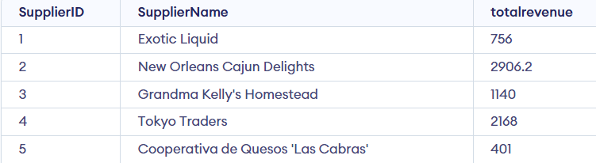

32. List all products with a unit price greater than $50:

Query: select ProductID,ProductName from Products

where Price> 50

Output: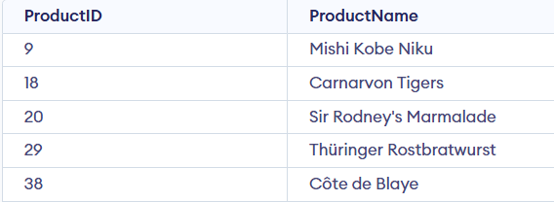

33. List all orders placed in the last 30 days:

Query: SELECT * FROM Orders

order by OrderDate DESC

limit 30;  
Output:  
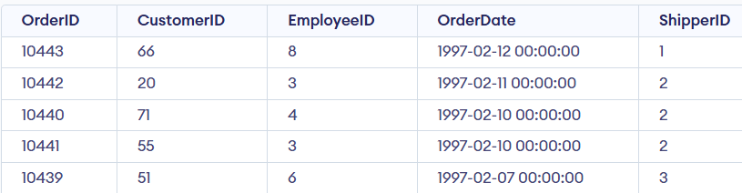

34. List all customers who have placed more than 5 orders:

Query: SELECT c.CustomerID,c.CustomerName, od.Quantity

FROM Customers as c

join Orders as o on c.CustomerID = o.CustomerID

join OrderDetails as od on o.OrderID = od.OrderID

where od.Quantity>5

Output:

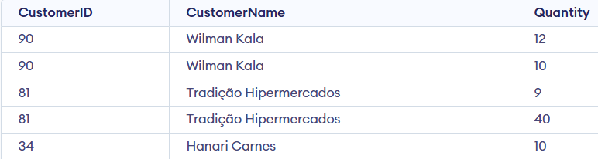

35. List all employees who have handled orders worth more than $10,000:

Query:

select e.EmployeeID,e.FirstName|| ' ' || e.LastName as name, sum(od.Quantity * p.Price) as totalamount

from Employees as e

join orders as o on e.EmployeeID = o.EmployeeID

join OrderDetails as od on o.OrderID = od.OrderID

join Products as p on od.ProductID = p.ProductID

group by e.EmployeeID, name  
having totalamount>10000;  
Output:

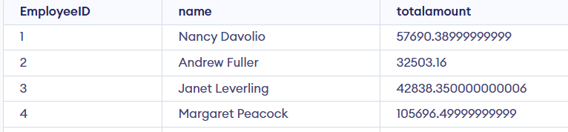

36. List all products supplied by 'Supplier A':

Query: select ProductID,ProductName from Products as p

join Suppliers as s on p.SupplierID =s.SupplierID

group by p.SupplierID

having s.SupplierID = 1  
Output:

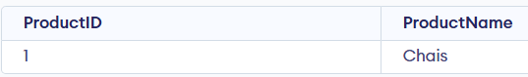

37. List all orders shipped by 'Shipper B':

Query:  
select * from Orders as o

join Shippers as s on o.ShipperID = s.ShipperID

group by s.ShipperID

having s.ShipperID = 2  
Output:

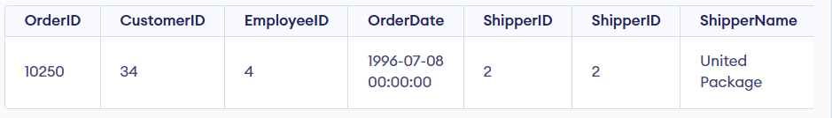

38. List all orders placed by 'Customer C':

Query:

select * from Orders as o

join Customers as c on o.CustomerID = c.CustomerID

group by c.CustomerID

having c.CustomerID = 3  
Output:

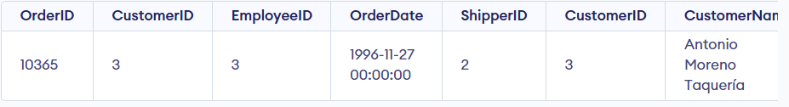

39. List all products in the 'Electronics' category:

Query: select * from Products as p

join Categories as c on p.CategoryID = c.CategoryID

group by c.CategoryName

having c.CategoryName = "Electronics"  
Output:

40. List all employees who have not handled any orders:

Query: select * from Employees as e

LEFT JOIN Orders o ON e.EmployeeID = o.EmployeeID

WHERE o.OrderID IS NULL;  
Output:

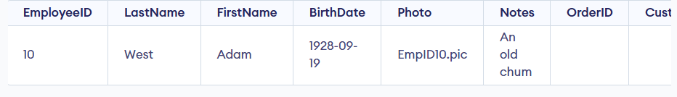

41. List all customers who have not placed any orders:

Query: select * from Customers as c

LEFT JOIN Orders o ON c.CustomerID = o.CustomerID

WHERE o.OrderID IS NULL;  
Output: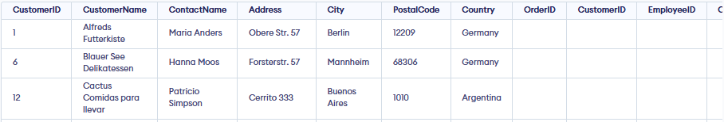

42. List all orders where the total order amount is greater than the average order amount:

Query:

with total_order_amount as ( select od.OrderID, sum(od.Quantity*p.Price) as order_amount from OrderDetails as od join Products as p on od.ProductID = p.ProductID group by od.orderID)

select * from total_order_amount where order_amount>(select avg(order_amount) from total_order_amount)  
Output: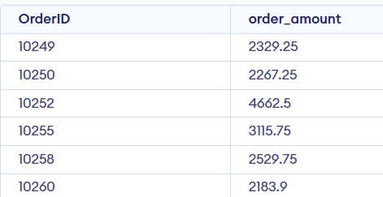

43. Find the product with the highest sales amount:

Query: select p.ProductID,p.ProductName, sum(od.Quantity * p.Price) as total_amount

from Products as p

join OrderDetails as od on p.ProductID = od.ProductID

group by p.ProductID,p.ProductName

order by total_amount desc

limit 1  
Output: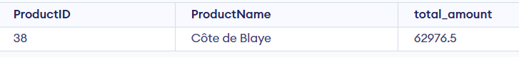

44. Find the customers who have placed the highest number of orders:

Query: with customer_order as (select c.CustomerID, c.CustomerName, count(o.OrderID) as order_count from Customers as c join Orders as o on c.CustomerID = o.CustomerID group by c.CustomerID, c.CustomerName )

select * from customer_order where order_count = (select Max(order_count) from customer_order)  
Output:

45. List the most popular products based on order quantity:

Query: select p.ProductID,p.ProductName, sum(od.quantity) as order_quantity from Products as p

join OrderDetails as od on p.ProductID = od.ProductID

group by p.ProductID,p.ProductName

order by order_quantity desc

Output: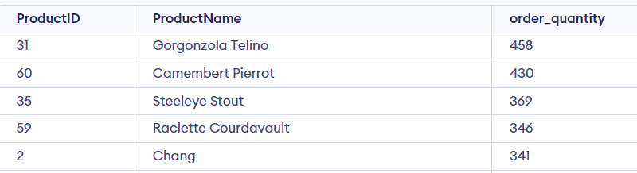

46. List all customers who have placed orders worth more than $5000:

Query:

select c.CustomerID, c.CustomerName, sum(od.quantity*p.price) as amount from Customers as c join Orders as o on c.CustomerID = o.CustomerID join OrderDetails as od on o.OrderID=od.OrderID join Products as p on od.ProductID = p.ProductID group by c.CustomerID, c.CustomerName having amount > 5000  
Output: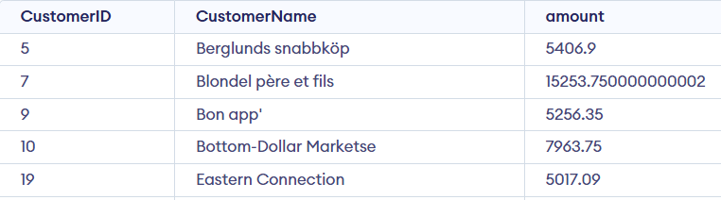

47. Find the top 5 most expensive products:

Query: select p.ProductID, p.ProductName, sum(od.quantity*p.price) as amount

from products as p

join OrderDetails as od on p.ProductID = od.ProductID

group by p.ProductID, p.ProductName

order by amount desc

limit 5  
Output: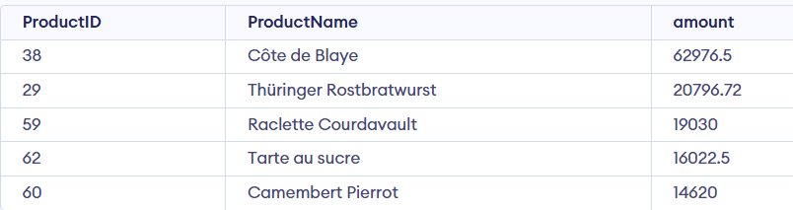

48. List all products that have never been ordered:

Query: select p.ProductID,p.ProductName from Products as p

left join OrderDetails as od on p.ProductID = od.ProductID

group by p.ProductID,p.ProductName

having od.OrderID is null  
Output:49. List all employees along with the number of orders they have handled:

Query: select e.EmployeeID, e.FirstName || ' ' || e.LastName as name , count(o.OrderID) as orders_handel from Employees as e

left join Orders as o on e.EmployeeID=o.EmployeeID

group by e.EmployeeID, name  
Output: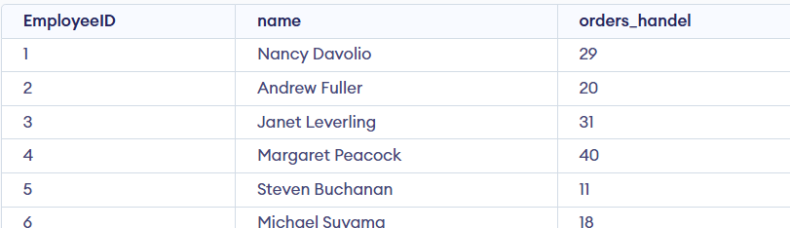

50. List all suppliers who supply products in the 'Electronics' category:

Query: select s.SupplierID, s.SupplierName from Suppliers as s

left join Products as p on s.SupplierID = p.SupplierID

left join Categories as c on p.CategoryID = c.CategoryID

group by s.SupplierID, s.SupplierName

having CategoryName="Electronics"  
Output:

51. Find the employees who have handled the fewest orders:

Query:

with orderCount as

(select e.EmployeeID, e.FirstName || ' ' || e.LastName as name,count(o.OrderID) as totalOrder from employees as e

left join Orders as o on e.EmployeeID = o.EmployeeID

group by e.EmployeeID, name)

Select * from orderCount

where totalOrder = (select min(totalOrder) from orderCount)  
Output: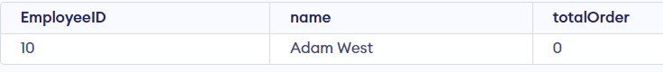

52. Calculate the running total of orders over time:

Query: with order_totals as ( select o.orderid,o.orderdate, sum(od.quantity * p.price) as order_total from orders o join orderdetails od on o.orderid = od.orderid join products p on od.productid = p.productid group by o.orderid )

select orderid,orderdate,order_total, sum(order_total) over (order by orderdate) as running_total_revenue from order_totals order by orderdate;  
Output: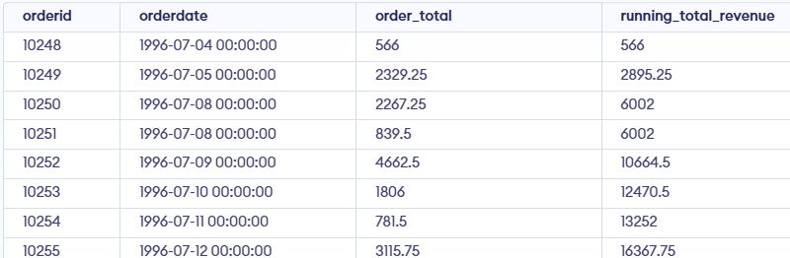

53. Rank customers by the total amount spent:

Query: select c.CustomerID, c.CustomerName, sum(od.quantity*p.price) as amountSpent, rank () over(order by sum(od.quantity*p.price) desc) as rank

from Customers as c join Orders as o on c.CustomerID = o.CustomerID

join OrderDetails as od on o.OrderID = od.OrderID

join Products as p on od.ProductID = p.ProductID

group by c.CustomerID  
Output:

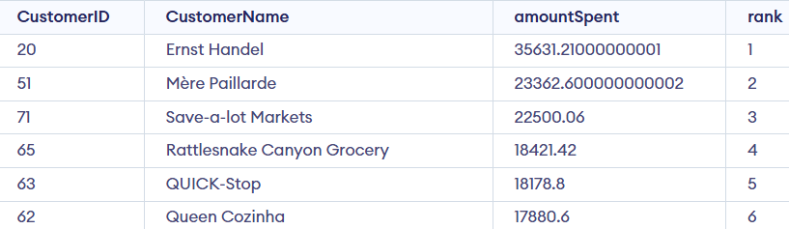

54. Calculate the difference in order totals between consecutive orders:

Query:

with orderTotal as (

select o.OrderID, sum(od.Quantity*p.price) as TotalAmount from Orders o

join OrderDetails od on o.OrderID = od.OrderID

join Products p on od.ProductID = p.ProductID

group by o.OrderID)

select OrderID, TotalAmount,

LAG(TotalAmount) over (order by ot.OrderID) as previousTotal,

TotalAmount - LAG(TotalAmount) over (order by ot.OrderID) as Difference

from orderTotal as ot  
Output:

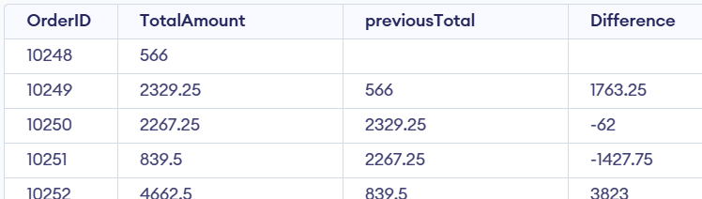

55. Calculate the cumulative total for each customer:

Query:

with cte as (select c.CustomerID, c.CustomerName,o.OrderID,o.OrderDate,

SUM(od.Quantity * p.Price) AS OrderTotal

FROM Customers c

JOIN Orders o ON c.CustomerID = o.CustomerID

JOIN OrderDetails od ON o.OrderID = od.OrderID

JOIN Products p ON od.ProductID = p.ProductID

GROUP BY c.CustomerID, c.CustomerName, o.OrderID, o.OrderDate)

select CustomerID, CustomerName,OrderID,OrderDate, OrderTotal,

sum(OrderTotal) over (partition by CustomerID order by OrderDate) as cumulative_total

from cte  
Output: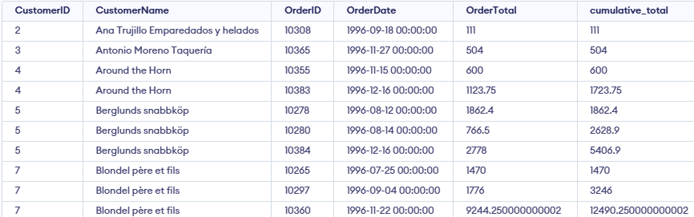

56. Rank products by total quantity ordered:

Query: select p.ProductID, p.ProductName , sum(od.quantity) as total_quantity, rank() over(order by sum(od.quantity) ) as Rank from Products as p join OrderDetails as od on p.ProductID = od.ProductID group by p.ProductID, p.ProductName

Output: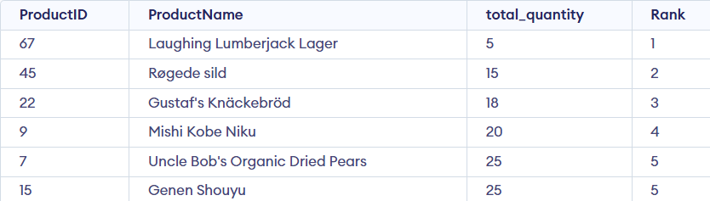

57. Calculate the average order total by employee:

Query:

with Total as (select e.EmployeeID,o.orderid, sum(od.Quantity*p.price) as TotalAmount from Employees e join Orders o on e.EmployeeID=o.EmployeeID join OrderDetails od on o.OrderID=od.OrderID join Products p on od.ProductID = p.ProductID group by e.EmployeeID,o.orderid)

select e.EmployeeID, e.FirstName || ' ' || e.LastName as name, avg(TotalAmount) as Average_order_total from Employees e join Total t on e.EmployeeID = t.EmployeeID group by e.EmployeeID, e.FirstName,e.LastName

Output: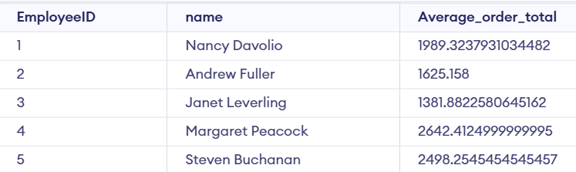

58. Find the difference between the highest and lowest product prices:

Query: select max(Price),min(Price), max(Price)-min(Price) as Difference_in_price from Products  
Output: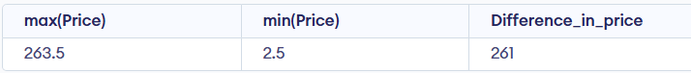

59. Calculate the percentage contribution of each order to the total revenue:

Query: with totalrevenue as ( select od.ProductID, sum(od.Quantity*p.Price) as totalamount from orders o join OrderDetails od on o.OrderID=od.OrderID join Products p on od.ProductID = p.ProductID )

select od.OrderID,round((sum(od.Quantity*p.Price)\**100)/t.totalamount,2) as contributon,sum(od.Quantity*p.Price) from totalrevenue as t join OrderDetails od on t.ProductID= od.ProductID join Products p on od.ProductID = p.ProductID group by od.OrderID

Output: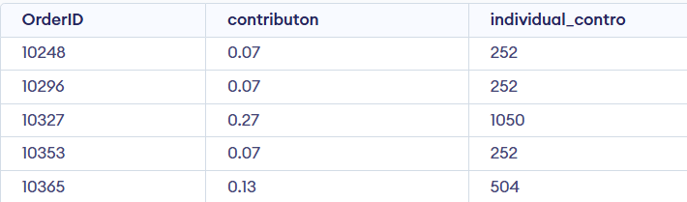

60. Calculate the moving average of order totals over a 3-order window:

Query: with orderTotal as (select od.orderid,sum(od.Quantity) as total_orders from orderdetails od

join Products p on od.ProductID = p.ProductID group by od.orderid)

select o.orderid,o.OrderDate,ot.total_orders,avg(ot.total_orders) over (order by o.orderdate rows between 2 preceding and current row) as moving_avg  
 from orderTotal ot join orders o on ot.orderid = o.orderid order by ot.orderid  
  
Output: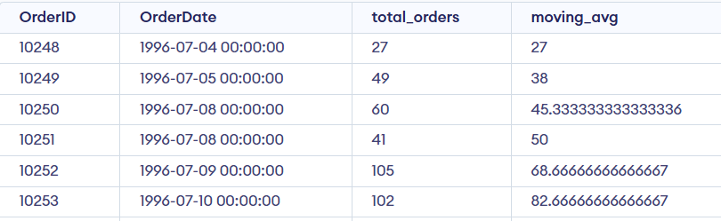

61. Rank customers by the number of orders they have placed:

Query: select c.CustomerID, c.CustomerName, count(o.OrderID) as NO_of_orders, rank() over (order by count(o.OrderID) desc) as rank from Customers c join Orders o on c.CustomerID = o.CustomerID group by c.CustomerID, c.CustomerName order by rank;  
Output: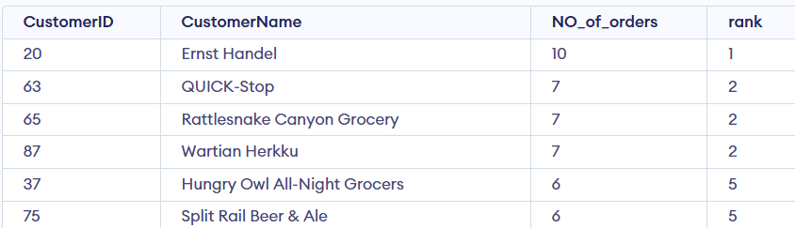

62. Calculate the total revenue for each supplier by year:

Query: select s.SupplierID,s.SupplierName,strftime("%Y",o.OrderDate) as year, sum(od.Quantity*p.price) as revenue from Suppliers s

join Products p ON s.SupplierID = p.SupplierID

join OrderDetails od ON p.ProductID = od.ProductID

join Orders o ON od.OrderID = o.OrderID

group by s.SupplierID, s.SupplierName, strftime('%Y', o.OrderDate)  
Output: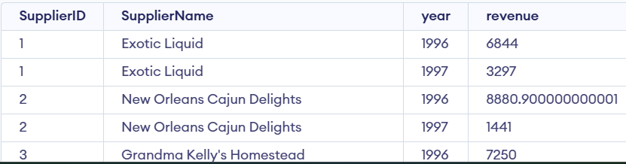

63. List the average order amount by employee:

Query:

with orderamount as (select e.EmployeeID, e.FirstName || ' ' || e.LastName as name,sum(od.Quantity*p.price) as Order_amount

from Employees e

join Orders o on e.EmployeeID = o.EmployeeID

join OrderDetails od on o.OrderID = od.OrderID

join Products p on od.ProductID = p.ProductID

group by e.EmployeeID, e.FirstName,e.LastName)

select EmployeeID, name, avg(Order_amount) as average

from orderamount

group by EmployeeID, name  
Output: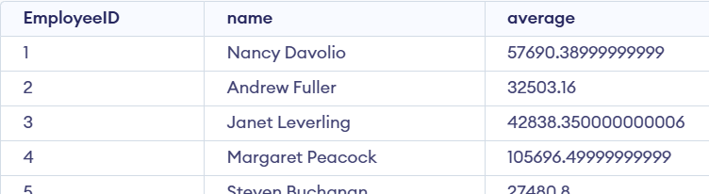

64. List the top 3 categories by sales amount:

Query: select c.categoryid,c.categoryname,

sum(od.quantity * p.price) as totalsales

from categories c

join products p on c.categoryid = p.categoryid

join orderdetails od on p.productid = od.productid

group by c.categoryid, c.categoryname

order by totalsales desc

limit 3;

Output: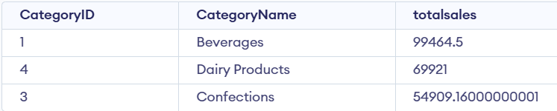

65. Calculate the total quantity ordered for each product by month:

Query:

select p.productid,p.productname, strftime('%Y-%m', o.orderdate) as order_month, sum(od.quantity) as total_quantity from products p join orderdetails od on p.productid = od.productid join orders o on od.orderid = o.orderid group by p.productid, p.productname, order_month order by order_month, total_quantity   
Output: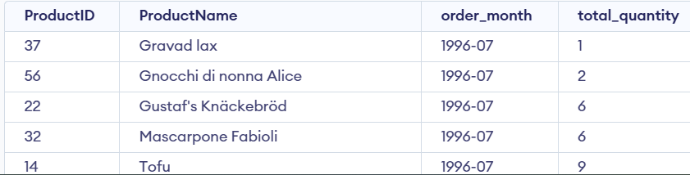

66. List the total revenue generated by each product in the last 6 months:

Query:

select p.productid,p.productname,

sum(od.quantity * p.price) as total_revenue from products p

join orderdetails od on p.productid = od.productid

join orders o on od.orderid = o.orderid

where date(o.orderdate) >= "1996-08"

group by p.productid, p.productname

order by total_revenue desc;

Output: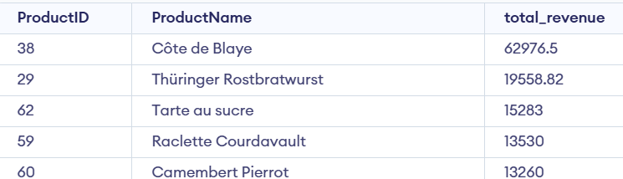

67. Calculate the total sales for each customer by year:

Query:

select c.customerid,c.customername, strftime('%Y', o.orderdate) as order_year, sum(od.quantity) as total_sales from customers c join orders o on c.customerid = o.customerid join orderdetails od on o.orderid = od.orderid join products p on od.productid = p.productid group by c.customerid, c.customername, order_year order by order_year, total_sales ;  
Output:

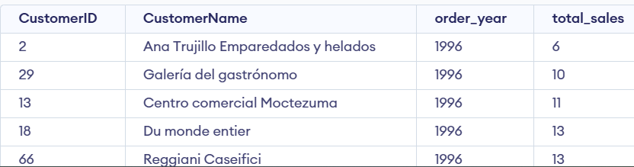

68. List the average quantity ordered per product:

Query:

select p.productid,p.productname,

round(avg(od.quantity),2) as average_quantity

from products p

join orderdetails od on p.productid = od.productid

group by p.productid, p.productname

order by p.productid;  
Output: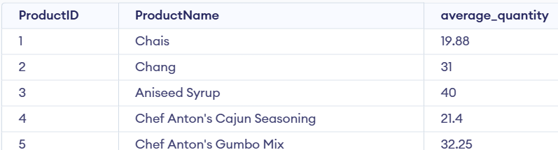

69. Calculate the total number of products ordered per category:

Query: select c.categoryid,c.categoryname, sum(od.quantity) as total_products_ordered from categories c join products p on c.categoryid = p.categoryid join orderdetails od on p.productid = od.productid group by c.categoryid, c.categoryname order by c.categoryid;  
Output: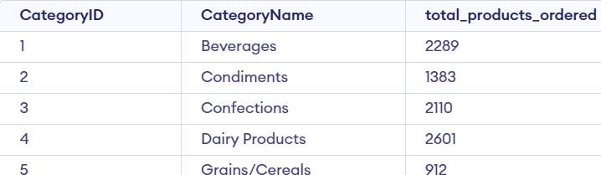

70. List the number of products ordered per supplier:

Query: select s.supplierid,s.suppliername, sum(od.quantity) as total_products_ordered from suppliers s join products p on s.supplierid = p.supplierid join orderdetails od on p.productid = od.productid group by s.supplierid, s.suppliername order by s.supplierid,s.suppliername;

Output: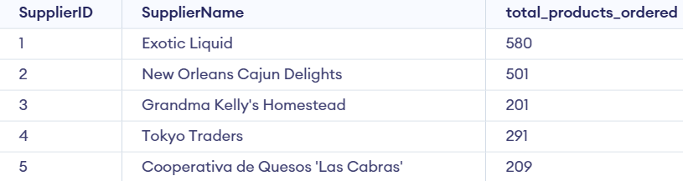

71. Find the average sales amount per order by category:

Query:

with category_order_totals as ( select c.categoryid,c.categoryname,o.orderid, sum(od.quantity * p.price) as order_total from categories c join products p on c.categoryid = p.categoryid join orderdetails od on p.productid = od.productid join orders o on od.orderid = o.orderid group by c.categoryid, c.categoryname, o.orderid )

select categoryid, categoryname, round(avg(order_total), 2) as avg_sales_per_order from category_order_totals group by categoryid, categoryname  
Output: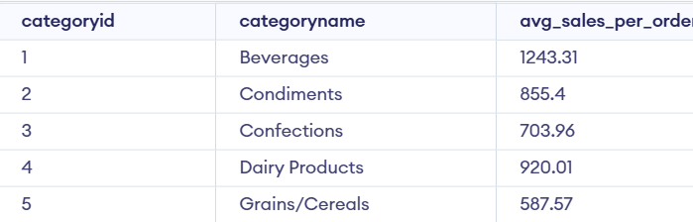

72. Calculate the total number of orders per customer by year:

Query: --Calculate the total number of orders per customer by year with total_no_orders as (select c.customerid, c.CustomerName,strftime("%Y",OrderDate) as order_year,count(o.OrderID) as total_order from Customers as c join Orders as o on c.customerid=o.customerid group by c.customerid, c.CustomerName,order_year )

select customerid,CustomerName,order_year,total_order from total_no_orders  
Output: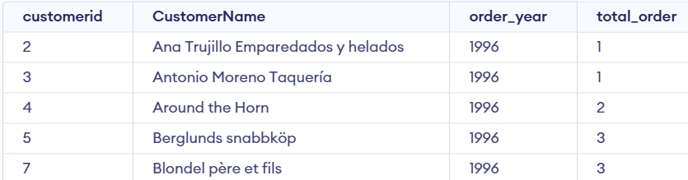

73. List the top 5 suppliers by total quantity supplied:

Query: select s.supplierid,s.suppliername, sum(od.quantity) as total_quantity_supplied from suppliers s join products p on s.supplierid = p.supplierid join orderdetails od on p.productid = od.productid group by s.supplierid, s.suppliername order by total_quantity_supplied desc limit 5;  
Output: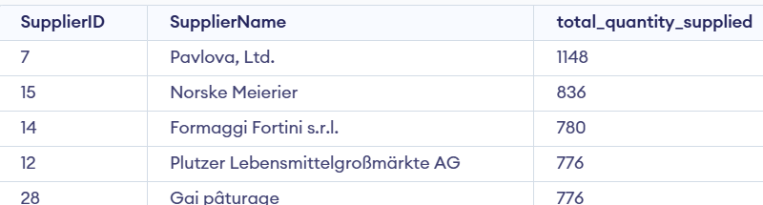

74. Calculate the total revenue for each category by month:

Query: select c.categoryid,c.categoryname,

strftime('%Y-%m', o.orderdate) as order_month,

sum(od.quantity * p.price) as total_revenue

from categories c

join products p on c.categoryid = p.categoryid

join orderdetails od on p.productid = od.productid

join orders o on od.orderid = o.orderid

group by c.categoryid, c.categoryname, order_month  
Output: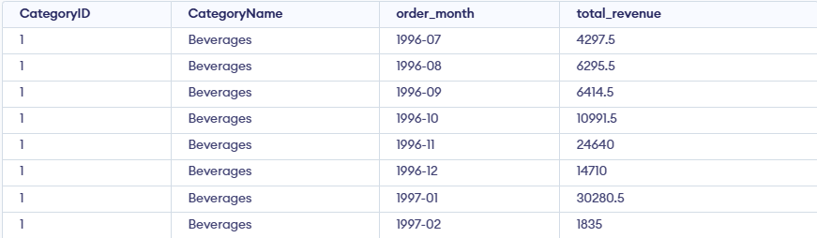

75. Find the average order amount for each employee:

Query:with order_totals as ( select e.employeeid, e.firstname || ' ' || e.lastname as employeename, o.orderid, sum(od.quantity * p.price) as order_total from employees e join orders o on e.employeeid = o.employeeid join orderdetails od on o.orderid = od.orderid join products p on od.productid = p.productid group by e.employeeid, o.orderid )

select employeeid, employeename, round(avg(order_total), 2) as avg_order_amount from order_totals group by employeeid, employeename  
Output: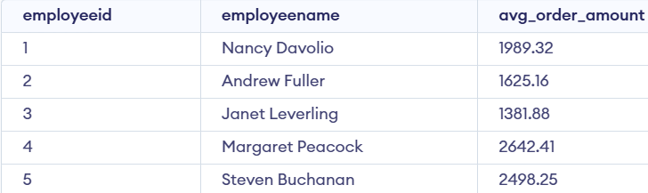

76. List all products that are supplied by more than one supplier:

Query: select productid, count(distinct supplierid) as supplier_count

from products

group by productid

having supplier_count > 1;  
Output:

77. List the most frequently ordered product in each category:

Query: with product_quantity as (

select c.categoryid,c.categoryname,p.productid,p.productname,

sum(od.quantity) as total_quantity,

row_number() over (partition by c.categoryid order by sum(od.quantity) desc) as rnk

from categories c

join products p on c.categoryid = p.categoryid

join orderdetails od on p.productid = od.productid

group by c.categoryid, c.categoryname, p.productid, p.productname)

select categoryid,categoryname,productid, productname, total_quantity

from product_quantity

where rnk = 1;

Output: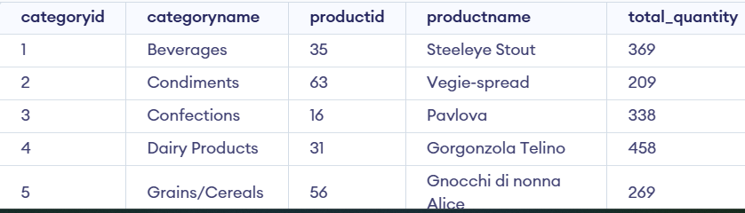

78. Calculate the total revenue for each product by quarter:

Query: with product_sales as (

select p.productid, p.productname ,strftime('%Y', o.orderdate) as order_year,

case

when cast(strftime('%m', o.orderdate) as integer) between 1 and 3 then 'Q1'

when cast(strftime('%m', o.orderdate) as integer) between 4 and 6 then 'Q2'

when cast(strftime('%m', o.orderdate) as integer) between 7 and 9 then 'Q3'

when cast(strftime('%m', o.orderdate) as integer) between 10 and 12 then'Q4'

end as quarter,

sum(od.quantity * p.price) as total_revenue

from orderdetails od

join orders o on od.orderid = o.orderid

join products p on od.productid = p.productid

group by p.productid, order_year, quarter)

select * from product_sales

Output: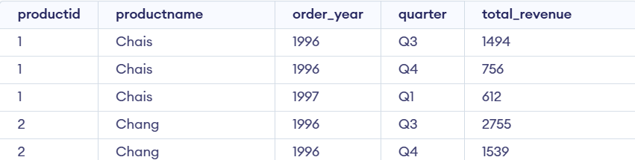

79. List all customers who have placed orders in every quarter of the year:

Query: with customer_quarters as (

select c.customerid,c.customername,

strftime('%Y', o.orderdate) as year,

case

when cast(strftime('%m', o.orderdate) as integer) between 1 and 3 then 'Q1'

when cast(strftime('%m', o.orderdate) as integer) between 4 and 6 then 'Q2'

when cast(strftime('%m', o.orderdate) as integer) between 7 and 9 then 'Q3'

when cast(strftime('%m', o.orderdate) as integer) between 10 and 12 then 'Q4'

end as quarter

from customers c

join orders o on c.customerid = o.customerid

group by c.customerid, year, quarter),

quarter_counts as (

select customerid, customername, year,

count(distinct quarter) as quarters_ordered

from customer_quarters

group by customerid, year)

select customerid, customername, year

from quarter_counts

where quarters_ordered = 4

80. Find the total revenue generated by each employee:

Query: select e.employeeid, e.firstname || ' ' || e.lastname as employee_name,

sum(od.quantity * p.price) as total_revenue

from employees e

join orders o on e.employeeid = o.employeeid

join orderdetails od on o.orderid = od.orderid

join products p on od.productid = p.productid

group by e.employeeid, e.firstname, e.lastname  
Output: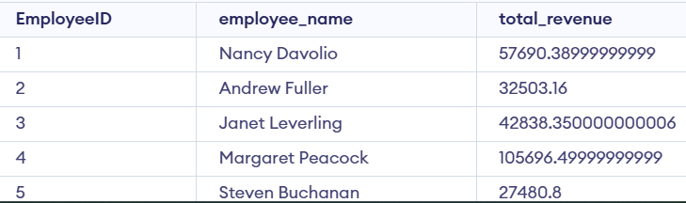

81. List the top 10 products by revenue for each supplier:

Query: with product_revenue as ( select s.supplierid,s.suppliername,p.productid,p.productname, round(sum(od.quantity * p.price),2) as total_revenue from suppliers s join products p on s.supplierid = p.supplierid join orderdetails od on p.productid = od.productid join orders o on od.orderid = o.orderid group by s.supplierid, p.productid ),

ranked_products as ( select *, row_number() over (partition by supplierid order by total_revenue desc) as rank from product_revenue )

select supplierid,suppliername,productid, productname, total_revenue from ranked_products where rank <= 10  
Output: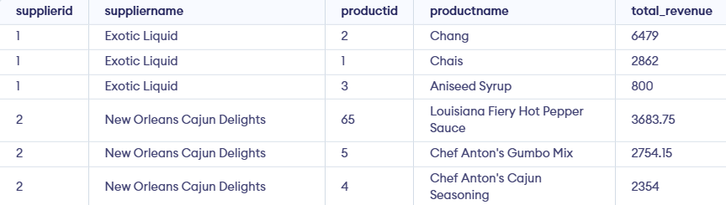

82. Calculate the total quantity ordered for each category by quarter:

Query: select c.categoryid, c.categoryname,

case

when cast(strftime('%m', o.orderdate) as integer) between 1 and 3 then 'Q1'

when cast(strftime('%m', o.orderdate) as integer) between 4 and 6 then 'Q2'

when cast(strftime('%m', o.orderdate) as integer) between 7 and 9 then 'Q3'

when cast(strftime('%m', o.orderdate) as integer) between 10 and 12 then 'Q4'

end as quarter,

sum(od.quantity) as total_quantity

from categories c

join products p on c.categoryid = p.categoryid

join orderdetails od on p.productid = od.productid

join orders o on od.orderid = o.orderid

group by c.categoryid, quarter  
Output: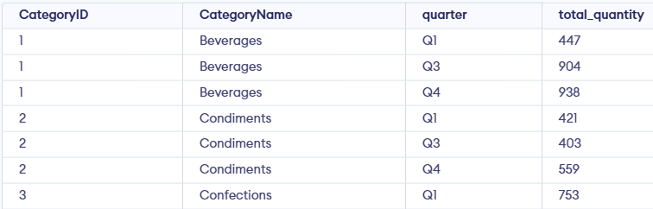

83. List the top 5 employees by total revenue generated:

Query: select e.employeeid, e.firstname || ' ' || e.lastname as employeename,

sum(od.quantity * p.price) as total_revenue

from employees e

join orders o on e.employeeid = o.employeeid

join orderdetails od on o.orderid = od.orderid

join products p on od.productid = p.productid

group by e.employeeid

order by total_revenue desc

limit 5;  
Output: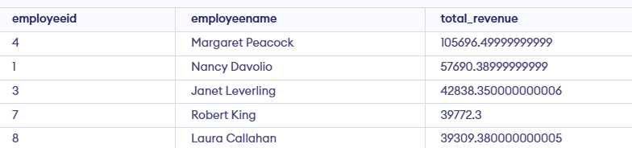

84. Find the most popular shipping method by total orders shipped:

Query: select s.shipperid,s.shippername,

count(o.orderid) as total_orders

from shippers s

join orders o on s.shipperid = o.shipperid

group by s.shipperid, s.shippername

order by total_orders desc

limit 1;  
Output:

85. Calculate the total revenue for each shipper by year:

Query: select s.shipperid,s.shippername,

strftime('%Y', o.orderdate) as order_year,

round(sum(od.quantity * p.price),2) as total_revenue

from shippers s

join orders o on s.shipperid = o.shipperid

join orderdetails od on o.orderid = od.orderid

join products p on od.productid = p.productid

group by s.shipperid, order_year  
Output: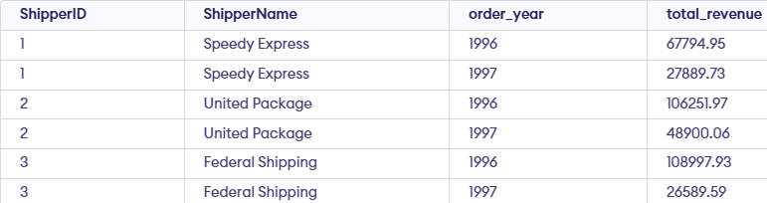

86. List all products that have never been ordered:

Query: select p.productid, p.productname

from products p

left join orderdetails od on p.productid = od.productid

where od.productid is null;  
Output:

87. List the total sales amount for each supplier by year:

Query: select s.supplierid,s.suppliername,

strftime('%Y', o.orderdate) as order_year,

sum(od.quantity * p.price) as total_sales

from suppliers s

join products p on s.supplierid = p.supplierid

join orderdetails od on p.productid = od.productid

join orders o on od.orderid = o.orderid

group by s.supplierid, order_year  
Output: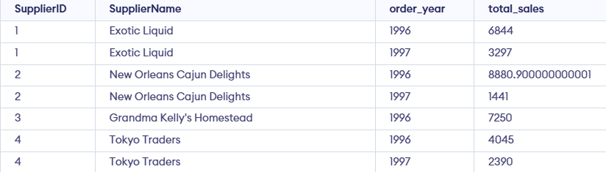

88. Calculate the average order amount by customer:

Query: with customer_orders as ( select c.customerid,c.customername,o.orderid, sum(od.quantity * p.price) as order_total from customers c join orders o on c.customerid = o.customerid join orderdetails od on o.orderid = od.orderid join products p on od.productid = p.productid group by c.customerid, o.orderid )

select customerid,customername, avg(order_total) as average_order_amount from customer_orders group by customerid, customername  
Output: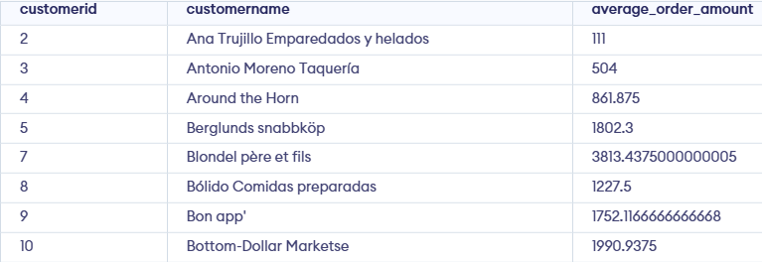

89. List the number of orders per product by month:

Query: select p.productid, p.productname, strftime('%Y', o.orderdate) as order_year, strftime('%m', o.orderdate) as order_month, count(distinct o.orderid) as order_count from orderdetails od join orders o on od.orderid = o.orderid join products p on od.productid = p.productid group by p.productid, order_year, order_month  
Output: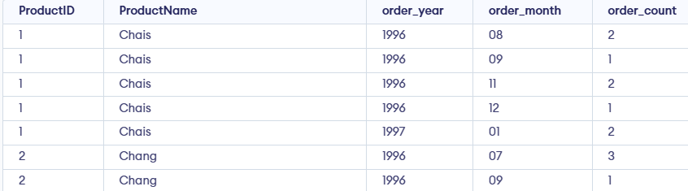

90. Find the top 3 customers by total revenue generated:

Query: select c.customerid,c.customername,

round( sum(od.quantity * p.price),2) as total_revenue

from customers c

join orders o on c.customerid = o.customerid

join orderdetails od on o.orderid = od.orderid

join products p on od.productid = p.productid

group by c.customerid, c.customername

order by total_revenue desc

limit 3  
Output: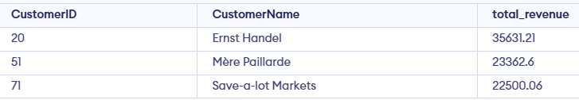

91. Calculate the total revenue for each product by category:

Query: select c.categoryid,c.categoryname, p.productid, p.productname,

round(sum(od.quantity * p.price),2) as total_revenue

from products p

join categories c on p.categoryid = c.categoryid

join orderdetails od on p.productid = od.productid

group by c.categoryid, p.productid  
Output: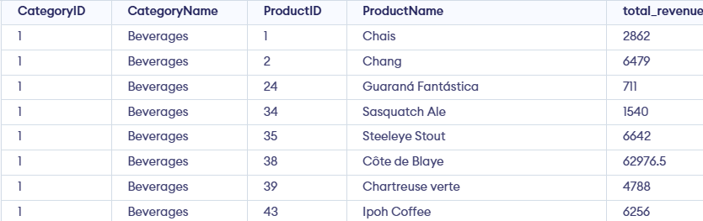

92. List the total quantity ordered for each product by year:

Query: select p.productid, p.productname,

strftime('%Y', o.orderdate) as order_year,

sum(od.quantity) as total_quantity

from orderdetails od

join orders o on od.orderid = o.orderid

join products p on od.productid = p.productid

group by p.productid, order_year  
Output: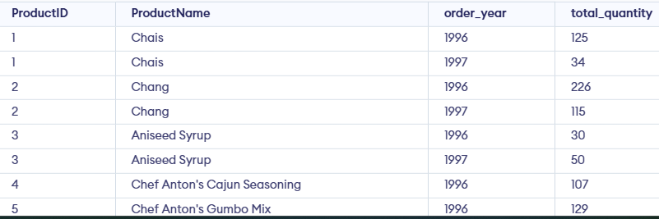

93. List the top 5 products by total quantity ordered:

Query: select p.productid,p.productname,

sum(od.quantity) as total_quantity

from orderdetails od

join products p on od.productid = p.productid

group by p.productid, p.productname

order by total_quantity desc

limit 5;  
Output: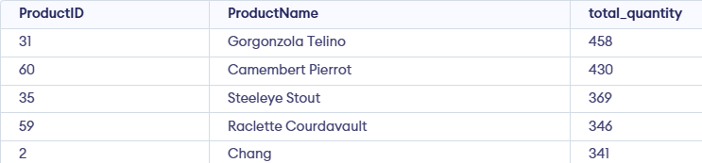

94. Calculate the average quantity ordered per product by month:

Query: select p.productid, p.productname, strftime('%Y', o.orderdate) as order_year, strftime('%m', o.orderdate) as order_month, round(avg(od.quantity),2) as average_quantity from orderdetails od join orders o on od.orderid = o.orderid join products p on od.productid = p.productid group by p.productid, order_year, order_month  
Output: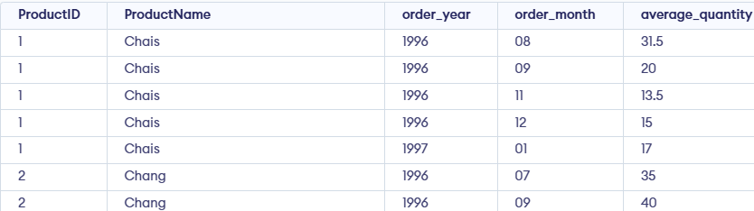

95. Find the total revenue generated by each employee by year:

Query: select e.employeeid, e.firstname || ' ' || e.lastname as employeename,

strftime('%Y', o.orderdate) as order_year,

round(sum(od.quantity * p.price),2) as total_revenue

from employees e

join orders o on e.employeeid = o.employeeid

join orderdetails od on o.orderid = od.orderid

join products p on od.productid = p.productid

group by e.employeeid, order_year  
Output: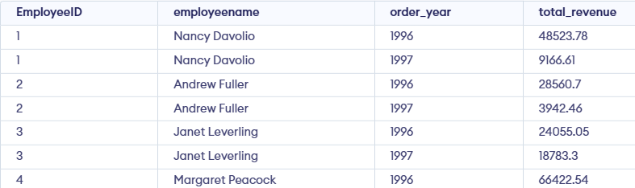

96. List the top 3 categories by total quantity ordered:

Query: select c.categoryid,c.categoryname,

sum(od.quantity) as total_quantity

from categories c

join products p on c.categoryid = p.categoryid

join orderdetails od on p.productid = od.productid

group by c.categoryid, c.categoryname

order by total_quantity desc

limit 3;

Output: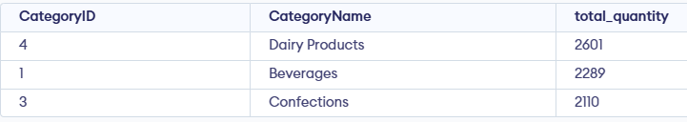

97. List all customers who have never placed an order:

Query: select c.customerid,c.customername

from customers c

left join orders o on c.customerid = o.customerid

where o.orderid is null;  
Output:

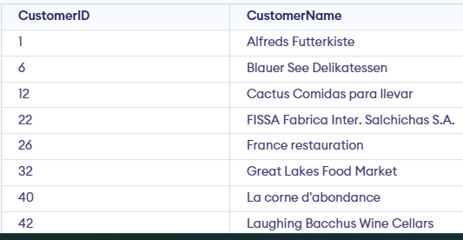

98. Calculate the average sales amount per customer by year:

Query: with customer_sales as ( select c.customerid,c.customername,o.orderid, strftime('%Y', o.orderdate) as order_year, sum(od.quantity * p.price) as order_total from customers c join orders o on c.customerid = o.customerid join orderdetails od on o.orderid = od.orderid join products p on od.productid = p.productid group by c.customerid, o.orderid)

select customerid, customername, order_year, round(avg(order_total), 2) as avg_sales_amount from customer_sales group by customerid, order_year  
Output: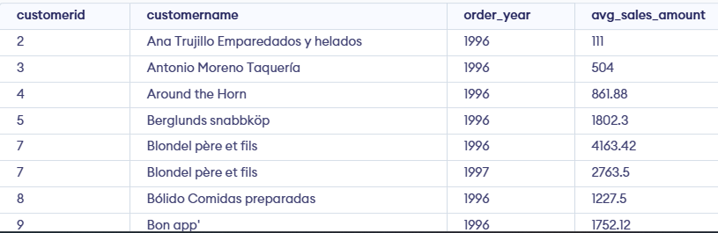

99. List the top 5 products by total revenue for each category:

Query: with product_revenue as ( select c.categoryid, c.categoryname,p.productid,p.productname, sum(od.quantity * p.price) as total_revenue, row_number() over ( partition by c.categoryid order by sum(od.quantity * p.price) desc) as rank from categories c join products p on c.categoryid = p.categoryid join orderdetails od on p.productid = od.productid join orders o on od.orderid = o.orderid group by c.categoryid, c.categoryname, p.productid, p.productname )

select categoryid,categoryname,productid,productname, round(total_revenue, 2) as total_revenue from product_revenue where rank <= 5 order by categoryid, rank;  
Output: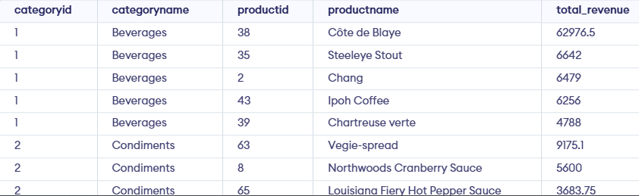

100. Calculate the total revenue for each shipper by month:

Query: SELECT s.shipperid,s.shippername,

strftime('%Y-%m', o.orderdate) AS order_month,

ROUND(SUM(od.quantity * p.price), 2) AS total_revenue

FROM shippers s

JOIN orders o ON s.shipperid = o.shipperid

JOIN orderdetails od ON o.orderid = od.orderid

JOIN products p ON od.productid = p.productid

GROUP BY s.shipperid, order_month  
Output: