**Embedded Systems Assignment 1: CPSR Flags**

**Kausik N**

**COE17B010**

**Code:**

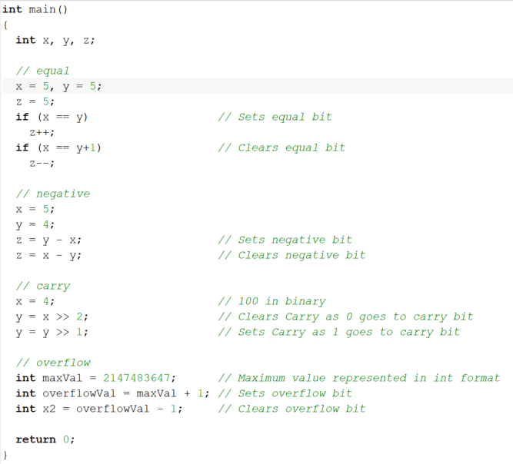

**Setting Zero CPSR Bit**

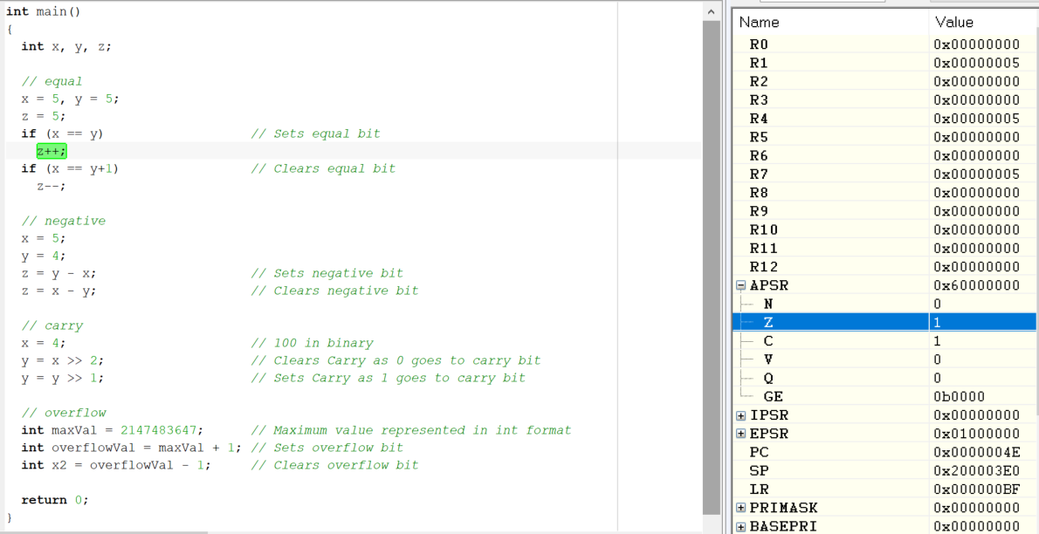

**As x and y are both 5, if (x==y) sets zero bit**

**Setting Negative Bit**

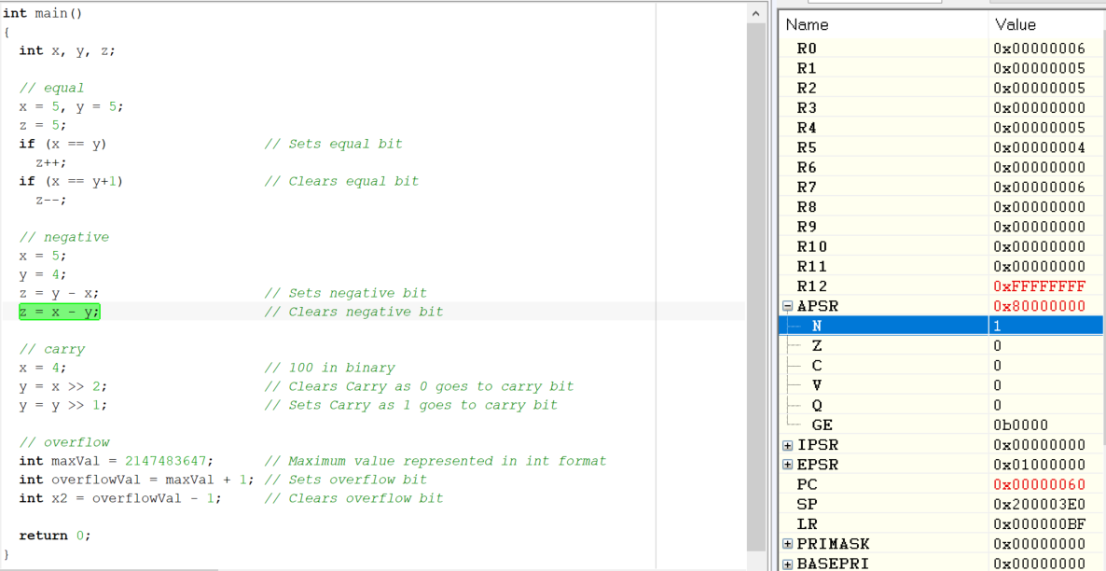

**As x = 5 > 4 = y, Therefore, y – x = -1 => negative, so, negative bit gets set**

**Setting Carry Bit**

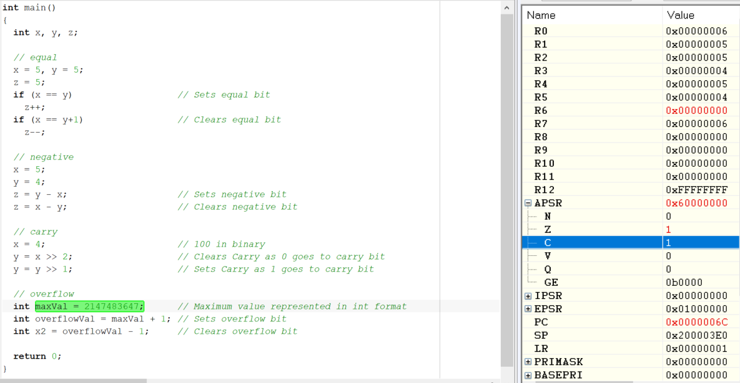

**As 4 = 100 in binary, right shift twice sets carry bit to 0. Now, y is 1. One more right shift sets carry to 1 as 1 gets right shifted to carry bit**

**Setting Overflow Bit**

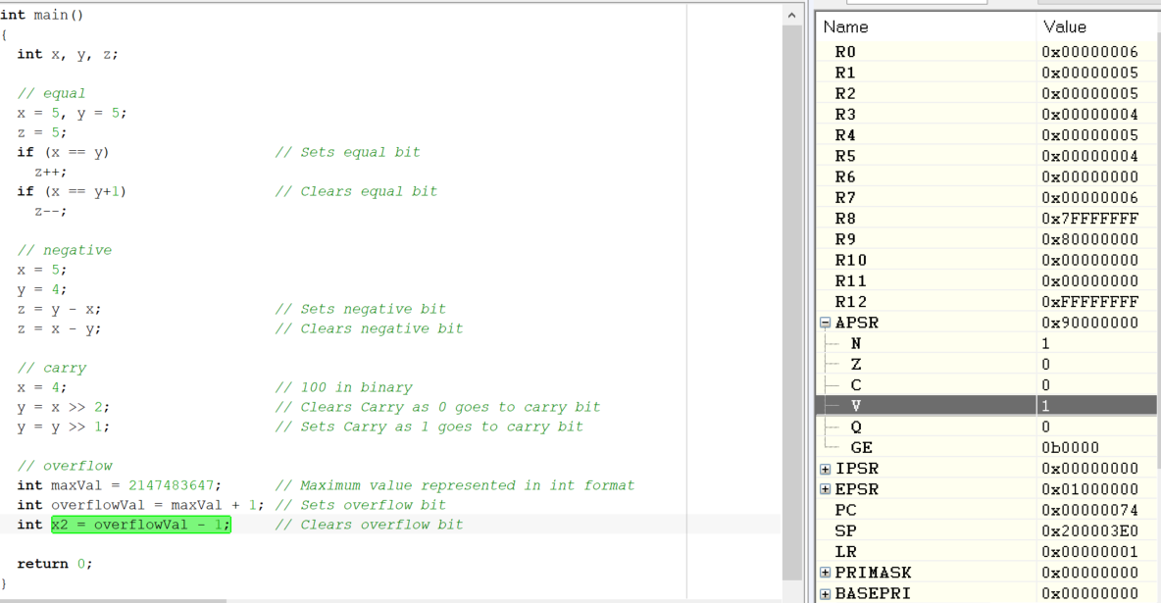

**2147483647 is the maximum value storable in 32-bit register. So, when 1 is added to it, overflow happens**