Activity 2

COE17B010

Chosen App:

Discord

Introduction:

* Instant Messaging Application
* Freeware
* Also supports VoIP and Data sharing

Concepts:

Mental Model Inertia:

Interfaces/ Interactions that users are already familiar with tend to stick and helps them have a more positive experience in any app.

In Discord,

Pros

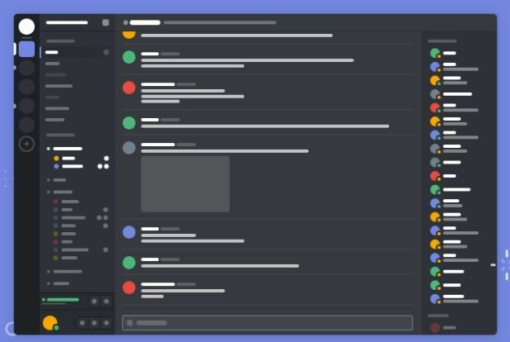

Core Instant Messaging UI is very similar to other famous applications like Whatsapp and Slack, where the following are provided,

* Messages, Emojis, Images, etc are displayed in center and is scrollable
* For user to send a message, input box provided at bottom (like Whatsapp)



* Add emojis, GIFs and other buttons provided at sides of the input box (like Whatsapp)
* Creating new Group / Server or Joining a server is done by dedicated button provided in Left along with all already joined servers (similar interaction as Slack)



* Online Status of people in the server also provided in Right portion of app (like Whatsapp Web)

Cons

* In each server, multiple text channels can be given. For a new user after using Whatsapp, this might be confusing as he might be searching for a message in the wrong text channel in same server.



Ease of Use:

How easy is it for any user (new or expert) to start using the product?

How usable is the product?

Pros

* As it has many interactions and UI elements similar to other famous platforms, it can be used easily by most people.
* Starting a voice chat, video chat, screen sharing, etc are all just a single click away and proper buttons are provided so it can be used without searching for buttons.
* Discord also offers support for making BOTS – can be used to automate tasks, moderate servers, kick, ban, etc. So, no need for manual moderation.
* Other functionality like muting, etc also have proper icons and placements for ease of use.
* Search bar provided for searching messages, etc

Affordances

Properties which show what all actions the user can perform using the product.

* Discord was initially meant for gaming community
* Now it can be used for communicating under business setup as well
* Can be used to send instant messages
* Can also be used to share files and data like Images, Documents, etc
* Can be used to hold meetings with Voice Chat, Video Chat and multiple screen share
* Discord bots can be used to perform a variety of tasks including server moderation

Modality

Computer-Human Modalities

Ways in which app sends information to humans

* Auditory
  + Voice chat
  + Screen share audio
  + Auditory cues when certain buttons are pressed and for UI elements
* Vision
  + Video chat
  + Screen share video
  + UI Icons

Human-Computer Modalities

Ways in which humans send information to the app

* Keyboard (Web and Desktop App)
  + Typing messages
  + Shortcuts (CTRL + C)
* Mouse (Web and Desktop App)
  + Clicking UI elements
  + Selecting files, etc to share
* Touch (Mobile App)
  + Typing
  + Selecting UI elements (Clicking buttons, etc)