Activity 6

COE17B010

Chosen Search Engine:

 Bing

Introduction:

* Search Engine by Microsoft
* Was earlier called MSN Search
* Handles 30% of all US search queries (2nd behind Google)

Bing vs Google:

As google is the only contender with a greater searches, we can compare them to see in which areas Bing does better and in which areas it does worse,

* Bing’s video searching is much better than google’s as,
  + Bing provides a grid of thumbnails in video search which is best suited for videos and much better than the standard of displaying a set of smaller thumbnails in a vertical fashion (like in text)

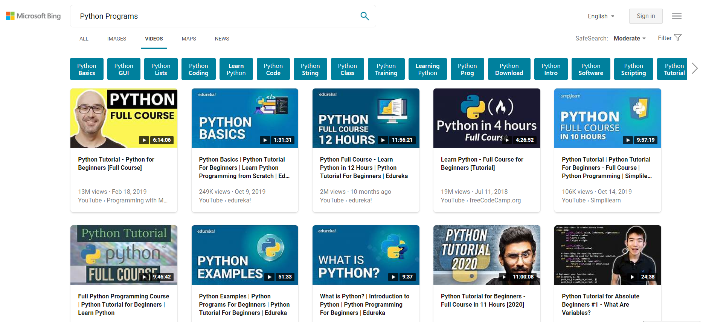

* + Videos can also be previewed before clicking by hovering over them (for some videos) thereby helping the user select what he wants
* Google is better regarding shopping suggestions as it is easier in google to find prices of items than in Bing
* Bing provides ability to choose layout of image in image search which can be useful
  + Bing also provides sample images in image search which helps user understand how to use it, whereas google does not provide such features
  + Bing also allows searching only a part of the input image
* Bing provides the Bing Rewards feature, where users can rack up points while using bing and then later redeem the rewards as gift cards for Amazon, Starbucks, etc which provides a great incentive for users to use Bing, whereas google does not have such reward systems.
* One big separator between Google and Bing is that Google’s search times are much faster than Bing’s.

Laws:

Weibull’s Law:

User interaction time with a website follows the Weibull’s distribution where they either stay for very less time or stay for a long time.

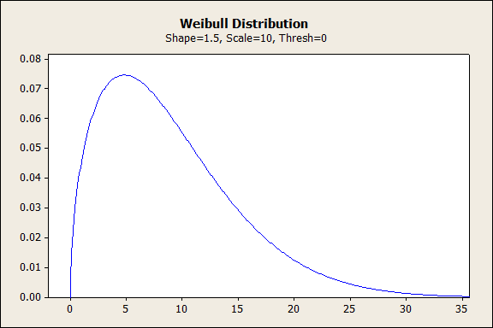 Once a user goes to a website, they quickly scan it and see if it has something they want. If no, they immediately leave within a minute. If it has something, they want they stay for a longer time.

Pros

* Bing provides a rewards system where users can rack up points for searching in Bing and later use those points to get Amazon gift cards, etc
* This provides a great incentive for users to keep using Bing and not just leave it after 1 search.

Gestalt’s Principles:

Law of Proximity:

Objects which are closer to each other are perceived as similar by humans.

Pros

* News items are grouped together at bottom of page as they are similar items



* Sign in, Account options are placed together at top right corner as they are related



* Languages are grouped together below search bar



* Search, Search using voice, Search using image (Search Options) are given together



Law of Similarity:

Objects that are having similar characteristics are perceived as similar or connected.

Pros

* Search options icons have similar look (transparent background with cyan colour) and so it helps connect them together



* News items all have a semi transparent black background



Law of Symmetry:

We tend to group objects that are symmetrical (helps us structure information)

Pros

* Video Search Results – Video Image followed by Title followed by Views and Release Date



* News Results – Title followed by description

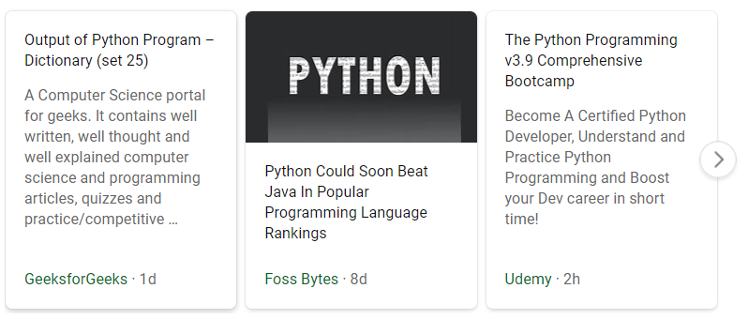

Law of Completion:

Even if some shapes are missing our brains automatically complete them to give information

Pros

* Simplified Icons – outlines of actual objects are enough to convey a functionality

 Search via voice (Microphone)

 Search via image (Camera)

Search (Magnifying Glass)

Law of Continuity:

Some elements make us perceive movement or direction

Pros

* List of Video results (Left to Right)

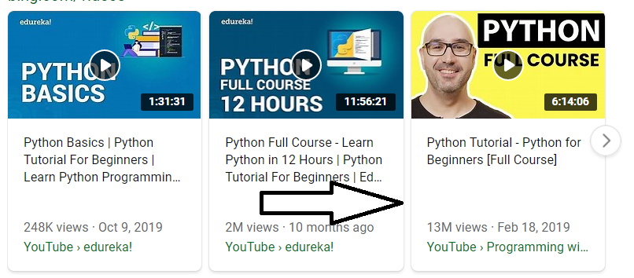

* List of search results (Top to Bottom)

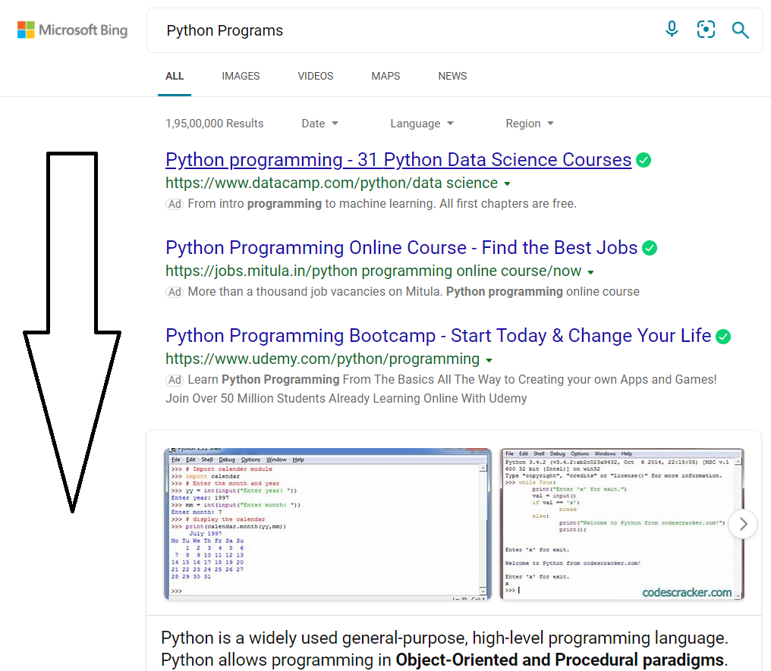

Law of Common Destiny:

Elements pointing in same direction no matter how further apart are grouped together

Pros

* Frequent Questions Dropdown – As all buttons point DOWN, all of them are perceived to do the same function, i.e. expand the question 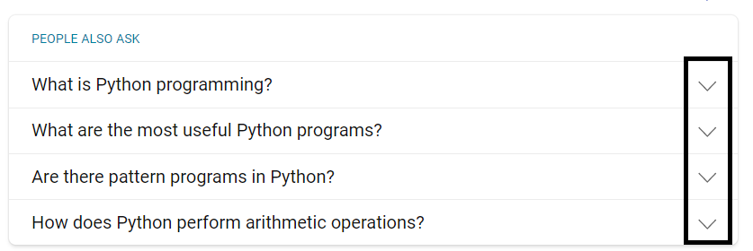
* Colours in Links and Titles

As all links are coloured green and blue for clickable title, they are perceived to have a common destiny, i.e. lead to a webpage.

