HCI Design Activity

N KAUSIK

COE17B010

Chosen App:

Discord

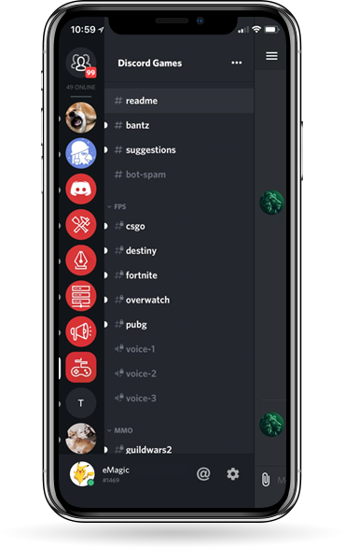

Introduction:

**Discord** is a mobile application that supports the following features,

* Instant Messaging
* Free to use!
* Also supports VoIP and Data sharing
* Screensharing

Pros:

* **Similar UI structure** in mobile to other apps
  + Compliant with user mental models of messaging applications
  + Uses commonly used icons related to real life objects (Skeuomorphism)

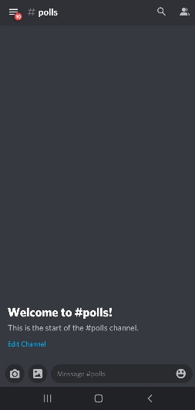 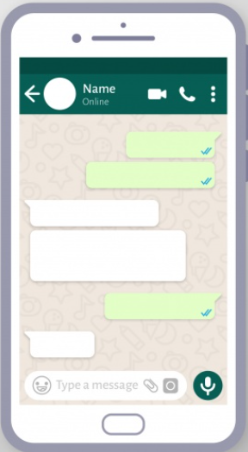

* Excellent **server controls** like muting, banning, etc with clear UI
  + Admin has full control of server so they can take proper actions in certain situations (Someone misbehaving must be banned) (Internal locus of control)
* Excellent and detailed server management for admins

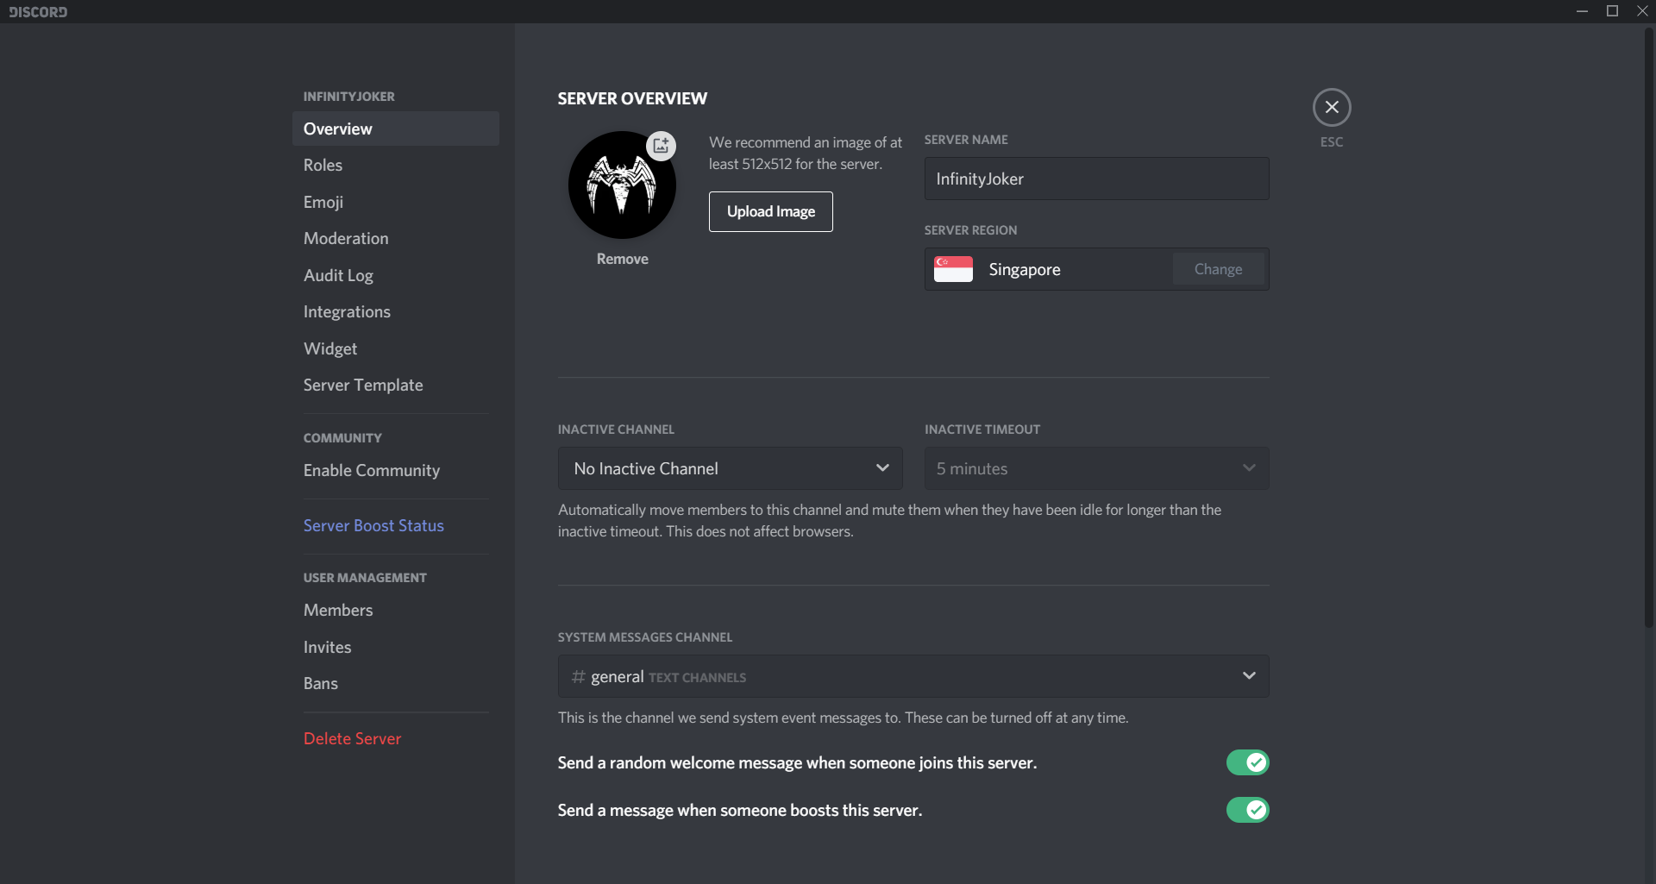

* **Bots** for automation of tasks, auto moderation, playing songs, etc
  + Auto moderation is used to address Asimov’s Second Law (Time of user, in this case the admin and other users should not be wasted by the system. Automation of these tasks takes the burden off the user)



* **Voice Chat Overlay** when other apps are opened (usually games)
  + Multithreading compliant – Flexibility usability principle

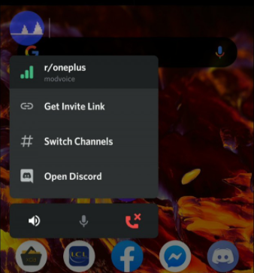

Cons:

* **Multiple text and voice channels** in a single server lead to confusion as to which channel is main channel of server
  + Violating **Hick and Hymans Law** that time for achieving a task by user increases with the number of choices
* **Direct messages are hidden** behind a button
  + Important feature which requires more navigation than what is necessary
  + New users might get stuck searching for it, **bad learnability and bad ease of use**
* **Poor navigation** between channels and servers in mobile
  + 1 swipe + search + 1 tap required – **bad ease of use**
* **Edit and quote options** can be made more easier to do
  + Long press + 1 Taps to quote – **bad ease of use**
* Inability to **clear all messages** in a server
* Inability to **reverse deletion** of messages and edits
  + Violates **Reversal of Actions** principle

So, I will be designing an app which has all the **pros of discord** while **rectifying the cons** to produce the optimal design compliant with HCI laws.

My Design:

Design done keeping in mind the following,

* UI structure kept similar to other apps (**Mental Model** Compliant)
* Other pros, bot automation, overlay, server controls kept same as discord
* Multiple text and voice channels issue
  + Default / Main text and voice channel **size increased and brought to top**
    - Increases visibility for the main channel (editable) – new users will not get confused which channel to go in a server
    - Compliant with **Fitt’s Law** as size increased for main channel
    - Compliant with **Serial Position Effect, Peak and End Law, Primality** as main channel kept at top
    - Compliant with **Customisability** as main channel can be changed by server admin

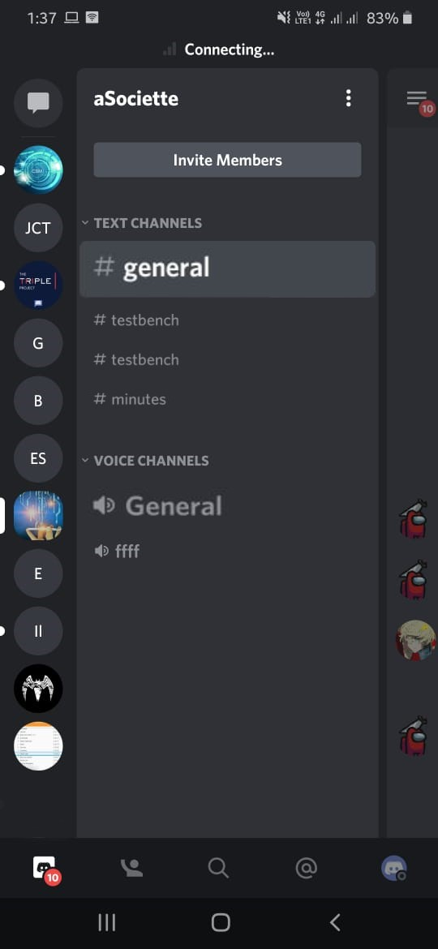

* Direct Messages Issue
  + Home Page created with all servers and direct messages listed instead of listing in left part
    - Home page opens by default (like WhatsApp) (**Mental Model**)
    - If we keep pressing back icon, we end up at this Home Page (**Reversal of Actions**) and can restart our task in case anything goes wrong
  + Servers and Direct Messages provided as separate tabs to reduce confusion and for easy selection
    - Compliant with **Hick and Hyman’s Law** of more time when selecting from more options (As servers and direct messages separated, lesser choices)
    - Swipe or tap to switch to other tab (**ease of use**)

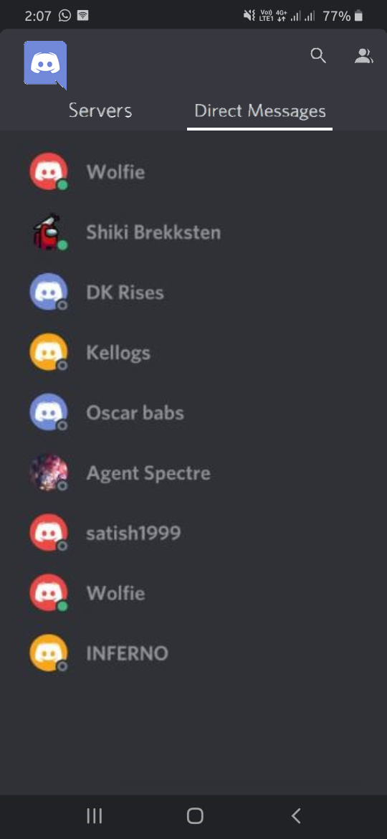

* Poor navigation between channels in a server
  + Instead of opening left options by swipe and then tap required channel, we can now swipe the channel name at top to move between channels with just 1 interaction (1 swipe)
    - Compliant with **ease of use**
    - **Swipe channel name left or right** to switch between channels

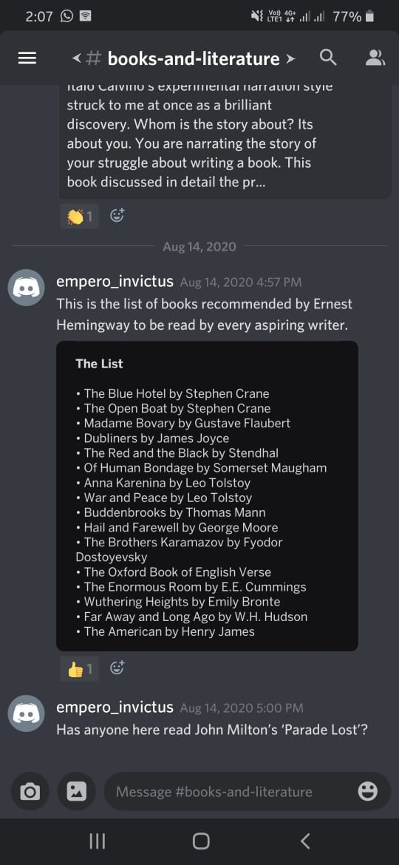 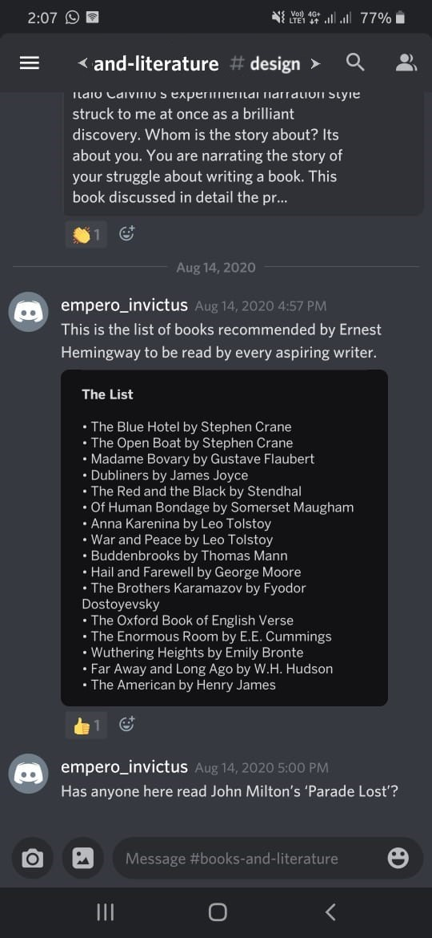 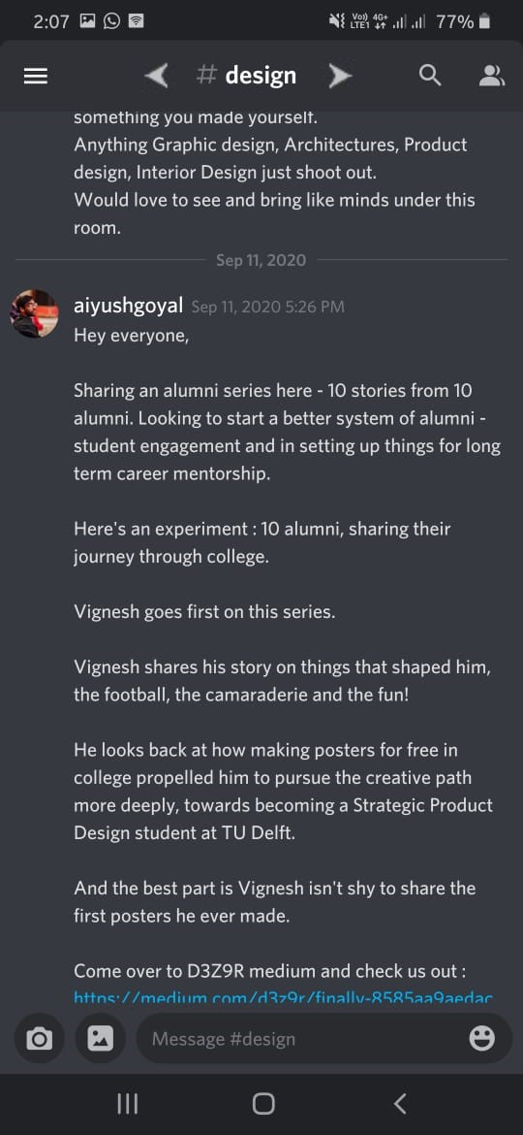

Channel 1 Swipe transition Channel 2

* Quote and Edit issue
  + Instead of long press message and select quote option, we can swipe the message to the right to directly quote
    - Similar model like in WhatsApp
    - Compliant with user **Mental Model**
    - Compliant with **ease of use** (only 1 Swipe as opposed to Long press + 1 Tap)
    - **Swipe any message to the right** to quote it

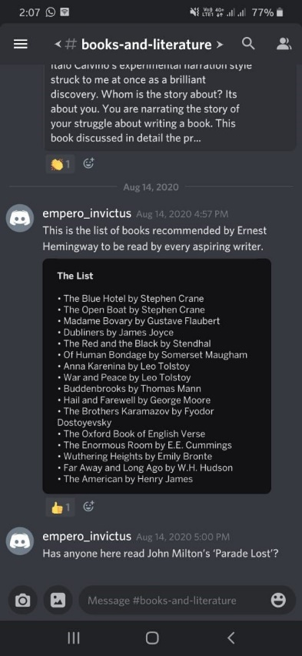 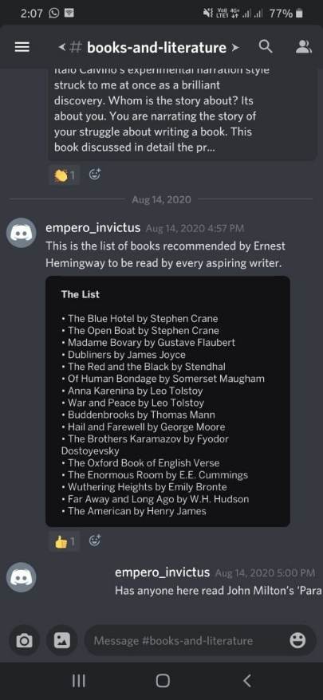 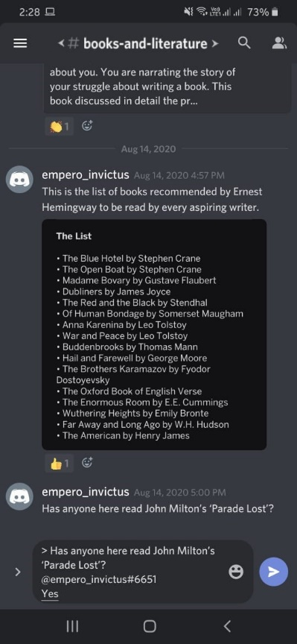

Message Swiped message Quoted message

* + Instead of long press message and select Edit option, we can double tap a message to directly edit it
    - **Ease of Use**
    - **Double tap** any message to edit it

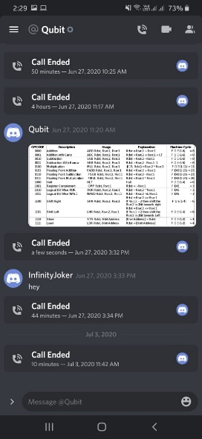 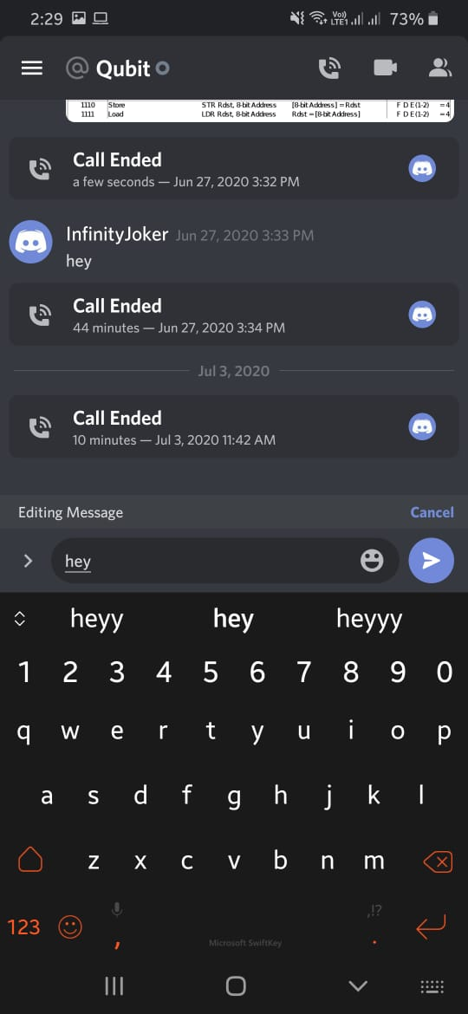 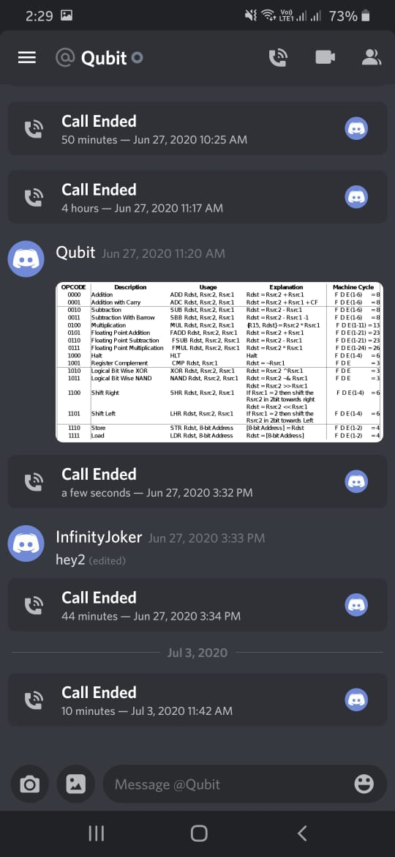

Message Double tapped – edit mode Edited message

* Clear Messages and Media Issue
  + Ability to clear your messages provided at channel settings
    - Compliant with **Mental Model** (Similar position and icon as WhatsApp)
    - Clear Chat given RED colour to keep it compliant with **Colour Theory** (RED – Extreme Action)
    - Clear chat option kept at **middle** – compliance with **Recency and Primality** (Clear chat should be kept in middle as it is infrequent operation)

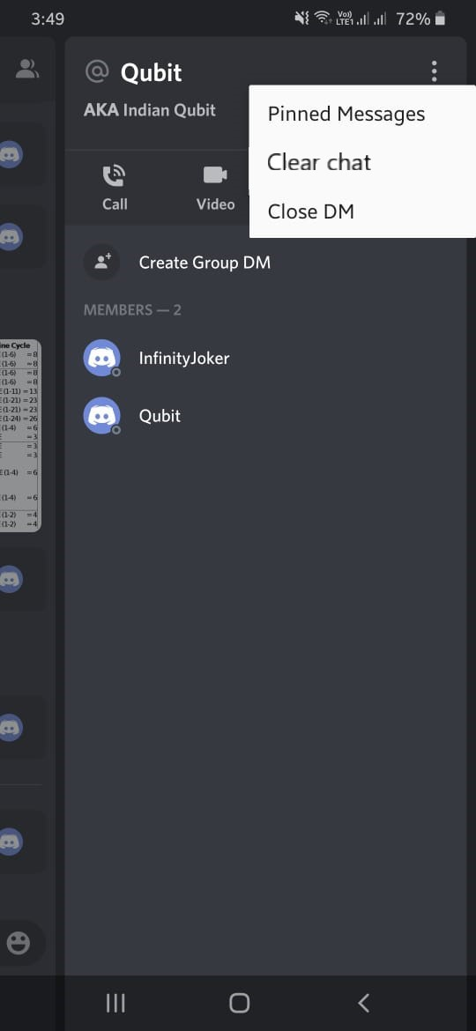

* Undo issue
  + Ability to undo latest deletion or edit provided like follows
    - Compliant with **Reversal of Action**
  + If message deleted, it displays message deleted with an Undo option. This will disappear when some other action like new message or another delete or edit is done.

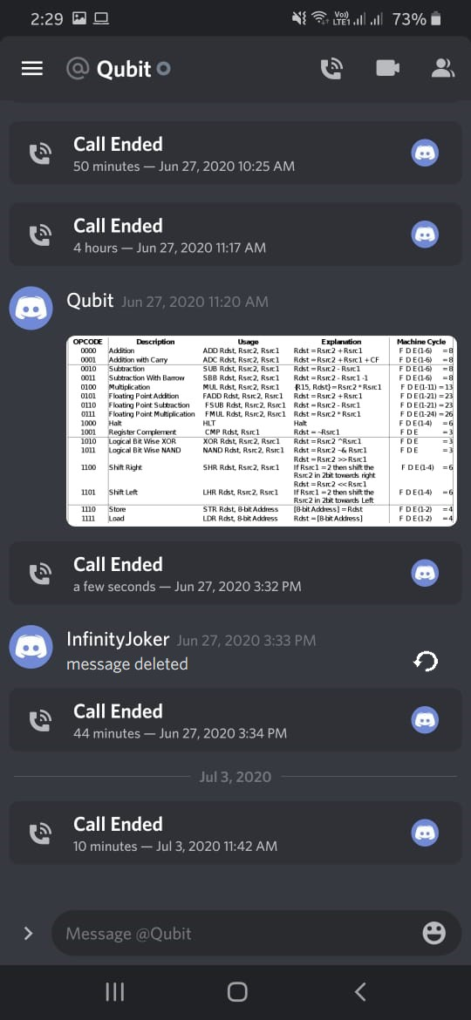

* + Similarly, when a message is edited, and undo option is provided below the message that also disappears after the next action is performed

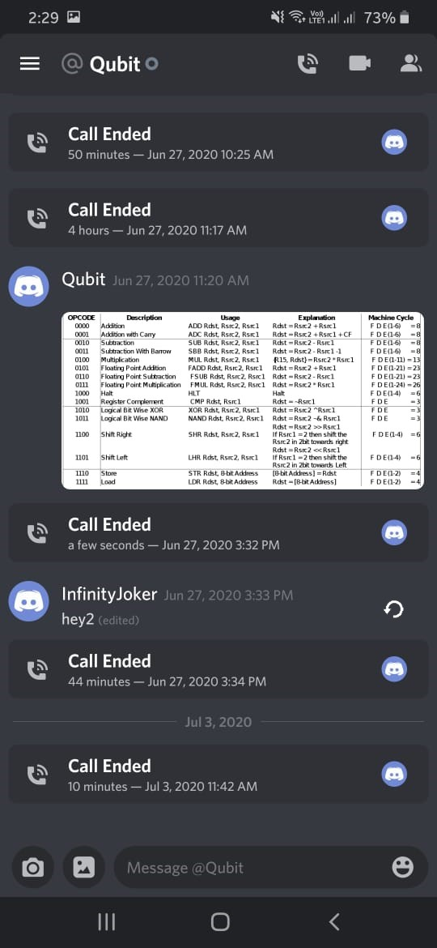

Thus, the improved discord application has been designed by analysing it using the various HCI laws and principles.

Further Analysis:

Psychology of persuasion

* Reciprocity
  + Provides connectivity with friends
  + Playing music while playing games
  + Collaborative working and playing games
  + Free files and data sharing
  + These features provided for user info
* Authority
  + **Leading** app for informal/casual gaming-based communication
* Liking
  + Helps communicate with friends and people we like easily, so people who use the service promote it to their friends
  + As it is focused for specific set of people, they tend to praise the app more and promote it
  + People can invite anyone to their servers using a simple link, if clicked it directly adds them to the server
* Social Proof
  + Many big gaming based Youtubers, twitch gamers and other gaming-based celebrities use this service and have discord servers for their fans and hence app is promoted
* Scarcity
  + Certain additive features like custom icons, tags, emojis and GIFs can be made scarce by the server admin and hence provides interest to obtain those features by using the service more

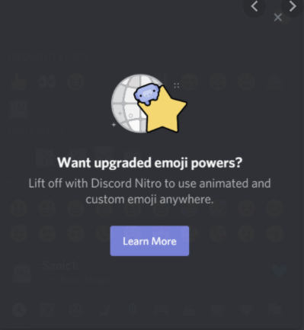

* + Famous gamers stream their gameplay at certain times (Live Gameplay) which anyone in the server can watch only when it is live

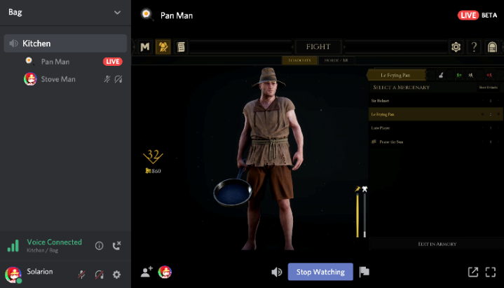

Von Restorff Effect

* Inviting Members button clearly visible as it looks different from others
* Main text looks same as other text channels in original app, so it violates this effect
  + My design is compliant as main channels are larger in size than others



* New messages in a server makes it stand out using a white semi-circle at left

Here server ES stands out due to the semi-circle.

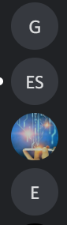

Visceral Reaction

* It displays profile image along with name for all messages which is visually pleasing and easy to identify for any user

Dual-Coding Theory

* Message from a user displays username and user profile picture for easy identification

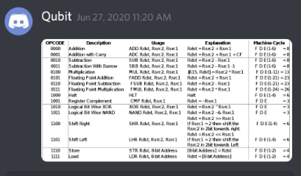

Psychology of colors

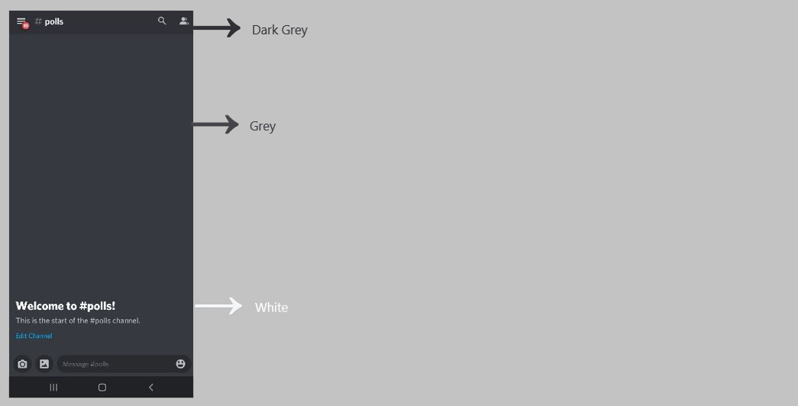

* Top panel is given Dark Grey
* Background is a lighter shade of grey for separation from other parts
* Text is given White color for high contrast from background
* All icons are kept at whitish-grey for subtle distinction from other parts and also contrast from background
* In mobile, Buttons like Invite People, etc are given light grey color for easy identification and separation from all other components of the screen.
* In desktop app, buttons are given Blue color for even easier identification and consistency with the color palette

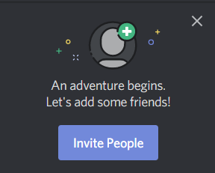

* New messages mentioning our name are highlighted in orange for high contrast with other messages

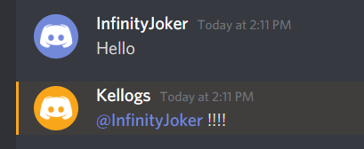

* Discord Color Palette is as shown

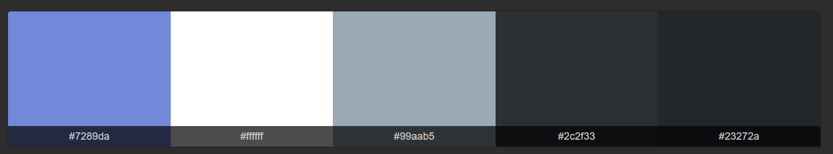

The Blue and Grey represent a sense of,

* + **Calmness** as discord is used casually
  + **Strong** as discord is a strong tool with many uses
  + **Honest** as discord provides transparent and full control to server admins and informs users of all the data that discord/server collects before joining
  + **Loyal** as core functionalities that were built keeping gaming in mind were not compromised in future updates
  + **Trustworthy and Secure**

Psychology of shape

* Shapes
  + All buttons and boxes are given a rectangular shape with curved edges for smooth visualization and for providing a clean layout



* Value
  + Elements are separated by a difference in pixel values (Dark Grey and Light Grey)\

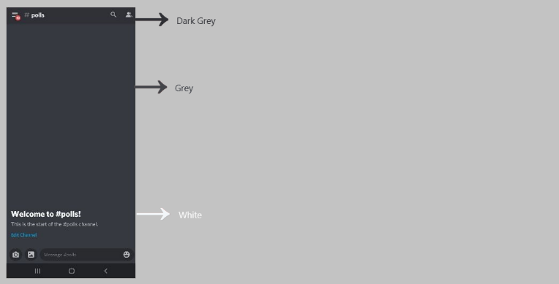

Principles of Universal Design

* Equitable use
  + Though discord started out for gaming, it can be used by anyone due to its casual use design and free data sharing capabilities
* Flexibility
  + Design is very simple and easy to use by anyone with different preferences
* Simple and Intuitive use
  + All icons are standard and similar to other famous apps like WhatsApp to increase intuitive usability
* Perceptible information
  + Important functions like buttons, user icons, text entry, etc are communicated clearly using appropriate color separation
* Tolerance for error
  + End Call button is kept small and at bottom of Voice Channel Tray to remove cases of accidental ending of call
  + Design alerts the user clearly in case of possible errors, like It displays “Connection Slow” for risk of slow network
  + Network connectivity strength is displayed and if network is too slow and at disconnects, the “Disconnected” is displayed to indicate the issue to the user

 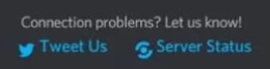

* Low physical effort
  + As minimal interaction is required to use all functions like sharing files (drag-drop allowed), voice chat, screen share (all 1 click), user achieves his functions with minimal effort
* Size and space for approach
  + Placements and sizes for important buttons and functions are kept appropriately
  + Voice Chat and Channels are kept at left for easy accessibility

Principles of navigation design

* Design for readers
  + Navigation between servers is simple and not visually complex and suited for the users
* Variety of navigation options
  + Navigating between servers can be done by directly clicking the server icon in the left panel
  + In my improved design, navigation between channels in a server can be done by selecting it from the left panel or also by swiping the channel name for better ease of use

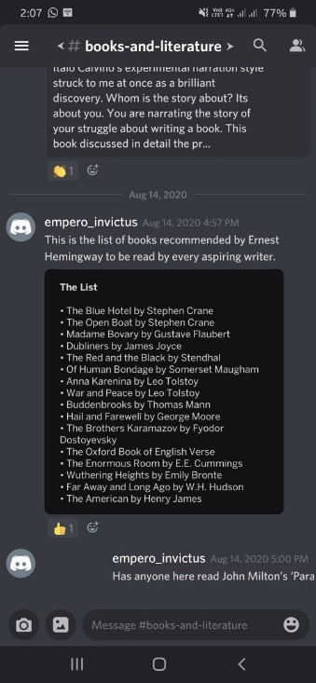

* + A variety of shortcuts and key bindings can also be used in the desktop version for various controls like switching between servers, etc

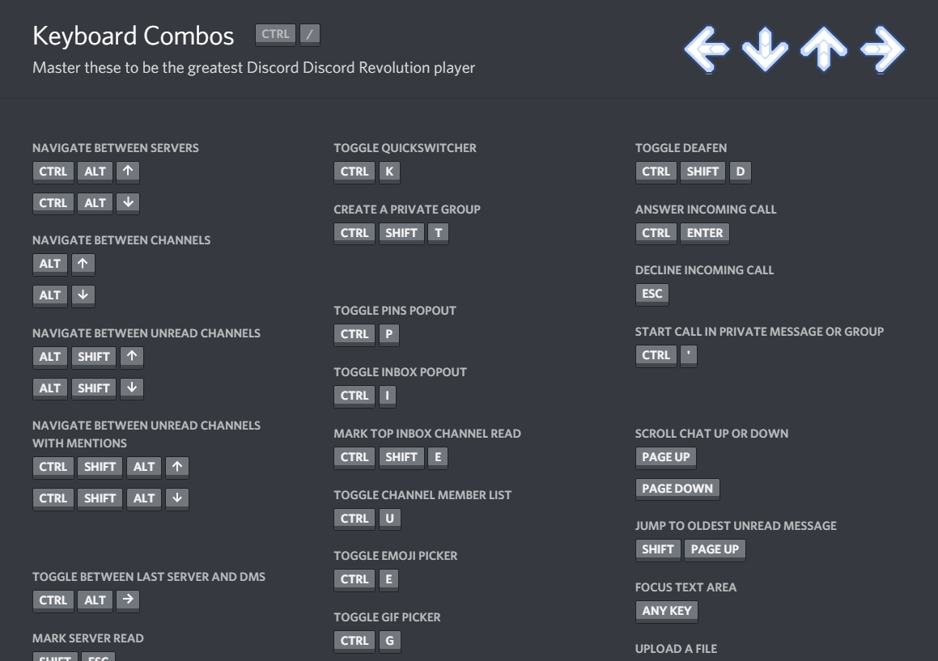

* Tell the user where they are
  + User is clearly informed of in which server and channel he is in

Server Channel

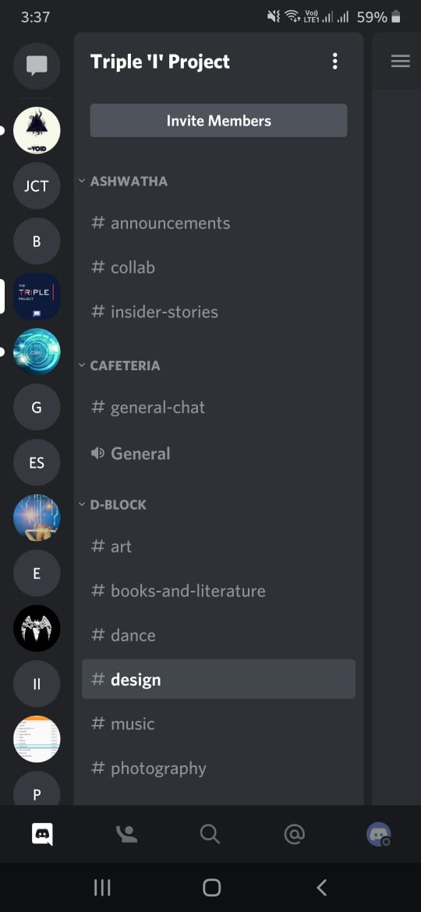 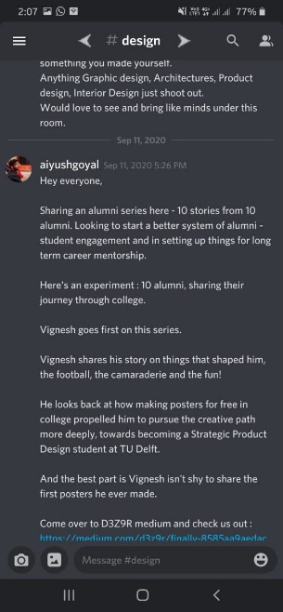

* Tell users where they have been
  + Discord does not show which server we earlier visited (CON)
    - So, in my improved design, the left server panel will show the servers which were visited recently instead of a fixed order (similar to WhatsApp – Mental Model Compliant)
* Tell users where they are going
  + Icons provided appropriately for Add Image, Emoji, etc to signify that a new dialog will open to select the image/emoji
  + Channel names mentioned which are buttons so that on tapping on the channel name it takes the user to that channel
  + Swiping on top to change channel shows a part of the next channel name to clearly mention where user will go next

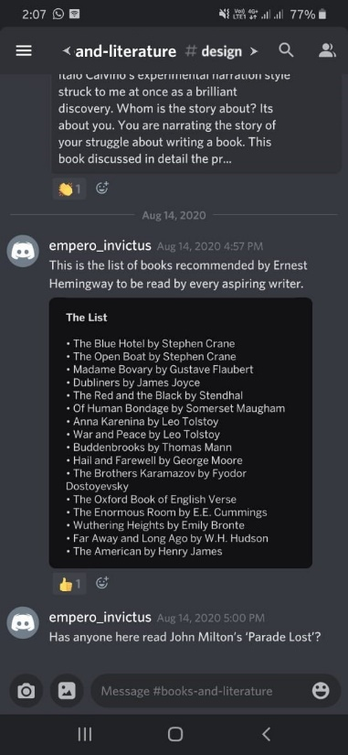

* Provide context
  + As discord opens directly into the previously opened server every time it is relaunched (CON)
    - So, in my improved design, app opens with a Home Page as designed earlier with all private chats and servers which provides clear context for the app

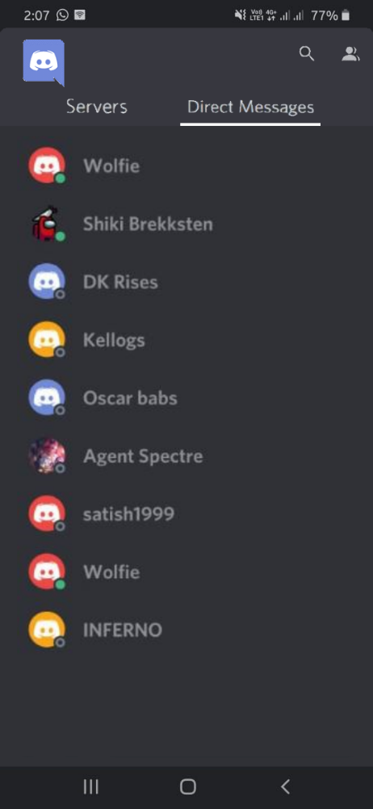

* Be consistent
  + All channel names are of same form (color, placement, etc)
  + All servers are displayed as circular icons in the left tray
  + So, user will never get confused which button to click to go to any server or channel
* Follow mobile app convention
  + Many conventions like swiping left part to reveal a tray of options and settings are followed

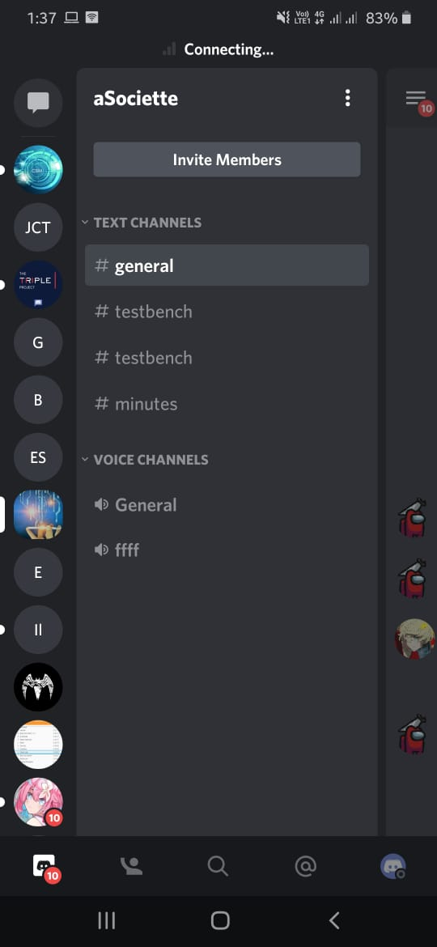

* + Conventional mobile app icons are used for common tasks like Image, Camera, Audio, etc
  + Pressing BACK button in mobile also follows the conventional going to previously visited channel / server
  + Conventional settings like Support, Language, Voice and Video, Notifications are provided
* Avoid surprise to user
  + Discord never surprises user or misleads them to do any impossible tasks as all functions are clearly available and easy to use
* Feedback
  + Feedback can be given by users using the Support feature which is provided along with the settings
  + Discord support is very active and comments are considered and looked upon

Progress Bars

* This indeterminate Loading bar is used at start to load the app (As short loading time this is better)

 

Logo rotates again and again

* Loading messages is also a indeterminate simplistic rotating loading animation (short loading time so indeterminate is better)



Captcha

* Discord bots can be made but to register them with the server and to control those bots, they need to be registered with discord as a bot to generate a BOT KEY
  + These bots have limited power and need to be added to the server with consent from the owner of the server
  + Owner has full control and can remove or add these bots at will

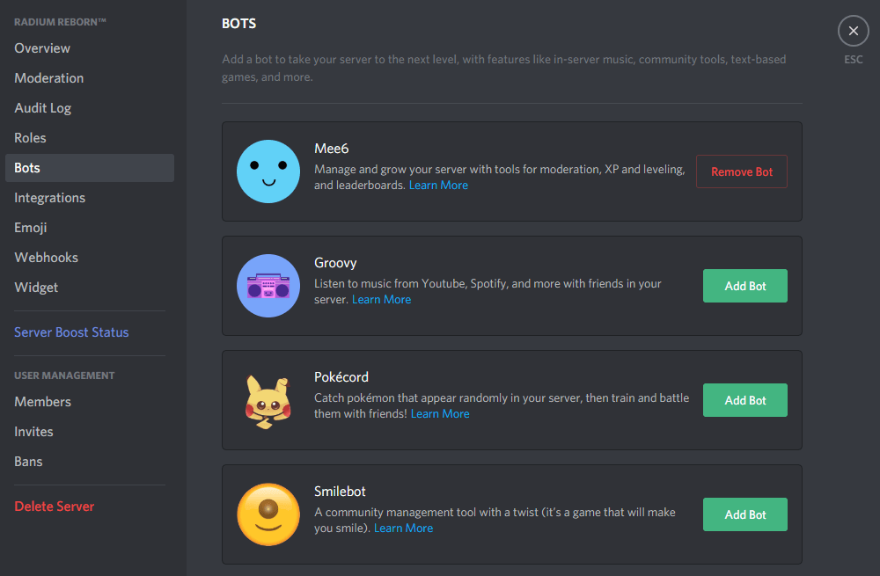

* Discord login security is pretty high and users can use the service only after logging in
* Discord also has automatic unauthorised bot detection

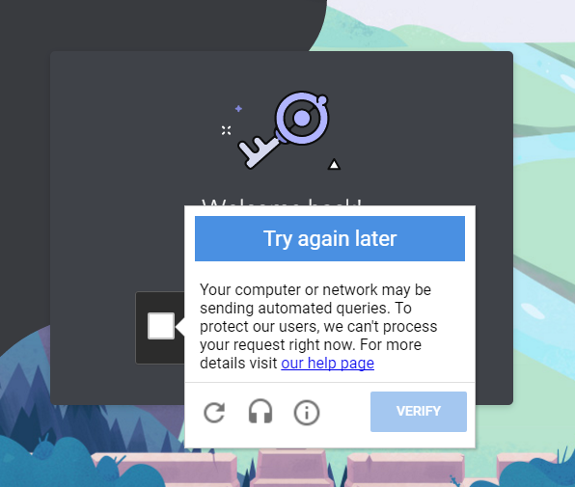

* However, the service can be made more secure against unauthorised bots by using Captcha
  + So, in my improved design, a standard Captcha like Re-Captcha will be integrated to further improve the security

