Rule-Based Expert Systems

Some Terminology:

Rule:

A rule is simply a function of sorts for which, given a input (here it is the condition or state), it gives an output (here it is the action or steps to be taken and how to take them).

Set of all rules is stored in a database of rules called the **Rule Base.**

It can be represented in a **IF-THEN** format.

IF part – it tells the condition or state of the system

THEN part – it gives information on what to do/ actions to be taken by the system

Eg.

IF Wake up late

THEN Run to class

IF Bored

THEN Watch movie

Expert System:

It is a system (usually a program or software) which uses a database which contains a set of rules to make expert decisions and/or give advice and/or do some action.

So, combining both (Rule and Expert System) we get the definition of rule-based expert system as,

Rule-Based Expert System is a system which uses a pre-existing database containing a set of well-defined and explained rules (set of IF and THEN blocks) to analyse the state or situation of the system and gives appropriate advice/ takes decisions and action based on the rules.

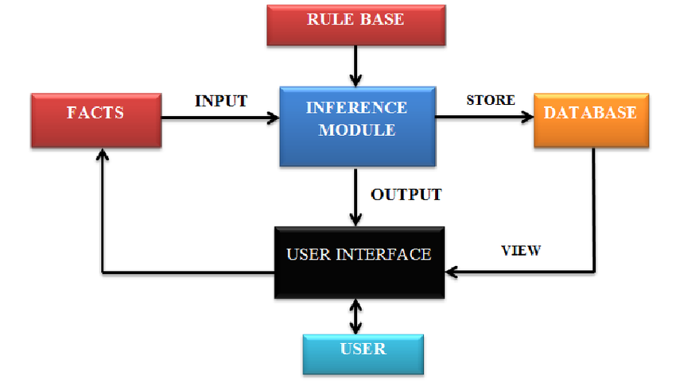

Here,

Rule Base:

It is something that contains all the well-defined rules (set if IF-THENs)

Facts:

It is basically the observations which we give as input.

(Eg. Velocity = 15m/s)

Database:

The output from the inference module is stored in a database for future use.

Inference Module:

It is a module that takes facts as input, applies rules from the rule base on it to get some inference/output which it stores in database.

User Interface:

User interacts with the system using this. (Eg. Display)

Advantages:

1. It is very simple to understand
2. It is very easy to code/implement
3. It gives exact solutions without vagueness or generalisation

Disadvantages:

1. Well defined rules may not be available all the time
2. Data may not be in exact values (like 0 or 1) and could be in a variety of states which can’t be used in rule-based expert systems
3. It is not applicable in most practical situations

Applications:

(Taking automated decisions where rules are definite and fixed)

1. Interpreting and compiling of programming languages like C, C++, Python, etc

IF for()

THEN Loop

IF if()

THEN Condition

1. Helping doctors to give prescriptions (decision) based on the patient’s symptoms (Rules)

IF Fever

THEN Give Antibiotics

IF Pain

THEN Give Pain Killer

Fuzzy-Based Expert Systems

Some Terminology:

Fuzzy Rule:

Fuzzy rules are rules where the conditions and actions taken are not perfectly definite.

These can be represented in IF-THEN format.

But, unlike rule-based expert systems’ rules, these rules need not be exactly true or exactly false, instead they can be partially true or false to some degree.

IF – gives some fuzzy condition – not defined well

THEN – gives the action

Eg.

Rule-based – IF Temperature > 30

THEN Switch on fan to speed 5

Fuzzy-based - IF Temperature is too hot

THEN Switch on fan

Here, in fuzzy-based, we don’t specify an exact threshold for the temperature and we don’t specify the fan speed. So, these can be any values.

Set of all values they can be is given in the Fuzzy Set.

Another way of representing is in the Premise-Implication-Consequent format.

Eg.

Premise: x is A*

Implication: IF x is A THEN y is B

Consequent: y is B

Here, Premise is only partially true (a value between 0 and 1)

So, due to the implication, y is B is also only partially true.

Definition:

So, combining both (Fuzzy rules and Expert System) we get the definition of fuzzy-based expert system as,

Fuzzy-Based Expert System is a system which uses a database containing a set of not necessarily well-defined or explained rules (set of IF and THEN blocks) to analyse the state or situation of the system and gives appropriate advice/ takes decisions and action (need not be well-defined) based on the rules.

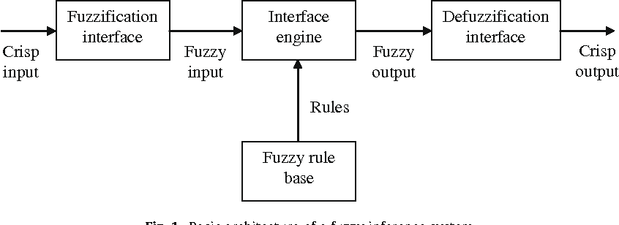

Eg. Instead of dealing with absolute values of Temperature for some system,

We define fuzzy sets like COOL, COLD, WARM, HOT, GOOD, etc

This process of conversion from absolute values to fuzzy sets is called Fuzzification. (Fuzzification Interface)

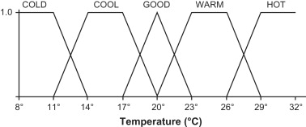

Inference Engine applies fuzzy rules on this and gives output to Defuzzification Interface to get back defined outputs.

Advantages:

1. Rules are very easy to make as they need not be well-defined
2. Accepts data in ranges and in different states also
3. It is applicable in most practical situations

Disadvantages:

1. It is more complex than rule-based
2. It is tougher to code/implement
3. Getting a proper solution requires defuzzification (more work)
4. It is more vague and generalised

Applications:

1. Taking automated decisions where rules are not definite or fixed
2. In air-conditioners, it changes its temperature based on the range

that the room temperature is in

Artificial Neural Networks

This concept is derived from how our own brains work, i.e. how we use our biological network of neurons to take complex decisions and computations.

Some Terminology:

Neuron:

Similar to biological neurons, in computing systems, neurons are simply a structure which takes a set of inputs, applies some complex function (eg. Sigmoid, perceptron, MP, etc) on them to get an output.

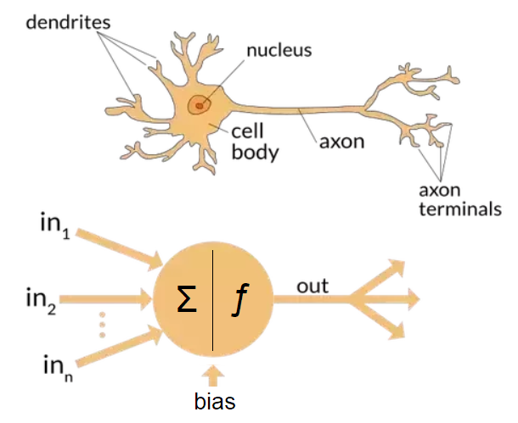

Neural Network:

It is simply a network of many neurons which is better than a single neuron being used.

Neural networks are simply a framework and are not algorithms.

Components of ANN:

The 3 components of any ANN are,

1. Input Layer: (1 layer only)

It contains all the inputs to be given to the ANN

1. Output Layer: (1 layer only)

It contains all the outputs coming out of the ANN\

1. Hidden Layers: (Many layers)

These are very mysterious as there are no methods to determine the perfect no. of layers and no. of neurons per layer in hidden layers

We have to experiment with different configurations for our problem to arrive at the best neural network structure. It is unpredictable and changes from problem to problem.

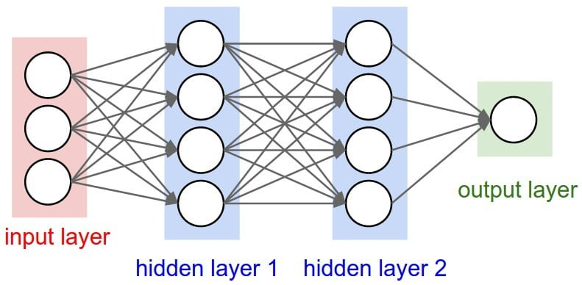

ANN is used in a variety of ways from making predictions like whether someone will like a product based on various factors to finding out possible values of stocks, etc.

Advantages:

1. Accepts any form of data – pictures, audio, text, etc
2. If trained well, it can make near perfect predictions
3. Can be used even when we don’t know exactly how the output is

Disadvantages:

1. We need a large amount to data to train the ANN
2. Identifying the correct hidden layer configurations is difficult
3. Coding and implementation is very complex and hard to learn

Applications:

1. Making predictions in various places
2. Identifying faces in pictures and videos
3. Voice Recognition
4. Speech to Text
5. Computer Vision

Eg.

If we have a dataset of all the properties and features in a mobile phone and also if we know whether it was liked by the public or not, we can train a ANN with this data.

So, in the future, if we have the specifications of some new model, we can predict if people will like this product or not.

This helps in taking business decisions.

Evolutionary Computations

Some Terminology:

Evolution:

It is a biological process by which a species, very slowly over time changes its form and structure and other properties to better survive in its environment.

Definition:

So, based on the biological phenomenon, in computer science, evolutionary computations are a set of specialised algorithms that are used in optimization problems.

These algorithms produce highly optimized solutions in a wide range of environments and settings, and hence these are very popular in AI applications.

How it Works:

* In this, an initial set of candidate solutions is generated and iteratively updated.
* Each new generation is produced by stochastically removing less desired solutions, and introducing small random changes.

(Or)

* In biological terminology, a population of solutions is subjected to natural selection (or artificial selection) and mutation.
* As a result, the population will gradually evolve to increase in fitness, in this case the chosen fitness function of the algorithm.

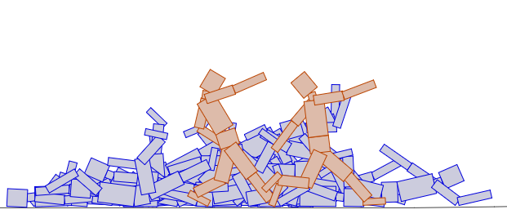

(This is a game/software that uses evolutionary computations to optimize and to help the object ‘walk’)

Techniques used:

Ant colony optimization:

Ant colony optimization algorithm is a probabilistic technique for solving computational problems which can be reduced to finding good paths through graphs.

Artificial immune systems

It is a set of systems inspired from the human immune system

Artificial life (also see digital organism)

It is a field of study wherein researchers examine systems related to natural life, its processes, and its evolution, through the use of simulations with computer models, robotics, and biochemistry.

Advantages:

1. It can be used to solve very difficult real-world problems
2. It is highly efficient in optimization problems

Disadvantages:

1. Requires more computational power
2. Results are not reproducible as in each iteration, results are different

Applications:

1. Learning fuzzy rule base using genetic algorithms
2. Molecular structure optimization (chemistry)
3. Dense pixel matching in images
4. [Audio watermark insertion/detection](https://en.wikipedia.org/w/index.php?title=Audio_watermark_insertion/detection&action=edit&redlink=1)