Payment

Payment Gateway – Gateway that authorises credit card or direct payments processing for merchant.

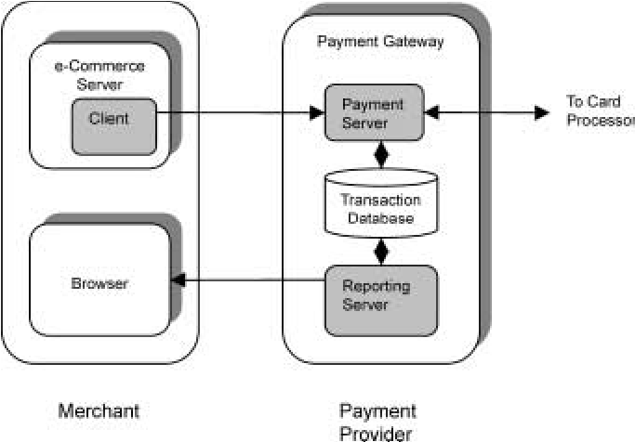

**Payment Methods:**

**India (Digital):**

1. Banking cards
2. USSD (Unstructured Supplementary Service Data) – Used for mobile service providers like Airtel
3. Aadhaar Enabled Payment System (AEPS)
4. UPI (Unified Payments Interface) – Combines functions of several bank apps into 1 app
5. Mobile Wallets
6. Bank pre-paid cards
7. Point of Sale (PoS)
8. Internet Banking
9. Mobile Banking
10. Bharat Interface for Money (BHIM) app

**Abroad:**

* Credit Cards. As a global payment solution, credit cards are the most common way for customers to pay online.
* Mobile Payments.
* Bank Transfers.
* Ewallets.
* Prepaid Cards.
* Direct Deposit.
* Cash.