Cloud Computing

Why Cloud Computing?

1. **Maintaining Focus on the Business**: Businesses are realizing that running an IT department is not their core competency, they are better lawyers, doctors or plumbers.  Buying cloud services, either in the form of a single application like Salesforce.com or their entire datacenter is often more cost effective, more reliable and lets them reallocate their limited resources to growing their business.
2. **Business Agility**: Businesses with significant technology investments can find themselves unable to take advantage of shifts in the market or respond to competitive pressures because the capital, people or time are not available in the measure needed to react.  Cloud services remove these barriers, allowing businesses to continually adapt their technology needs to their business without the costs that would normally have to be considered with an onsite datacenter.
3. **Reduced Capital Expenditures**: Large capital investments can be minimized or eliminated altogether in favor of small monthly payments.  Capital can be protected as keeping capital and operational expenses to a minimum can be very important to small and medium businesses alike.
4. **Scale**: Businesses that have peak seasons or different seasonal staffing demands can benefit from cloud services by letting them temporarily dial up more capacity for the seasonal business peaks, without purchasing the hardware or software that would otherwise go unused during the slower times of the year.
5. **Access from Anywhere**: Being able to do Business without Borders™ is one of the major benefits of cloud services.  Access to your applications and data is available to authorized users anywhere there is Internet access.
6. **Staffing Efficiency**: Cloud services can help you maintain an efficient technology staff, outsourcing key technical specializations or technology staff as it makes sense for your business.

Types of Clouds,

**Public Clouds**: “A public cloud is one in which the services and infrastructure are provided off-site **over the Internet**. These clouds offer the **greatest level of efficiency in shared resources**; however, they are also **more vulnerable** than private clouds.

**Private Clouds**: Private clouds offer **increased security and added levels of control** that are not available with public cloud offerings as each private cloud is built exclusively for one organization and can be located onsite or, more typically, offsite.

**Hybrid Clouds**: **Often organizations select hybrid cloud models** that let them take advantage of the cost saving utility-like pricing of public clouds for things like the company website for instance, while maintaining a private cloud for applications and content more sensitive in nature or subject to regulatory guidelines.

Future,

Future is that most applications and services will be accessible from the cloud. Also most cloud services will become Hybrid.

Cloud computing Architecture,

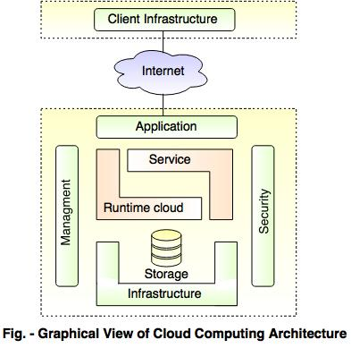

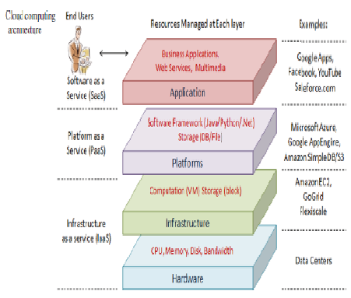

Ways to use Cloud,

1. The Software as a Service (SaaS) model allows businesses to provide direct access to the applications by employees, partners or clients. Because these applications are centrally managed on the cloud, there are no licenses or upgrades to maintain.
2. The Platform as a Service (PaaS) model is an application development platform delivered on demand, allowing developers to focus on software design, development and deployment — without the cost and complexity of buying and managing the underlying hardware, software, provisioning and hosting.

For example, by using PaaS, an online gaming company can become more nimbler and innovative. Before cloud resources became available, it might have taken the company two to four months to launch products using only its own infrastructure and custom configurations. The PaaS approach allows that same company to provide the right resources in just hours for developers building games, and the customers who want to play them.

Cloud Foundry is the industry’s Open PaaS and provides a choice of clouds, frameworks and application services. As an open source project, there is a broad community both contributing and supporting Cloud Foundry.

1. The Infrastructure as a Service (IaaS) model delivers compute power, storage and networking on demand, eliminating the high cost of maintaining, staffing and providing power and cooling for an in-house data center if the service is provided externally. If it’s provided internally at a departmental level, it still offers greatly improved speed and efficiency in providing compute resources needed for the business.

Cloud usage in Web apps and Mobile apps,

* Data storage is a cloud-like feature
* Data can be temporarily stored to be used later when the device is offline
* The cloud application is user-friendly in such a way that it supports various consumers prerequisites which include; backup schedule, security, and compression of data.
* It can be operated under a device that is connected on internet on the web browser. The devices may include your phone or your desktop.