**Report: Advanced Driver Assistance System (ADAS) incident data analysis**

*Team Name*: Mavericks

*Team Members:*

1. Kausthuban R S
2. Kathirvel S
3. Kishore A

**Abstract**:

This report provides an in-depth analysis on the Advanced Driver Assistance Systems (ADAS) incidents, with a focus on enhancing road safety and driver awareness. The Analysis process includes alert frequency, cluster analysis, geospatial mapping which provides insights which can lead to predicting accidents and promoting road safety.

**Introduction/Motivation:**

In a world where Artificial Intelligence is rapidly becoming integral to all fields, the field of road safety will face a positive growth due to technologies like Advanced Driver Assistance Systems (ADAS). Our goal is to analyse and find a way to predict the driver behaviours on various scenarios on the Indian roads ultimately playing a part on reducing road accidents.

**Related Works:**

Past studies on ADAS have proved its role on road safety, our analysis will focus on calculating and predicting clusters which can be deemed into Black sports or accident-prone zones. Studied real time situation and data of actual accident-prone zones.

**Data Source:**

* ADAS Alert dataset – Contains data such as geo-coordinates, date and time, alert types, vehicle information and speed of the vehicles.
* Insights from traffic cops on how they handle black spots

**Analysis – Insights and Patterns (External Data):**

**Cluster Detection: HDBSCAN algorithm**

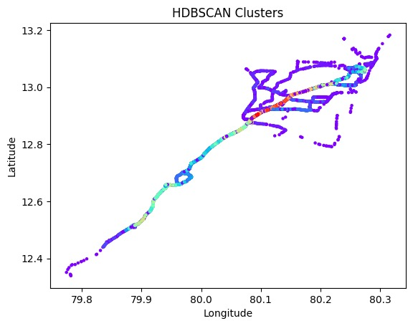

* Used HDBSCAN algorithm to detect clusters based on the latitude and longitude which will used to detect and predict black spots.
* Understanding the actual ground data will lead to efficiently predict black spots and take necessary prevention measures.

**Alert Based Cluster Analysis:**

* Categorizing the clusters based on the type of alert helps to detect alert based clusters using DSCAN algorithm.

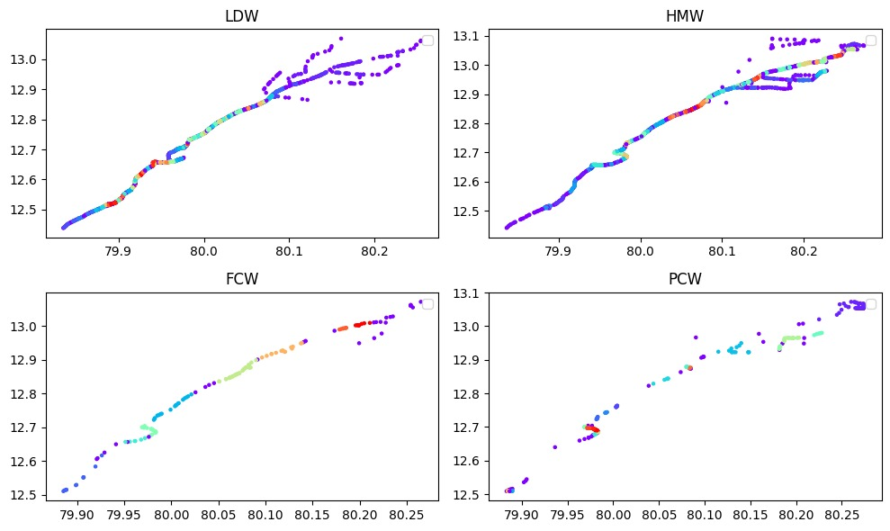

* By categorizing the clusters leads to specialized black spots which are prone to specific type of accidents and which will induce more number of a specific alert
* Handling the traffic control would be benefitted from this.

**Alert Frequency Analysis:**

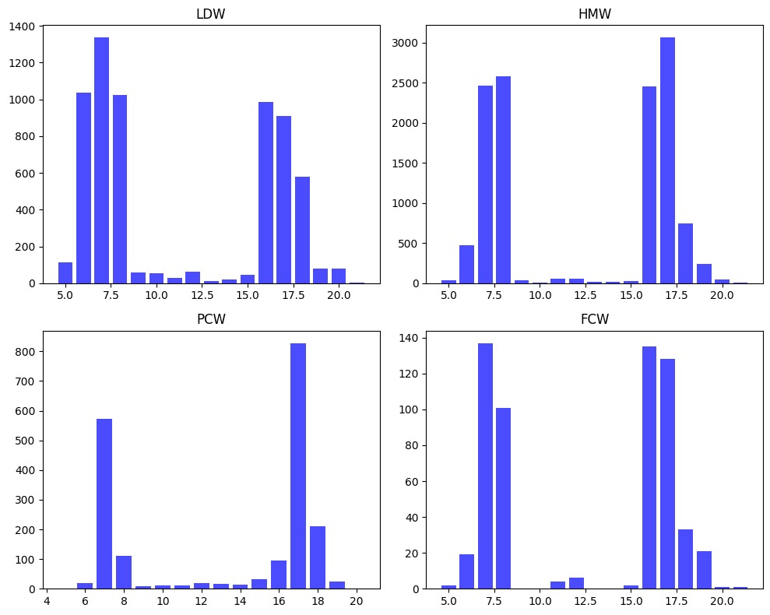

* The above bar charts point that the alert count is at its highest from 6 AM to 8 AM and 4 PM to 6 PM.
* On further Investigation based on traffic data during the specific hours, we can find that the density of vehicles during the duration is high.

Geospatial Analysis:

* With necessary data, we can identify the live analysis on the predicted clusters by the above analysis.
* Location-based analysis helps to understand the causes of accidents and evaluate the effectiveness of safety measures.

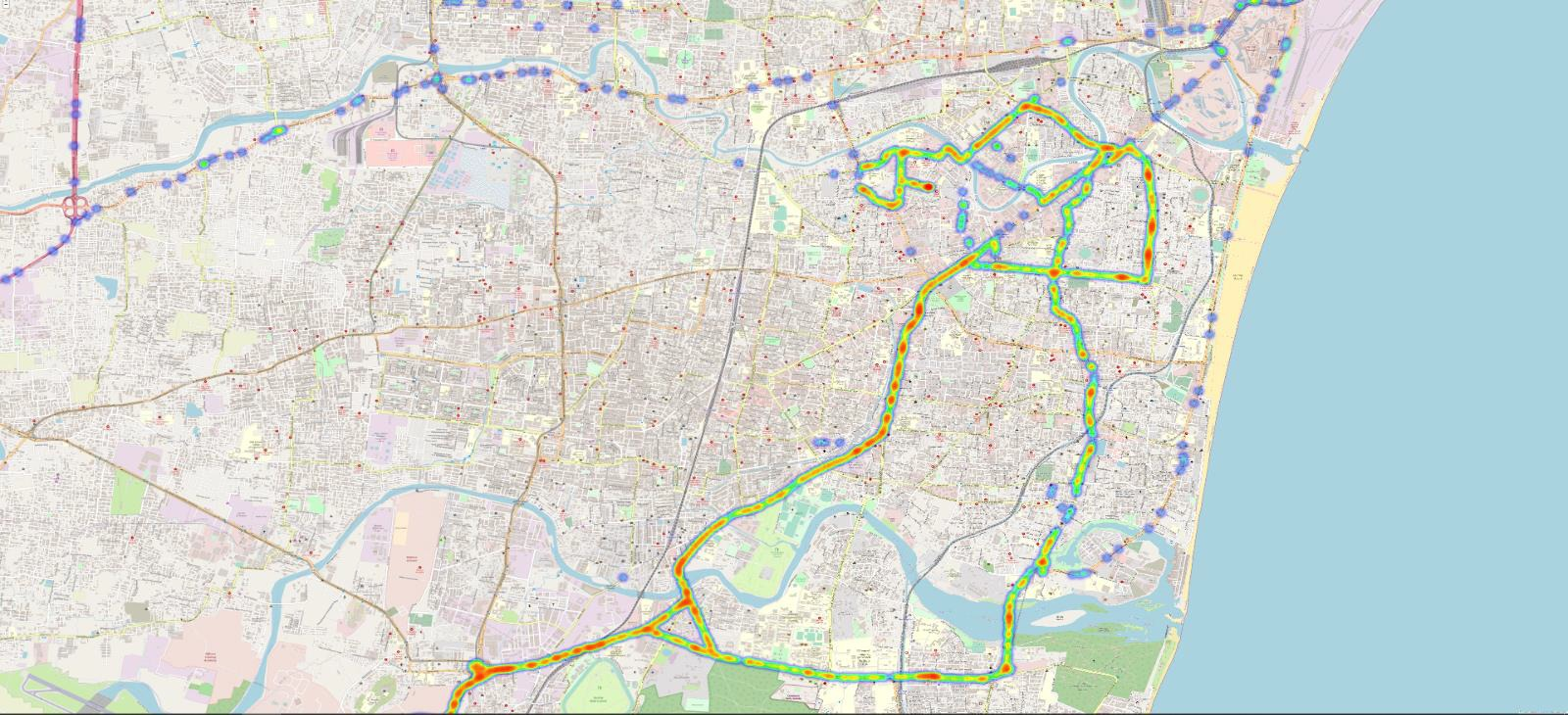

**URL:**

To access the results, code and interactive visuals, please visit:

https://github.com/KausthubanRS/ADAS_dataset_analysis

This report provides an overview on ADAS incident analysis, following a format that includes team/author information, a brief abstract, introduction, references and URL for further results.