How to get below requirement done:

1. List all the files in a directory



1. List all files and their details (owner, mtime, size, etc)

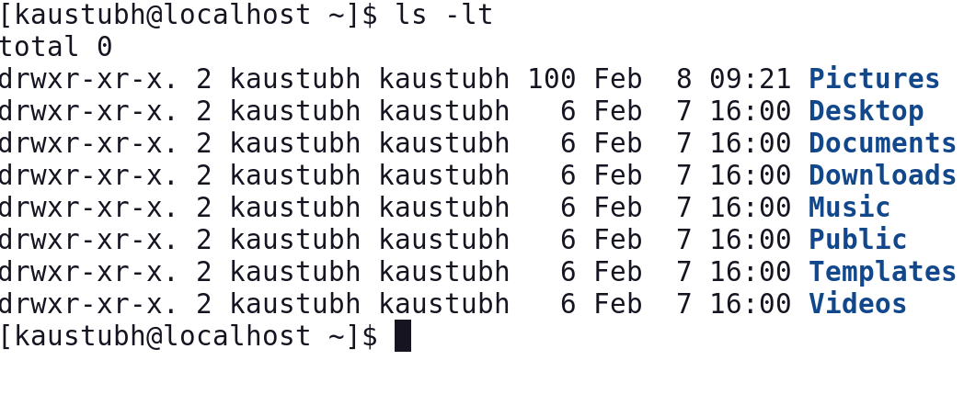

1. List all the files in a directory (including hidden files)

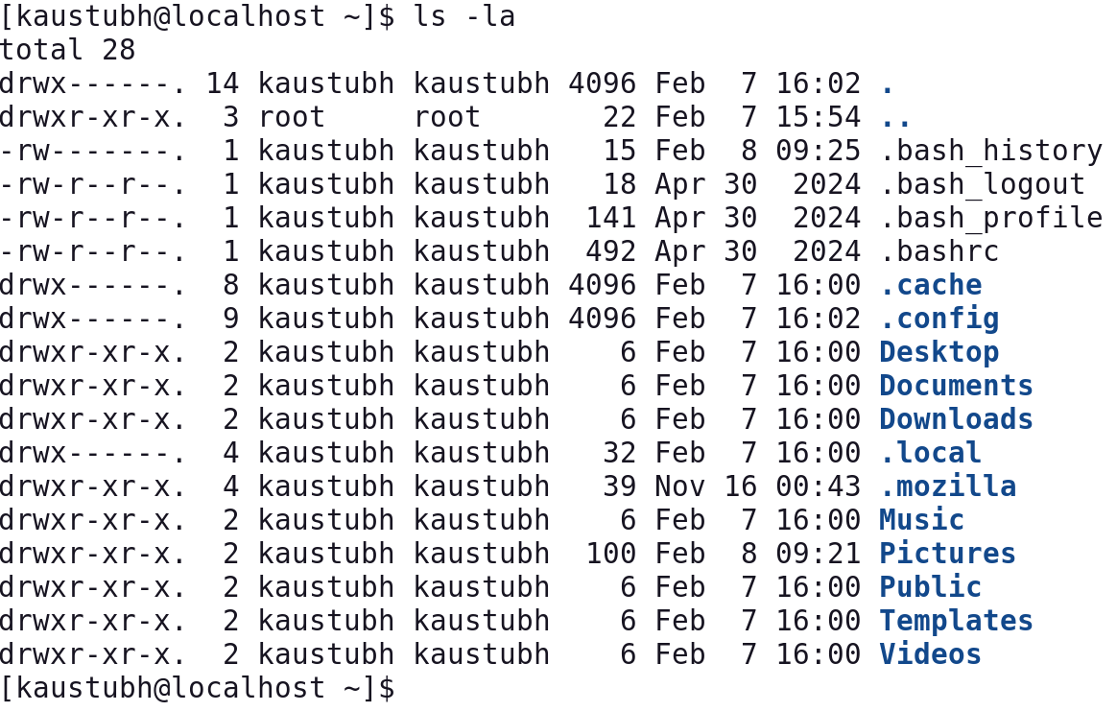

1. List the present working directory

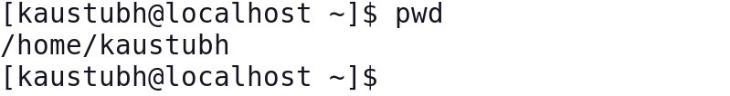

1. Change directory to some other location



1. Create a new directory structure

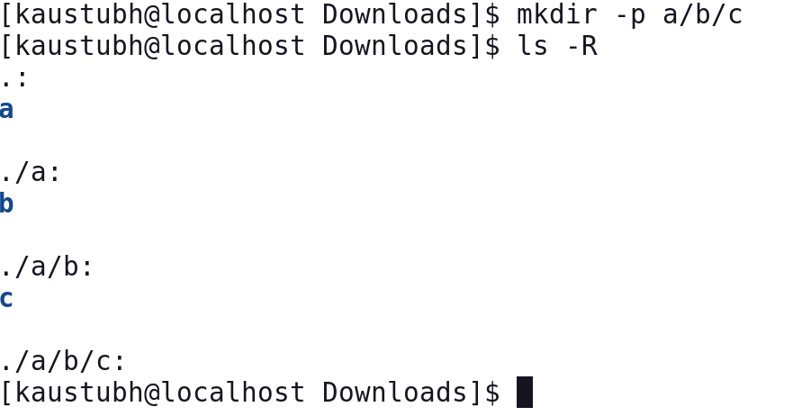

1. Create a new, empty file, or update the modified time of an existing one

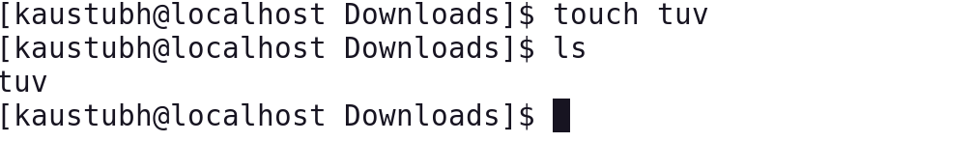

1. Create a new file with the text you type after

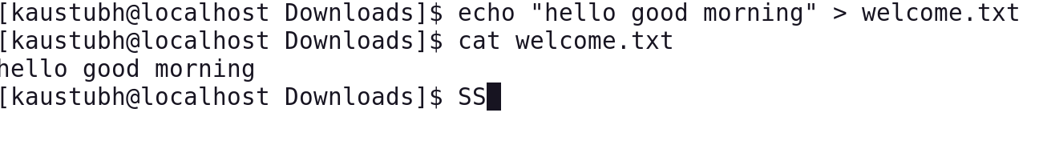

1. View the contents of a file with line numbers

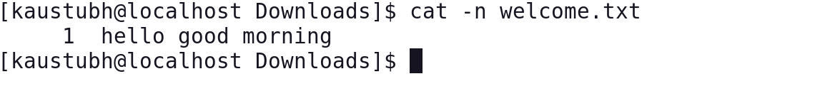

1. Remove a file

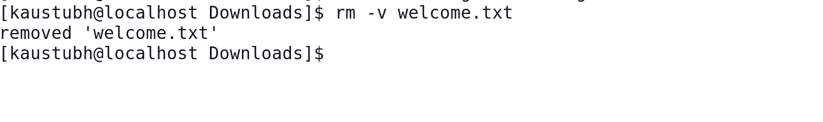

1. Remove directory which is not empty

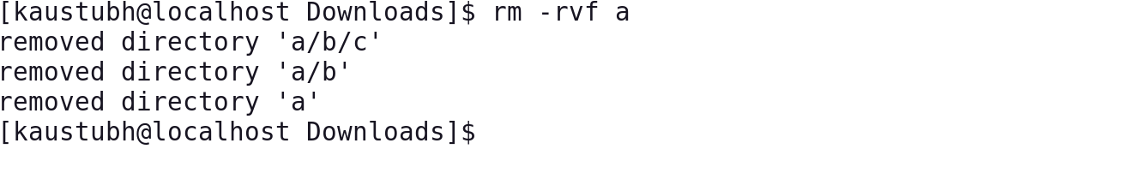

1. Deletes file recursively from current directory

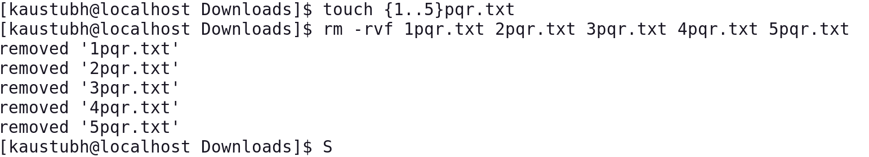

1. Create empty file

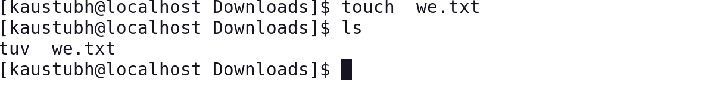

1. Create multiple empty files

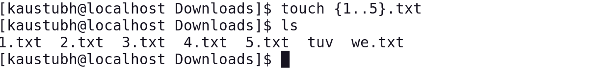

1. Change file access and modifications time



1. How to change only modification time



1. How to avoid creating new file

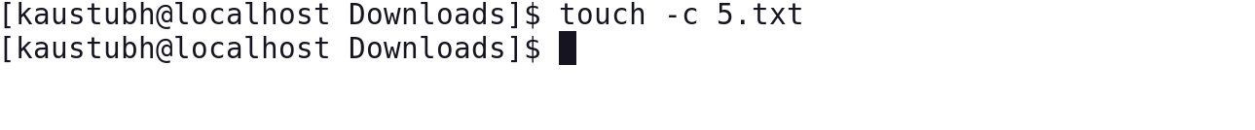

1. Explicitly set access and modification time of file

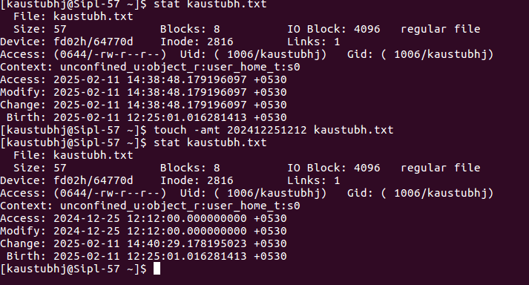

1. How to use access time stamp of another file

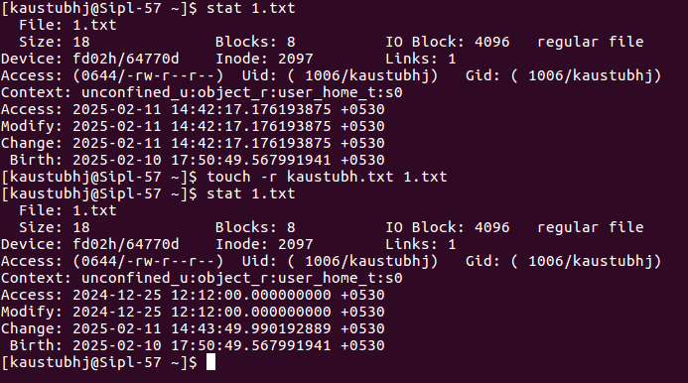

1. Create a file with a specified time

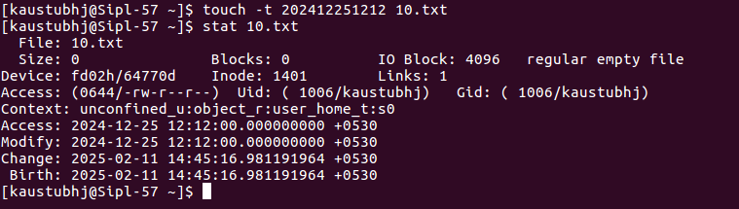

1. Create a new file using cat command

change the specified time: WORD is access, atime, or use: equivalent to -a WORD is modify or

mtime: equivalent to -m



1. Display contents of file

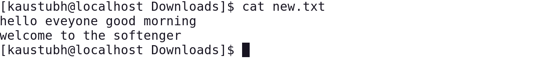

1. View contents of multiple files

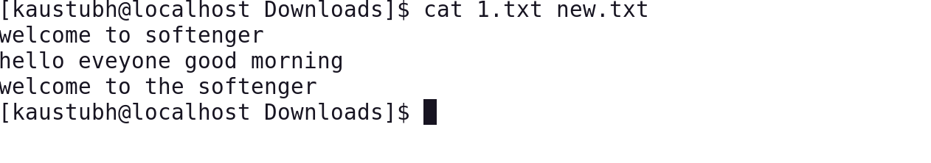

1. Display line numbers in file

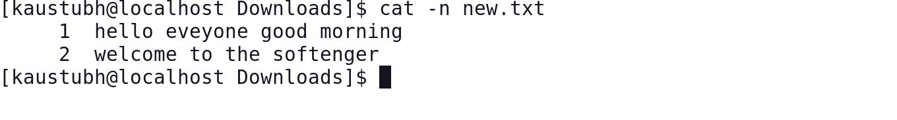

1. Display $ at the end of the file



1. Display multiple files at once



1. Use standard output with redirection operator

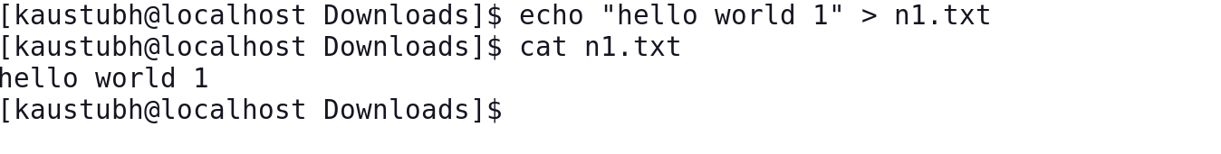

1. Appending standard output with redirection operator



1. Sorting contents of multiple files in single file

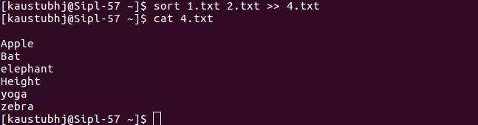

1. Remove single file using rm

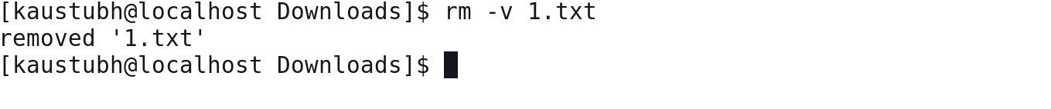

1. Remove multiple files

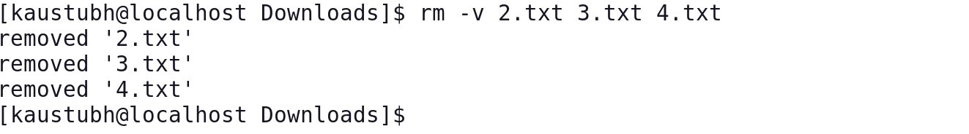

1. Remove empty/ non empty directory

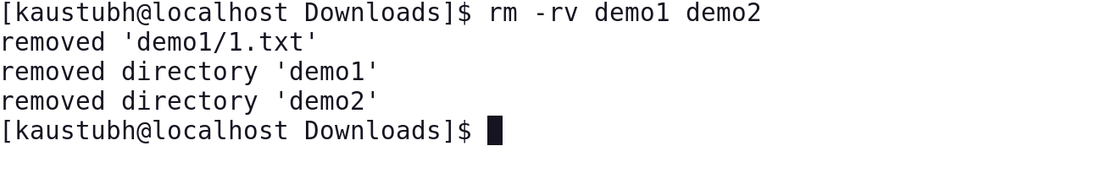

1. Remove file/directory with confirmation prompt

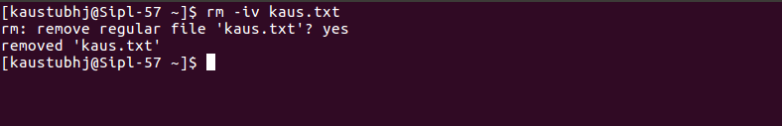

1. Remove file/ directory forcefully

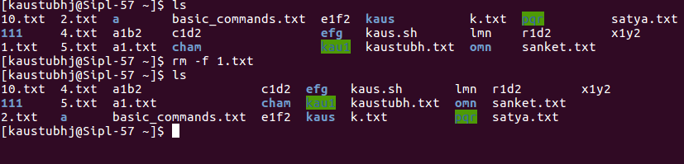

1. Remove file recursively and forcefully. (most dangerous command, that you should never run on a Linux system, especially as root.)

