How to get below requirement done:

1. To see a list of processes running on the system.

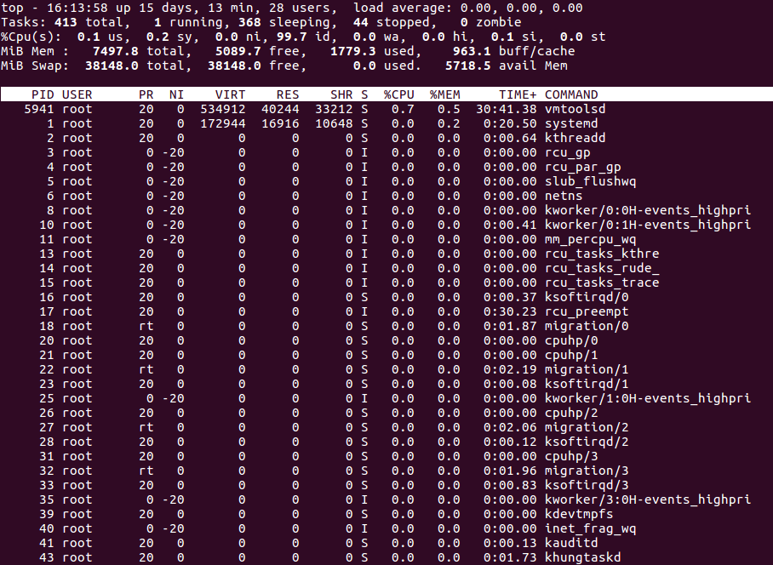

1. To get detailed information about a specific process, use the ps -p command with a process ID.



1. To see the process states

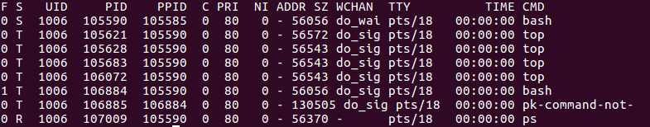

1. **a.Start a Process**:

**#** sleep 60 & [background process]

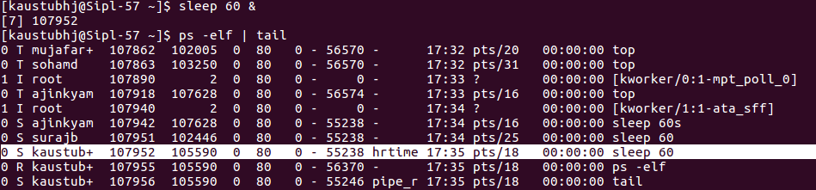

**b. Terminate a Process**: Find the PID of the sleep command and terminate it using kill

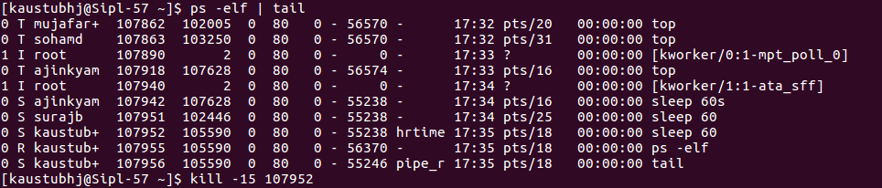

**c**. **Verify Process Termination**: After running the kill command, use ps to verify the process has been terminated.

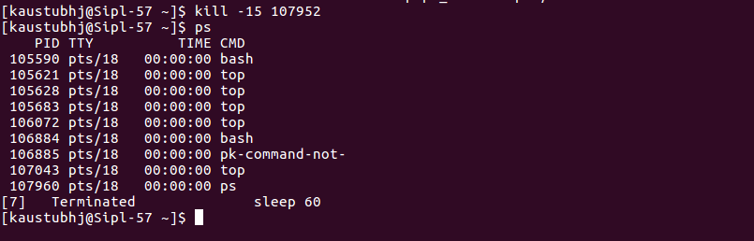

1. To see every process on the system

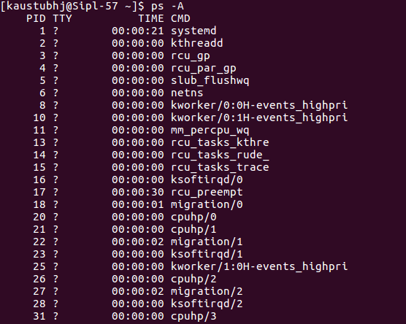

1. To get info about threads

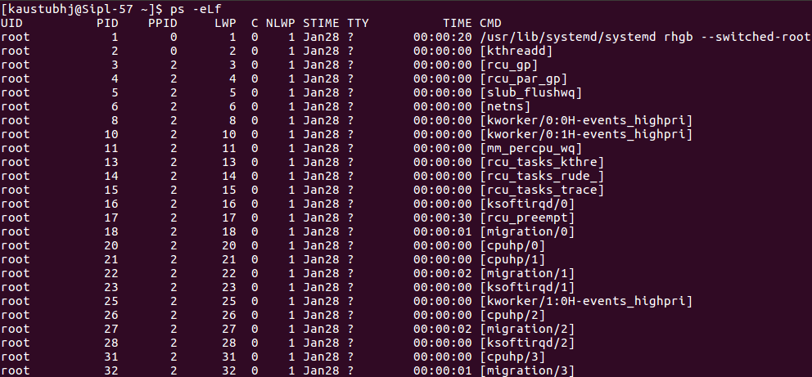

1. To display more fields in ps output

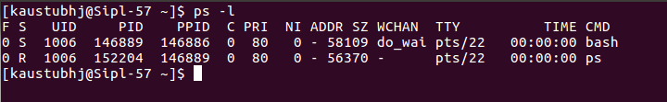

1. To display a process tree

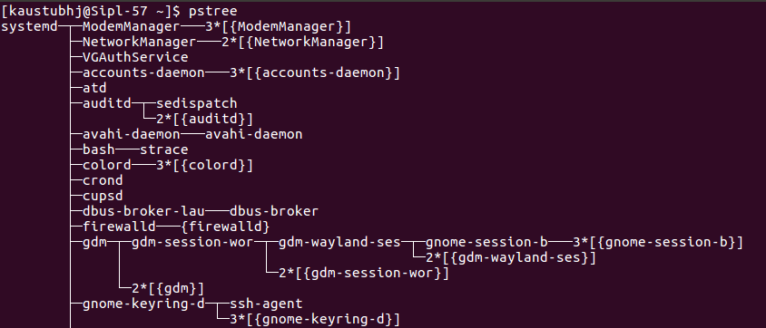

1. to immediately kill the process assigned a PID

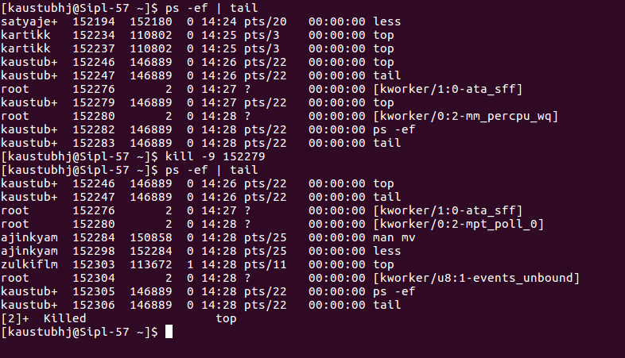

1. to suspend a process



1. To list all suspended processes

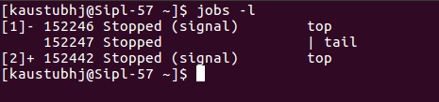

1. To bring a suspended process to foreground

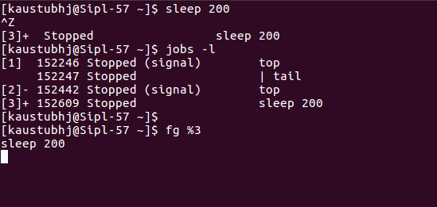

1. To run a suspended process in the background



1. To display running process as per CPU usage



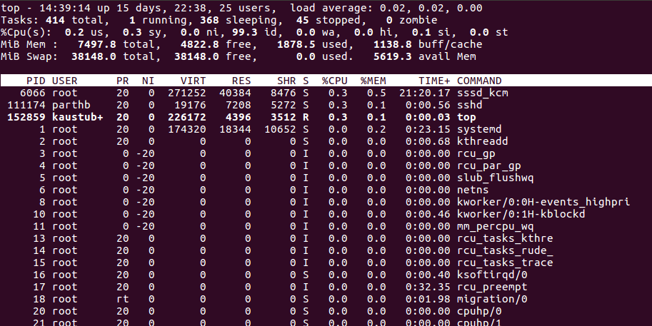

1. To check total, used and available memory

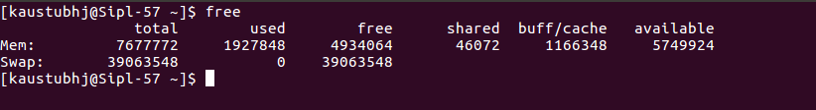

1. To Display the amount of memory in megabytes

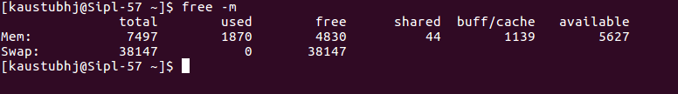

1. To Display the amount of memory in gigabytes.

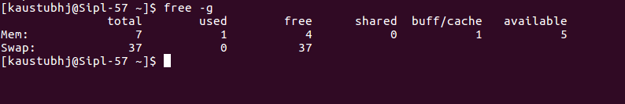

1. To show the detailed low and high memory statistics

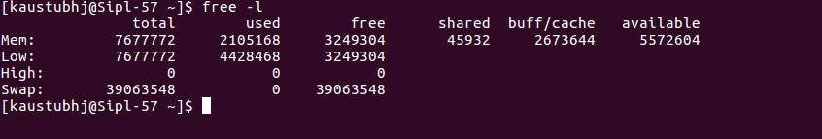

1. To check how long the system is active (running).

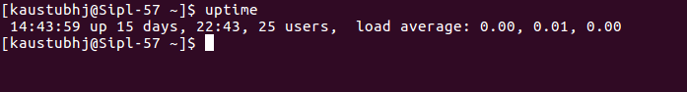

1. To check who is logged on and what they are doing.

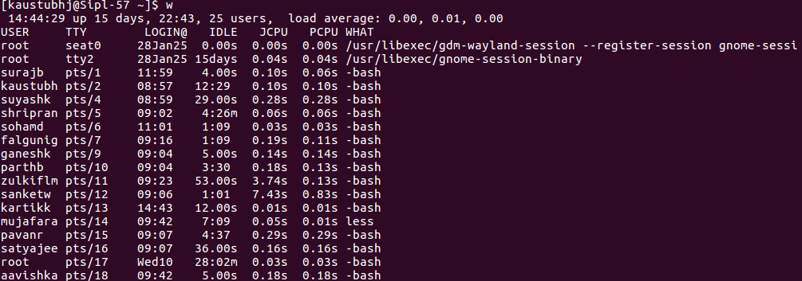

1. How to check idle time and login time of a user

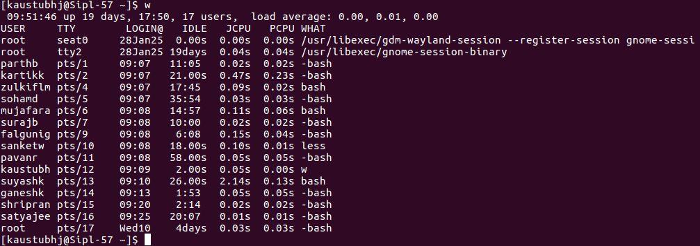

1. To rename a file

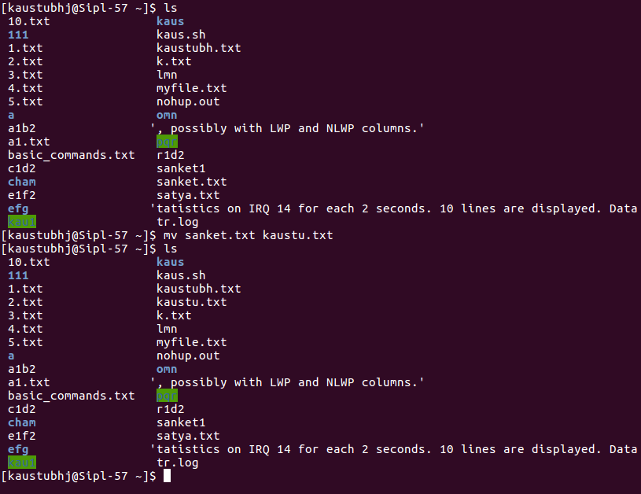

1. To prevent an overwrite while renaming or moving

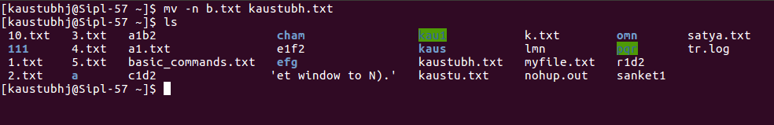

1. To display first 15 lines of a file

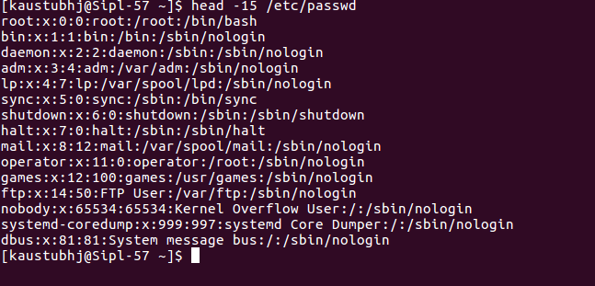

1. To display first 5 lines of multiple files

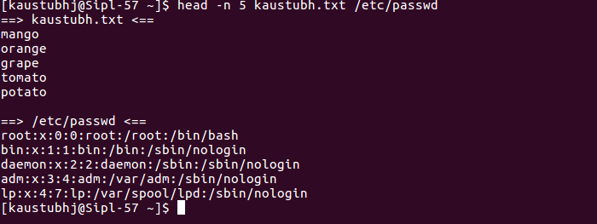

1. To display last 15 lines of a file

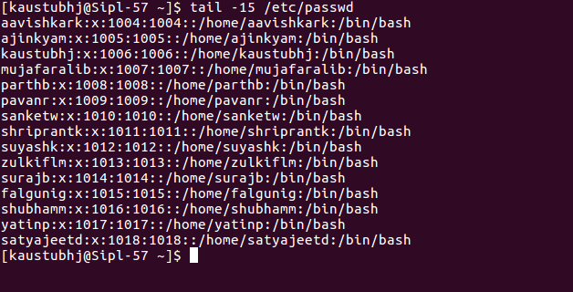

1. To display last 5 lines of multiple files

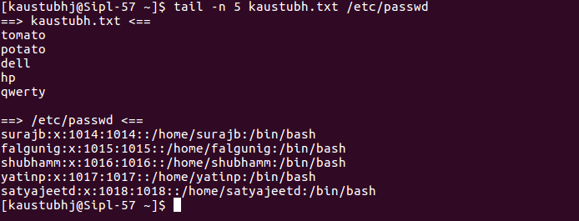

1. To list all open files belonging to all active processes.

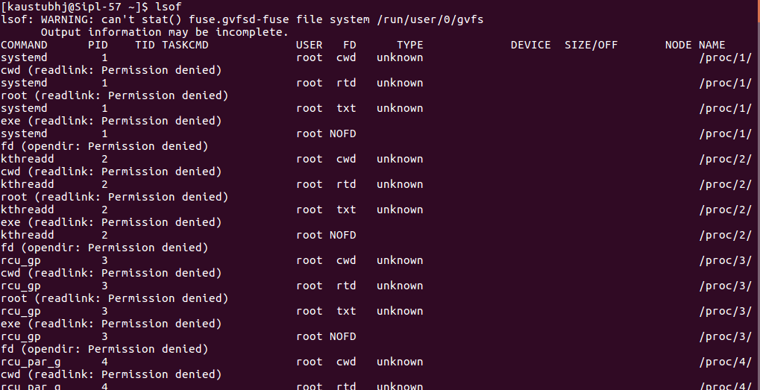

1. To find a list of files that are opened by a specific user

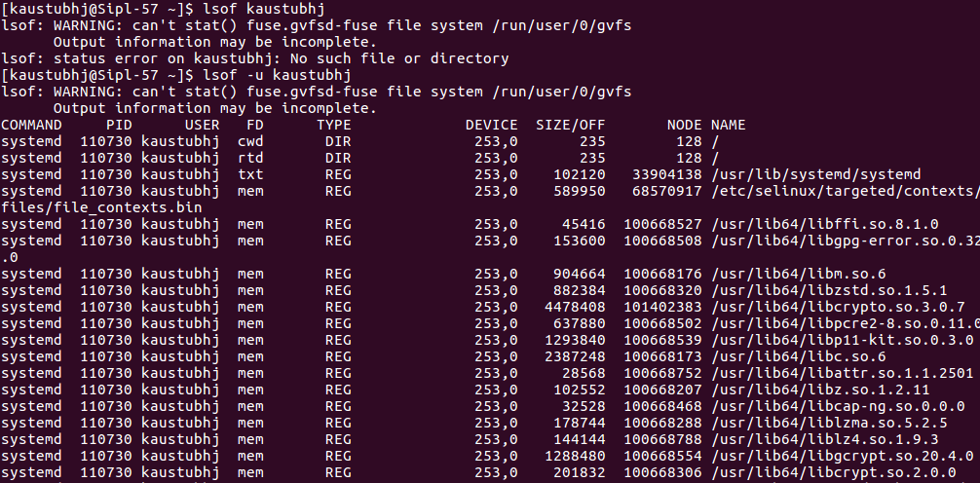

1. List all files which are opened by everyone except a specific user

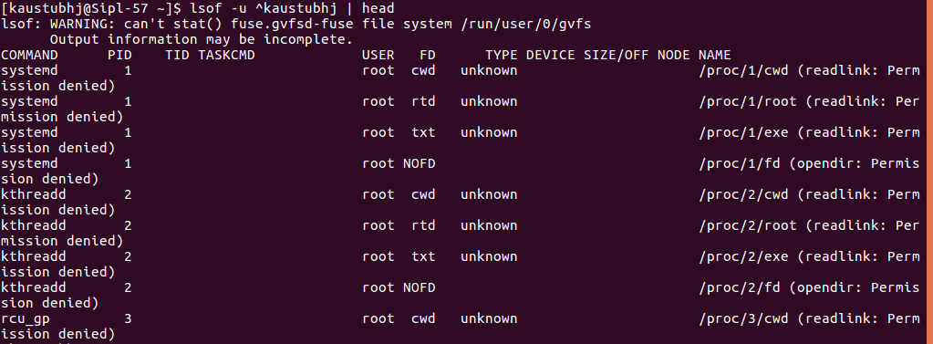

1. List all open files by a particular Process

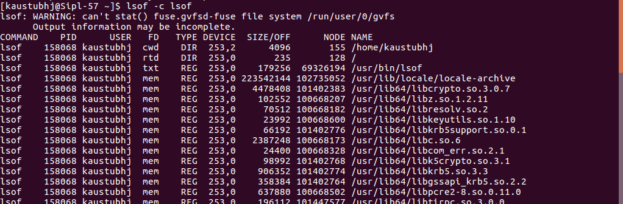

1. List all open files by a particular Process ID

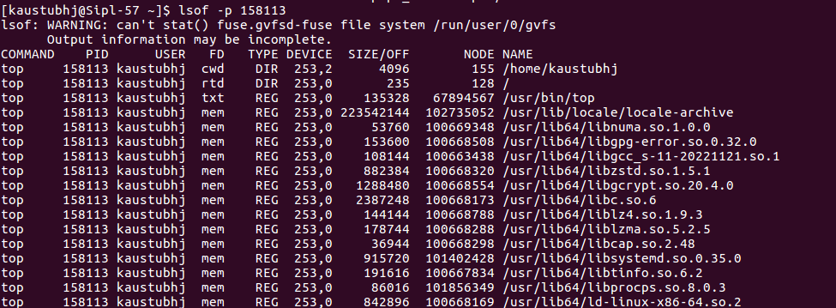

1. List open files from a particular directory

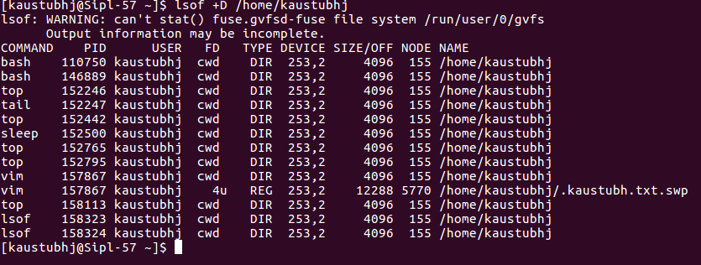

1. To exit Top Command After Specific repetitions

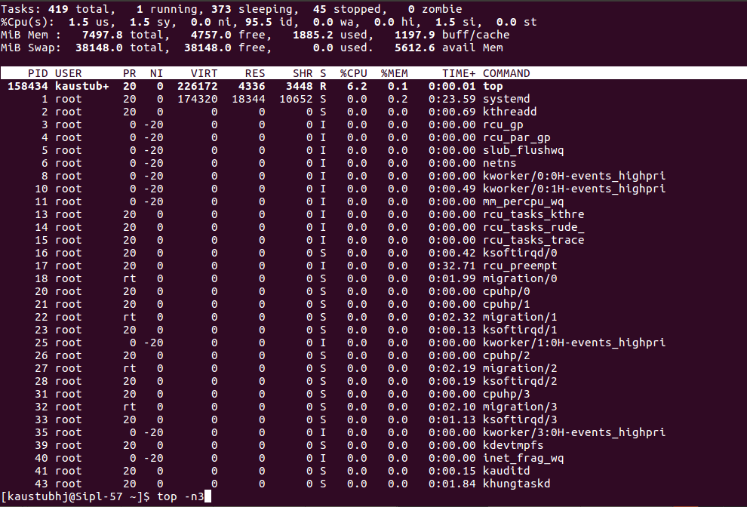

1. To display absolute path of running processes.

