How to get below requirements done:

1. To display block devices.

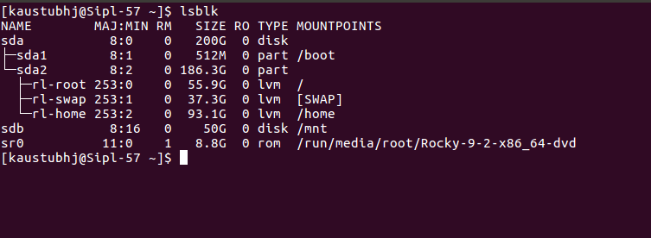

1. To display empty block devices as well

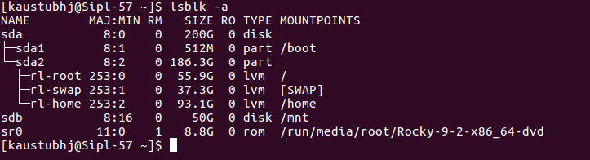

1. To display 0utput info about device owner, group and mode.

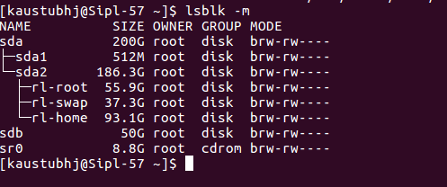

1. To print the SIZE column in bytes

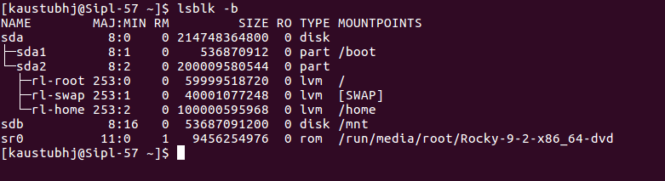

1. To print full paths of devices.

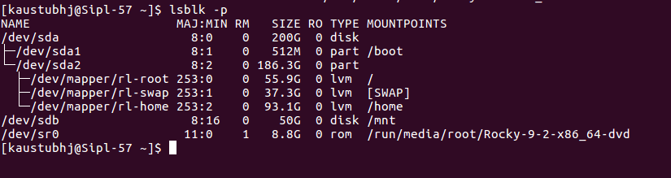

1. To print the number of lines present in a file.

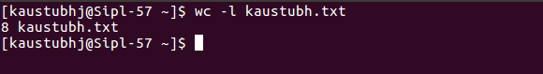

1. To print the number of words present in a file.



1. To display the count of bytes present in a file.



1. To display the count of characters from a file.

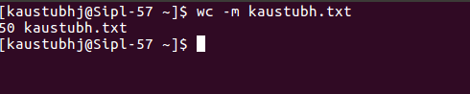

1. Find Files Without 777 Permissions in a particular directory

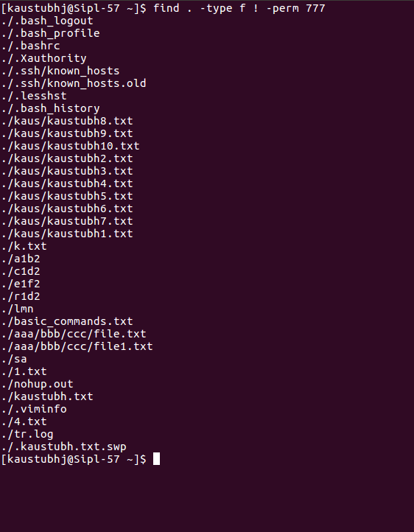

1. Find Sticky Bit Files with 644 Permissions in a particular directory

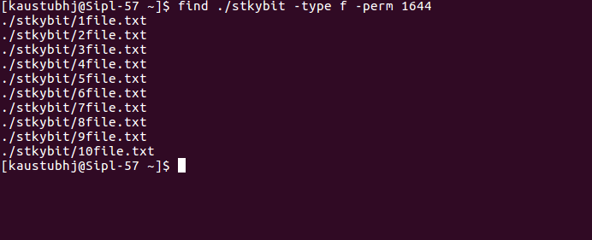

1. Find Read-Only Files in a particular directory

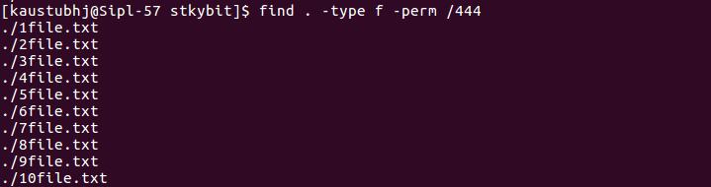

1. Find Directories with 777 Permissions and Chmod to 755 in a particular directory



1. Find and remove Multiple Files older than 100 days from a particular directory

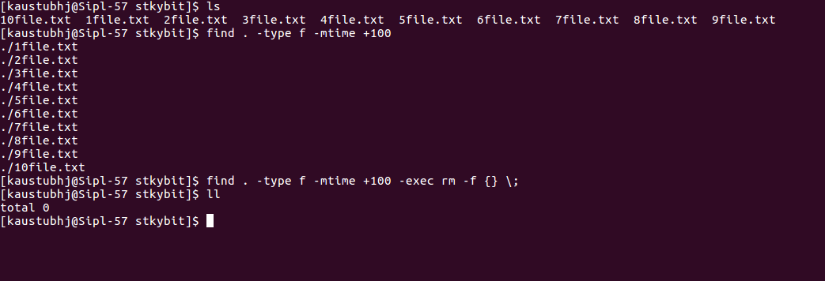

1. Find all Empty Directories in a particular directory

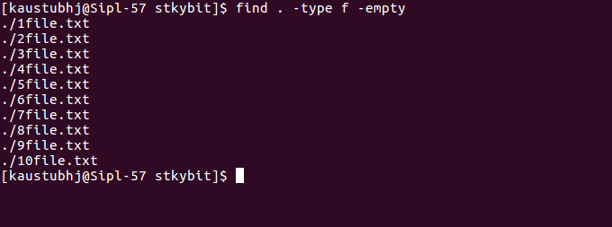

1. Find Single File Based on User in a particular directory



1. Find all Files Based on User in a particular directory

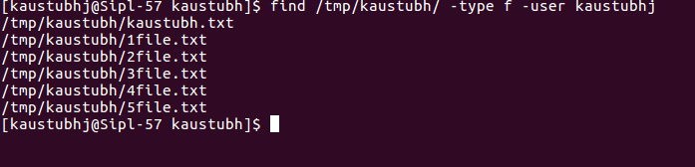

1. Find all files modified within last 5 days in a particular directory

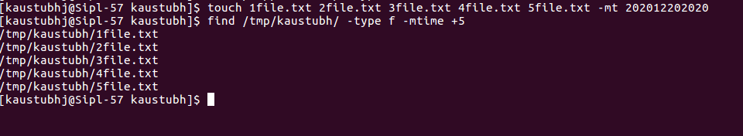

1. Find all files accessed more than 15 days ago in a particular directory

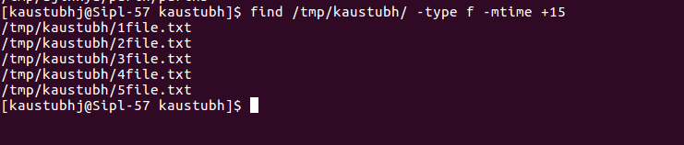

1. Find all files modified within last 5 to 10 days

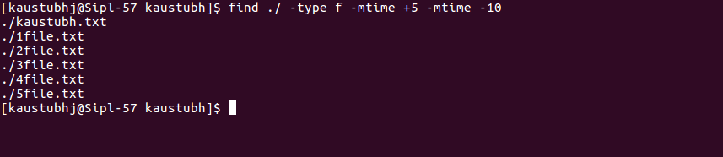

1. Find kernel name and kernel verision of your system



1. Find out the Run levelof your system

