1. Basic Disk Management

1.1 List Available Disks
# lsblk
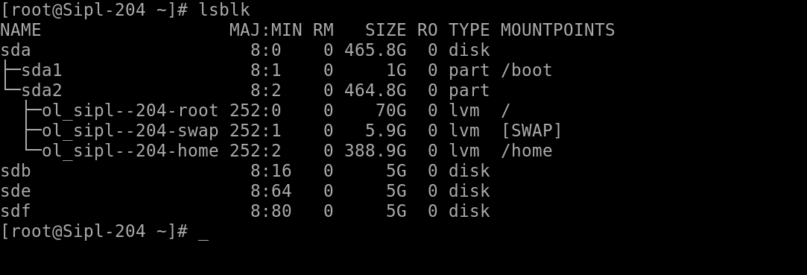

1.2 Partition a New Disk
# fdisk -l
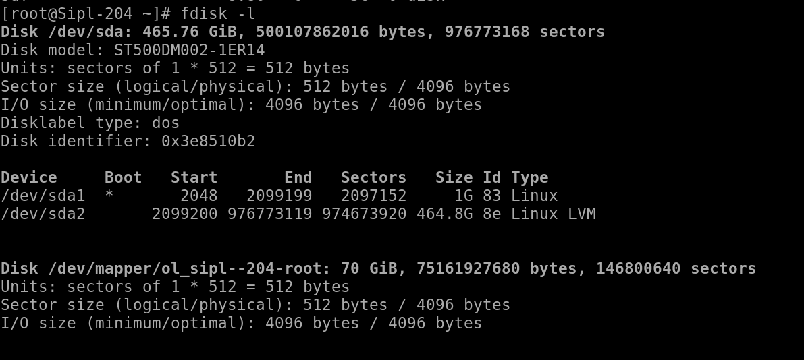

2. LVM (Logical Volume Manager) Management

$ sudo pvcreate /dev/sdX1

Create a physical volume

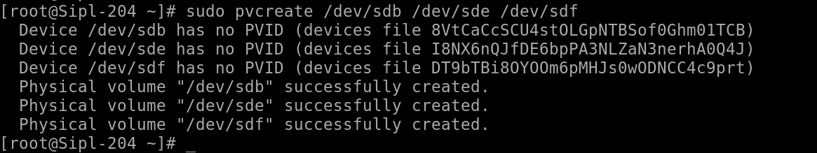
$ sudo vgcreate my_vg /dev/sdb /dev/sde /dev/sdf

Create a volume group

$ sudo lvcreate -L 10G -n my_lv my_vg

Create a logical volume

$ sudo mkfs.ext4 /dev/my_vg/my_lv

Format the logical volume

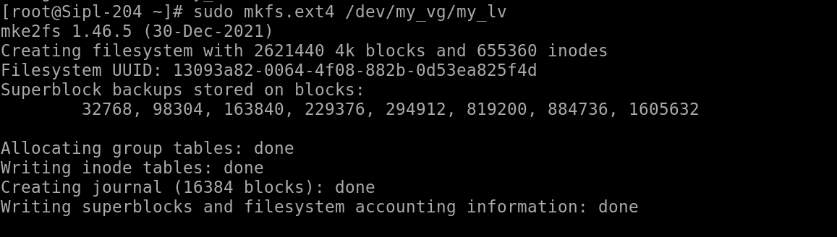

$ sudo mkdir /mnt/mydata
$ sudo mount /dev/my_vg/my_lv /mnt/mydata

Mount it

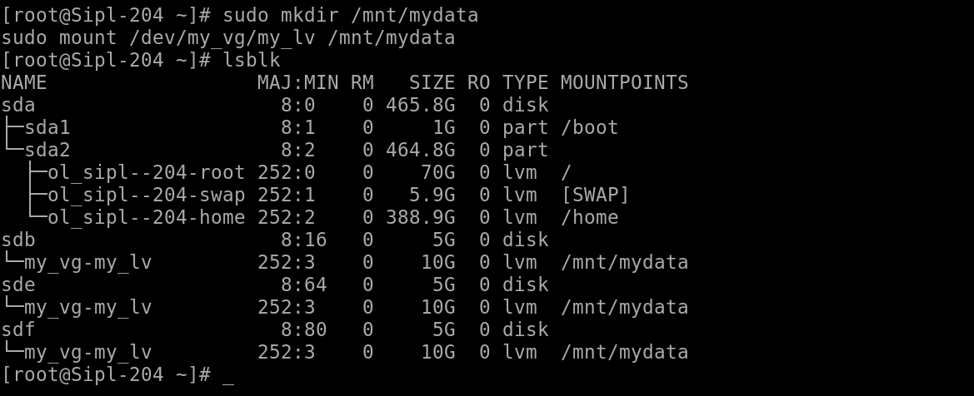

2.2 Extend a Logical Volume
Extend LV size

$ sudo lvextend -L +2G /dev/my_vg/my_lv
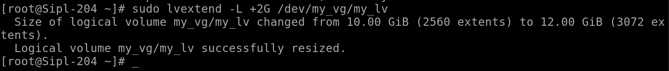
Resize filesystem (ext4)

$ sudo resize2fs /dev/my_vg/my_lv
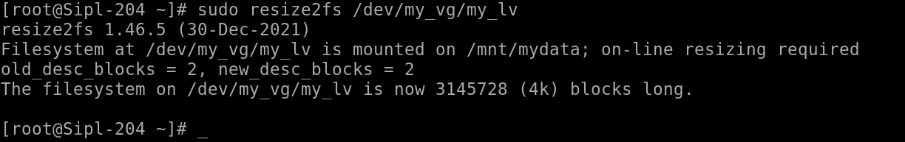

2.3 Reduce a Logical Volume (use with caution!)
Unmount the volume

$ sudo umount /mnt/mydata
Check filesystem

$ sudo e2fsck -f /dev/my_vg/my_lv

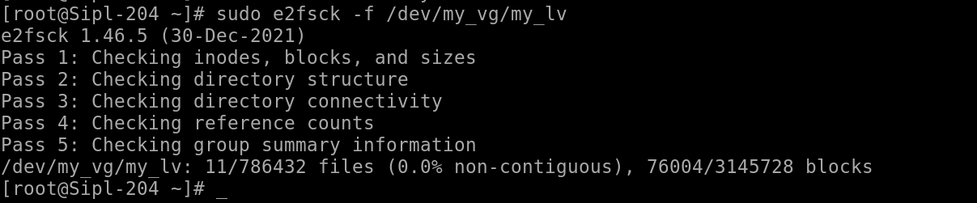
Resize filesystem

$ sudo resize2fs /dev/my_vg/my_lv 8G

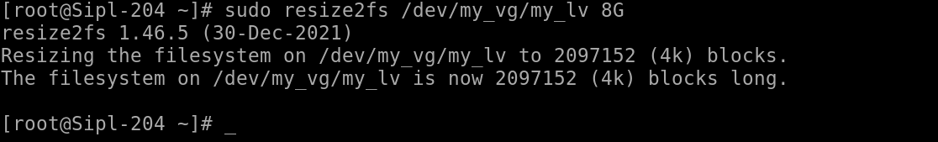
Reduce LV size

$ sudo lvreduce -L 8G /dev/my_vg/my_lv

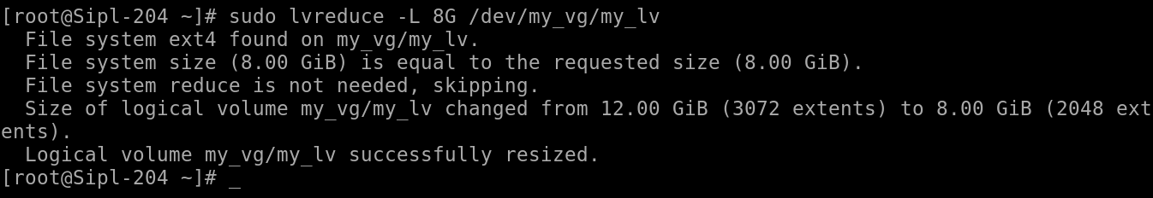
Mount it back

$ sudo mount /dev/my_vg/my_lv /mnt/mydata

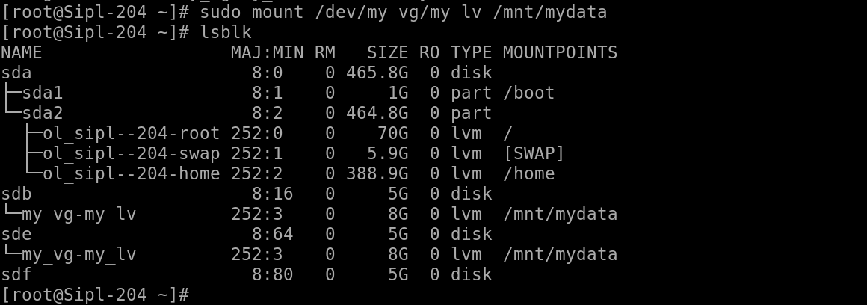

2.4 Remove LVM Setup
# first umount the storage
sudo umount /mnt/mydata
# remove lvm
sudo lvremove /dev/my_vg/my_lv

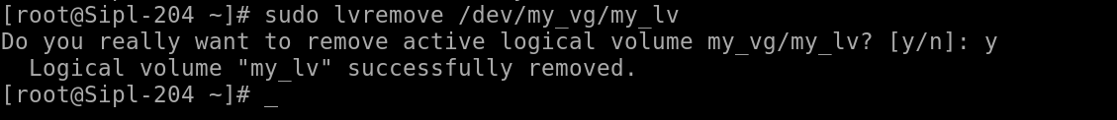
# remove vg
sudo vgremove my_vg

# remove pv

sudo pvremove /dev/sdX1

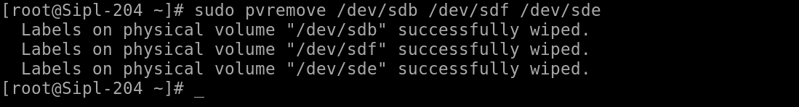

3. RAID Management (mdadm)

3.1 Create RAID 0, 1, or 5
# Install mdadm

sudo mdadm --create --verbose /dev/md0 --level=1 --raid-devices=2 /dev/sdd /dev/sdf
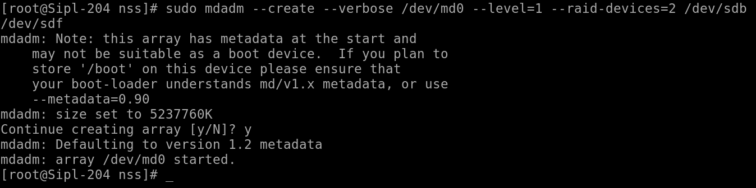
# Create filesystem

sudo mkfs.ext4 /dev/md0

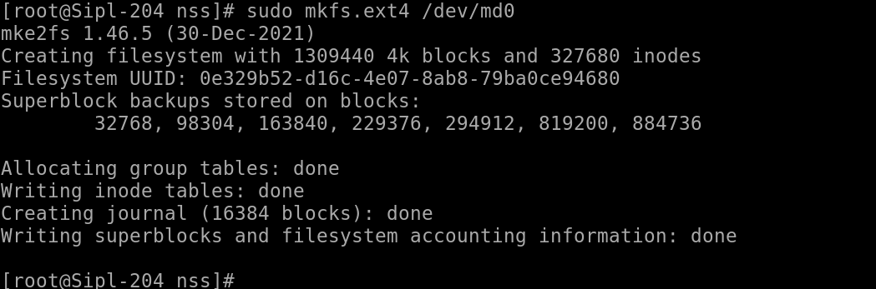

# Mount

sudo mkdir /mnt/raid
sudo mount /dev/md0 /mnt/raid
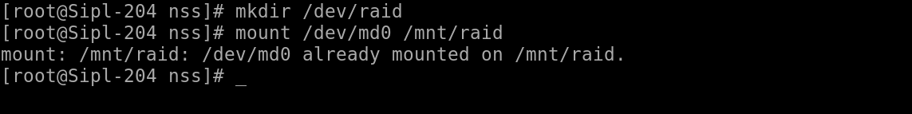

3.2 View RAID Status

sudo mkdir /mnt/raid
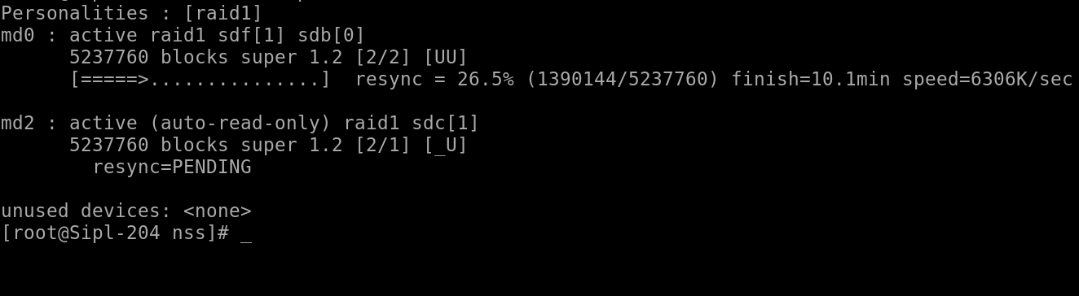
sudo mdadm --detail /dev/md0
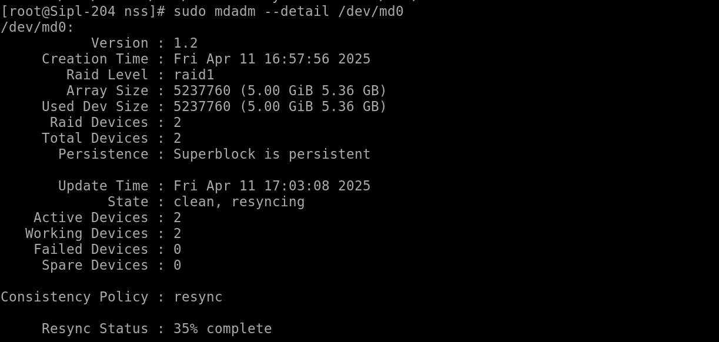
sudo umount /mnt/raid
sudo mdadm --stop /dev/md0
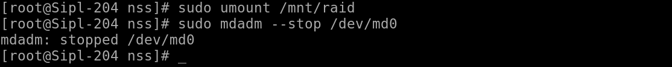

4. Filesystem and Mounting

4.1 Format and Mount

sudo mkfs.ext4 /dev/sdX1
sudo mkdir /mnt/mydisk
sudo mount /dev/sdX1 /mnt/mydisk

4.2 Add to /etc/fstab (Persistent Mount)

/dev/sdX1 /mnt/mydisk ext4 defaults 0 2

Important commands and their options :
pvcreate – Initialize a physical volume
Option | Description | Example
--dataalignment | Align data to improve performance | pvcreate --dataalignment 1m /dev/sdX
--zero | Wipe first 4 sectors (default: y) | pvcreate --zero y /dev/sdX
--uuid | Set custom UUID | pvcreate --uuid YOUR-UUID /dev/sdX

vgcreate – Create a volume group

Option | Description | Example
-s | Set physical extent size | vgcreate -s 16M vg1 /dev/sdX
--addtag | Add tag to VG | vgcreate --addtag mytag vg1 /dev/sdX

lvcreate – Create a logical volume

Option | Description | Example
-L | Specify size | lvcreate -L 10G -n lv1 vg1
-n | Name the logical volume | lvcreate -L 10G -n lv1 vg1
--type | Specify RAID type or striped/mirrored | lvcreate --type raid1 -L 10G -n lv1 vg1
-i | Number of stripes | lvcreate -i2 -I64 -L 10G -n lv1 vg1
-I | Stripe size | lvcreate -i2 -I64 -L 10G -n lv1 vg1

lvextend – Extend a logical volume

Option | Description | Example
-L | Set new absolute size | lvextend -L 15G /dev/vg1/lv1
-l | +%FREE or +XG relative increase | lvextend -l +100%FREE /dev/vg1/lv1
-r | Resize filesystem after extending | lvextend -r -L 15G /dev/vg1/lv1

lvreduce – Reduce a logical volume

Option | Description | Example
-L | Set reduced size | lvreduce -L 8G /dev/vg1/lv1
--resizefs | Resize filesystem before reducing | lvreduce --resizefs -L 8G /dev/vg1/lv1

lvremove – Remove a logical volume

Option | Description | Example
-f | Force removal without confirmation | lvremove -f /dev/vg1/lv1

vgremove – Remove a volume group

Option | Description | Example
-f | Force removal | vgremove -f vg1

pvremove – Remove a physical volume

Option | Description | Example
--force | Force removal | pvremove --force /dev/sdX

mkfs.ext4 – Format a disk/partition with ext4

Option | Description | Example
-L | Set volume label | mkfs.ext4 -L mydata /dev/sdX1
-m | Set reserved block percentage | mkfs.ext4 -m 1 /dev/sdX1

resize2fs – Resize ext2/ext3/ext4 filesystem

Option | Description | Example
(no option) | Resize to max | resize2fs /dev/vg1/lv1
<size> | Resize to specific size | resize2fs /dev/vg1/lv1 8G

mdadm – Manage software RAID

Option | Description | Example
--create | Create RAID array | mdadm --create /dev/md0 --level=1 --raid-devices=2 /dev/sdX /dev/sdY
--verbose | Show verbose output | mdadm --create --verbose ...
--level | RAID level | mdadm --level=1 ...
--raid-devices | Number of devices | mdadm --raid-devices=2 ...
--detail | Show RAID details | mdadm --detail /dev/md0
--stop | Stop RAID device | mdadm --stop /dev/md0
--remove | Remove RAID device | mdadm --remove /dev/md0
--detail --scan | Output config info | mdadm --detail --scan

