Key responsibilities:
1. Creating, modifying, and deleting user accounts.
2. Managing user groups and permissions.
3. Ensuring passwords policies are followed.
4. Locking/unlocking users.
5. Monitoring user activity and login information.

1- Creating user accounts.
useradd : create a new user.

-e, --expiredate | The date on which the user account will be disabled. Format YYYY-MM-DD
-f, --inactive | The number of days after the password expires until the account is permanently disabled.
-g, --gid | The group name or number of the user’s initial login group. (Primary)
-G, --groups | A list of supplimentary group which the user is also a member. (Secondary)
-m, --create-home | Create user’s home directory if it does not exist.
-u, --uid | The numerical value of the user’s ID. Value must be unique, unless the -o option is used.
-s, --shell | The name of a new user’s login shell. (/etc/default/useradd)
-U, --user-group | Create a group with the same name as the user.

2- Modifying user account.

Usermod

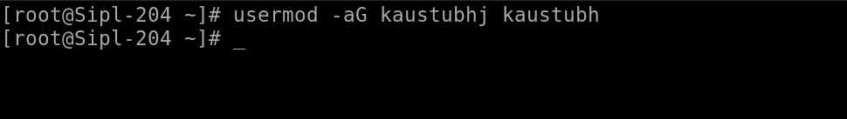

-a, --append | Add the user to the supplimentary groups. Use only with the -G option
-d, --home | The user’s new login directory.
-e, --expiredate | The date on which the user account will be disabled.
-g, --gid | The group name or number of the user's new initial login group. The group must exist.
-G, --groups | A list of supplementary groups which the user is also a member of. Each group is separated from the next by a comma, with no intervening whitespace.
-L, --lock | Lock a user’s password. This puts a '!' in front of the encrypted password,  effectively disabling the password.
-o, --non-unique | When used with the -u option, this option allows to change the user ID to a  non-unique value.

3- Remove user

Userdel

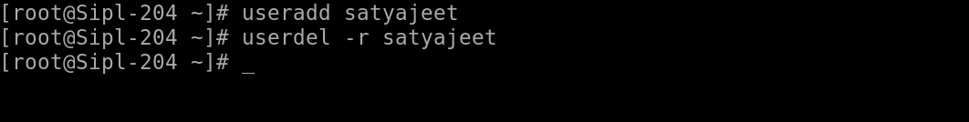
-r | Remove user and home directory

4. passwd – Set or change user password

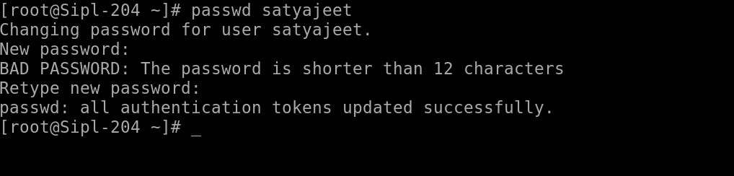

-l | Lock account
-u | Unlock Account
-e | Expire password
-d | Delete password

GROUP MANAGEMENT

1 . groupadd – Add a new group.

-g | Specify GID
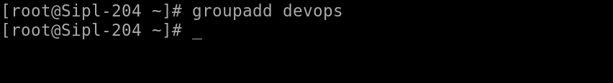
2. groupdel devops

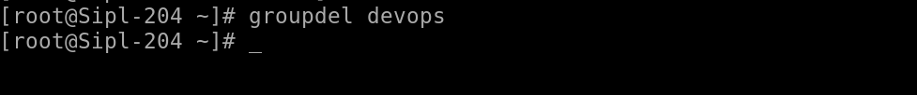

3. gpasswd – Manage group membership

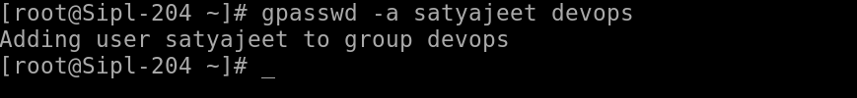
gpasswd -a kaustubh devops | Add user to group
gpasswd -d kaustubh devops | Remove user from group
gpasswd devops | Change group password

4. Viewing and Verifying

Command | Purpose | Example
id kaustubh | Show UID, GID, groups | id kaustubh
groups kaustubh | List user groups | groups kaustubh
getent passwd kaustubh | Show passwd entry | getent passwd kaustubh
getent group devops | Show group entry | getent group devops
cat /etc/passwd | List all users | cat /etc/passwd
cat /etc/group | List all groups | cat /etc/group
lastlog | Show last logins | lastlog
chage -l kaustubh | Show password aging | chage -l kaustubh

5. Password Aging with chage

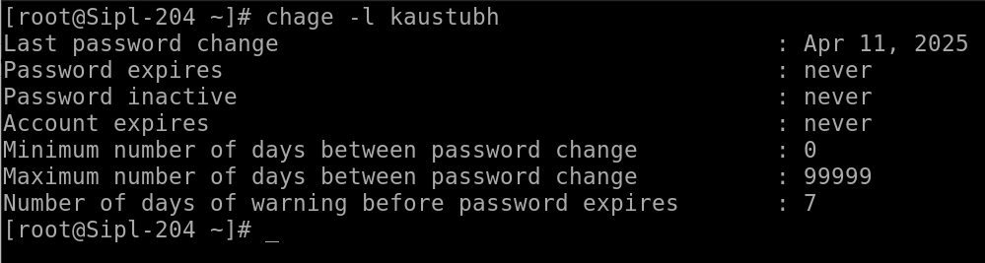

Option | Description | Example
-l | List aging info | chage -l kaustubh
-M | Max days between changes | chage -M 90 kaustubh
-m | Min days between changes | chage -m 1 kaustubh
-W | Warning before expiry | chage -W 7 kaustubh
-E | Expiration date | chage -E 2025-12-31 kaustubh

6. Lock/Unlock Accounts

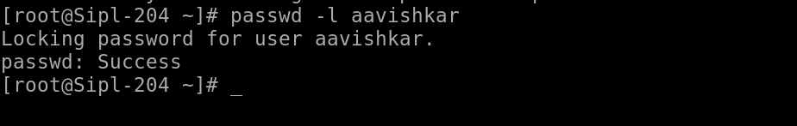

Command | Action
passwd -l kaustubh | Lock account
passwd -u kaustubh | Unlock account
usermod -L kaustubh | Lock account
usermod -U kaustubh | Unlock account

