- Find all occurrences of word “home” in passwd file in your $HOME and replace it with “HOME”

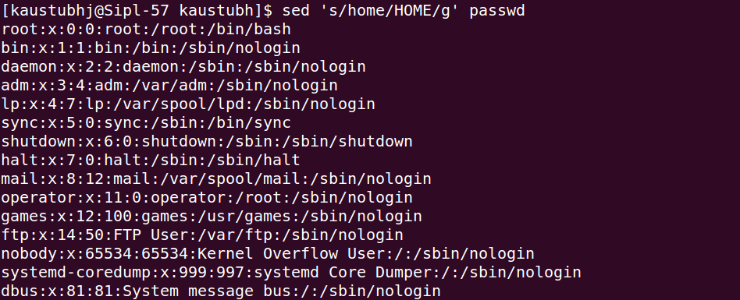

- Create a file named emp in your $HOME having 3 fields separated by tab, column names should be ename, eid, salary. Sums up the values in the second column.

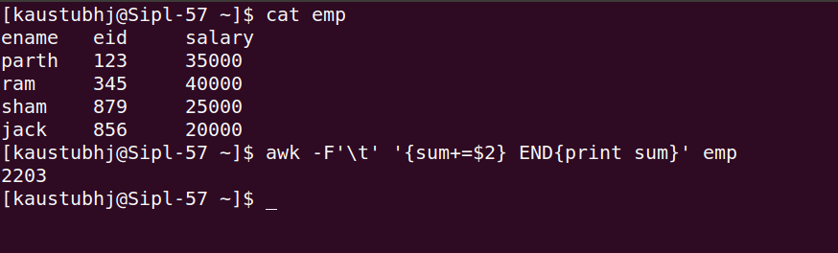

- Explain output of below command executed on file emp which is created in above exercise.
awk '{if ($2 > 100) print $1, "High"; else print $1, "Low"}' emp

>> Above command print “HIGH” in front of column which is empname when second column value is greater than 100, and is these value is lower than 100 it’ll print “LOW” in front of ename column.
- Count the Number of Lines in a passwd File using awk command

- Extract Lines Matching a Pattern “error” in /tmp/messages
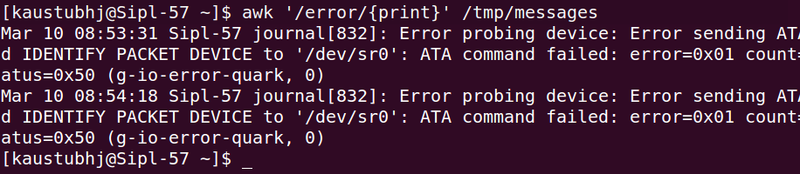
- Split a passwd file on field separator “:” and prints the first two columns with a tab separator.

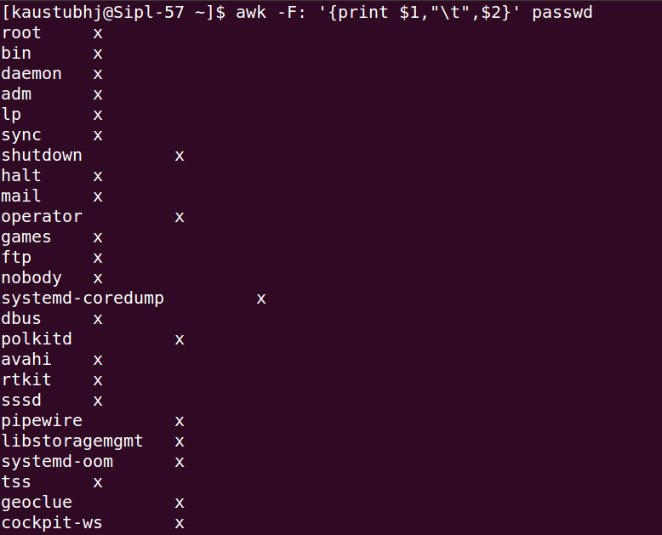

- Print unique values from 5th column of passwd file.
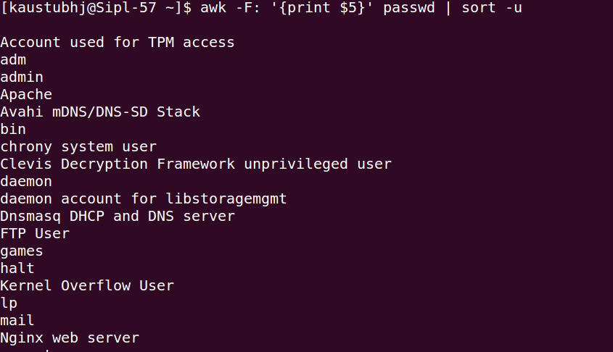
- Print every third line from passwd file.
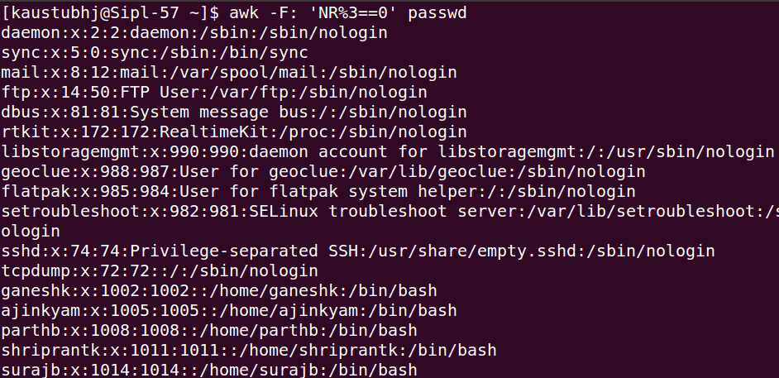
- Extract unique values from a 7th column of /etc/passwd
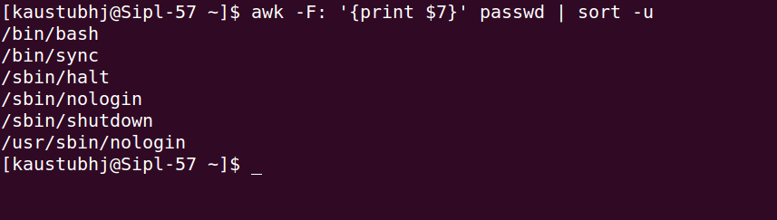
- List all usernames in the system

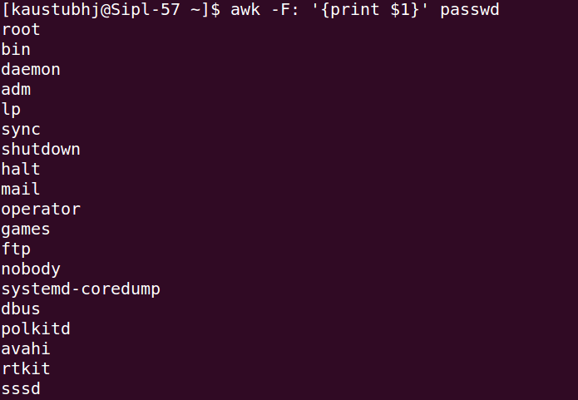
- Find Users with UID ≥ 1000 (Normal Users)
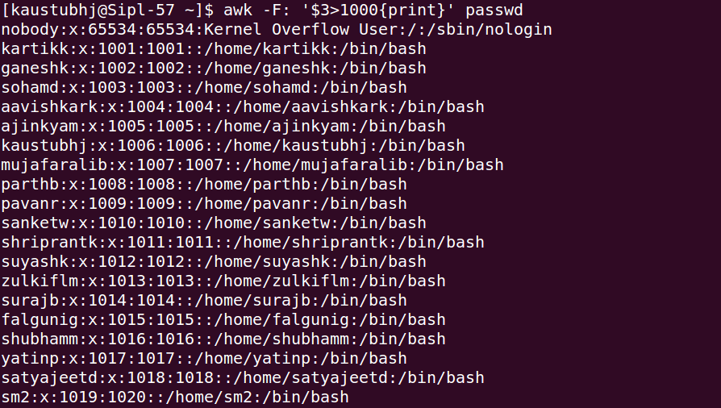
- Count Total Users on system


- Check Disk Usage and Alert if Usage Exceeds 80% (Hint use df)

- Count Number of Open Connections (hint: use netstat -ant)
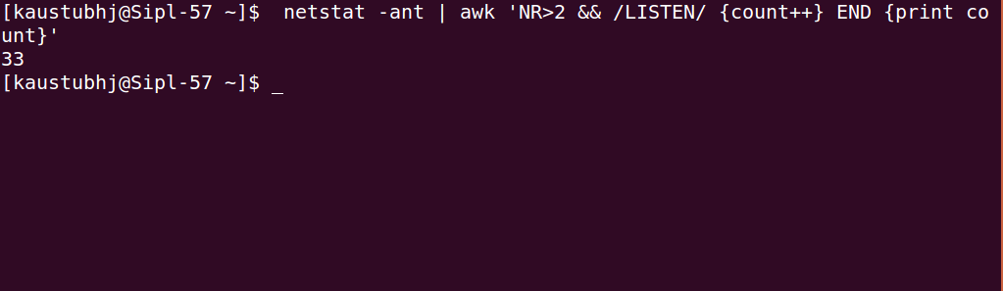

- Print name of users who are currently logged in.

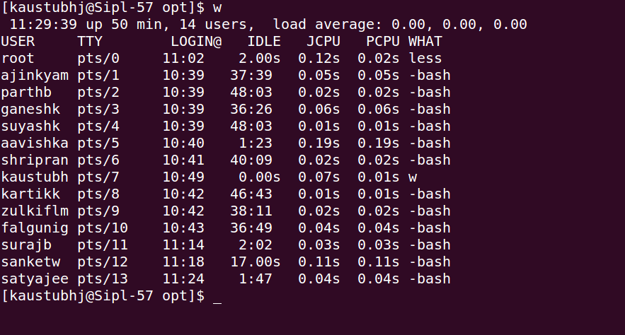
- Find Users with UID 0 (Superuser Accounts)
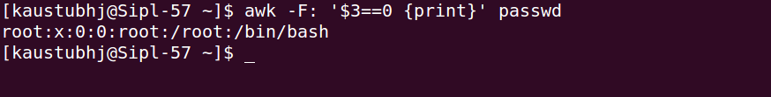

- Print users with their $HOME directory
