**SOP to Install YUM repository locally**

**STEP 1 : Setup YUM repository server**

1. Install Required Package



2. Create Repository Directory

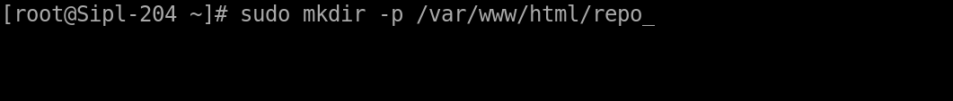

3. Install Required Tools on the Repo Server

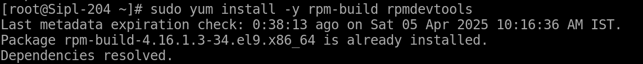

4. Set Up RPM Build Envrionment

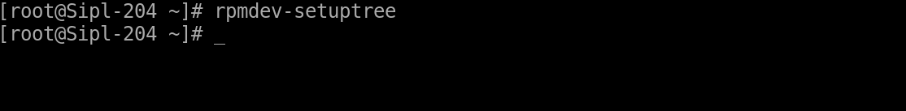

5. Create a SPEC File



add the following content (modify as needed):

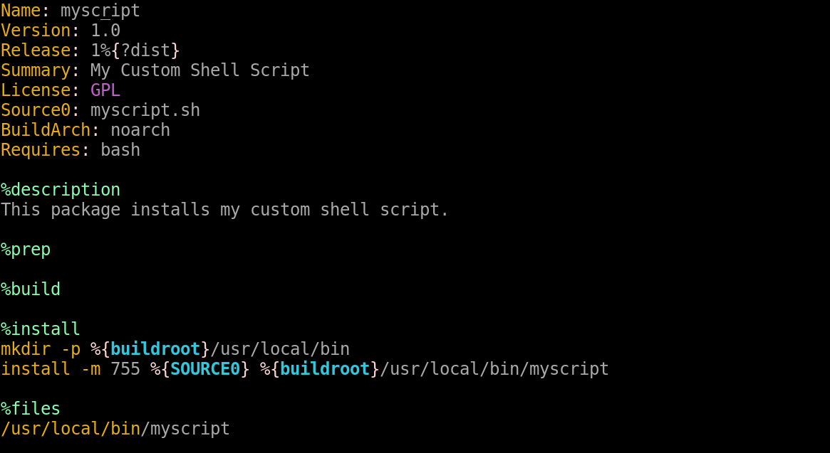

6. Copy Your Shell Script



7. Build the RPM

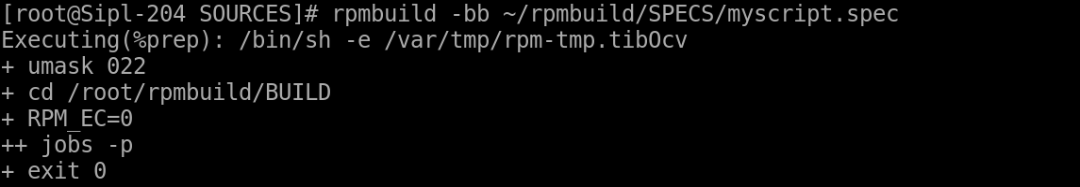

This will create an RPM package under ~/rpmbuild/RPMS/noarch/.

**STEP 2 : Add the RPM to Your Repository**

1. Copy the RPM to your repository directory:



2. Update repository metadata:

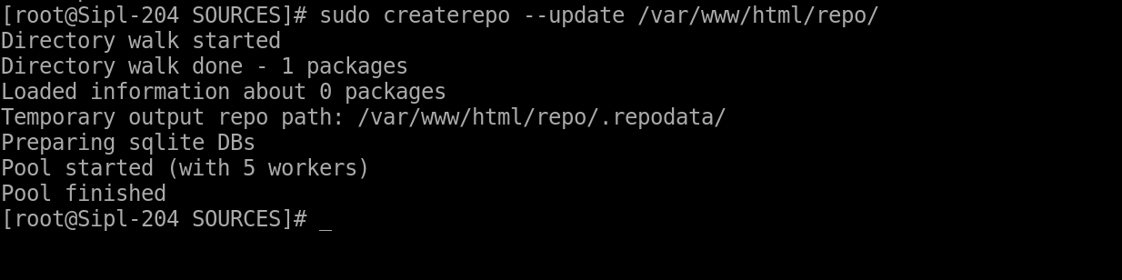

3. Ensure correct permissions:

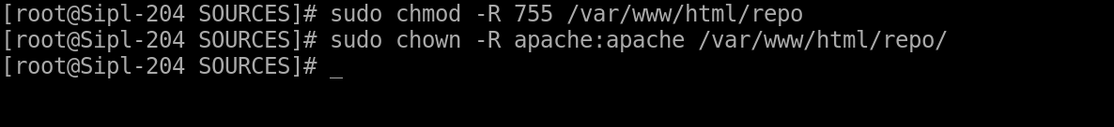

**STEP 3. Install the script via YUM on client machines**

1. check ‘/etc/yum.repos.d/global.repo’ and ensure It has the correct baseurl:(client)

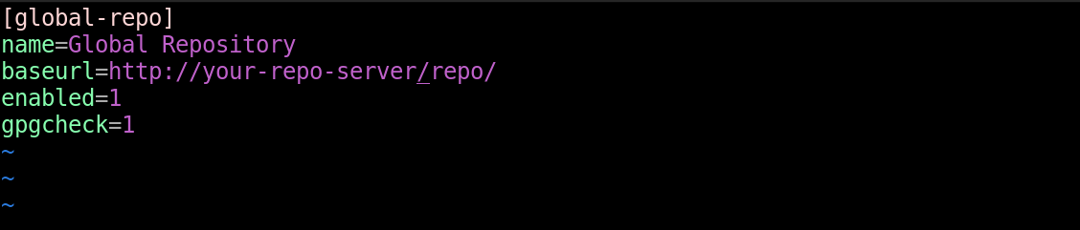

2. then clear yum cache on server side (server)

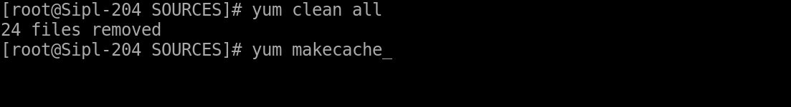

3. Check for Selinux or Firewall issues (server)

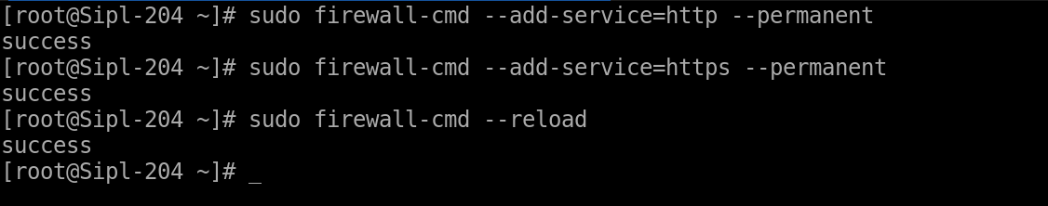

**STEP 4: install the script via yum on client machine (client)**

