WEEK 4 | QUALITY ASSURANCE PROJECT

Performance Testing and Analysis
Online Student Management Portal
Local mock HTTP load run and measured analysis
Report date: 13 September 2026
Internship period: 21 August 2026 to 2 October 2026
Prepared by: Junior Quality Assurance Analyst

Document control
Field | Details
Document ID | QA-OSMP-PERF-004
Version / status | 1.0 / Executed local mock exercise
Application | Hypothetical Online Student Management Portal API
Performance tool | Python standard-library concurrent HTTP harness; JMeter practices researched
Report date | 13 September 2026
Execution capture | 6 October 2026
Internship period | 21 August 2026 to 2 October 2026

Execution and evidence notice
No company portal or staging build was supplied. To perform the requested exercise, a local mock HTTP portal was created and tested on loopback. The measurements and HTTP 503 responses in this report were collected from that mock run on 6 October 2026; they are real measurements of the local training mock, not measurements of the company application. The mock uses a deliberately bounded 24-request service gate and fixed 60 ms service delay so load behavior can be observed. Findings about its capacity apply only to this mock.

1. Executive summary
This report records a local HTTP performance exercise against a mock Student Management Portal API. Three 30-second measured profiles (10, 50, and 100 concurrent virtual users) followed a five-second ramp-up and used a mix of login, dashboard, profile, and student-search requests. At 50 users, p95 latency was 75.71 ms, successful throughput was 299.13 requests/second, and no errors were recorded, meeting the proposed mock-run gates. At 100 users, the mock returned 6,366 HTTP 503 capacity responses (35.513%); total request rate reached 597.53 requests/second, while successful throughput was 385.33 requests/second. The result shows the mock’s configured gate saturating under the stress profile. These are measured mock results only, not performance results for an employer system.

2. Objectives and scope
The objective is to execute a repeatable local load scenario, specify thresholds, and analyze response time, throughput, and error behavior as concurrency increases. The test target represents a small student-portal HTTP API with synthetic data and a bounded processing gate.

In scope
- HTTP login endpoint with synthetic credentials
- Dashboard and profile retrieval endpoints
- Student search endpoint over a 5,000-record synthetic dataset
- Response-time percentiles, total and successful throughput, and HTTP error rate
- Repeatable virtual-user load profiles against the local mock HTTP API

Out of scope
- Production load generation or testing without written authorization
- Real student data or production credentials
- Security penetration, accessibility, browser rendering, and mobile network testing
- Root-cause confirmation without server-side telemetry

3. Tool selection and test design
Apache JMeter was researched as the planned industry tool; its documentation describes Thread Groups for concurrent users and recommends command-line mode for load execution with few listeners. Because JMeter was not installed in this environment, the measured mock run used a documented Python standard-library harness built with ThreadPoolExecutor, HTTPConnection, and a local ThreadingHTTPServer. Python documents ThreadPoolExecutor as a thread pool for concurrently executing tasks and ThreadingHTTPServer as a server that handles requests in threads. The harness, mock capacity gate, workload mix, and raw request samples are described as training evidence; this execution does not claim JMeter was used. [1][2][3]
Workload item | Executed setting
Target | Local mock HTTP portal bound to 127.0.0.1; no external host
User profiles | 10-user baseline; 50-user expected load; 100-user stress profile
Ramp-up | 5 seconds per profile, users introduced gradually
Measured hold | 30 seconds at each target concurrency; one run per profile
Cool-down | Wait for workers to finish, stop the mock, and save CSV/JSON results
Think time | 100 ms between HTTP requests per virtual user
Request mix | Login POST 10%; dashboard GET 25%; profile GET 15%; student search GET 50%
Test data | 5,000 synthetic student records; seeded names and example.test emails
Mock service behavior | 24 concurrent processing permits; 60 ms configured service delay; HTTP 503 returned when permit wait exceeds 20 ms
Harness/output | Python standard-library ThreadPoolExecutor and persistent HTTP connections; per-request CSV and aggregated JSON

4. Workload journeys and acceptance criteria
Journey | Representative requests | Checks
Authentication | POST /api/login with synthetic QA payload | HTTP status and response body captured; endpoint is stateless in this mock
Dashboard | GET /api/dashboard | HTTP 200 and expected summary JSON
Profile | GET /api/profile | HTTP 200 and expected profile JSON
Student search | GET /api/students/search?q=Student%2000123 | HTTP 200 and bounded result JSON

Metric / gate | Proposed threshold at 50 users | Why it matters
p95 response time | ≤ 200 ms on this local mock | Flags slow tail responses within the controlled training scenario
Error rate | ≤ 1.0% | Limits failed requests during the expected-load profile
Successful throughput | ≥ 250 HTTP requests/second | Confirms the expected mock workload can be sustained
Resource headroom | No sustained CPU or memory saturation; no growing queue or pool exhaustion | Requires server-side monitoring to determine capacity and cause

5. Test environment and controls
- Use a staging environment representative of production topology, with production-like application configuration but synthetic records.
- Record host/OS, application build, database version and size, cache configuration, network route, JMeter version, JVM settings, and load-generator specifications.
- Capture server CPU, memory, garbage collection, database query latency, connection-pool utilization, cache hit rate, network saturation, and application logs at the same timestamps as JTL data.
- Run the load generator separately from the application where practical; confirm the generator has enough CPU/network capacity so it does not become the bottleneck.
- Obtain target-owner approval, define stop conditions, and avoid external or production endpoints.
- Use a gradual ramp and non-GUI execution. Avoid heavy GUI listeners during the measured run. [2]

6. Proposed execution procedure
- Start the local mock HTTP server on loopback with its 5,000-record synthetic dataset and bounded 24-request service gate.
- Use a 5-second ramp-up, then hold each profile at 10, 50, and 100 virtual users for 30 seconds. Each virtual user uses a persistent HTTP connection and 100 ms think time.
- Send login, dashboard, profile, and student-search requests at the documented 10/25/15/50 percent mix; record status, response time, route, and any error body per request.
- Compute p50, p95, p99, total request rate, successful request rate, error count, and error percentage for each profile. Preserve the raw CSV and aggregated JSON output.
- Stop the server after workers finish and classify HTTP 503 responses separately from client transport errors. This final run had zero client transport errors.
- This short local exercise validates workload behavior for the mock only. A longer duration, repeat runs, and server-side monitoring would be needed for a formal service-capacity assessment.

7. Executed results — local mock portal
These results were run by the trainee on 6 October 2026 against the local mock target. The report date remains 13 September 2026 as scheduled for Week 4. Each row covers a 30-second profile with a five-second ramp. The successful request rate excludes HTTP 503 failures. No client-side transport errors occurred in this run.
Users | Samples | Mean ms | p50 ms | p95 ms | p99 ms | Total req/s | Success req/s | HTTP 503 | Error %
10 | 1,822 | 64.57 | 63.01 | 68.99 | 70.48 | 60.73 | 60.73 | 0 | 0.000
50 | 8,974 | 66.62 | 67.20 | 75.71 | 84.07 | 299.13 | 299.13 | 0 | 0.000
100 | 17,926 | 66.55 | 72.62 | 100.47 | 109.22 | 597.53 | 385.33 | 6,366 | 35.513

Error evidence | Observed result
10-user baseline | 1,822 requests; all returned HTTP 200; no failed request.
50-user expected load | 8,974 requests; all returned HTTP 200; no failed request.
100-user stress | 6,366 responses returned HTTP 503 with body {"error":"simulated capacity limit","code":"MOCK_BUSY"}; 11,560 responses returned HTTP 200.
Transport / client failures | Zero client-side transport errors in the trainee-run profiles.

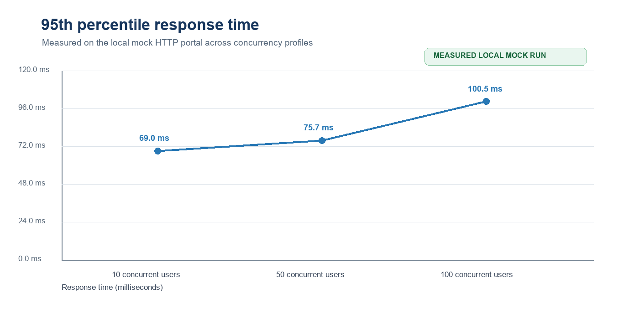
Measured p95 response times for the local mock app; these are not company-system measurements.
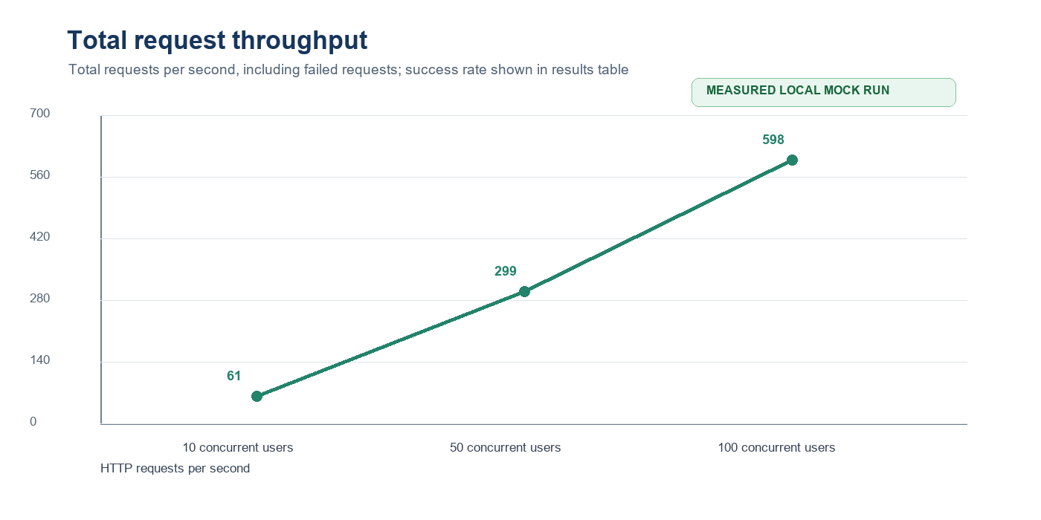
Measured total request rate, including HTTP 503 responses, for the local mock app.
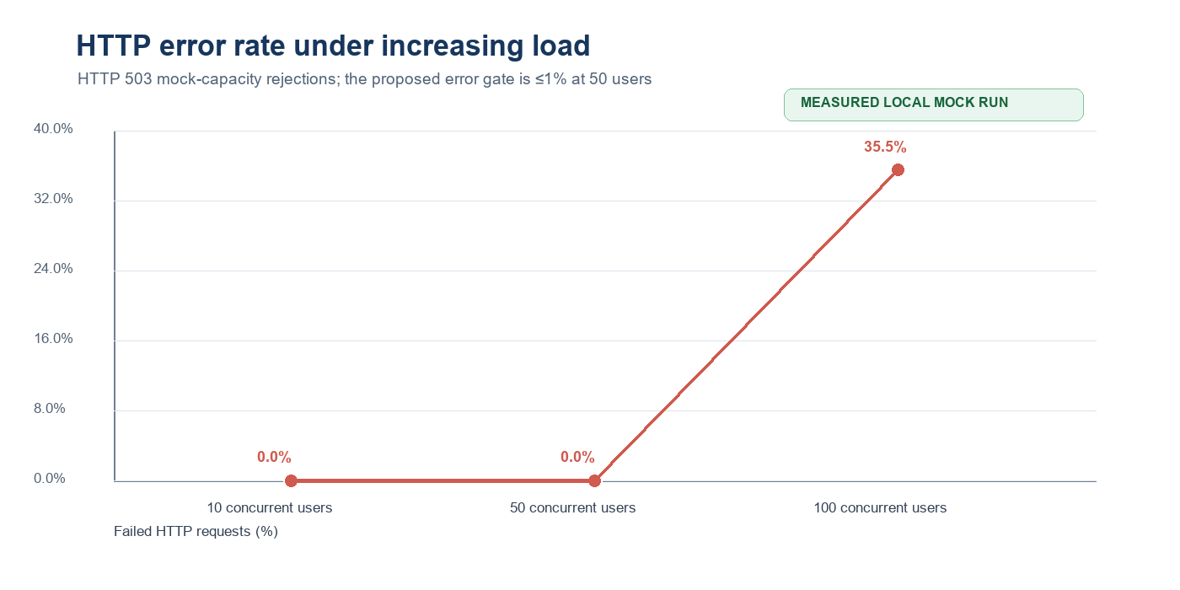
Measured mock-app HTTP error rate; proposed expected-load gate is ≤1%.

8. Analysis and interpretation

10-user baseline
The 10-user profile completed 1,822 requests with p95 latency of 68.99 ms and no errors, at 60.73 successful requests/second. This is the local mock baseline, not a product SLA measurement.

50-user expected load
At 50 users, the measured p95 was 75.71 ms, successful throughput was 299.13 requests/second, and the error rate was 0.000%. This profile passed all three proposed local-mock gates (p95 ≤200 ms, error rate ≤1%, and success rate ≥250 requests/second).

100-user stress profile
At 100 users, the mock recorded 17,926 requests, including 6,366 HTTP 503 responses (35.513% error rate). Total request rate was 597.53/second, while successful throughput was 385.33/second. The mock’s bounded 24-request service gate returned 503 with code MOCK_BUSY after a 20 ms permit wait; the recorded error payloads confirm this configured gate was saturated. The p95 for all responses (including quick 503 rejections) was 100.47 ms. This is an intentional training constraint in the mock and does not identify a bottleneck in any company application.

Acceptance decision for the executed mock run
The 10-user baseline passed the error and latency gates; the expected-load 50-user profile passed all proposed local-mock thresholds. The 100-user stress profile failed the 1% error-rate gate because 6,366 requests received the mock-specific HTTP 503 MOCK_BUSY response. Response percentiles remained below 200 ms, demonstrating why error rate and successful throughput must be reviewed alongside latency. These decisions apply only to this mock configuration.

9. Improvement areas to investigate
- The mock-specific issue is capacity-gate rejection above 24 simultaneous permits. In a real service, inspect error counts by route and correlate server responses with CPU, worker queues, database pools, and dependency telemetry.
- Repeat the 100-user profile after increasing the mock gate or changing its wait policy; compare HTTP 503 counts, successful throughput, and p95/p99 rather than total traffic alone.
- On a real portal, review student-search query plans, indexes, pagination, payload size, connection pools, and bounded queue behavior.
- For production-like testing, use JMeter CLI with minimal listeners, multiple repeat runs, a longer steady-state period, and synchronized server telemetry. [2]
- Validate changes using the same dataset, route mix, ramp-up, hold duration, and load generator so results are comparable.

10. Risks, limitations, and exit conditions
Risk / limitation | Mitigation or exit condition
Mock is not the employer portal | Report all measures as local-mock results; do not extrapolate them to the company system.
Short 30-second hold, one run per profile | Repeat and extend to a longer steady state before making durable capacity claims.
No CPU, memory, database, or network telemetry | Bottleneck conclusion is limited to the mock’s observed 24-slot gate; instrument a real test environment for further diagnosis.
Python harness is not JMeter | Harness and methods are documented; use JMeter CLI for a formal organizational run if required.
Simplified route mix and fixed service delay | Use realistic endpoint behavior and workload proportions if a fuller simulated or real build becomes available.
Thresholds are training assumptions | Have the product owner approve service objectives before release decisions.

The trainee-run local exercise completed all three profiles and saved per-request CSV and aggregated JSON results. The expected-load profile passed the proposed gates; the 100-user profile failed on the mock-specific error-rate gate. A real production-capacity conclusion requires a representative application and server-side monitoring.

Conclusion
This report documents an executed 10/50/100-user HTTP workload against a locally hosted mock portal and records measured latency, throughput, and 503 error counts. The mock met the proposed expected-load thresholds at 50 users and rejected a substantial share of 100-user stress requests through its configured capacity gate. These results meet the training exercise objective of planning, running, and analyzing a performance scenario, while remaining explicitly limited to the mock target and the short run duration.

References
[1] Apache Software Foundation, Apache JMeter User Manual, “Elements of a Test Plan” and “Building a Web Test Plan.” https://jmeter.apache.org/usermanual/test_plan.html ; https://jmeter.apache.org/usermanual/build-web-test-plan.html
[2] Apache Software Foundation, Apache JMeter User Manual, “Getting Started” and “Best Practices.” https://jmeter.apache.org/usermanual/get-started.html ; https://jmeter.apache.org/usermanual/best-practices.html
[3] Python Software Foundation, Python Library Reference, “concurrent.futures” and “http.server.” https://docs.python.org/3/library/concurrent.futures.html ; https://docs.python.org/3/library/http.server.html
Accessed 6 October 2026. Apache JMeter guidance recommends non-GUI mode and limiting listeners for load tests. Python documentation describes the thread-pool and threaded HTTP server components used in this local training harness.

