

KAUSTUBH NAITHANI

# Linux Basic Commands Assignment

***Assignment Part-3***

Playing with files

1. Create a file like **nano file1.txt**

* Edit some data and then save the file
* Answer->

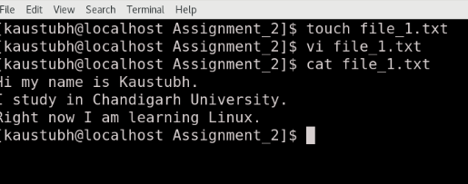

1. Now we will copy date from file1 to new file2

# o cp file1.txt file2.txt

* Then see the output of file2.txt, **cat file2.txt**
* Give screenshot
* Answer ->

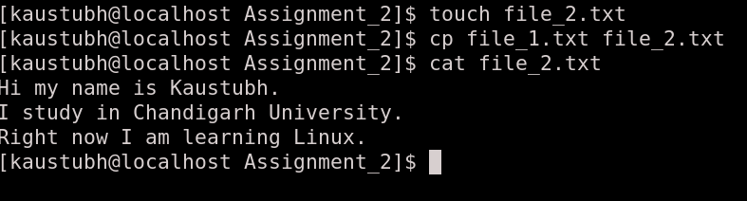

1. Now we will move the file2.txt to new folder **/home**

# mv file2.txt /home

# 

* + Then go to **home** directory and check **ls,** file exits or not?
  + Given screenshot
  + Answer ->

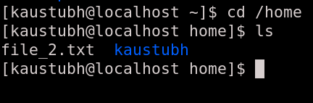

1. Then we create a new **file3.txt and file4.txt** in **home directory** and add content in it.
   * 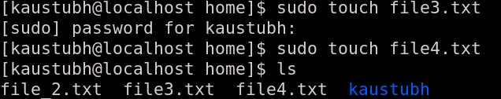
   * Now do **echo “Hello I am newline” > file3.txt** and provide the output of file3.txt
   * 
   * Now do **echo “Hello I am newline” >> file4.txt** and provide the output of file4.txt
   * 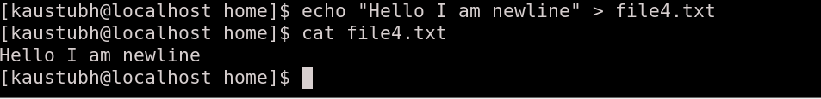
2. For remove a file or directory you can use the below two commands

* To delete a file – **rm <any_filename>**

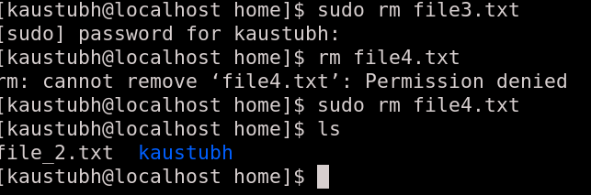

* To delete a directory - **rmdir <any_directoryname>**

