Assignment sheet for IAM

**Assignment 1** :- Create an IAM user with username of your own wish and grant administrator policy.

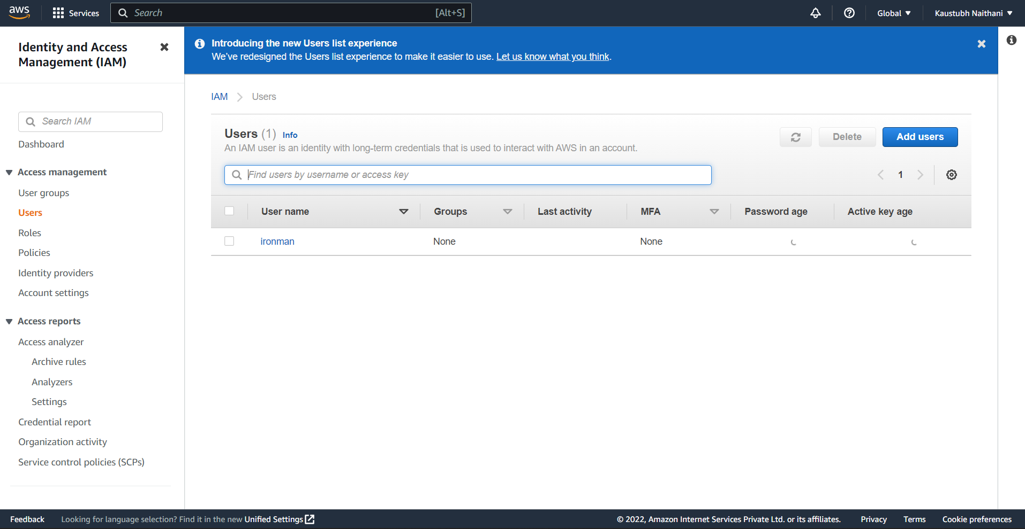

Added administrative perms

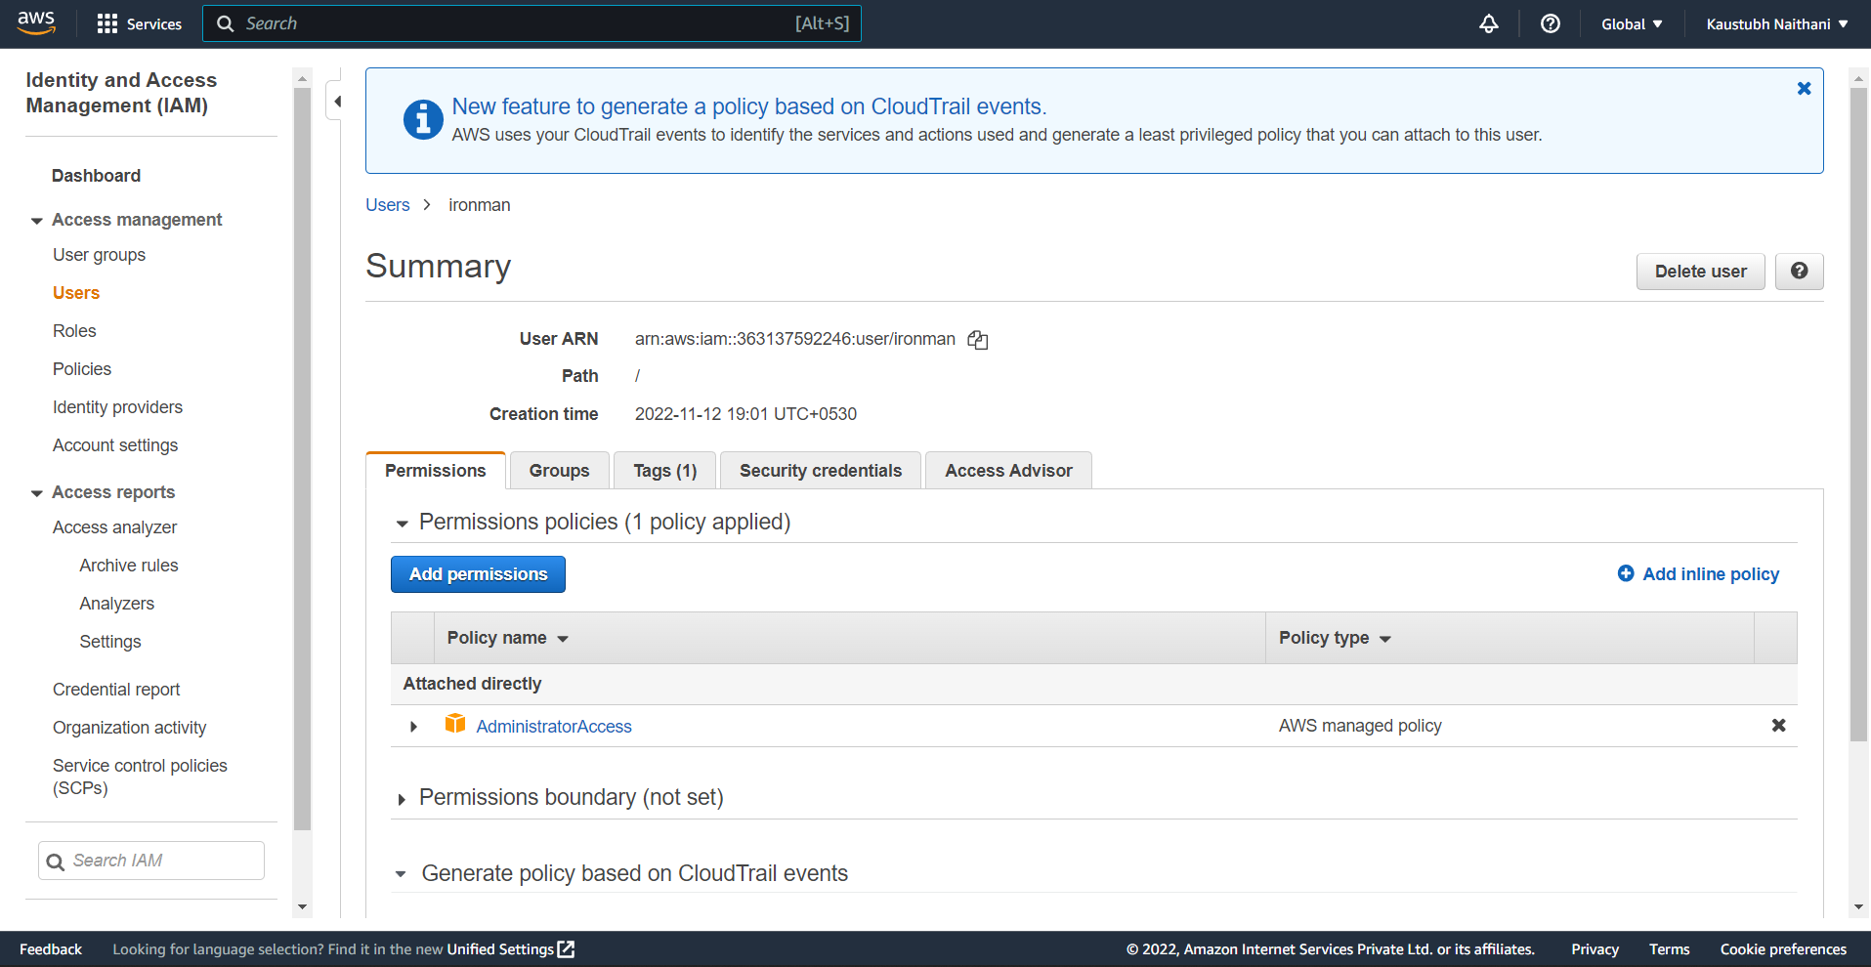

**Assignment 2** :- Hello students, in this assignment you need to prepare a developers team of avengers.

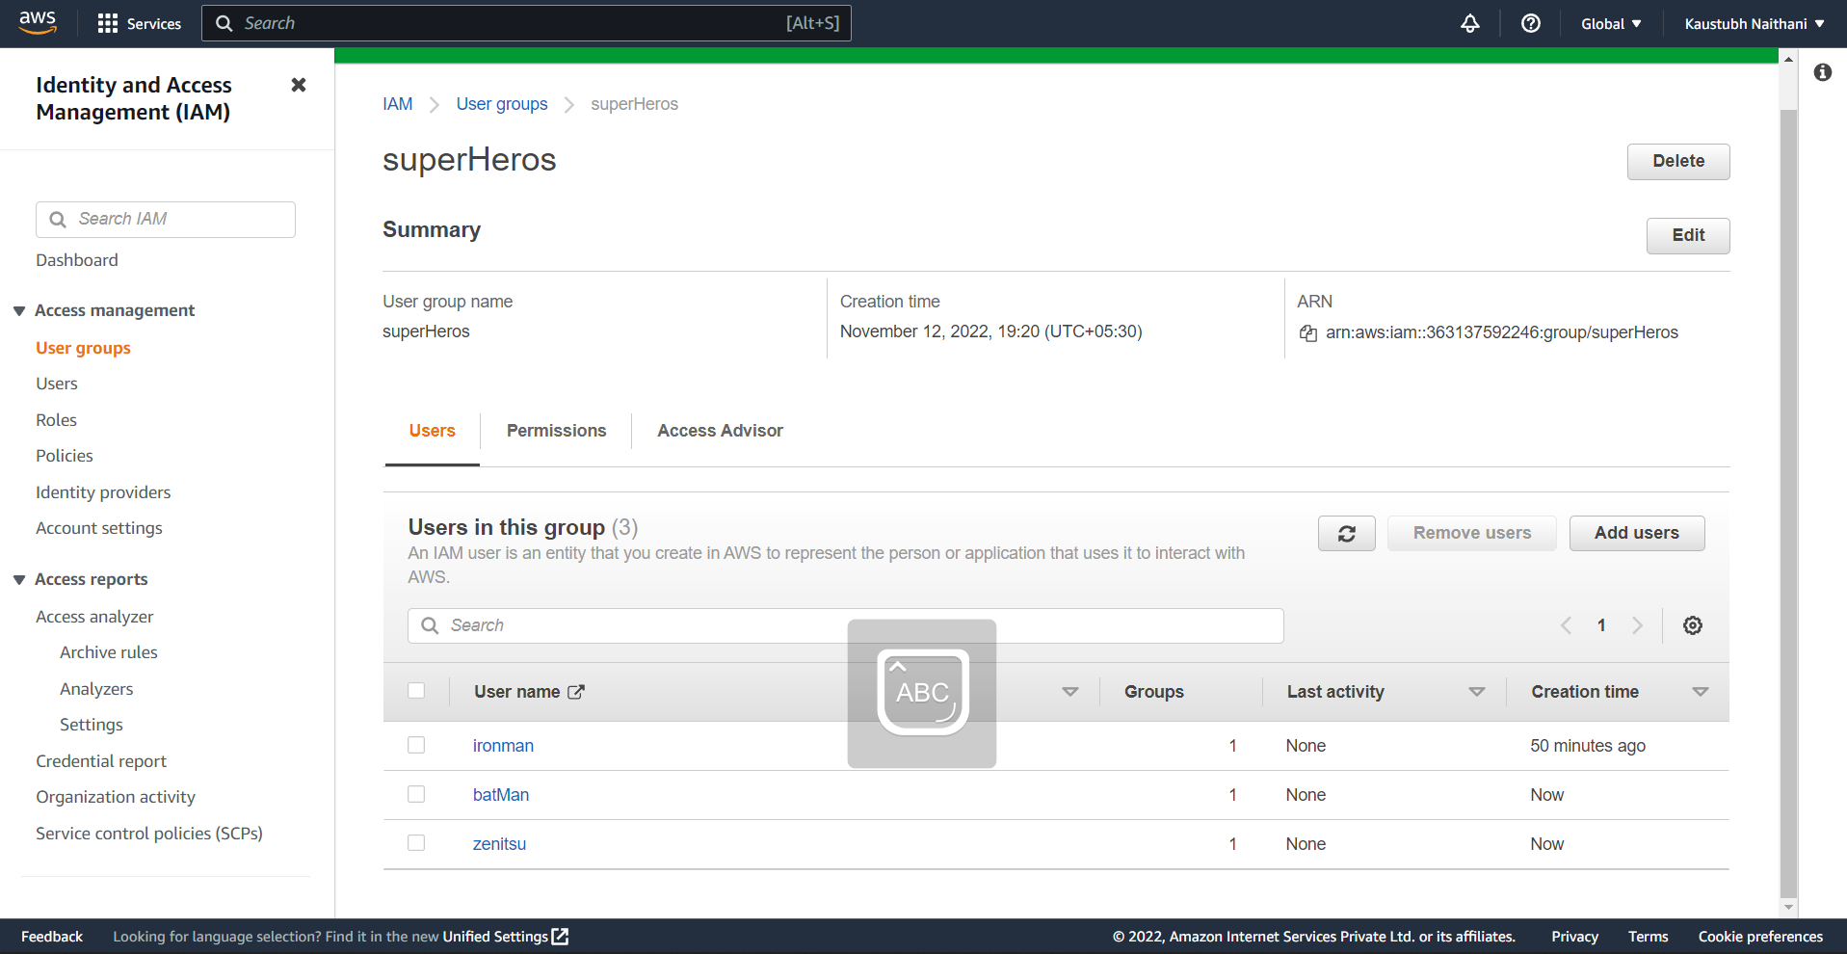

Created a team of super heros with three members.

- Create 3 IAM users of avengers and assign them in developer’s groups with IAM policy.

**Assignment 3** :- Define a condition in policy for expiration like

"DateGreaterThan": {"aws:CurrentTime":

"2020-04-01T00:00:00Z"},

"DateLessThan": {"aws:CurrentTime": "2020-06-30T23:59:59Z"}

Define the span of 4 months as per your wish

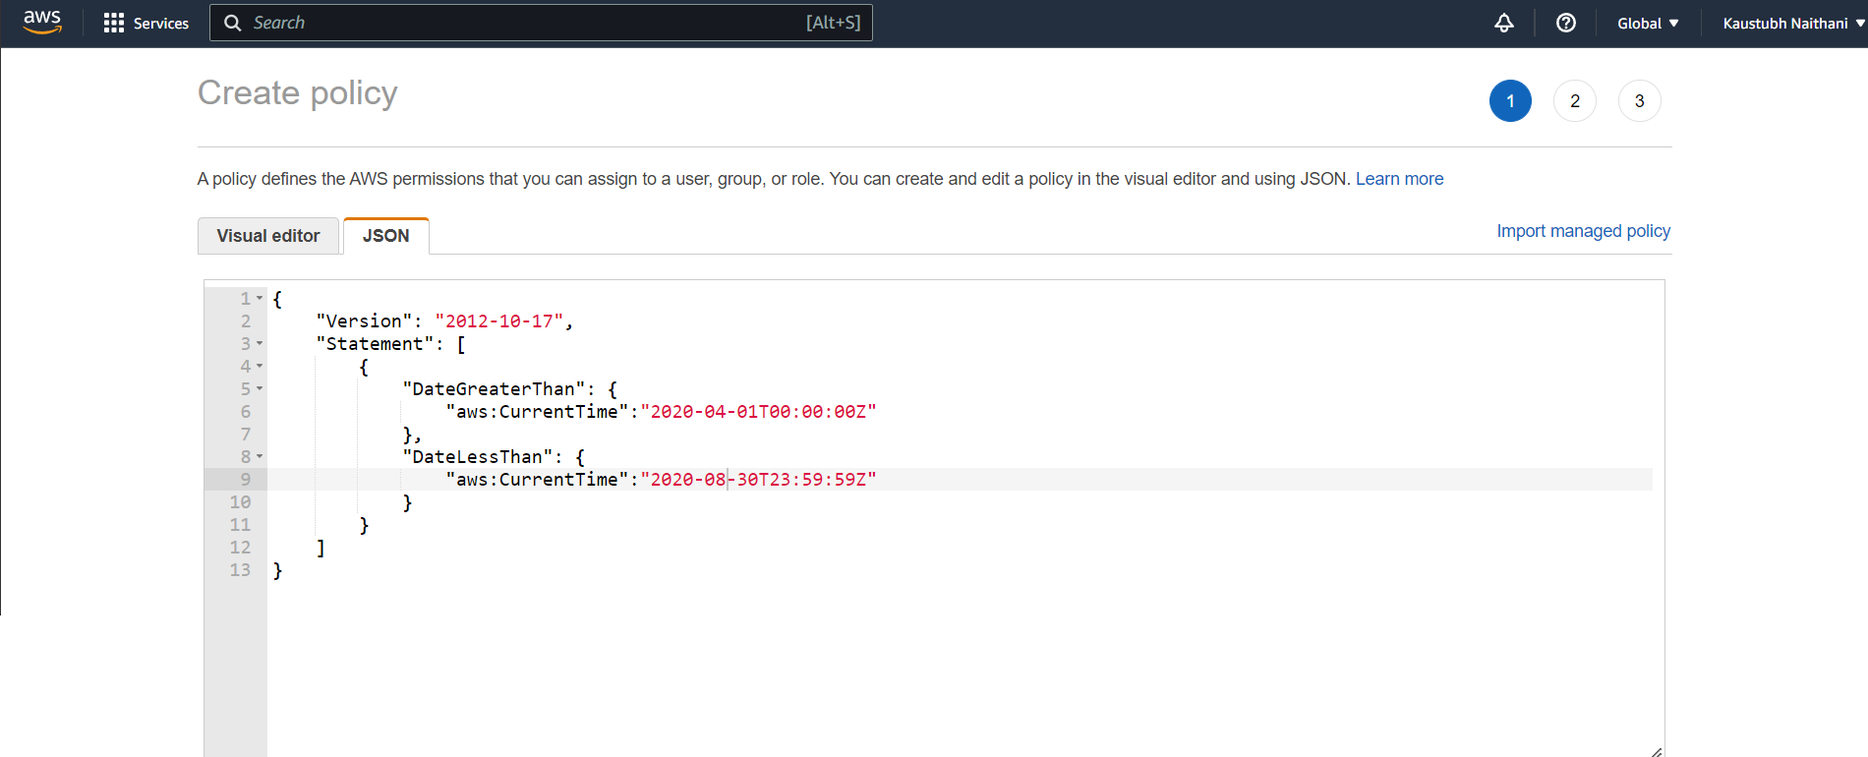

**Assignment 3** :- Prepare 15 authentic MCQ questions related to IAM.

|  |  |  |  |  |  |  |  |  |  |
| --- | --- | --- | --- | --- | --- | --- | --- | --- | --- |
| **1.** | **Identify the wrong statement.**   |  |  | | --- | --- | | (a) | Identity and access management (IAM) is a framework for business processes that facilitates  the management of electronic or digital identities | | (b) | With IAM technologies, IT managers can control user access to critical information within their  organizations | | (c) | Identity and access management products offer role-based access control | | (d) | In IAM roles are defined according to the ability of an individual user to perform a specific task,  such as view, create or modify a file | |

**Answer:**

Option **(d)**

|  |  |  |  |  |  |  |  |  |  |
| --- | --- | --- | --- | --- | --- | --- | --- | --- | --- |
| **2.** | **Which of these is Identity in IAM?**   |  |  | | --- | --- | | (a) | Users | | (b) | Groups | | (c) | Roles | | (d) | All of these | |
|  |  |
|  | **Answer:**  Option **(d)** |
| **3.** | **When you first create an Amazon Web Services (AWS) account, you begin with a single sign-in**  **identity that has complete access to all AWS services and resources in the account. This identity**  **is called:**   |  |  | | --- | --- | | (a) | Root user | | (b) | Main user | | (c) | Super user | | (d) | None of these | |
|  |  |
|  | **Answer:**  Option **(a)** |
| **4.** | **An IAM user:**   |  |  | | --- | --- | | (a) | is an entity that you create in AWS | | (b) | is to give people the ability to sign in to the AWS Management Console for interactive tasks and  to make programmatic requests to AWS services using the API or CLI | | (c) | A and B both | | (d) | None of these | |
|  |  |
|  | **Answer:**  Option **(c)** |
| **5.** | **Choose the below statements are true or false for AWS: 1. When you create an IAM user, you grant it permissions by making it a member of a group**  **that has appropriate permission policies attached (recommended), or by directly attaching**  **policies to the user 2. You can also clone the permissions of an existing IAM user, which automatically makes the**  **new user a member of the same groups and attaches all the same policies.**   |  |  | | --- | --- | | (a) | 1. True, 2. True | | (b) | 1. True, 2. False | | (c) | 1. False, 2. True | | (d) | 1. False, 2. False | |
|  |  |
|  | **Answer:**  Option **(a)** |

|  |  |  |  |  |  |  |  |  |  |
| --- | --- | --- | --- | --- | --- | --- | --- | --- | --- |
| **6.** | **IAM group:**   |  |  | | --- | --- | | (a) | Is same as IAM users | | (b) | Can be used to specify permissions for a collection of users | | (c) | Is truly an identity | | (d) | All of these | |
|  |  |
|  | **Answer:**  Option **(b)** |

|  |  |  |  |  |  |  |  |  |  |
| --- | --- | --- | --- | --- | --- | --- | --- | --- | --- |
| **7.** | **Which of these is IAM principal?**   |  |  | | --- | --- | | (a) | A user | | (b) | A role | | (c) | An application | | (d) | All of these | |
|  |  |
|  | **Answer:**  Option **(d)** |
| **8.** | **IAM role:**   |  |  | | --- | --- | | (a) | Have credentials (password or access keys) associated with it | | (b) | Does not have any credentials (password or access keys) associated with it | | (c) | May or may not have credentials (password or access keys) associated with it | | (d) | None of these | |
|  |  |
|  | **Answer:**  Option **(b)** |

|  |  |  |  |  |  |  |  |  |  |
| --- | --- | --- | --- | --- | --- | --- | --- | --- | --- |
| **9.** | **Temporary credentials:**   |  |  | | --- | --- | | (a) | It expires automatically after a specified time | | (b) | Have a same set of permissions that your standard IAM user have | | (c) | We can have control over the duration that the credentials are valid | | (d) | A and C both | |
|  |  |
|  | **Answer:**  Option **(d)** |
| 10. | **AWS evaluates _______ when an IAM principal makes a request.**   |  |  | | --- | --- | | (a) | Username and Password | | (b) | MAC Address | | (c) | Security Policies | | (d) | IP Address | |
|  |  |
|  | **Answer:**  **Option (c)**  11. Which of the following is the most secure way of giving access to AWS services to applications running on  Ec2 instances?  (a). Creating Service users  (b) Creating service groups  ( c) . Roles  (d). Attaching policies to applications  Answer ( c ) |

12. True or False : An explicit Deny in IAM precedes over an explicit allow

TRUE

FALSE

Answer True

13. Which of the following sections in a policy specifies the entities to whom access to a resource is granted or denied?

A Statement ID

B Resources

C Principal

D Conditions

Answer C

14. TRUE or FALSE : By default a new user in IAM has permisiions to log in to the AWS Console.

TRUE

FLASE

Answer False

15. Which of the following is not an IAM best practice?

A Delete user accounts not in use

B Attach policies to individual users

C Manage permissions by adding users to groups

D Enable MFA on user accounts