**Practical-0**

Configuring and Installation of Django

1. Install Python

2. Open prompt (Ensure you have internet connection working)

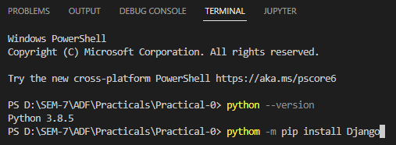

3. Installing Editor (pycharm or visual studio code can be used. It is recommended to use visual studio code i.e vscode)

Go to the link: https://code.visualstudio.com/ and install visual studio code in your system.

After successful installation of vscode, open it and go to the project folder

Install extentions named:

1. Python

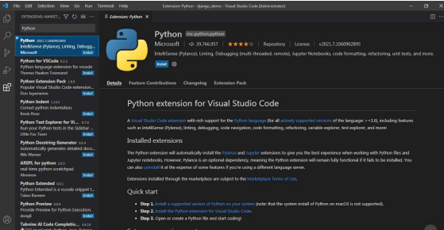

1. Pylance:

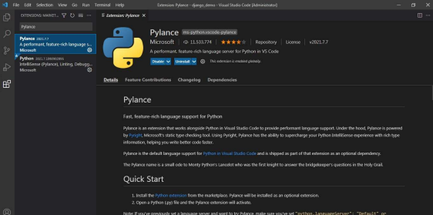

In terminal run python manage.py runserver from created project.

That will run your server.



Basic python programming:

RollNo:21BCE528

Aim:a.Developapythonprogramandmakethesimplecalculatorwhichusingandconditional loop.

1. WriteafunctionareaTrianglethattakesthelengthsofthreesidesofthetriangleasinput parametersandreturnstheareaofthetriangleasaoutput.Also,assertthatsumofthelength ofanytwosidesisgreaterthanthethirdside.Writeamainfunctionthatacceptsascommand lineargumentsandcomputerstheareaoftriangleusingthefunctionareaTriangle.
2. WriteafunctionthattakestwonumbersasinputparametersandreturnsTrueorFalse dependingonwhethertheyareco-primes.Twonumbersaresaidtobeco-primeiftheydonot have any common divisor other than one.
3. Writeafunctionthattakesastringasaparameterandreturnsastringwitheverysuccessive repetitive character replaced with a star(*). For Example, ‘balloon’ is returned as ‘bal*o*n’.
4. Writeafunctionthattakesanumberasninputparameterandreturnsthecorrespondtextin words,forexample,oninput452,thefunctionshouldreturn‘FourFiveTwo’.Useadictionaryfor mappingtodigitstotheirstringrepresentation.
5. Writearecursivefunctionthattakesnumbernasaninputparameterandprintn-digitstrictly increasing number.

UserInputsrelatedPrograms

1. ThebellshapedGaussianfunction,

f(x)=1/(s*√(2π )) exp〖[ (-1)/2〖((x-m)/s)〗^2]〗

isoneofthemostwidelyusedfunctionsinscienceandtechnology.Theparametersmands>0areprescribedrealnumbers.Makeaprogramforevaluatingthisfunctionfordifferentvalues ofs,xandm.Askusertoinputthevalues.

1. Acardriver,drivingatvelocityv0,suddenlyputsonthebrake.Whatbrakingdistancedis neededtostopthecar?Onecanderive,usingNewton’ssecondlawofmotionora corresponding energy equation, that:

d=1/2(v_0^2)/μg

Makeaprogramforcomputingdaboveequation,whentheinitialcarvelocityv0andthefriction coefficientµaregivenonthecommandline.Runtheprogramfortwocases:v0=120andv0= 50 km/h, both with µ = 0.3 (µ is dimensionless).

(Note:convertthevelocityinm/s)

PythonClassesrelated

1. DefineaclassBankthatkeepstrackofbankcustomers.Theclassshouldcontainthe following data member:

Datamembername Details

name

Nameofcustomer accountNum Account Number type

AccountType amount

Amountdepositedinthebankaccount interest

Interestearnedbythecustomer

Theclassshouldsupportthefollowingmethods:

1. **init**forinitializingthedatamembers.
2. depositfordepositingmoneyinthemembers.
3. withdrawalforwithdrawingmoneyfromtheaccount
4. findInterestthatdeterminestheinterestonthebasisofamountintheaccount

Programs:

num1=int(input("EnterNumber1:")) num2=int(input("EnterNumber2:")) op = input("Enter operator")

if op=='+':

print(num1+num2) elif op=='-':

print(num1-num2) elif op=='*':

print(num1*num2) elif op=='/':

print(num1/num2) else:

print("Please Enter correct Operator")

Please Enter correct Operator

#AreaofTraingle def Area(a,b,c):

if(a+b>canda+c>bandb+c>a): s = (a+b+c)/2

area = round((s*(s-a)*(s-b)*(s-c))**0.5,5)

print("Area of Traingle:"+ str(area))

else:

print("Cannot from Triangle")

a = int(input("Enter 1st side:"))

b = int(input("Enter 2st side:"))

c=int(input("Enter3stside:")) Area(a,b,c)

Area of Traingle:6.0

#coprimes

n1=int(input("Enter1stnumber:")) n2=int(input("Enter2ndnumber:")) def divisor(num):

list=[]

foriinrange(2,int(num-1)): if num%i==0:

list.append(i) return list

l1=divisor(n1) l2=divisor(n2) print(l1) print(l2)

same=False for i in l1:

for j in l2:

if i==j:

same=True if(same == False):

print("Givennumbersarecoprime") else:

print("Given numbers are not coprime")

[2,5] []

Given numbers are coprime

s=input("EnterString") list =[]

s1 = ""

for i in s:

ifinotinlist: s1+=i

elifiinlist: s1+='*'

list.append(i) print(s1)

bal*o*n

defnumber_to_words(number): digits = {

'0': 'zero',

'1': 'one',

'2': 'two',

'3': 'three',

'4': 'four',

'5': 'five',

'6': 'six',

'7': 'seven',

'8': 'eight',

'9': 'nine'

}

word = ''

fordigitinstr(number): if digit in digits:

word+=digits[digit]+'' return word.strip()

number = 718

word=number_to_words(number) print(word)

seven one eight

speed=int(input("enterspeedinkm/h:")) speed1 = round(speed * 5/18,4)

friction = 0.3

g = 9.8

distance=round((1/2)*((speed1**2)/(friction*g)),3) print(distance)

1181.027

s = int(input("Enter s:"))

x = int(input("Enter x:"))

m=int(input("Enterm:")) if s>0:

f=round(((1/(s*((2*3.14)**0.5)))**((-1/2)*((x-m)/s)**2)),3) print(f)

1.119

def distance(v0, mu):

v0_mps=v0*1000/3600 g = 9.81

d=0.5*v0_mps**2/(mu*g) return d

v0_1 = 120

mu_1 = 0.3

d_1 = distance(v0_1, mu_1)

print(f"Brakingdistance(d)forv0={v0_1}km/handmu={mu_1}is{d_1:.2f}meters.") v0_2 = 50

mu_2 = 0.3

d_2 = distance(v0_2, mu_2)

print(f"Braking distance (d) for v0 = {v0_2} km/h and mu = {mu_2} is{d_2:.2f} meters.")

Brakingdistance(d)forv0=120km/handmu=0.3is188.77meters. Braking distance (d) for v0 = 50 km/h and mu = 0.3 is32.77 meters.

class Bank:

definit(self,name,accountNum,accountType,amount): self.name = name

self.accountNum = accountNum self.accountType=accountType self.amount = amount self.interest = 0

defdeposit(self,amount): self.amount += amount

print(f"Deposited{amount}intheaccount.Currentbalance:{self.amount}") def withdrawal(self, amount):

ifself.amount>=amount: self.amount -= amount

print(f"Withdrawn{amount}fromtheaccount.Currentbalance:{self.amount}") else:

print("Insufficientbalance.Withdrawalnotallowed.") def findInterest(self):

if self.amount >= 500000: self.interest=self.amount*0.08

elif 300000 <= self.amount < 500000: self.interest=self.amount*0.07

elif 100000 <= self.amount < 300000: self.interest=self.amount*0.05

else:

self.interest = self.amount * 0.03 print(f"Interestearned:{self.interest:.2f}")

customer1 = Bank("abc", "1111111111", "Savings", 400000)

customer2=Bank("xyz","2222222222","Current",800000) customer1.deposit(50000)

customer1.findInterest() customer2.withdrawal(100000) customer2.findInterest()

Deposited50000intheaccount.Currentbalance:450000 Interest earned: 31500.00

Withdrawn100000fromtheaccount.Currentbalance:700000 Interest earned: 56000.00

 