**Practical-4**

Aim:

Apply concept of Class Based Views and demonstrate the CRUD operations for registration page designed. Also, design the app/module for posts.

Design a view, templates and filters for different modules. Ensure that your application has following features:

1.     Login and registration page

2.     The dashboard which displays the latest post

Output:

CRUD operation:

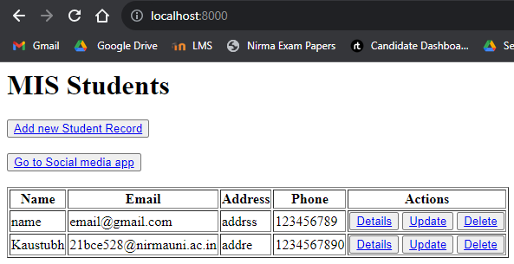

Show details:

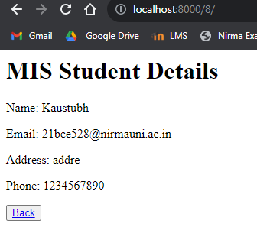

Update:

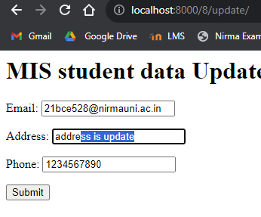

Effect of update and delete another record:

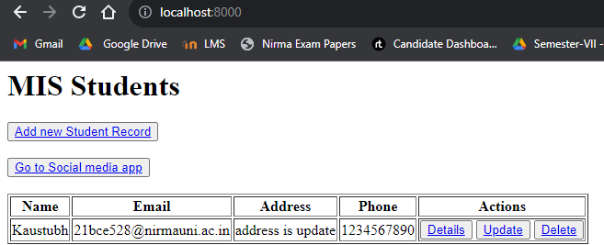

Login/logout and showing posts

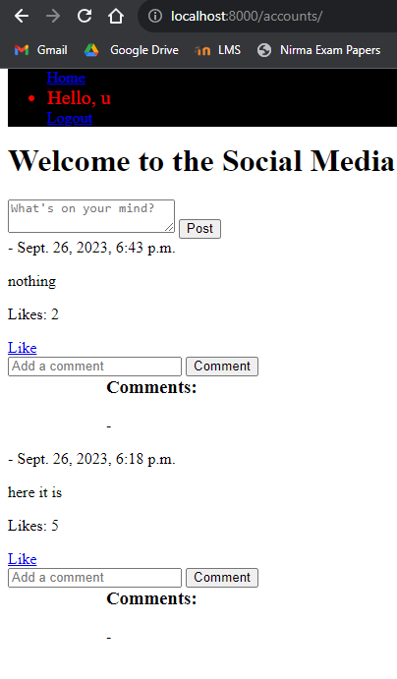

In above screenshot the “u” is the username that is enterd while creating a user from registeratio page.

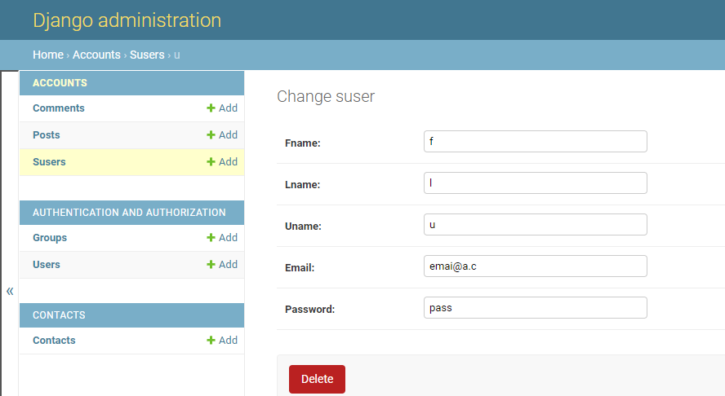

Social media before login.

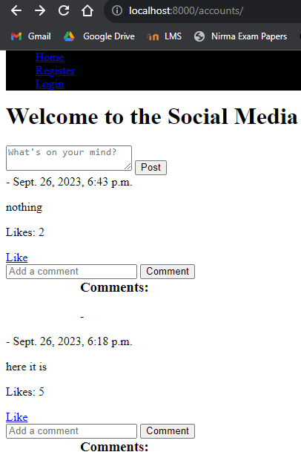

And I can not add Post, comment and Like.

Registering a user.



